- PNR #2 (Risky)
  - TUID should be in Non-Fraud Status
    - 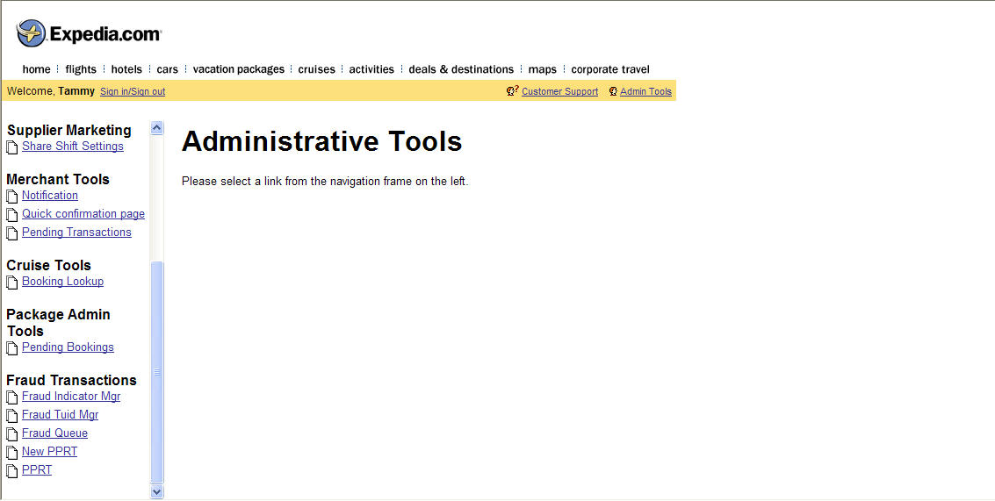
    - 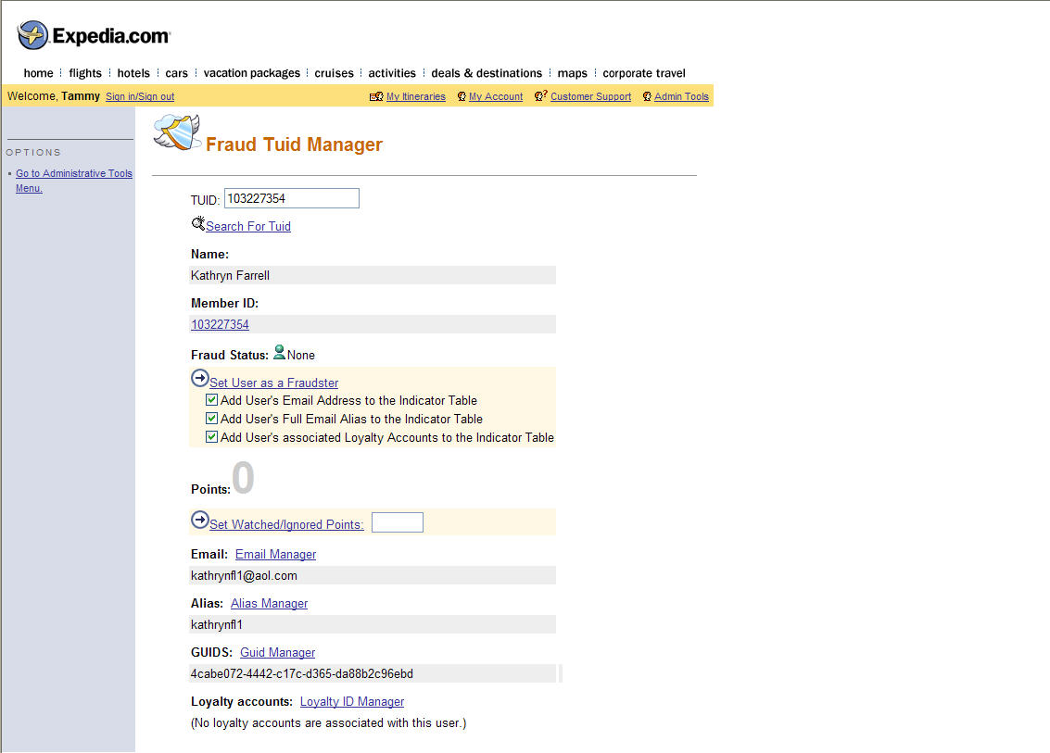
  - Create “risky” PNR #2 in the TUID
    - Parameters for a risky PNR
      - Cardholder different than traveler
      - Same day or next day travel
      - High dollar amount
      - One way ticket
    - Validation
      - PNR #2 should move to fraud queue
        - 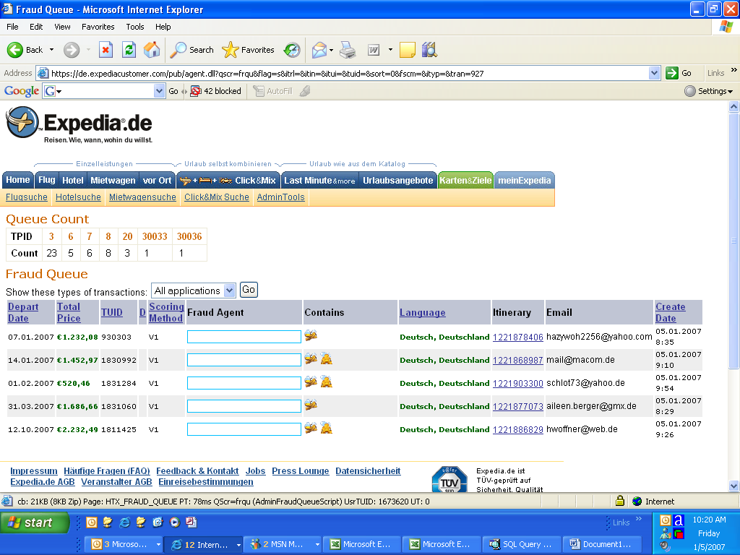
      - PNR #2 should stay in the fraud queue and not move to GDS ticketing queue
        - From Sabre, type “*QH” on the command line to bring up the queue history
        - 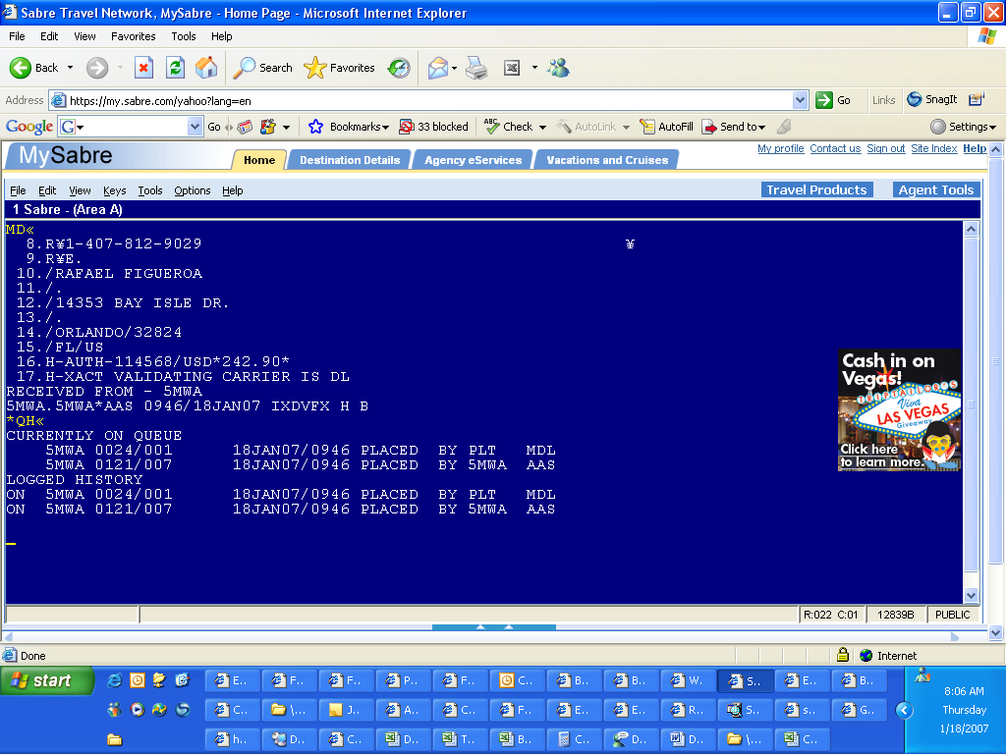
      - PNR #2 should have “RAIN OK” UDID 43 line and the “Purchase In Process” lines added
        - 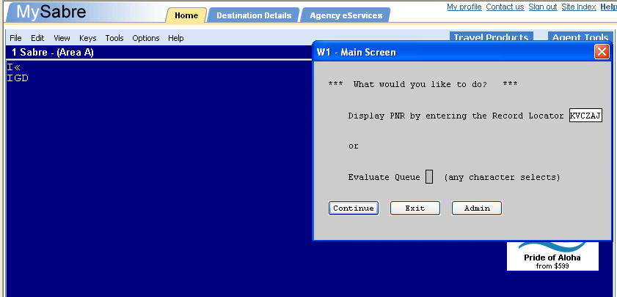
        - 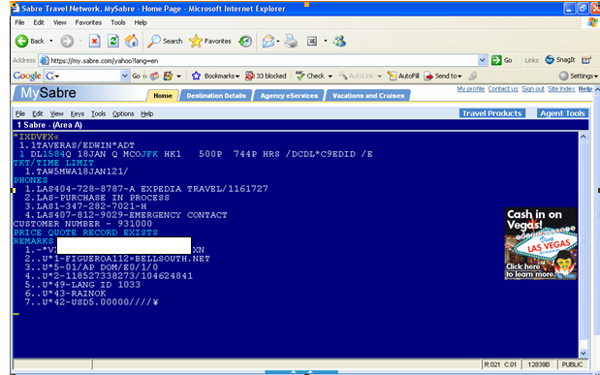

  - Pass PNR #2
    - From the Admin Tools - Credit Card Fraud Log Viewer, select the dropdown “pass-not fraud” fraud option.
      - 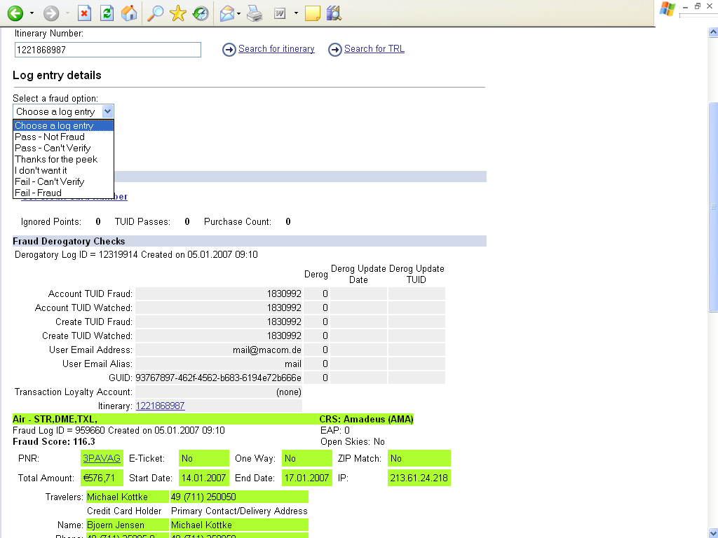
    - Validation
      - PNR #2 should move from the fraud queue
      - PNR #2 should move to the GDS ticketing queue
        - From Sabre, type “*QH” on the command line to bring up the queue history
        - 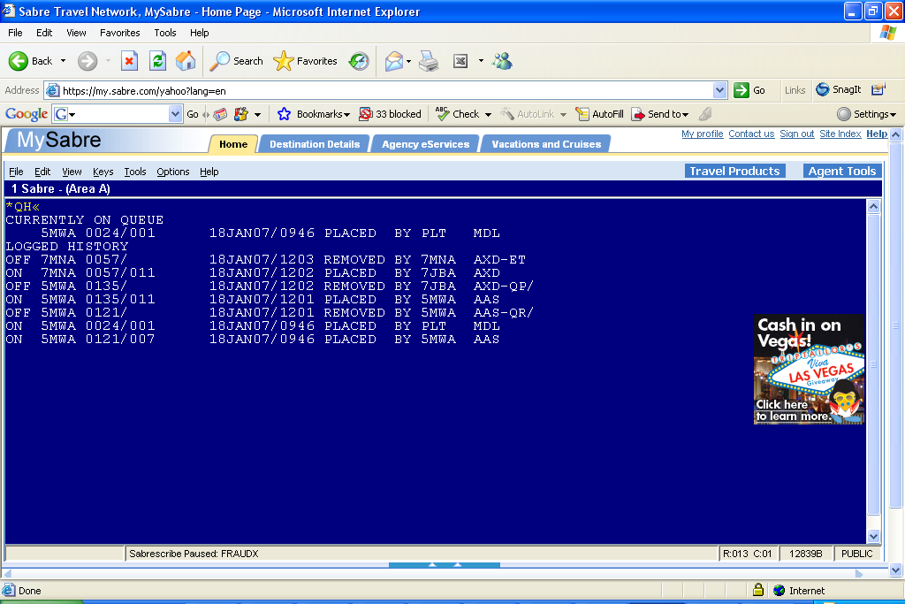
      - PNR #2 should have UDID 43 “RAIN OK” line and “Purchase In Progress” line removed
        - 