- PNR #3 (Fraud TUID)
  - Mark the TUID to Fraud Status
    - Parameters to mark a TUID to Fraud Status
      - In the TUID Manager, select the “set user as a fraudster” link.
        - 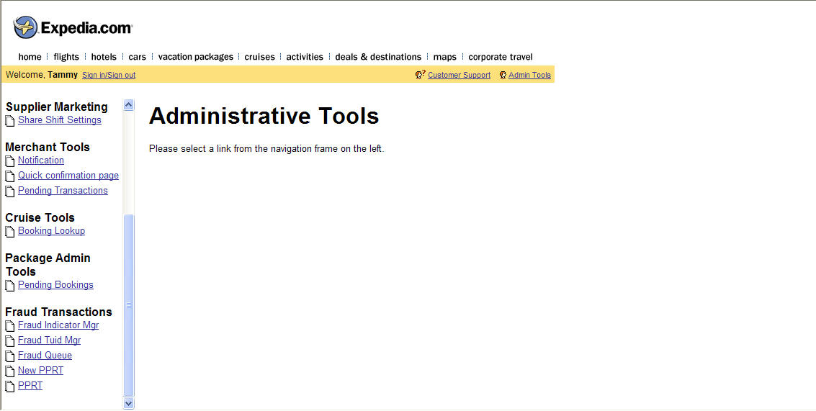
        - 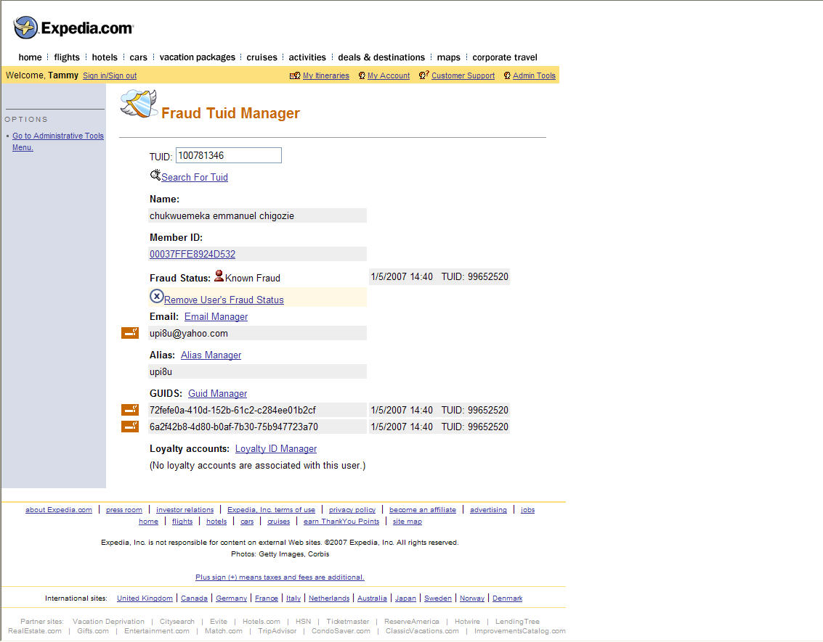
  - Create PNR #3 in the TUID with Fraud Status
    - Parameters for PNR #3 can be any parameters. The TUID fraud flag will score the PNR as fraud.
    - Validation
      - PNR #3 should move to fraud queue
        - 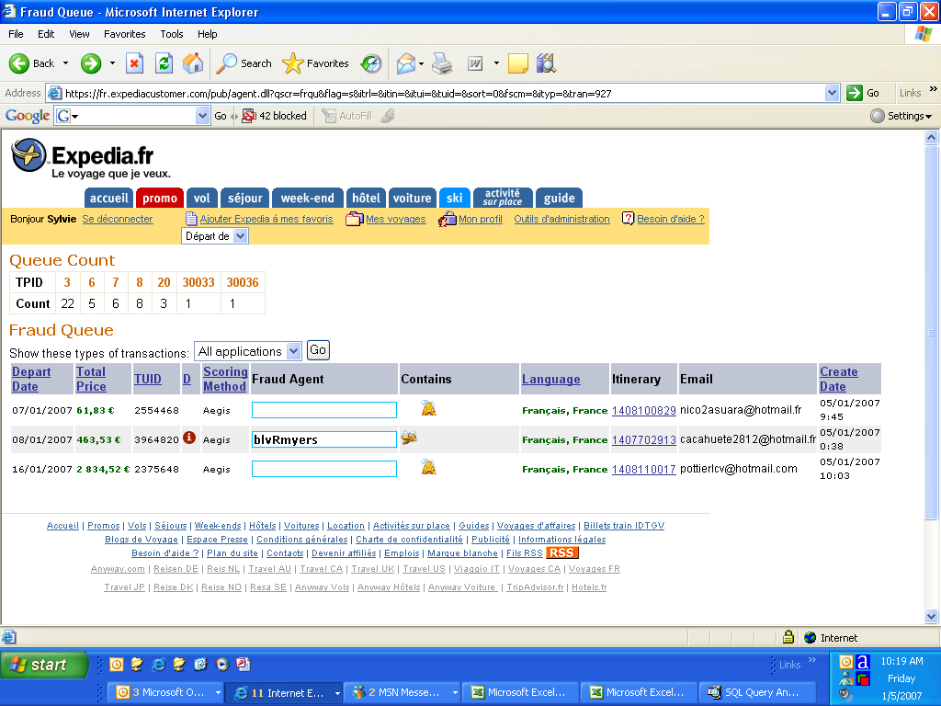
      - PNR #3 should stay in the fraud queue and not move to GDS ticketing queue
        - From Sabre, type “*QH” on the command line to bring up the queue history
        - 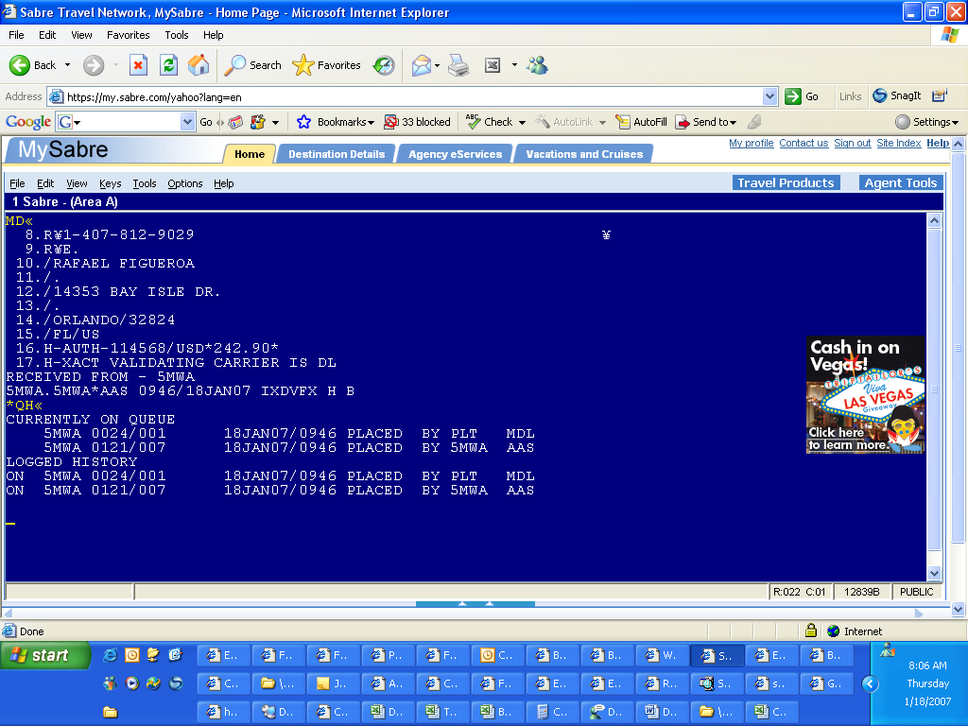
      - PNR #3 should have “RAIN OK” UDID 43 line and the “Purchase In Process” lines added
        - 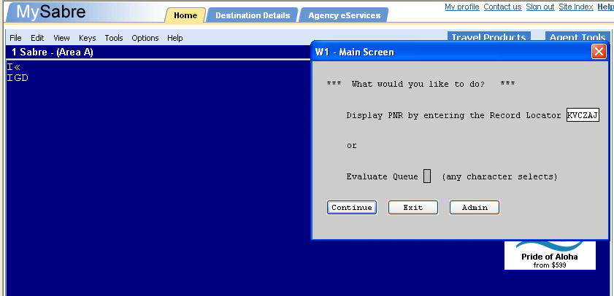
        - 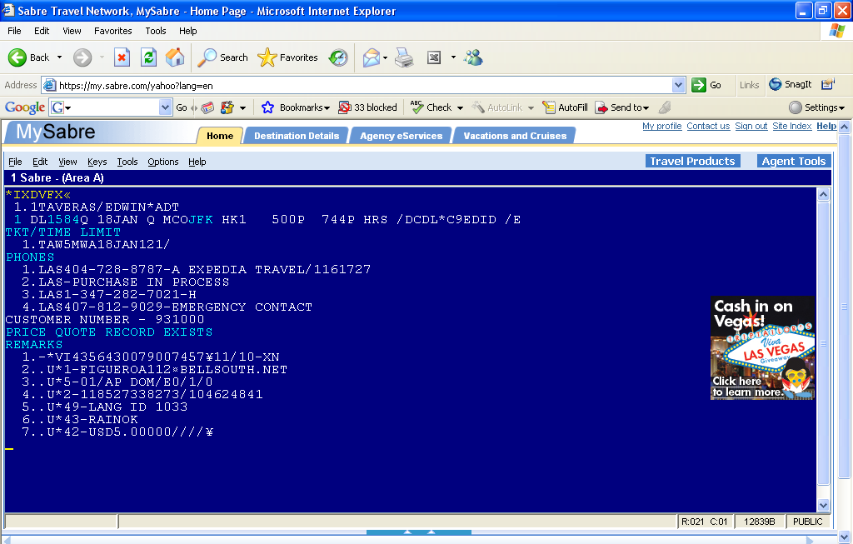
  - Cancel PNR #3
    - From the Admin Tools - Credit Card Fraud Log Viewer fail PNR #3 by selecting the dropdown “fail-fraud” fraud option.
      - 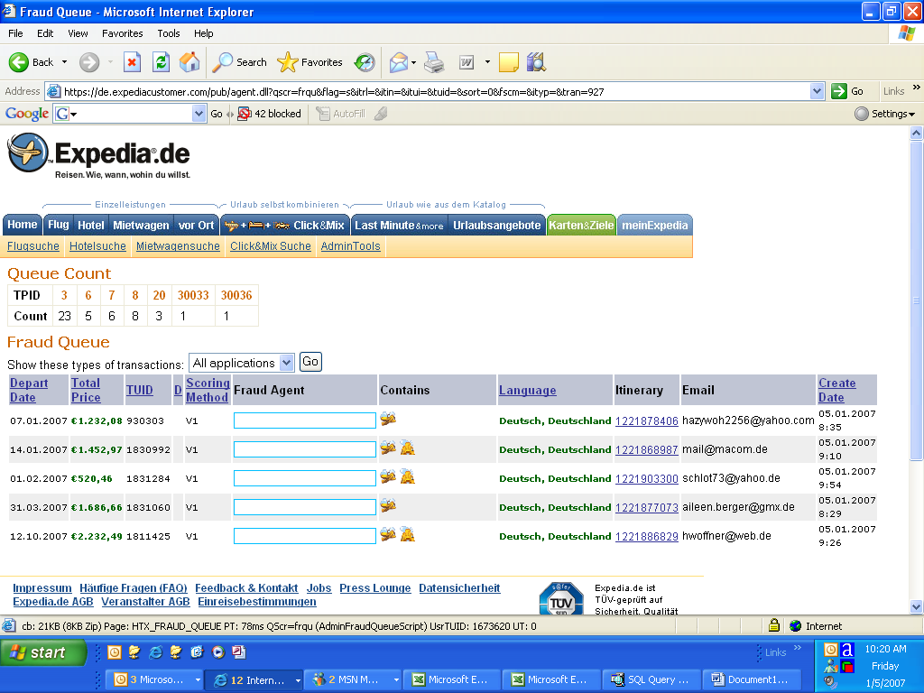
      - 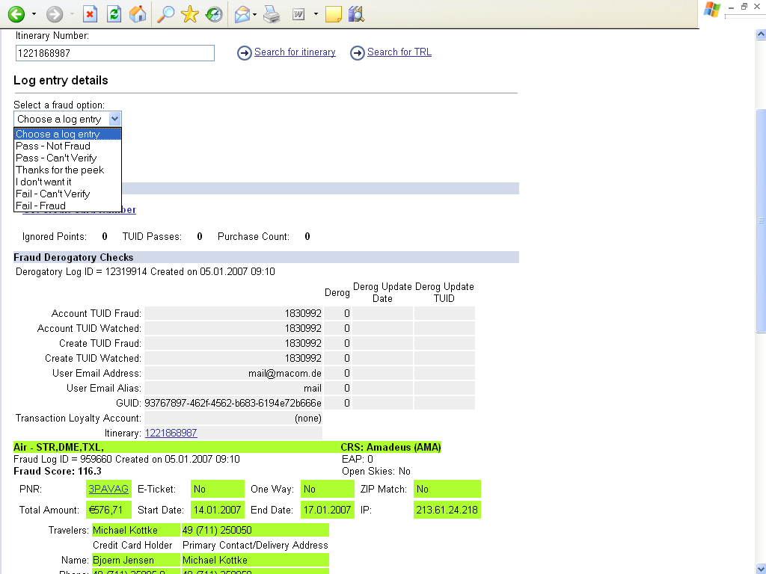
    - Validation
      - PNR #3 should be removed from the Admin Tools fraud queue
      - PNR #3 should stay in the GDS fraud queue and not move to the GDS ticketing queue
        - From Sabre, type “*QH” on the command line to bring up the queue history
    - From the GDS Fraud Script manually cancel PNR #3 at the GDS.
      - 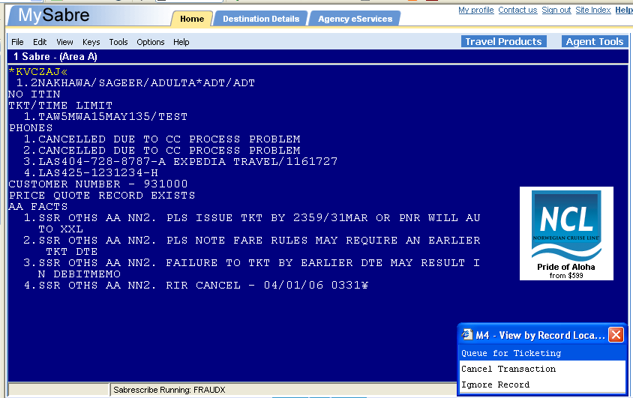
      - 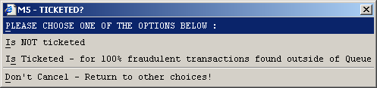
        - Is NOT Ticketed. This is for the transactions that are in the queue.
        - Is Ticketed. This is for the fraud found outside the queue.
    - Validation
      - PNR #3 should have the “RAIN OK” UDID 43 line removed.
      - PNR #3 should have the “Purchase In Process” changed to “Cancelled Due to CC Process Problem”.
      - PNR #3 should have the following added to the A5H notes: "Cancelled due to credit card processing problems. Please advise customer to contact process@expedia.com."
        - 
         