PackageTest

Nicole Grunert

2017-07-28

# challenges:

# create analysis directory

# create rmd in that directory

# use bookdown to get cap/cross-refs

# write a fn in R

# document your function with roxygen

# use the function in your rmd

knitr::opts_chunk$set(echo = TRUE)

# rubish

just learning learning learning

library(mytestpkg)

# function

fantastic shiny rubish function that doesnt work properly

plot(-1, xlim = c(0,5), ylim = c(0,5))  
curve(5*x^3,add=T) # Plot an equation as a curve

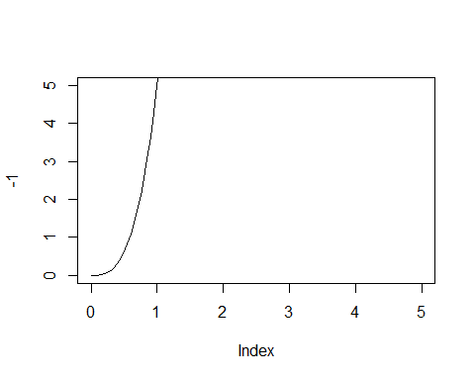

# bibliographic citations example

reproducible research is important (Hillier et al. 1976)

more than one author:(see these ones: Hillier et al. 1976; Jammer 1969; Gregory 1994)

Gregory (1994) is a very good paper...

Hillier build the whole concept of Space Syntax Theory (1976)

here is a footnote:[1]

# License

devtools::use_mit_license() * Updating license field in DESCRIPTION. * Creating LICENSE from template. devtools::use_testthat() * Adding testthat to Suggests * Creating tests/testthat. * Creating tests/testthat.R from template.

# test has to be reviewed closely

Gregory, Derek. 1994. “Geographical Imaginations.”

Hillier, Bill, Adrian Leaman, Paul Stansall, and Michael Bedford. 1976. “Space Syntax.” *Environment and Planning B: Planning and Design* 3 (2). SAGE Publications Sage UK: London, England: 147–85.

Jammer, Max. 1969. “Concepts of Space.”

1. Text and things