paper

Nicole Grunert

2017-07-19

## R Markdown

This is an R Markdown document. Markdown is a simple formatting syntax for authoring HTML, PDF, and MS Word documents. For more details on using R Markdown see <http://rmarkdown.rstudio.com>.

When you click the **Knit** button a document will be generated that includes both content as well as the output of any embedded R code chunks within the document. You can embed an R code chunk like this:

summary(cars)

## speed dist   
## Min. : 4.0 Min. : 2.00   
## 1st Qu.:12.0 1st Qu.: 26.00   
## Median :15.0 Median : 36.00   
## Mean :15.4 Mean : 42.98   
## 3rd Qu.:19.0 3rd Qu.: 56.00   
## Max. :25.0 Max. :120.00

knitr::kable(head(cars),  
 caption = "My Demo Table")

Table 1 My Demo Table

|  |  |
| --- | --- |
| speed | dist |
| 4 | 2 |
| 4 | 10 |
| 7 | 4 |
| 7 | 22 |
| 8 | 16 |
| 9 | 10 |

## Including Plots

You can also embed plots, for example:

plot(-1, xlim = c(0,5), ylim = c(0,5))  
curve(5*x^3,add=T)

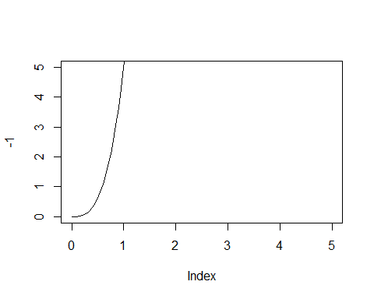

Figure 1 curve

Note that the echo = FALSE parameter was added to the code chunk to prevent printing of the R code that generated the plot.

# references and footnote

reproducible research is important (Hillier et al. 1976)

more than one author:(see these ones: Hillier et al. 1976; Jammer 1969; Gregory 1994)

Gregory (1994) is a very good paper...

Hillier build the whole concept of Space Syntax Theory (1976)

here is a footnote:[1]

# captions and crossrefs

In figure XX ?? you can clearly see a big increase... But in table ?? we can see...

Gregory, Derek. 1994. “Geographical Imaginations.”

Hillier, Bill, Adrian Leaman, Paul Stansall, and Michael Bedford. 1976. “Space Syntax.” *Environment and Planning B: Planning and Design* 3 (2). SAGE Publications Sage UK: London, England: 147–85.

Jammer, Max. 1969. “Concepts of Space.”

1. Text and things