GearBox Simulator

**Description**

Automata design involves basic movements unit such as crank slider, cam, gear, linkage etc. As part of my dissertation thesis, I am developing web based application name called Kinemaker (is part of http://craftml.io), provides set of movement units as cubic module, enabling 3D host objects downloaded from elsewhere (such as SketchUp 3D warehouse, Thingiverse, etc.) to host movement unit inside – finally create a solid 3D model movable. I plan to develop an mobile application that simulate automat movements along with gear unit, projecting each different unit’s different movement affecting to the host 3D object.

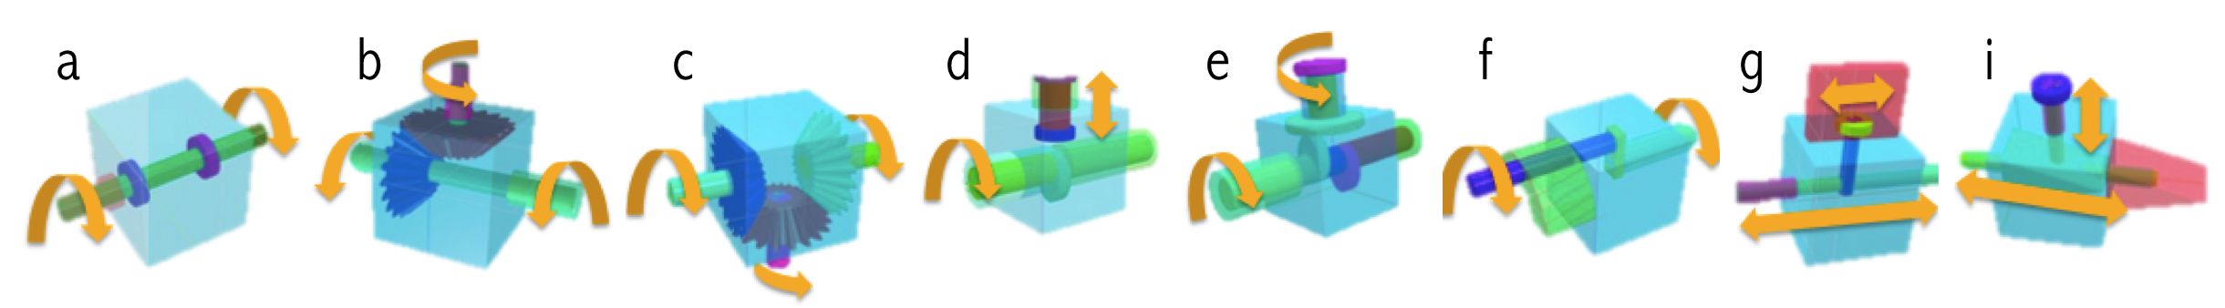

**Figure 1. Movements unit embedded into 3D host object and allow it movable. (a)linkage, (b)jumper gear, (c) friction gear, (d)crank, (e)double cam**

**UI components**

* Segment ControlMacintosh HD:Users:JeeeunKim:Desktop:Screen Shot 2015-09-17 at 9.37.39 PM.png

Enable users to choose options in rand of host 3D models. Kind of host 3D objects (numbers of option) could be vary based upon time constraints of project, and the number of images I could attach to the project

* Buttons

Macintosh HD:Users:JeeeunKim:Desktop:Screen Shot 2015-09-17 at 9.37.47 PM.png

This will be projecting designated gear units inside host 3D object in sequence. The number of gears will be also vary (I am currently thinking only 3 units, not all 5 as shown in figure1 for now)

Macintosh HD:Users:JeeeunKim:Desktop:Screen Shot 2015-09-17 at 9.37.52 PM.png

Image view shows set of images in loop of regulated frame rate, so that it seems to be simulating movements in the selected host object, projecting movement of selected gear units

* Slider

Macintosh HD:Users:JeeeunKim:Desktop:Screen Shot 2015-09-17 at 9.37.43 PM.png

This will change the delay between images set to change simulation speed

**UI Sketch**

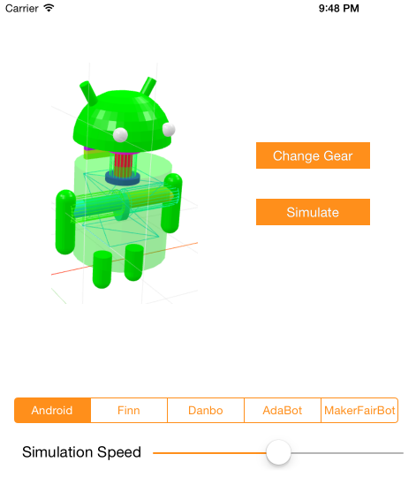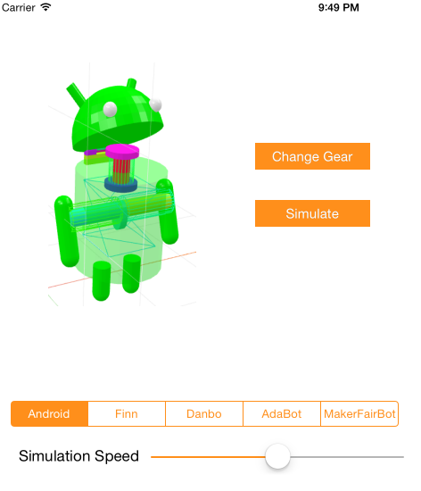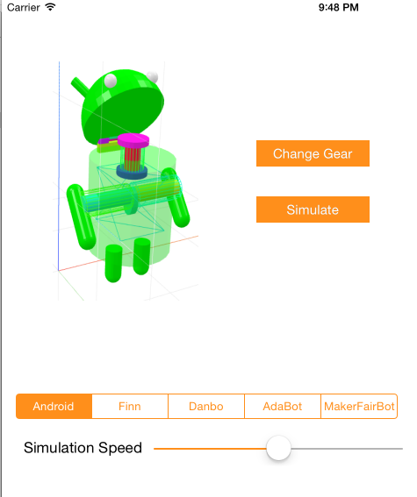

**Figure 2. Robot automata simulations, with movements of rotating arm and opening mouth as time passes.**

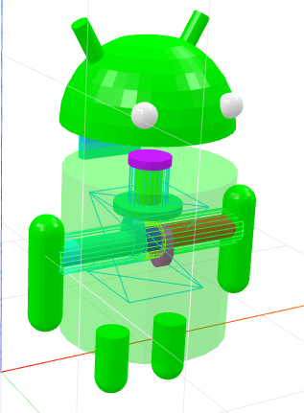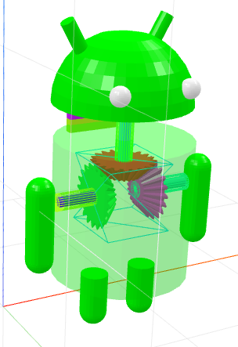

**Figure 3. The android bot with different inner gear unit projected into the body. When the inner structure of gear is changed to friction gear(left, Figure.1c), double cam(right, Figure.1e)**