# Report of Deep reinforcement learning Nano-degree Project 3: Collaboration and Competition

2019-2-24

This report summarizes the brief detail of my implementation of this project.

## Environment

In this environment, two agents control rackets to bounce a ball over a net. If an agent hits the ball over the net, it receives a reward of +0.1. If an agent lets a ball hit the ground or hits the ball out of bounds, it receives a reward of -0.01. Thus, the goal of each agent is to keep the ball in play.

## Algorithm

I borrowed the typical Deep Deterministic Policy Gradients (DDPG) framework of the former lessons, and Multi DDPG agent’s framework are built based on it.

Two agents have separate networks and same actor-critic structures. As suggested in the benchmark, they shared the same replay buffer in this project.

Parameters:

Actor:

Full connected hidden layer 1: (input states, 256)

ReLU function

Batch Normalization of layer 1

Full connected hidden layer 2: (256, 256)

ReLU function

Output layer (256, actions)

Tanh function

Critic:

Full connected hidden layer 1: (input states, 256)

ReLU function

Batch Normalization of layer 1

Full connected hidden layer 2: (256+action_size, 256)

ReLU function

Output layer (256, 1)

Linear function

Hyperparameters of the agent:

BUFFER_SIZE = int(1e5) # replay buffer size

BATCH_SIZE = 256 # minibatch size

GAMMA = 0.99 # discount factor

TAU = 1e-3 # for soft update of target parameters

LR_ACTOR = 1e-4 # learning rate of the actor

LR_CRITIC = 1e-4 # learning rate of the critic

WEIGHT_DECAY = 0 # L2 weight decay

OUNoise: mu=0., theta=0.15, sigma=0.2

Update_frequecy=2

## Reflection and Results

In this project, the main effort is to re-construct the framework which could train multi-agents with DDPG in this environment. The basic DDPG framework without changing in noise (small noise may cause slow learning in this case) or adding grad norm was applied.

The plot of training result is follows:

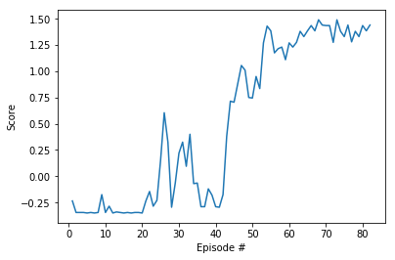

It seems that a larger Batch size for the shared replay buffer would be useful. Since these two agents could be considered to face very similar experiences, it would be helpful for them to learn from each other.

## Perspective

It would be interesting to see what happens if these two agents did not share replay buffers or both agents share one DDPG network. Also, I would like to check out other algorithms used by others for this project.