Bug Reports

# BUG #01 - About Us video fails to play and shows an error message:

# Steps to Reproduce:

1. Go to https://www.demoblaze.com

2. Click on the **"About us"** link in the top navigation bar

3. Observe the popup window that appears

4. Notice that the video does not play and an error message is displayed

# Expected Result:

# The video should play smoothly when the "About us" modal is opened.

# Actual Result:

# The video fails to play and shows an error message: "The media could not be loaded, either because the server or network failed or because the format is not supported."

# Attachment:

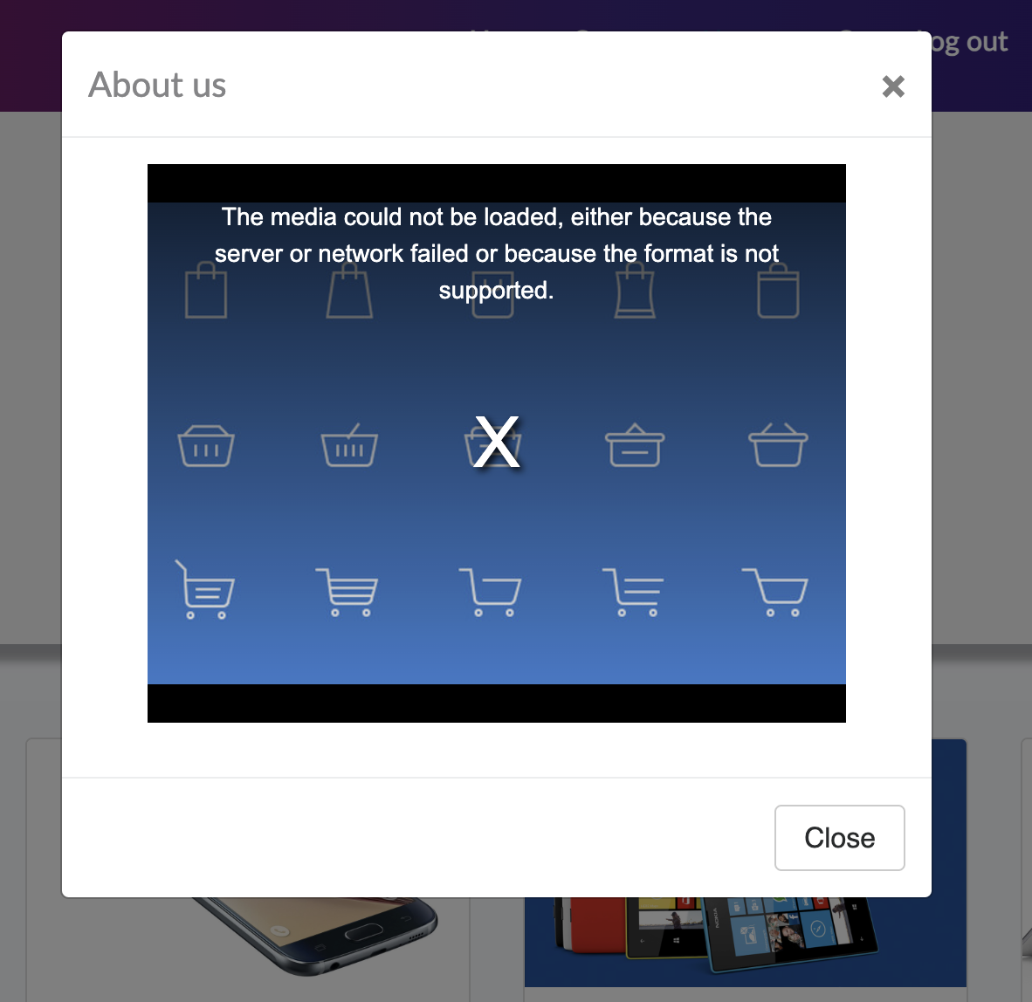

# Priority:

High – This issue significantly impacts the user experience by preventing them from viewing the About Us content.

# BUG #02 - Navigation menu item stays highlighted incorrectly after clicking another module:

# Steps to Reproduce:

1. Go to https://www.demoblaze.com

2. Log in with a valid user (e.g., customer2)

3. Click on **"About us"** in the top navigation bar

4. Then click on **"Home"** or any other navigation link

5. Observe the navigation bar

**Expected Result:**

Only the currently active navigation menu item should be highlighted, while others return to their default style.

**Actual Result:**

The previously clicked navigation menu item (e.g., **"About us"**) remains highlighted even after navigating to another section, which causes confusion about which module is currently active.

**Attachment:**

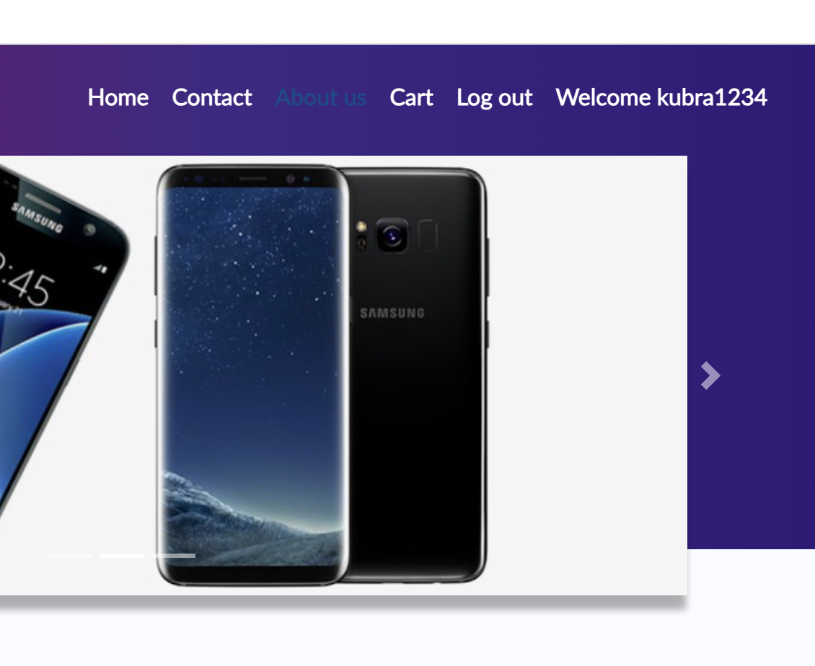 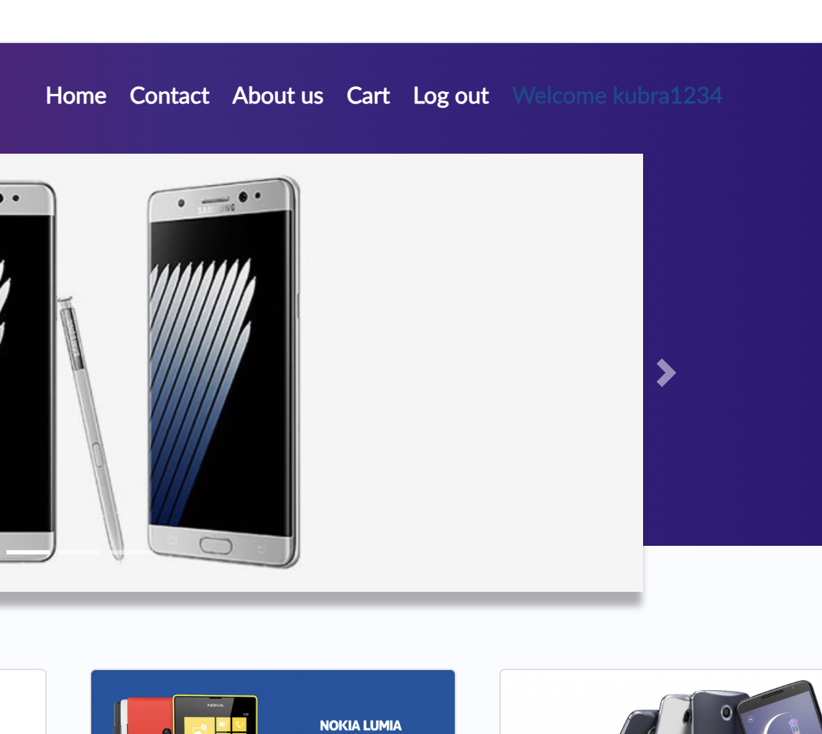

# Priority:

# Medium – This issue causes visual inconsistency and may confuse users about which page they are viewing.

# BUG #03 - Selecting "Laptops" category also displays a monitor product on the next page:

# Steps to Reproduce:

1. Go to https://www.demoblaze.com

2. On the left side, click on the **"Laptops"** category under **CATEGORIES**

3. Scroll to the bottom of the list and click **"Next"** to view the next page of laptops

4. Observe the listed products

**Expected Result:**

# Only products that belong to the ****Laptops**** category should be displayed.

# Actual Result:

# A ****monitor product**** is incorrectly displayed alongside laptops on the next page.

# Attachment:

BUG#03_ScreenRecording-

<https://drive.google.com/file/d/18ncBdFjo67z164OMuGw-rdlu_3DTZ5Jn/view?usp=drive_link>

# Priority:

High – This causes incorrect product categorization, potentially confusing users and affecting purchase decisions.

# BUG #04 - Place Order button is enabled and allows order form to open even when cart is empty:

# Steps to Reproduce:

1. Go to https://www.demoblaze.com

2. Log in with a valid user (e.g., customer2)

3. Click on the Cart link without adding any products

4. Click the Place Order button

# Expected Result:

The Place Order button should be disabled or clicking it should show a warning that the cart is empty.

# Actual Result:

The Place Order button is enabled, and the order modal opens, allowing the user to proceed with the purchase.

# Attachment:

BUG#04_ScreenRecording –

<https://drive.google.com/file/d/1ZyVadzaIzCM9QEbubqQpCdojBO9nYZgg/view?usp=drive_link>

# Priority:

Medium – affects purchase flow logic and could lead to invalid order attempts.

# BUG #05 - Order form allows purchase with only Name and Card Number fields filled:

# Steps to Reproduce:

1. Go to https://www.demoblaze.com

2. Log in with a valid user (e.g., customer2)

3. Add any product to the **Cart**

4. Go to the **Cart** page

5. Click on the **"Place Order"** button

6. In the order form, fill **only** the following fields; **Name, Card Number**

7. Leave **Country**, **City**, **Month**, and **Year** fields empty **or fill only one of them, leaving others blank**

**8.** Click the **"Purchase"** button

# Expected Result:

# The system should ****not**** allow the purchase to be completed and should display a validation error message indicating that ****all required fields must be filled in****.

# Actual Result:

# The system ****successfully processes the order**** even when some or all of the required fields (****Country****, ****City****, ****Month****, ****Year****) are left blank.

# Attachment:

BUG#05_ScreenRecording –

# <https://drive.google.com/file/d/1JtTMWh5o3LIXNBfC058cYI8X3kUC94Os/view?usp=drive_link>

# Priority:

Critical – This is a serious issue that can lead to incomplete or invalid orders being created, negatively impacting the ordering process and data integrity.

# BUG #06 - Contact form allows sending message without filling any fields:

# Steps to Reproduce:

1. Go to https://www.demoblaze.com

2. Click on the **"Contact"** link in the top navigation bar

3. In the **Contact form**, **leave all fields empty**:

* Contact Email
* Contact Name
* Message

4. Click the **"Send message"** button

**Expected Result:**

The system should **not** send the message and should display a **validation error** indicating that all required fields must be filled in.

# Actual Result:

# A success ****alert message**** appears, indicating that the message was sent successfully, even though ****no information was provided**** in the form.

# Attachment:

BUG#06_ScreenRecording –

# <https://drive.google.com/file/d/1LEwRKgCYELBjRJs90sgMZZMWB3lZVRMj/view?usp=drive_link>

# Priority:

High – This issue allows empty or invalid messages to be submitted, reducing the reliability of the contact system and potentially causing communication problems.

# BUG #07 - Pagination issue – "Previous" button displays incorrect products in Laptops category:

# Steps to Reproduce:

1. Go to https://www.demoblaze.com

2. From the **CATEGORIES** section, click on **"Laptops"**

3. Verify that the first page displays only laptop products

4. Scroll down and click **"Next"** to go to the second page of laptop products

5. Then click **"Previous"** to return to the first page

**Expected Result:**

The **"Previous"** button should return the user to the **original first page**, showing the **same laptop products** as initially displayed.

**Actual Result:**

Clicking **"Previous"** shows **incorrect products**, including items from other categories, instead of the original laptop list.

# Attachment:

BUG#07_ScreenRecording –

<https://drive.google.com/file/d/1lZNbAR_C7TZCXFRIKCGJXCFWhRmtNpd_/view?usp=drive_link>

# Priority:

High – This impacts the browsing experience and confuses users, making it difficult to navigate products correctly.

# BUG #08 - Session management issue – User can access previous session data after logout:

# Steps to Reproduce:

1. Go to https://www.demoblaze.com

2. **Log in** with a valid user account

3. Perform some actions, such as:

* Adding products to the cart
* Navigating between categories

4. Click on the **"Logout"** button

5. After logout, click the browser's **Back** button

**Expected Result:**

The user should **not** be able to see any pages or data from the previous session. The system should redirect to the **login page** or a **logged-out state**.

**Actual Result:**

# Even after logging out, clicking the ****Back**** button shows pages and data from the ****previous session**** (e.g., cart items, user-specific information). This indicates improper session termination.

# Attachment:

BUG#08_ScreenRecording –

<https://drive.google.com/file/d/1XeeBOpm95-aQxp2fQWKXhSuv_VyIE9T7/view?usp=drive_link>

**Priority:**

High – This is a **security issue** that could expose sensitive user data and lead to unauthorized access.

**\*\*\*If the case is not tested by our existing test suite, then I will add it as a new test case but if the case is already covered by an existing test case, then I will investigate the test case and update it so that the given scenario is also covered by our test suite.**