

**Sultan Qaboos University**

**College Of Science**

**Department Of Computer Science**

**COMP3502: Computer Networks.**

**Project: TCP Socket Programming**

**Task 1**

Team Members:

Aya Al Balushi (135131)

Quds Al Breiki (133343)

Khadija Al Bulushi (133556)

**Contents**

**Introduction** 3

**Analysis & Design** 4

**1-** **Design and IP Configuration of network _ Hub case** 4

**2-** **Design and IP Configuration of the same network _ Switch case 1** 4

**Testing** 5

**Conclusion** 6

# **Introduction**

A network that has the potential to experience packet collisions has collision domain as a part of it. In contrast to switches, bridges, and routers, hub devices do not isolate collision domains. When two devices transmit a packet simultaneously on a shared network segment, a collision occurs. Network efficiency is decreased as a result of the packet collision and subsequent resending by both devices. Because every port on a hub is in the same collision domain, collisions frequently happen in hub environments. On a bridge, switch, or router, however, every port is in its own collision domain.

# **Analysis & Design**

**Our network consists of 6 PCs that are connected to a hub and another network of 6 PCs that are connected to a switch.**

**with static IP addresses from 10.10.10.2 to 10.10.10.7**

**that are distributed among the PCs. where PC 0 has the IP address 10.10.10.2, PC 1 has the IP address 10.10.10.3, PC 2 has the IP address 10.10.10.4, PC 3 has the IP address 10.10.10.5, PC 4 has the IP address 10.10.10.6 and PC 5 has the IP address 10.10.10.7**

## **Design and IP Configuration of network _ Hub case**

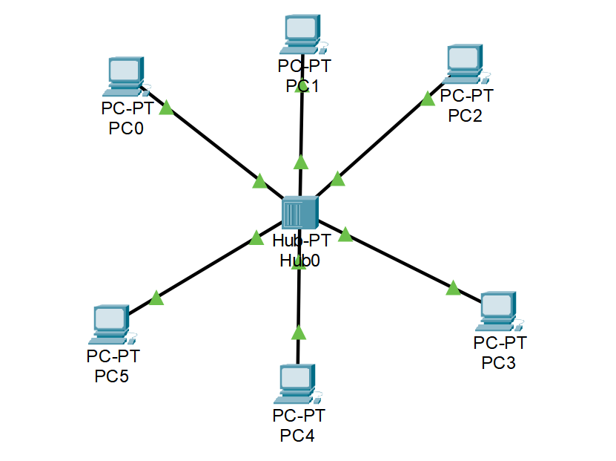

## **Design and IP Configuration of the same network _ Switch case**

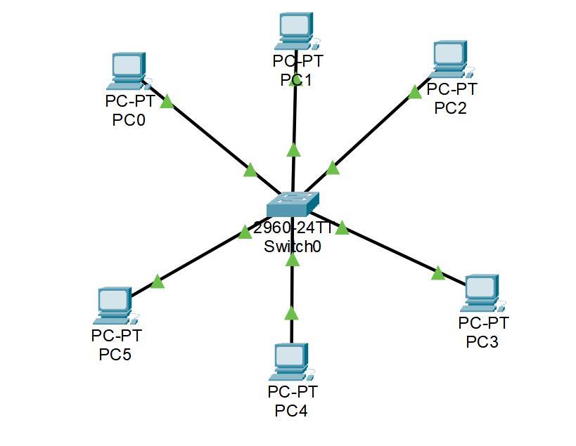

## **IP Configuration of both network _ Hub and network _ Switch**

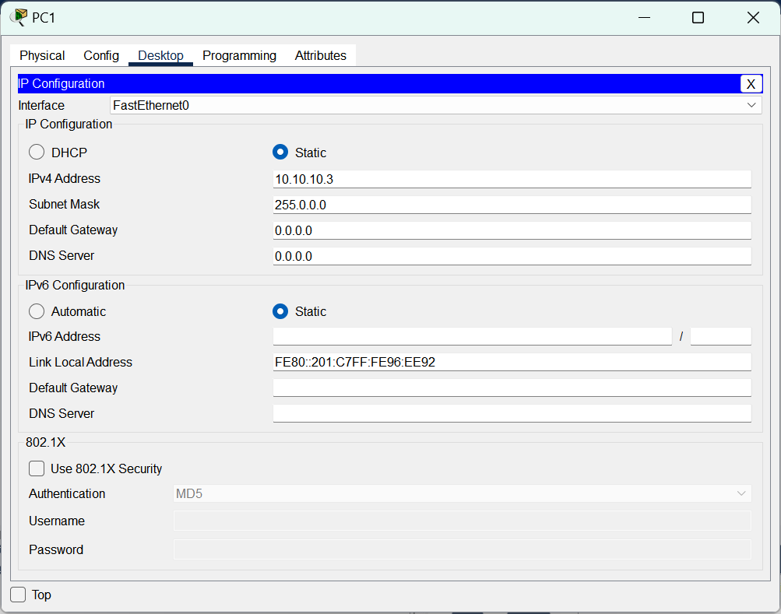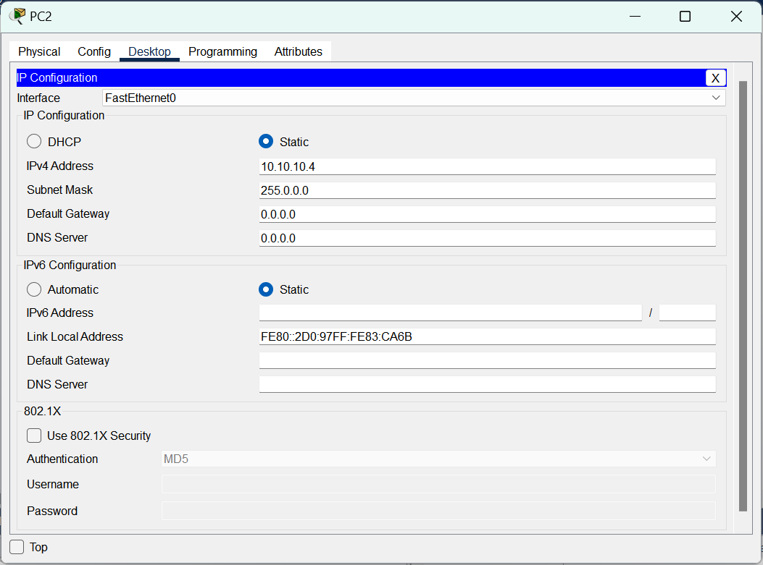

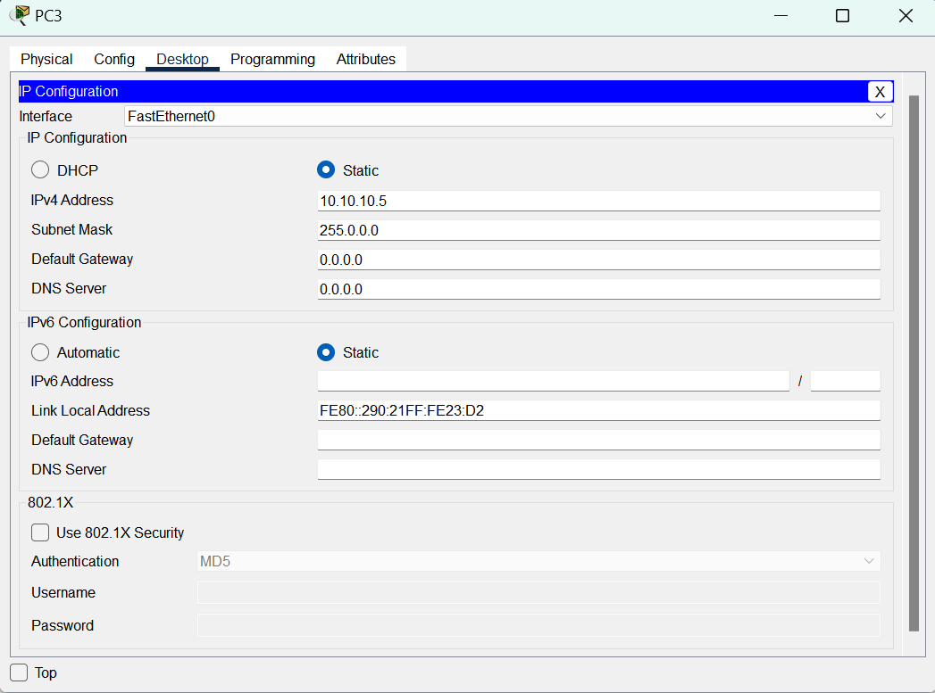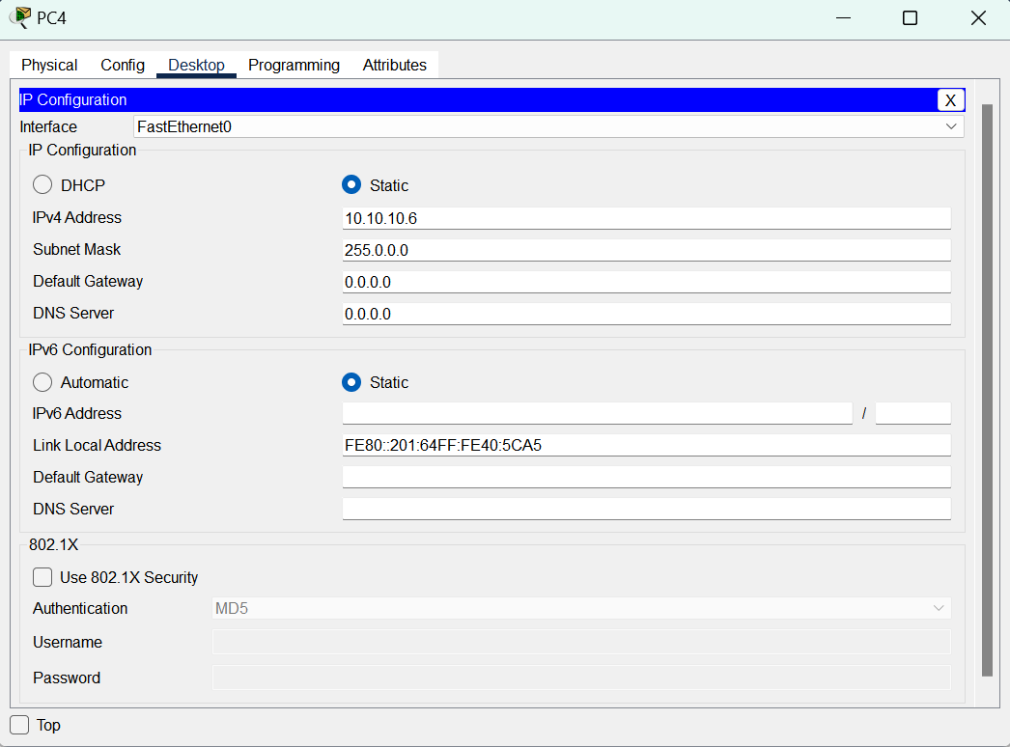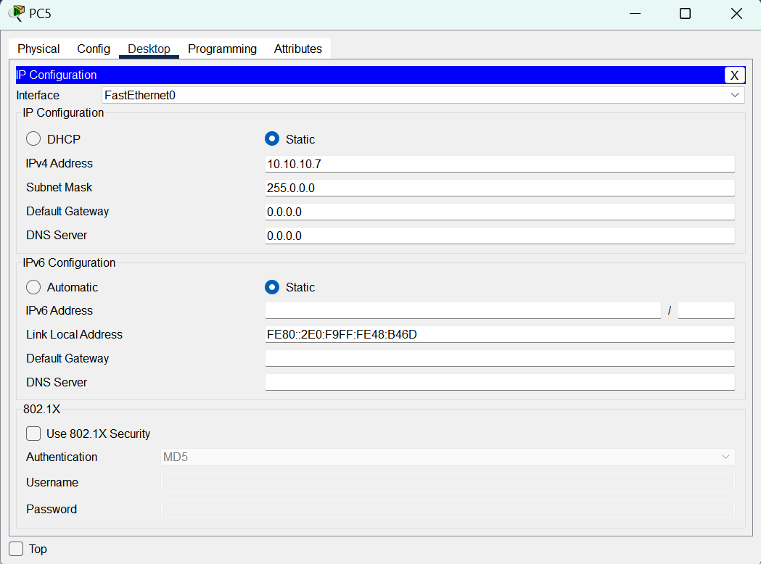

# **Testing**

## **Network _ Hub case**

* The message will be transmitted from pc0 t0 pc3.
* Check if the mac address of pc3 in arp table of pc0

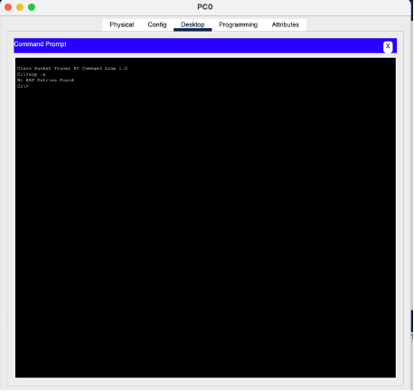

* The arp table of both PC1 and PC2 are empty

Collision domain _ Hub case:

* Attempting to send two messages at the same time from PC1 to PC4 and from PC2 to PC5.

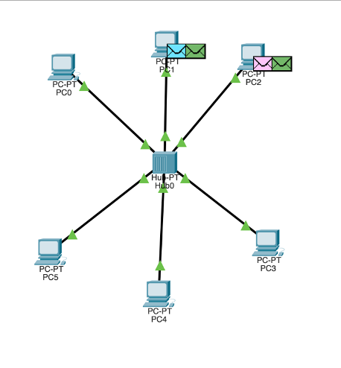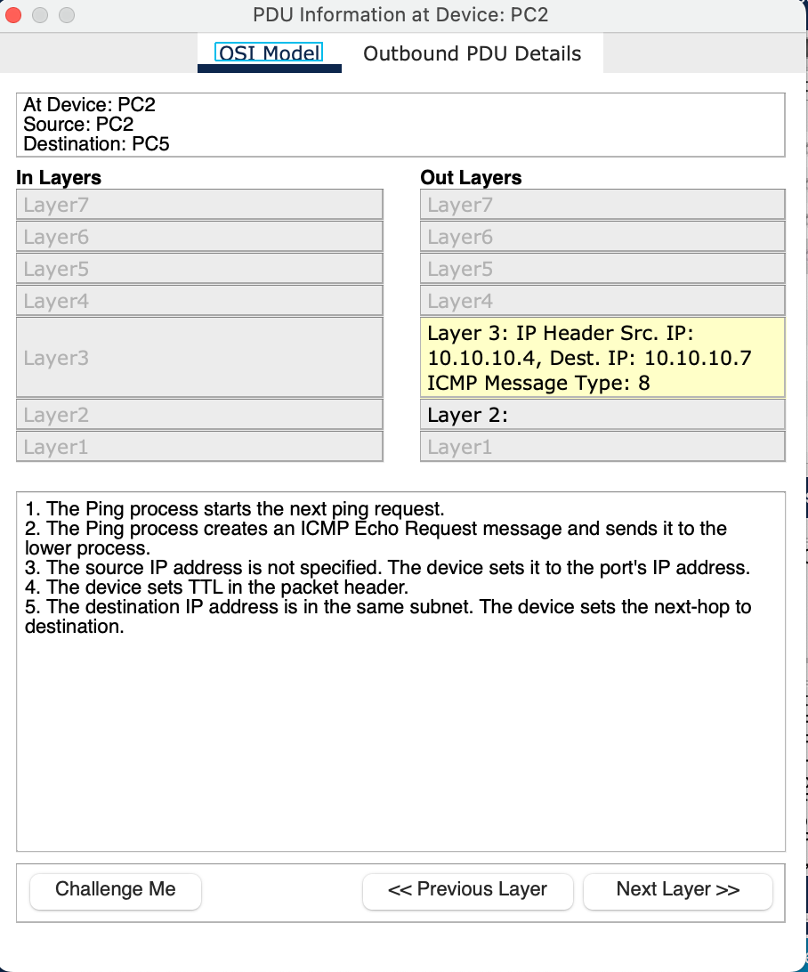

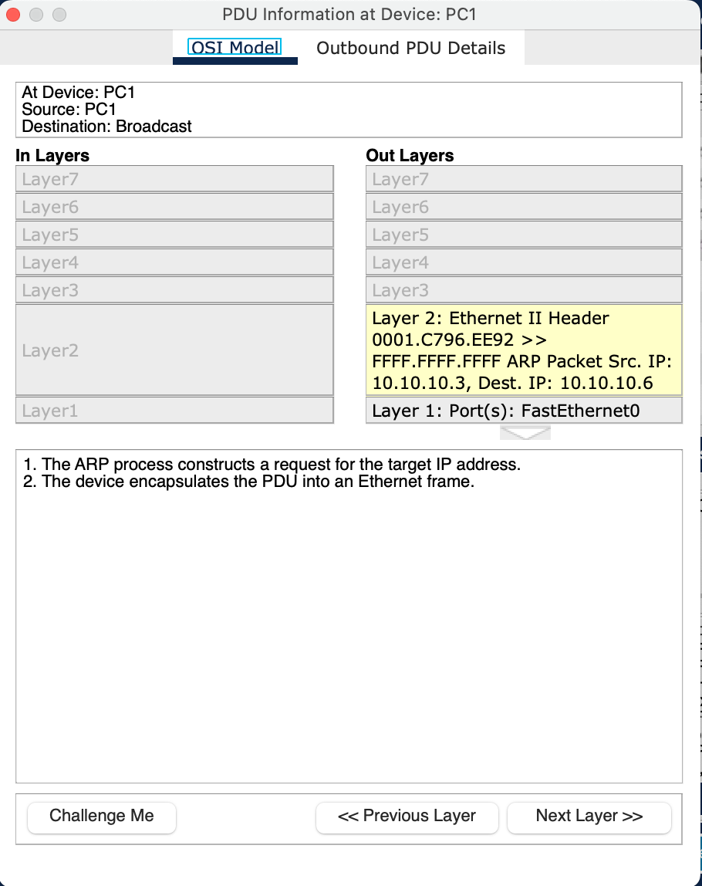

* When both of the messages reach the hup they will collide and then content will be destroyed.

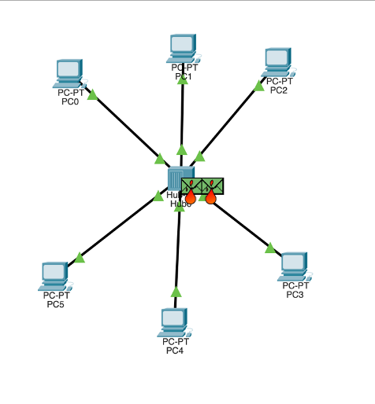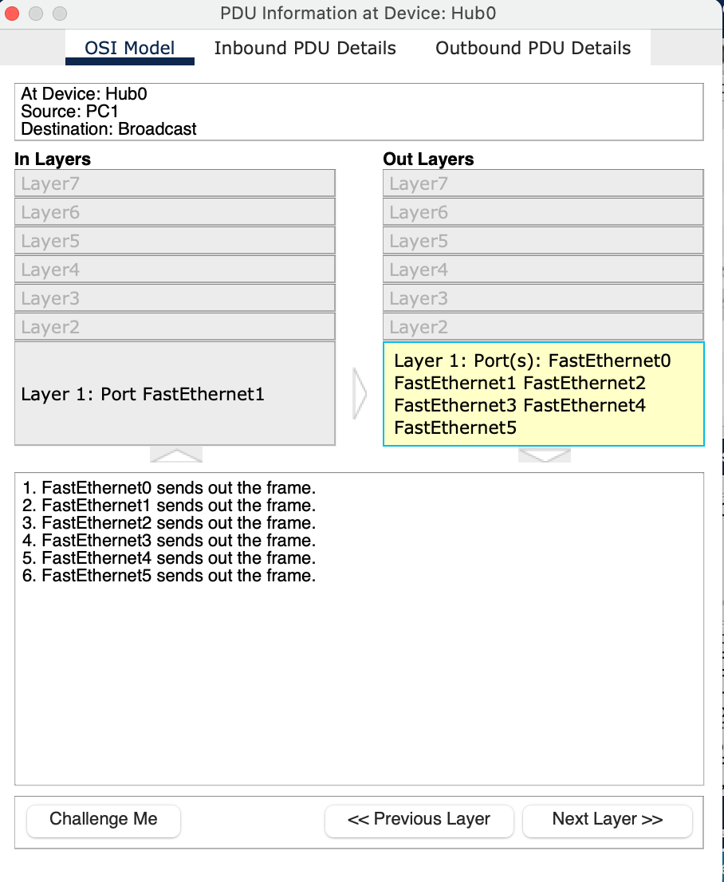

* Now the hub will broadcast the damaged messages.

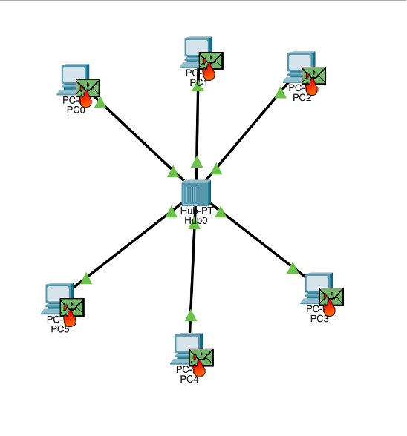

* In this case the mac address of the destination(PC4 & PC5) will not be known by the source (PC1 & PC2).

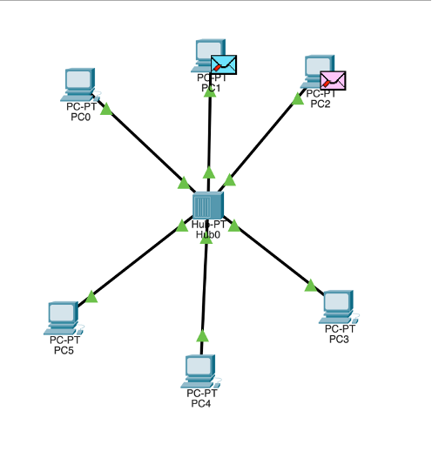

## 

## **Network _ Switch case**

* scenarios used to demonstrate collision domains:

1. **The same scenario is used as in network_Hub case:** Attempting to send two messages at the same time from PC1 to PC4 and from PC2 to PC5, by using switch the two frames will go to the switch, they won't collide and the content won't be destroyed. Then, they will be forwarded to their destination and will return back to the source successfully.

* **PC1** already knows about the destination(**PC4**)'s IP address and MAC address so no need for ARP broadcast to get the mac address .
* **PC2** already knows about the destination(**PC5**)'s IP address and MAC address so no need for ARP broadcast to get the mac address .

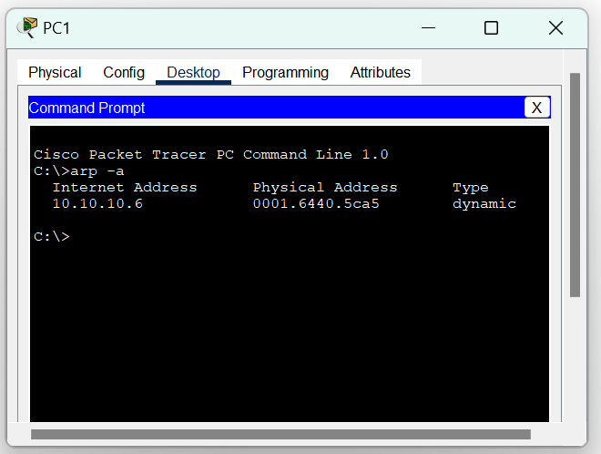

* Sending two messages at the same time from PC1 to PC4 and from PC2 to PC5.

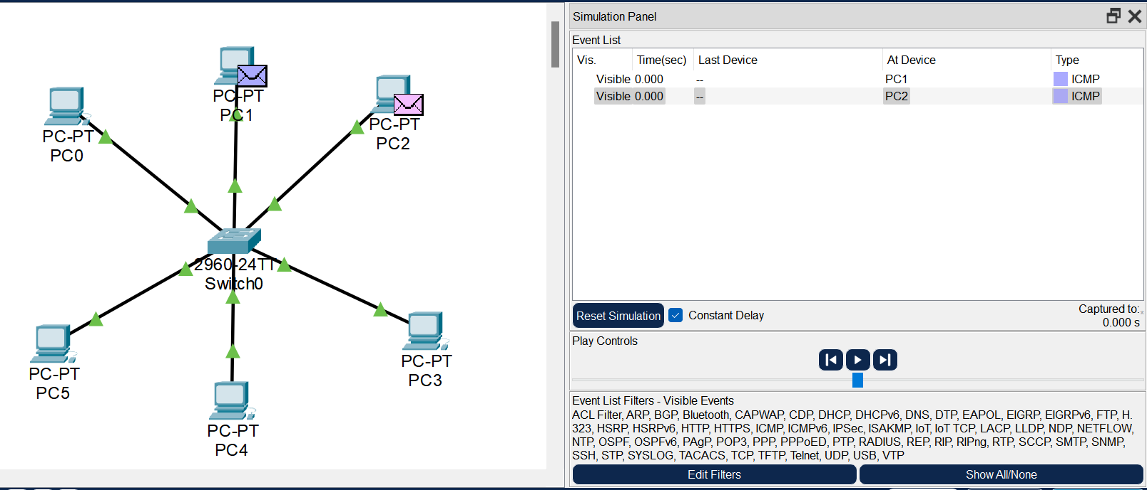

* The two frames will go to the switch and they won't collide and the content won't be destroyed.

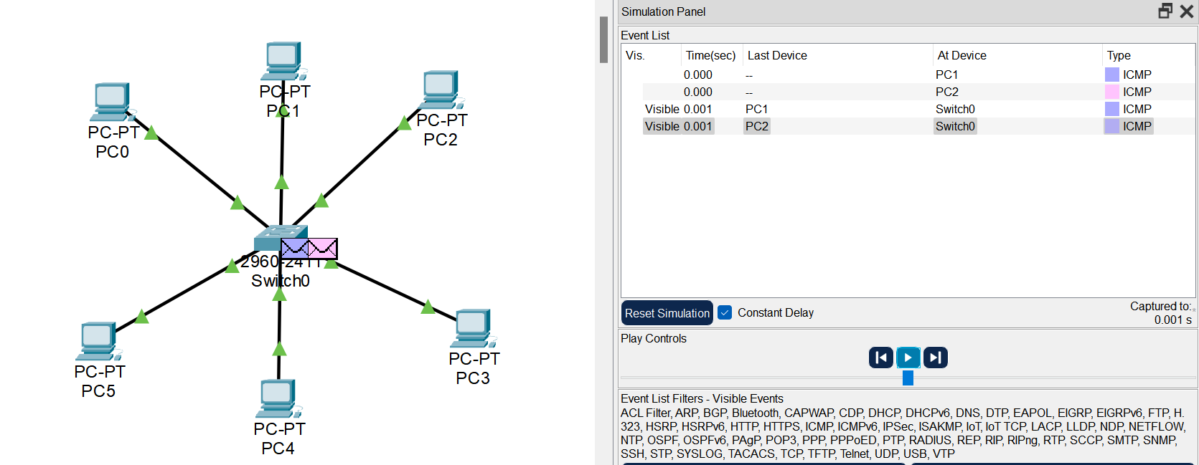

* After reaching the switch the frames will be forwarded to their destination and will return back to the source successfully.

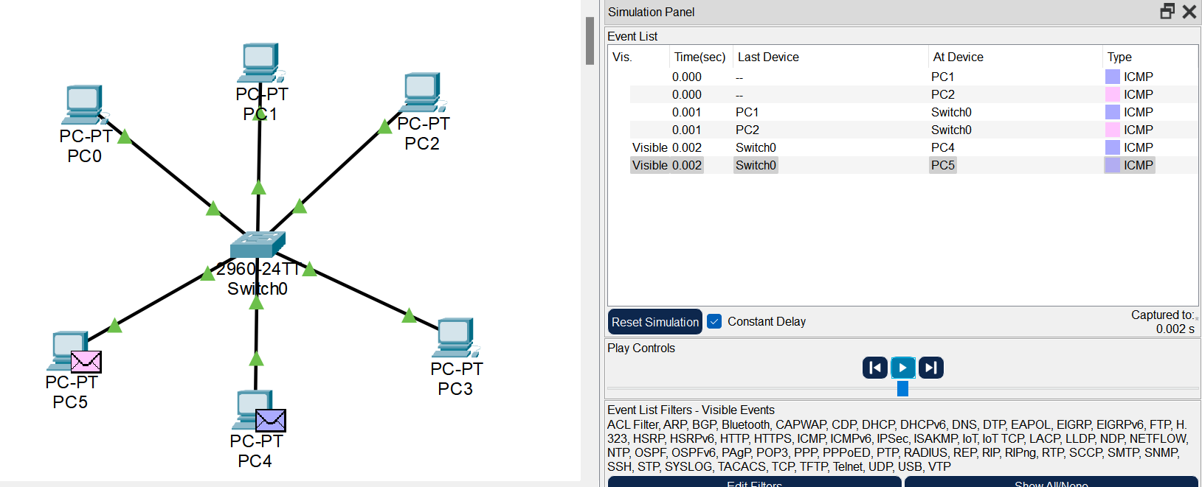

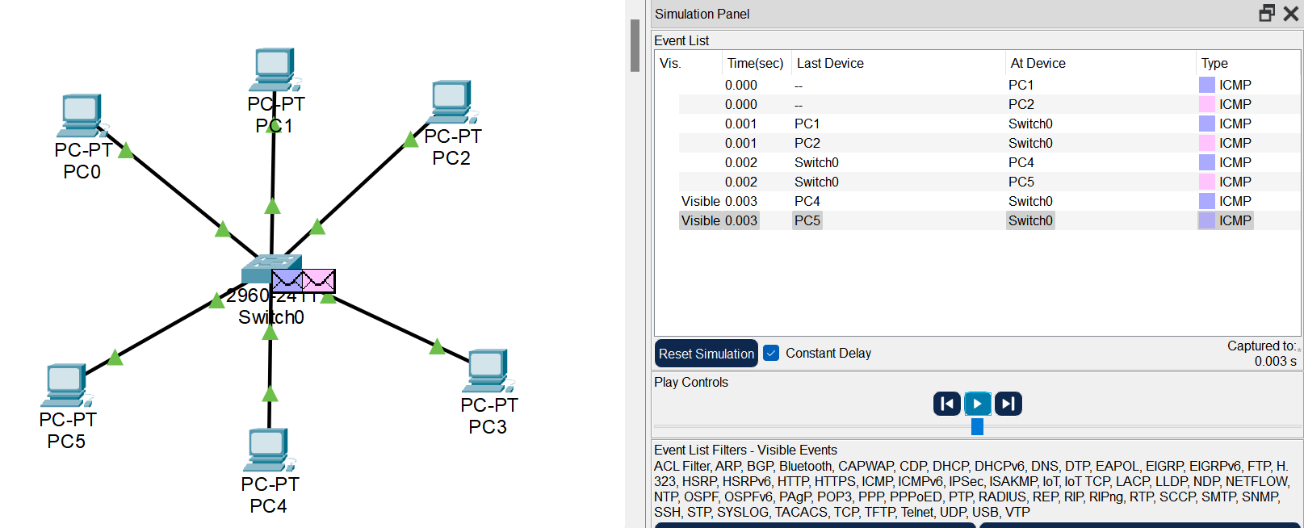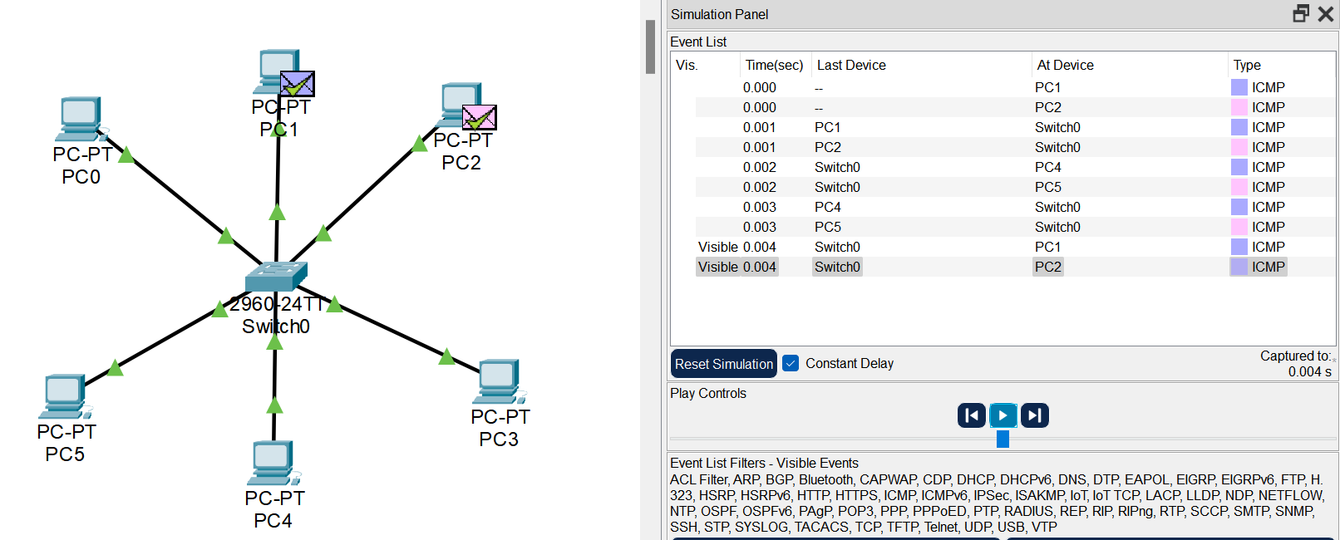

# 

# **Conclusion**

**In conclusion, packet collision can occur in a network when two devices send a packet at the same time which will require re-sending the packets, and because there exists a collision domain as a part of the network if two devices want to send packets at the same time in the hub case they will be damaged because each port on a hub is in the same collision domain. But in the switch case collision will never happen because each port on a switch is in a separate collision domain and because switches operate in a full_duplex mode.**