

**Sultan Qaboos University**

**College Of Science**

**Department Of Computer Science**

**COMP3502: Computer Networks.**

**Project: TCP Socket Programming**

**Task 2**

Team Members:

Aya Al Balushi (135131)

Quds Al Breiki (133343)

Khadija Al Bulushi (133556)

Contents

**Introduction 3**

**Design & Implementation (with screenshots) 4**

Design 4

Implementation 5

**Testing (sample run) 7**

**Conclusion 10**

# 

# 

# **Introduction**

The aim of this project is to develop a client-server socket application using Python to check if a string is a palindrome or not. The client will ask the user to enter a string then it will send it to the server to check whether the string is palindrome or not. If it is then the server will provide an appropriate message indicating that the string that was sent is a palindrome otherwise it will provide a message that the string is not. This program will allow the client to send multiple strings to the server to check. Once the user decides to stop the client will send an appropriate string to the server to disconnect the connection.

# **Design & Implementation (with screenshots)**

## **Design**

Our program consists of two python files: client and server. On the server side we’ve imported socket module since it provides a way to create socket connections and communicate between them and _thread module to allow the server to accept multiple clients . Then we defined the function isPalindrom(string) which accepts a string as parameter and it checks if it is palindrome it returns a boolean value true for a palindrome string and false for not. Another function is on_new_client(clientSocket , address) which handles the communication with the client. It takes the client socket and address as a parameter. In the server file a server socket has been made and it is binded to a specific name and port. Server port is 45000 and a maximum number of connections is seven. The server will accept the incoming connection request then it will call on_new_client(clientSocket , address). On the client side we’ve also imported socket module it oses port number 45000 and server name localhost then we created client socket and connects it to the server the client will ask user to enter a string after that it will send it to the server to check if palindrome the server will reply to the client by providing appropriate message. The client will ask the user again if he/she wants to check another string if not the client and server will terminate.

## **Implementation**

* **Server**

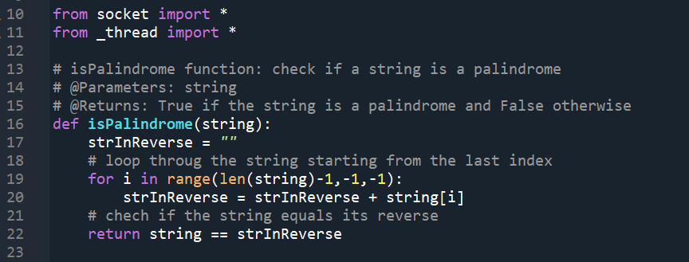

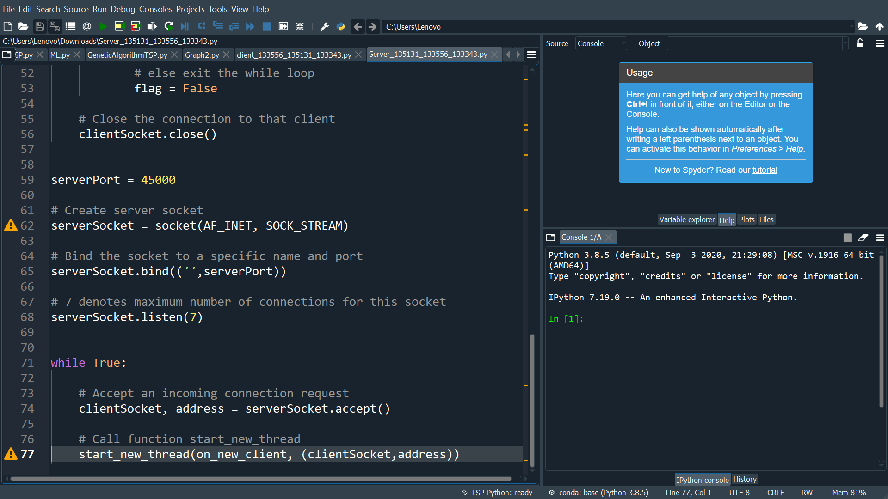

* **Client**

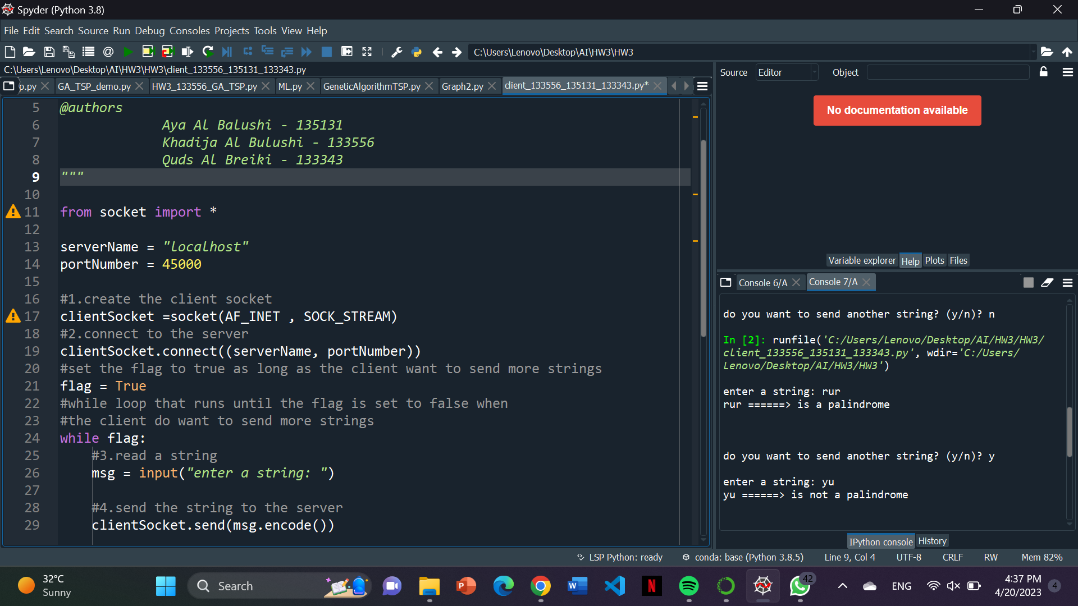

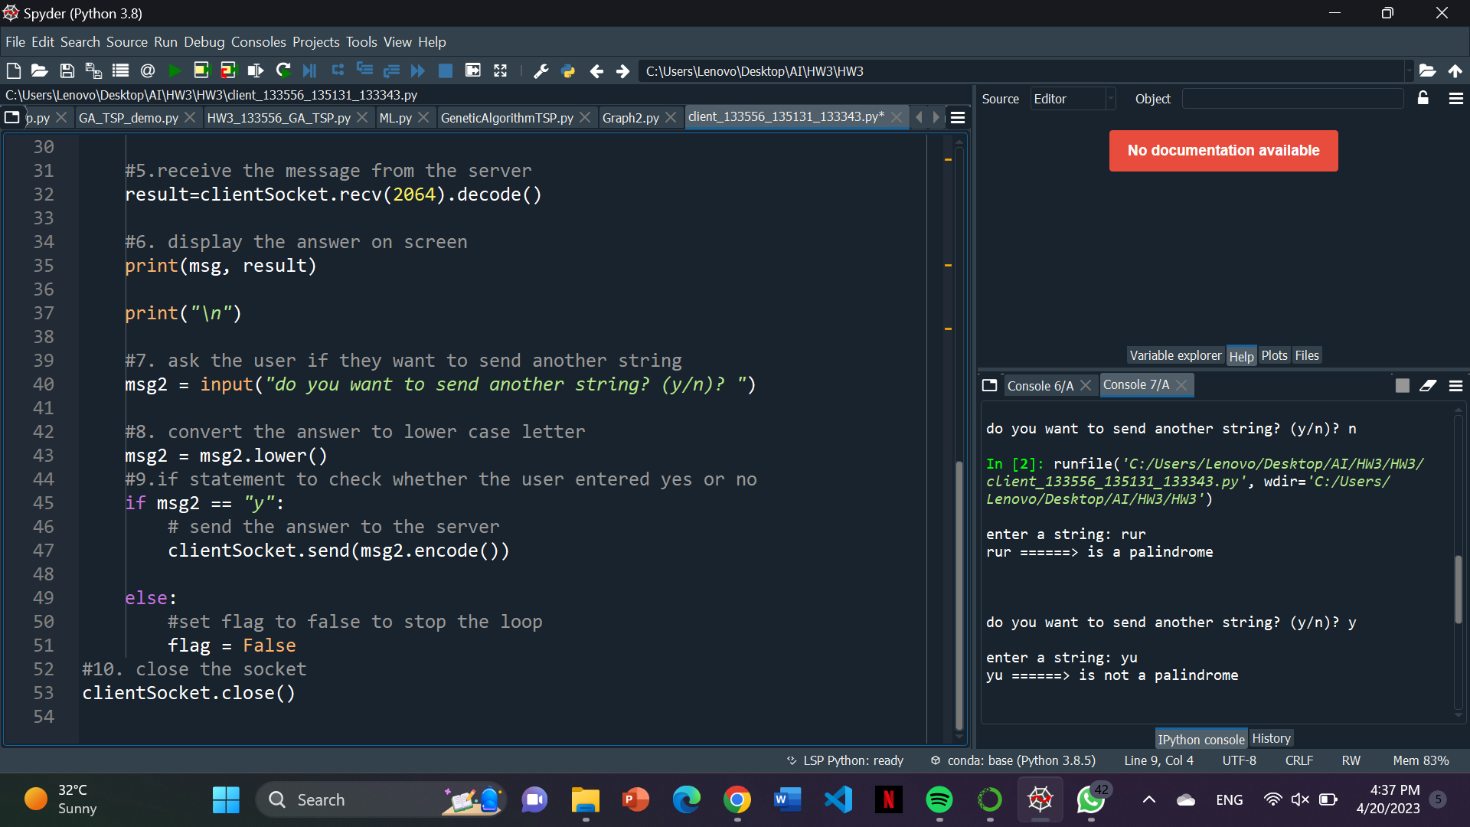

# **Testing (sample run)**

* **The server is running**

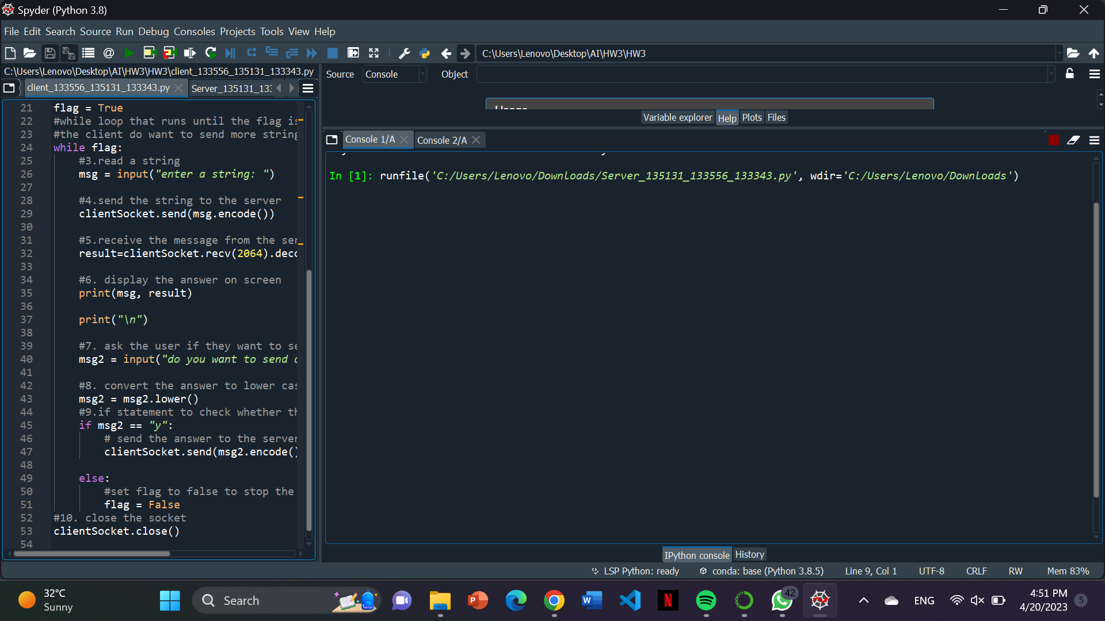

* **Open a new console and run the client**

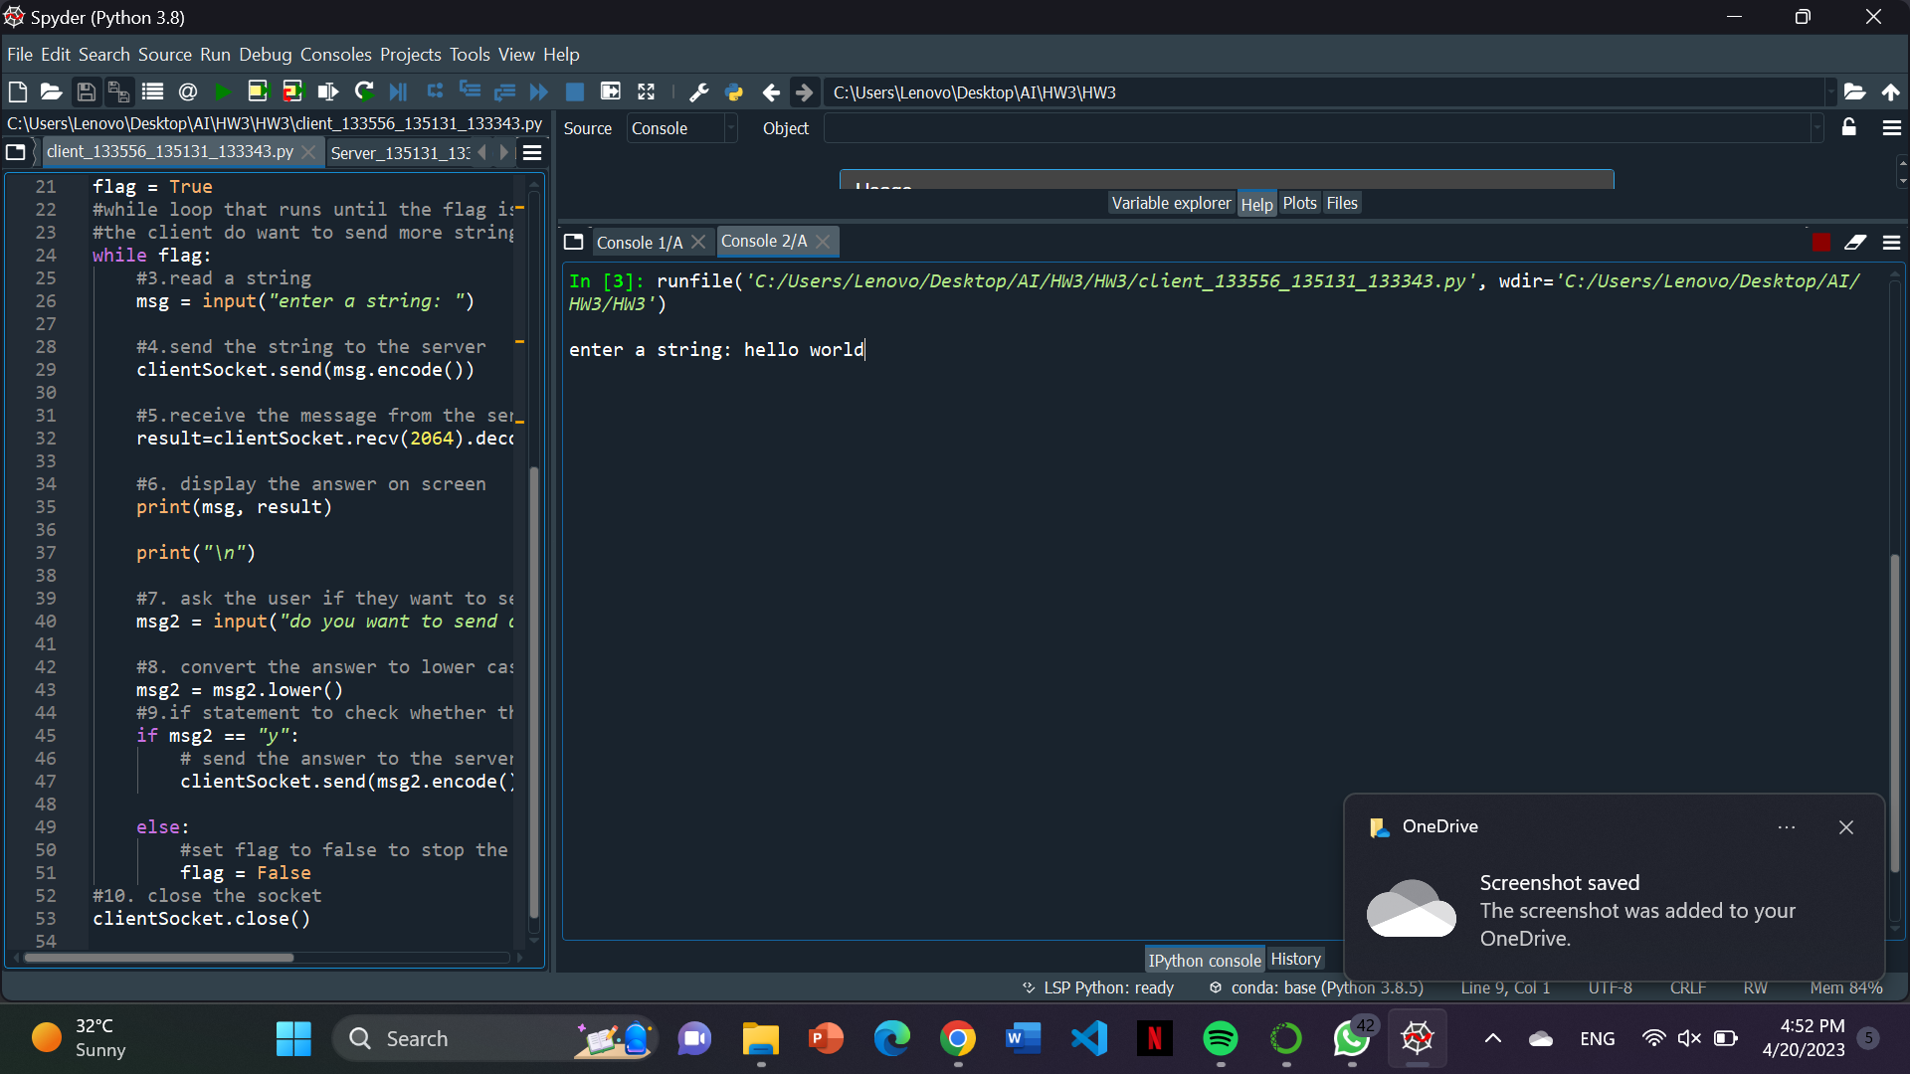

* **Enter a string that is not palindrome**

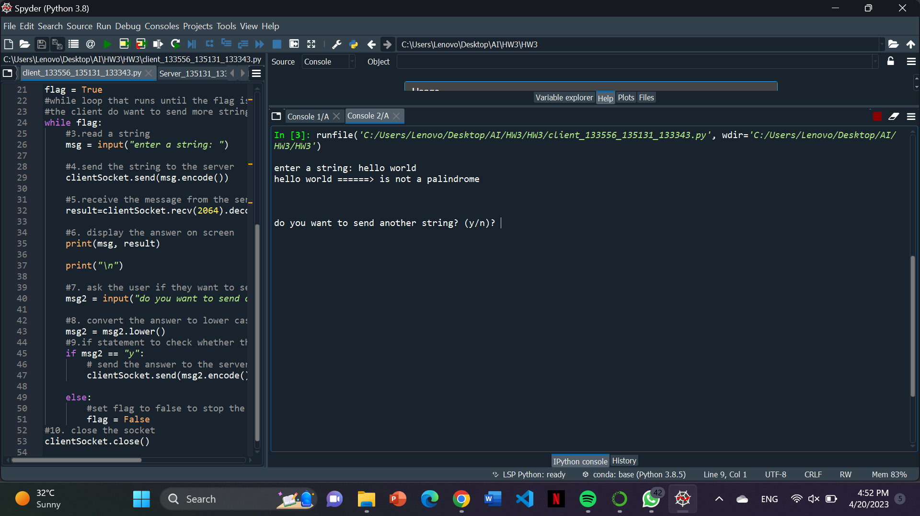

* **Enter Y to enter a new string**

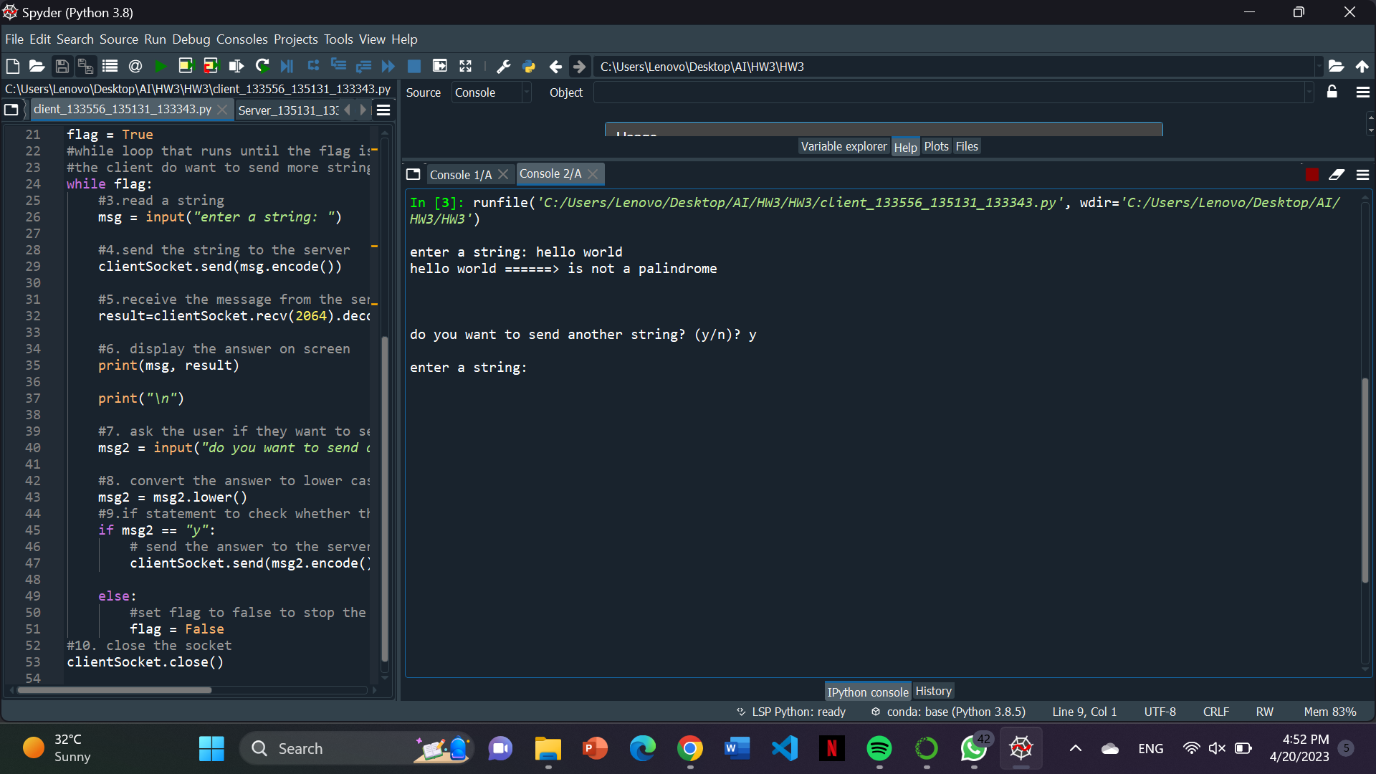

* **While still running open a new console for a new client**

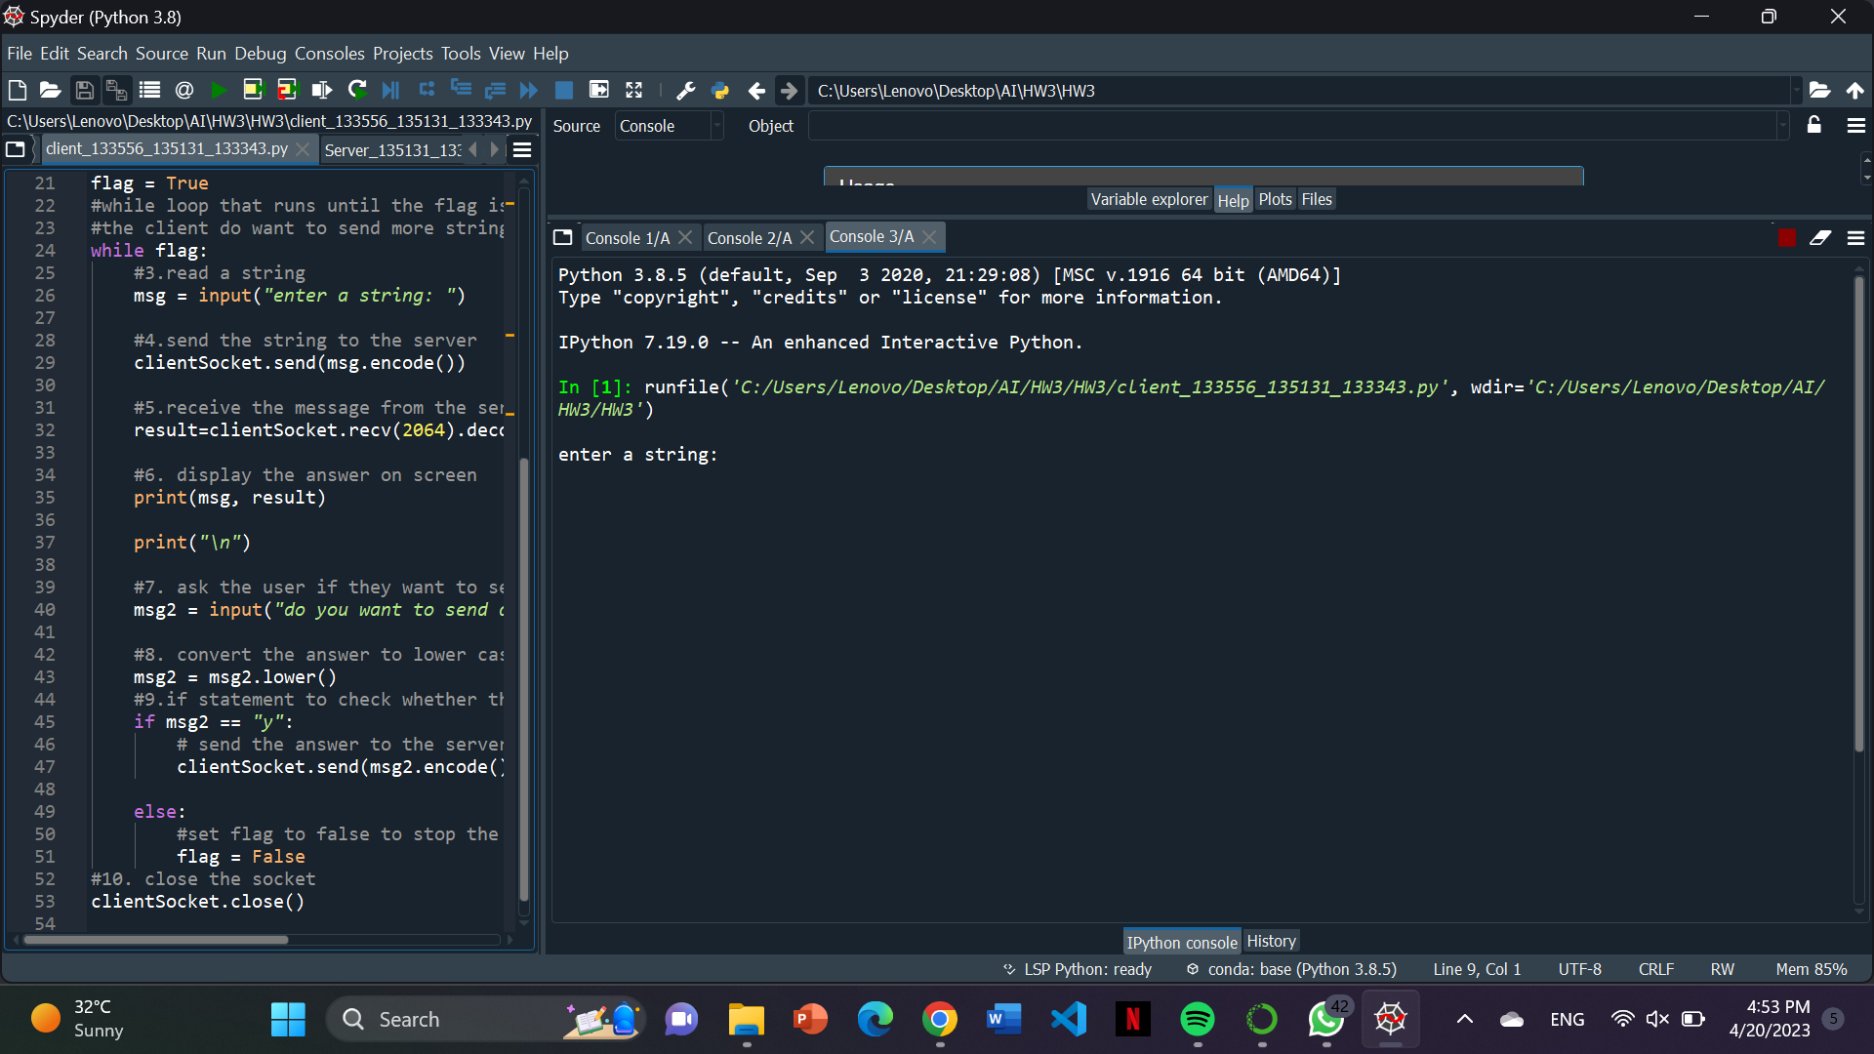

* **Add a string that is palindrome**

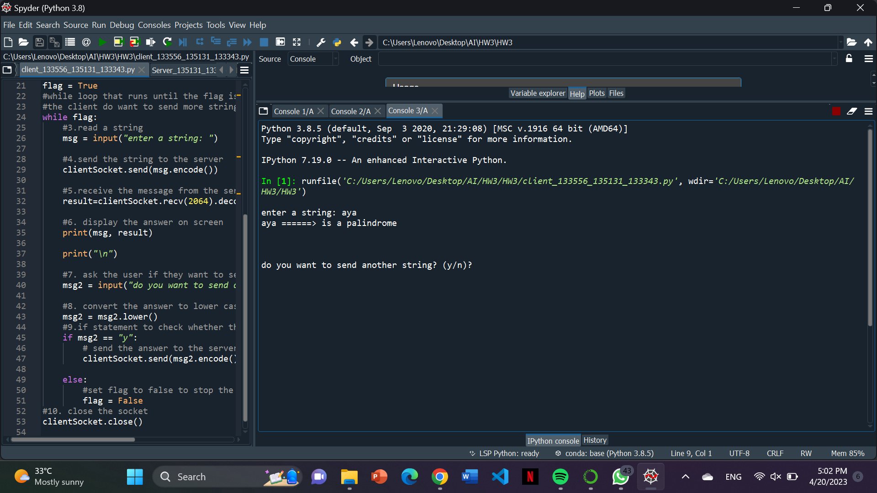

* **Enter N to disconnect the connection**

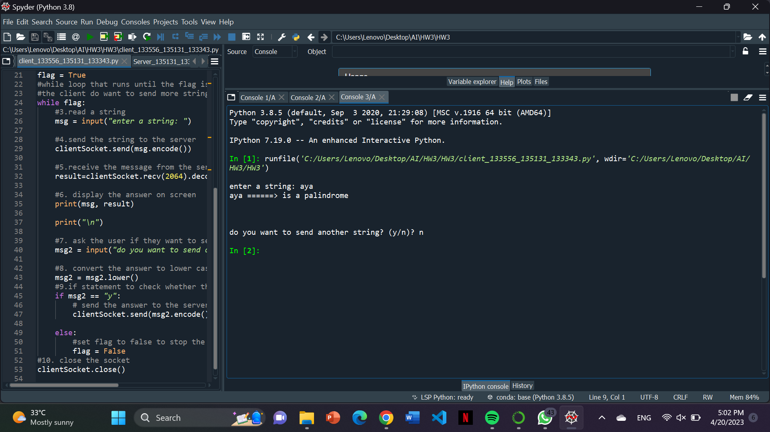

# **Conclusion**

This client-server socket program checks if a string sent by a client is a palindrome or not. The server can accept multiple connections simultaneously. This program works properly for all of the cases as we had tested it.