AI Prompt Log – My Cafe Website
Student Name: Qudsia Arshad
Roll Number: 26i-3151
Section: A
AI Tool Used: ChatGPT

Prompt 1: Initial Introduction and Website Context

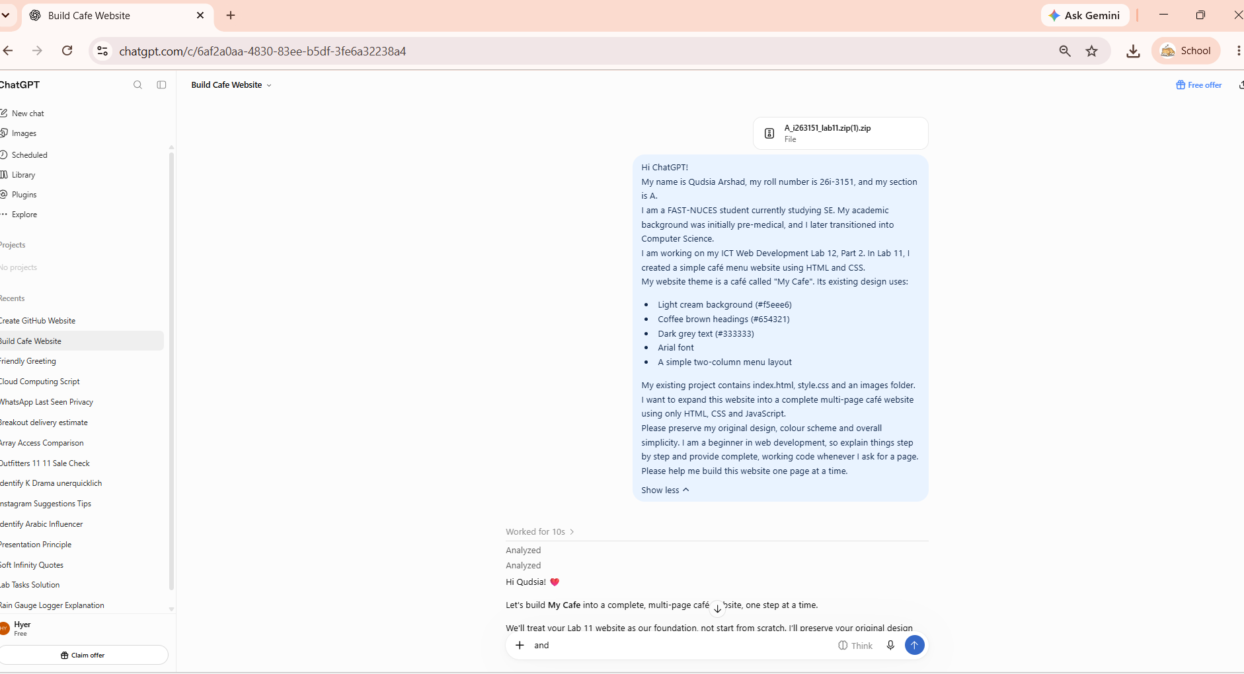
Result:
ChatGPT reviewed my Lab 11 café website files and understood the existing design, including its cream background, brown headings, Arial font and menu layout. It provided guidance for expanding the existing website into a multi-page website while maintaining the original theme.

Prompt 2
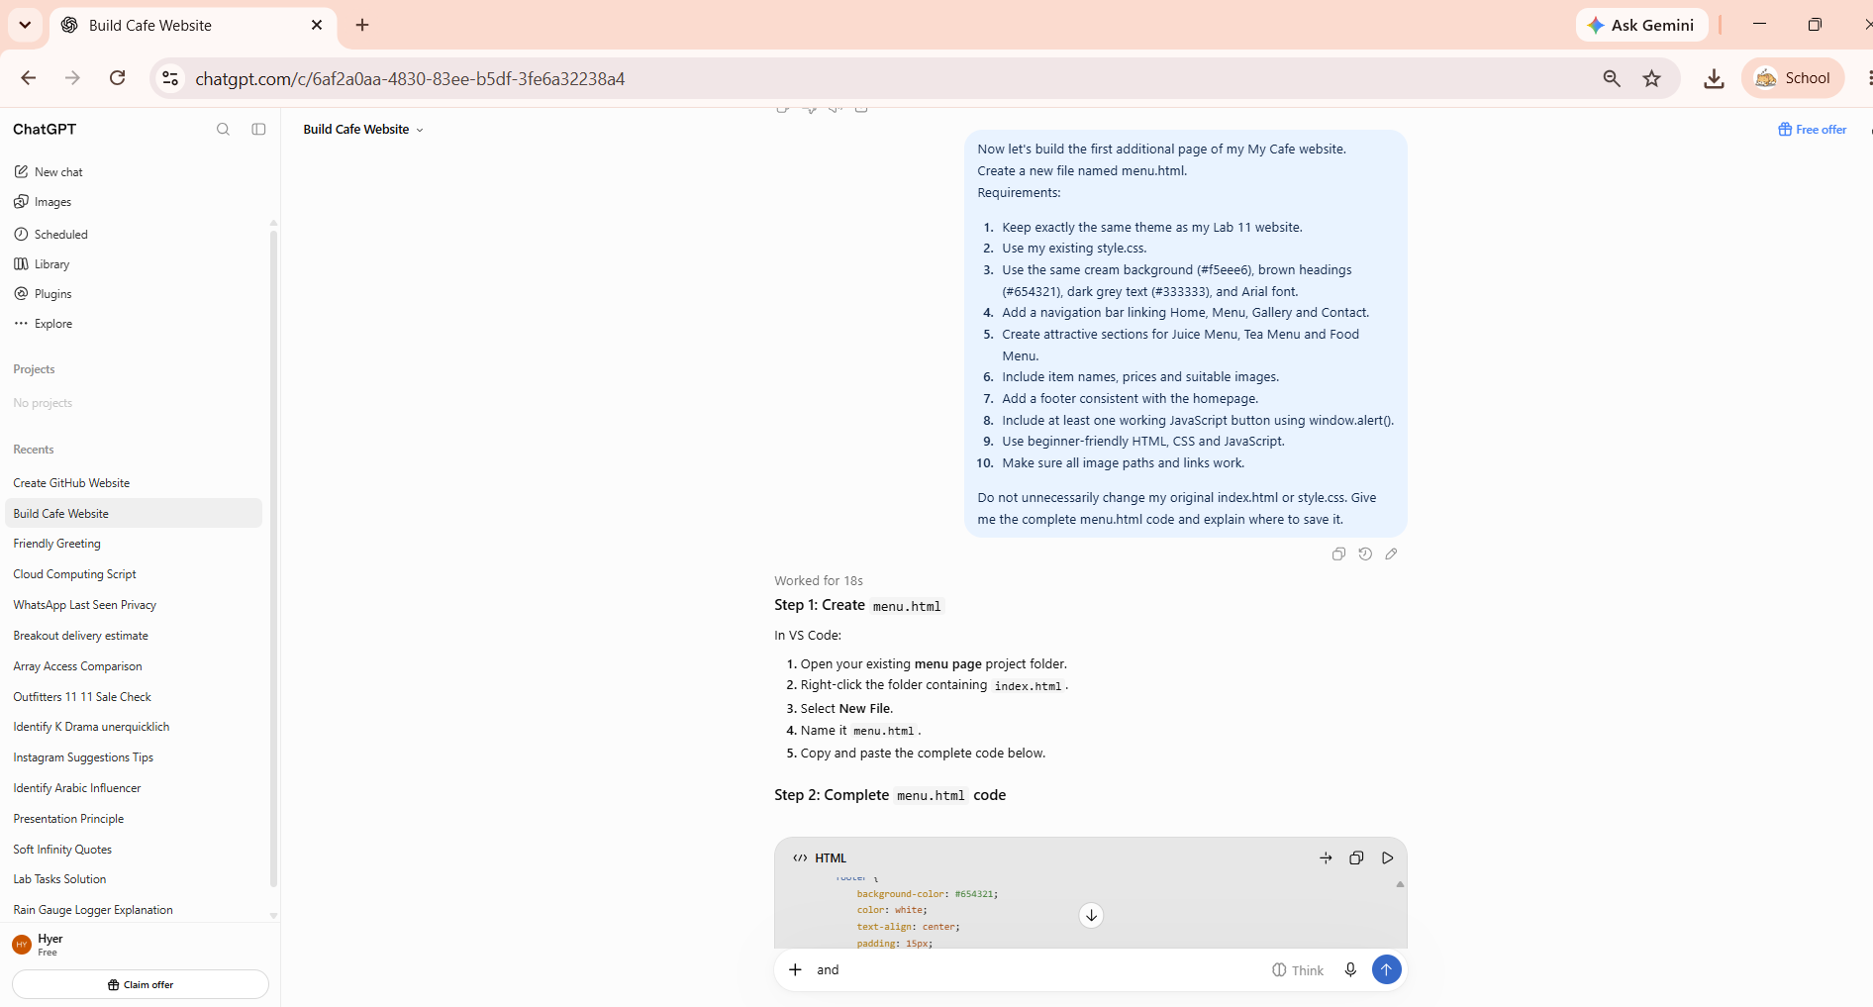

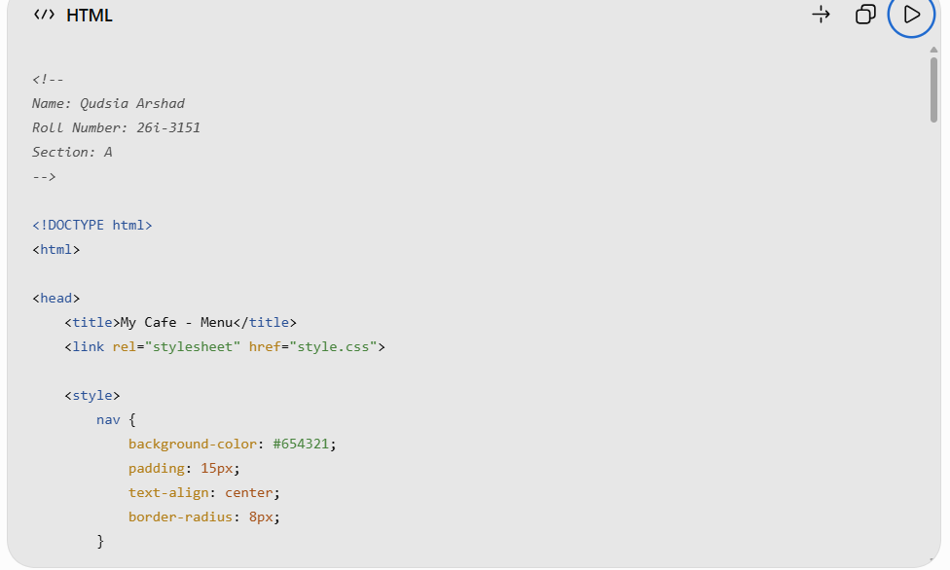
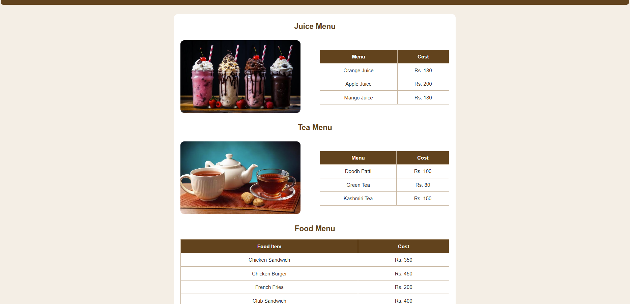
Result:
The menu page was successfully created and tested in Chrome. The navigation bar, menu sections, images and Confirm Order button are working correctly."

