Writer Recognition based on user handwriting
Que Qi
MSCS at NEU
Project link: https://github.com/que-qi-neu/Writer_Recognition/
Introduction
Everyone has different styles of painting, and the same goes for handwriting. This program identifies the writer of a handwritten image based on its unique pattern. To achieve this, the program takes the pre-trained TROC model and modifies it to output unique embedding vectors which will be stored into the database. These unique vectors will be served as “fingerprint” to identify specific user.
Methodology
Pretrained TROC
The key to identify writing patterns is to analyze the specific texture of an image, including the curves, twists, alignment preference and so on. One approach is to apply deep learning using CNN (Convolution Neural Network) to allow the model to learn all the features of an image. To avoid spending enormous amounts of time and resources on training the model, this program applies to a pre-trained image recognition model called TROC. This model has already learned enough details about image texture and pattern which can be used for writer recognition instead.
Triplet Loss
With Triplet Loss as its loss function, the model replaces original TROC decoder head with 3-layer MLP which outputs identifier vector. The reason for applying Triplet loss is to differentiate as much as possible among vectors from different writers, while minimizing the vector difference among the same writers. This way the program output vector among same writer’s pattern will be categorized into same group.
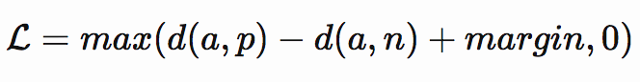
Fig.1.1 Triplet Loss formula
The triplet loss above randomly selects 2 model output vectors a, p among the same label, and a third output vector n from different labels. The d(a, p) represents the vector distance between a, p, and margin is a customized value. Since the label for this program is the unique ID for each writer, the loss function penalizing a high vector distance d(a, p) and low d(a, n) will suit the purpose of this project. The margin value of this project is set to 0.4 to achieve a higher difference between same writer category against different writer categories.

Training
The training uses handwritten text images from CVL database categorized based on 310 unique writers. 80% of writing texts are used for training and rest of them are used for testing and evaluation. The model trains on maximum of 20 epochs, with each epoch processing 1408 images from those 80% writers.
For pre-processing, the purpose of this program is to identify the writer style while ignoring all irrelevant information such as the color, size, rotation, empty spaces and brightness of text. The preprocessing randomly change the images by rotating -10 to 10 degrees, resizing 80 to 100%, randomly varies contrast, brightness, saturation by 20% and randomly change color spectrum by 5%.
The training result is shown below.
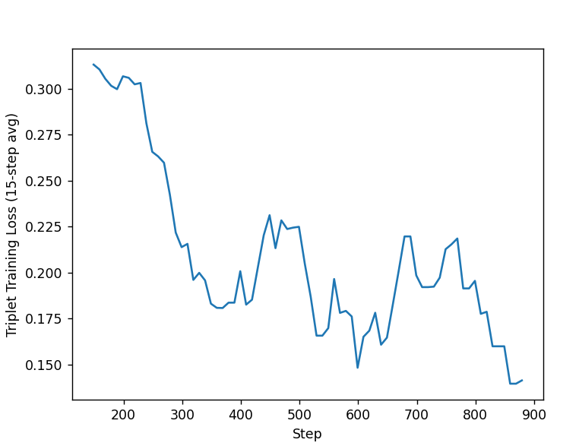
Fig 1.2 training loss
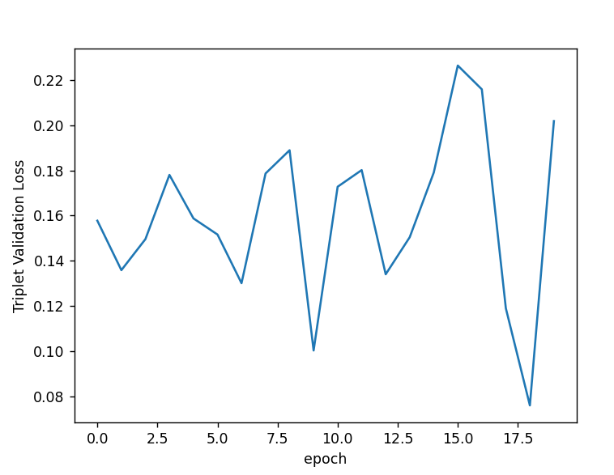
Fig 1.3 validation loss

The training loss gradually declines over time and there’s more fluctuation in validation set. The program uses the model from epoch 18’s result with minimum validation loss.
Storage
Once the model is trained, the program applies model to take all images and generate a list of output vectors. These identifier vectors will be stored into ChromaDB database optimized for vector querying. This database uses indexing and hashing to ensure vector search takes approximately O(log(N)) time.
During identification, the input image is then converted to the vector again by the model. The program applies KNN (K Nearest) to get the k closest vector for the given input vector of those handwritten images. These vectors are each associated with the existing image that looks like the input. For verification, the program sets k = 1 and find the vector distance between the input and closest vector. If the distance < 0.15 it is from the known writer, otherwise it is from the unknown writer.

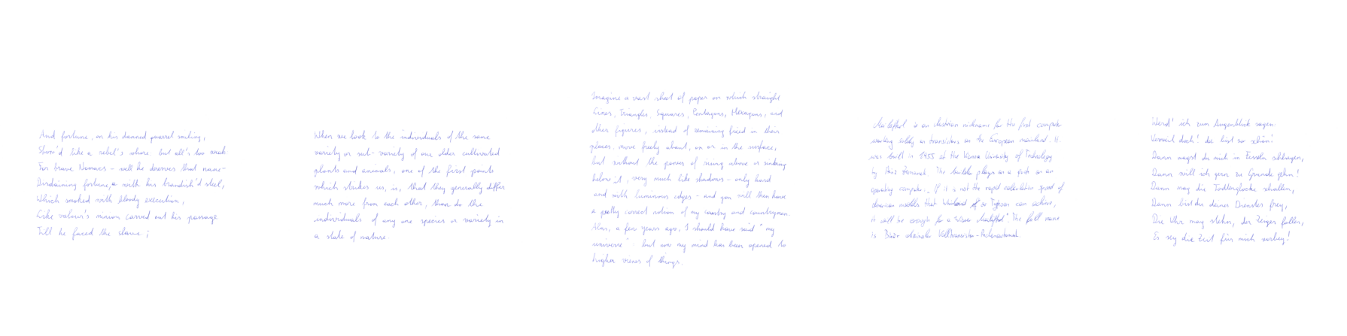
Fig 1.4 showing similar images for the input from image 950-2(second image from writer ID 950)

Evaluation and Conclusion
Testing first stores 1084 images vectors into DB. Then it evaluates 297 un-stored images from the same writer of the DB, and the program is supposed to label them as existing writer. In comparison, the program passes another set of 138 images from unknown writers, with expectation that program shall label them as Non existing writers.
The test attempts to find closes vector for each of testing samples, with k = 1 for KNN search, and test result is shown below:
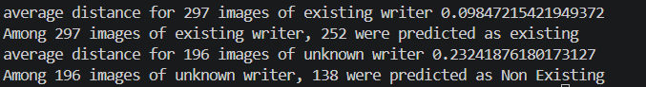
Fig 1.5 test results

There’s an 84.8% correct rate for the samples from the positive group, and 70% correct rate for samples from negative group.
The result shows the program runs decently on distinguishing the input from existing writers, meanwhile having a slightly lower performance on identifying the non-existing writers. Among test samples, certain writers would write in similar styles, and this is the primary cause of lower accuracy in negative groups.
Overall, the program would perform decently on unique style of writing, and the program can be applied to fields like signature detection and suggesting possible source of a written text image.
Citation

