

ITT626: BACK-END TECHNOLOGY

**Semester March 2022 – August 2022**

**BACK-END TECHNOLOGY Case Study Report:**

***[ Sweet Gift Shop]***

Prepared by:

Name of Group Members Student ID

|  |  |
| --- | --- |
| 1. NUR AUNI QISTINA BINTI MOHD ZAKRI | 2021102241 |
| 2. NURZALIKHA IZZATIE BINTI ZAIDI | 2021100633 |
| 3. TENGKU NUR AIN NADHIRAH BINTI  TENGKU NAZMUDIN | 2021156079 |

Prepared for:

PROFESOR MADYA DR NOR SHAHNIZA KAMAL BASHAH

Remarks:

|  |  |
| --- | --- |
| **TABLE OF CONTENTS** | |
| **CONTENT** | **PAGE** |
| **CHAPTER 1: INTRODUCTION** |  |
| 1.1 Project Background | 1 |
| 1.2 Module for each user | 4 |
| 1.3 Use Case of the Project | 5 |
| 1.4 Flowchart or Activity Diagram | 6 |
| 1.5 Entity Relationship Diagram (ERD) | 11 |
| 1.6 User Interface | 12 |

CHAPTER 1 INTRODUCTION

# 1. Project Background

Sweet GiftShop is a well-known gift shop in Kota Bharu, Kelantan, and still requires specifications for a new web application for administration. Customers may usually find a variety of gifts in the gift shop. Sweet GiftShop offers a wide range of surprise gifts in two categories: standard gifts such as chocolate and flowers, and special gifts. The new system will be designed to make it easier for customers to choose the package their orders, survey their budgets before purchasing, menu options based on gift type by user preference, and manage the process using a web application.

This system is very essential because it is already achieving the business goals of serving the customers by ordering gifts through an online system, saving them time and gas money, making it easier for customers to order various gift packages, improving better customer service, enhancing the management system, and increasing sales and profit margins. Currently, the sweet gift shop handles its business in a conventional or manual manner, and the proprietor solely advertises them via Whatsapp, Instagram, and Facebook.

Furthermore, customers may only contact via WhatsApp and Telegram, making it difficult for staff to record each customer's data and booking information one by one. It's also more challenging if they have more than one customer who wants to order the gift on the same day. Customers can save time by purchasing a gift with all of the available features utilizing this technique. Customers may choose their gifts using the sweet gift shop system. The technology will also make it easier for staff to manage customer data. Customers will be more attracted due to the user-friendly technology, which will help the business generate more profit.

1

## Problem Statement

In this ‘Sweet GiftShop’, there have been a few incidents and issues recently that have reduced the effectiveness of the ongoing work, which has served as the impetus for the development of these projects. Firstly, **package order issues due to unavailability or wrongly taken orders**. This issue manifests itself most frequently at times when there is a high volume of orders coming in from customers, which leads to the management being careless and making mistakes when they are taking those orders. Additionally, there is a possibility that the unavailability of products is not updated, which results in a problem between the customer and management. This results in management accepting orders for products that are unavailable, which causes a hassle for customers and makes it impossible for customers to have their orders canceled after they have already been confirmed.

Next, one of the issues that motivate the development of this project is the **customer's budget constraints**. Due to a large number of gifts available to customers as a means of expressing their appreciation for a loved one, there may be budget constraints for customers who wish to purchase a gift for a loved one but have a limited budget. Based on our motto, *"Everyone Gets Their Desired Gifts at Affordable Prices,"* there are no obstacles for anyone, including students, to purchase gifts for their loved ones. As a result, package orders can result in an increase in price if the customer adds items without knowing the price, which can make it difficult for them to pay. Therefore, with this project, customers can place suitable package orders after confirming the prices of the products, so there are no issues between customers and management.

Lastly, one of the issues that occurred in 'Sweet Gift Shop' that led to inefficiency in the work process is **choosing gifts can be difficult due to the abundance of options**. Due to the limited number of options available to customers, this situation is stressful. This is due to the fact that only a small number of customers choose to purchase designs that are already available in the shop, as opposed to choosing package designs, to save time and for urgent orders. Customers have a sufficient budget, but the issues related to a lack of options make it difficult for them to find the best gift for their loved ones. As a result, it is difficult for customers to choose gifts based on design and budget when there are not enough options for them to choose from.

2

## Solution

Few solutions have been discussed to solve the problems that we justified in the preceding problem statement. First and foremost, one of the main solutions that contribute to developing this project is a **systematic package order option**. Since there are a large number of orders specifically tailored to the preferences of a subset of customers, it is possible for orders to be confused, especially when the volume of orders is high. As a result, with the systematized package order option, customers' orders are no longer taken incorrectly, and they can choose the appropriate products for their package orders as they can view product availability. This action benefits both customers and management, as the system already assists management in organizing order options, particularly during periods of high order volume.

Next, **customers can survey the budget first before buying through price-range functionality** as the chosen solution to the aforementioned problem. Users of this application are given the opportunity to select the price range for which they would be willing to purchase their desired gifts. Therefore, there is no problem with the fact that customers are unable to purchase the gifts because it is not within their price range. So, customers can buy their desired gifts that fulfil their preferences and budget.

The final solution to the problem is the **availability of menu options based on the gift types offered** which include user preference for their type of gifts. Customers can view the types of gifts offered by this shop based on type, such as for the teddy bear option, where they can choose from a few options based on the teddy bear used as the base for the gift.

## Objective

The objectives for developing this project are as follows:

1. **To design a gift menu the system allows customers to configure their orders based on their preferences.**
2. **To develop a web-based system or application to handle gift shop transactions**
3. **To test the web-based system in terms of its usability and functionality**

3

# Module for each user

|  |  |
| --- | --- |
| **Admin** | **User** |
| * Login | * Login |
| * LogOut | * SignUp |
| * Add New Gift | * LogOut |
| * Update Gift | * Edit Profile |
| * Delete Gift | * Choose the budget range of the menu |
| * View Order | * Choose Menu based on customers’ preference |
| • | * Generate receipt |
| • | * Make order method Pickup only |

4

* 1. **Use Case of the Project**

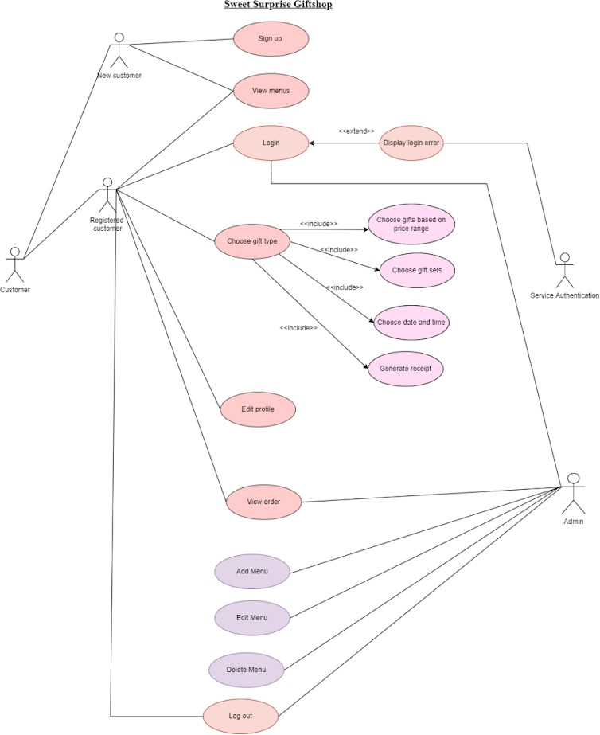

5

# Flowchart or Activity Diagram

1. **User**
2. User Authentication

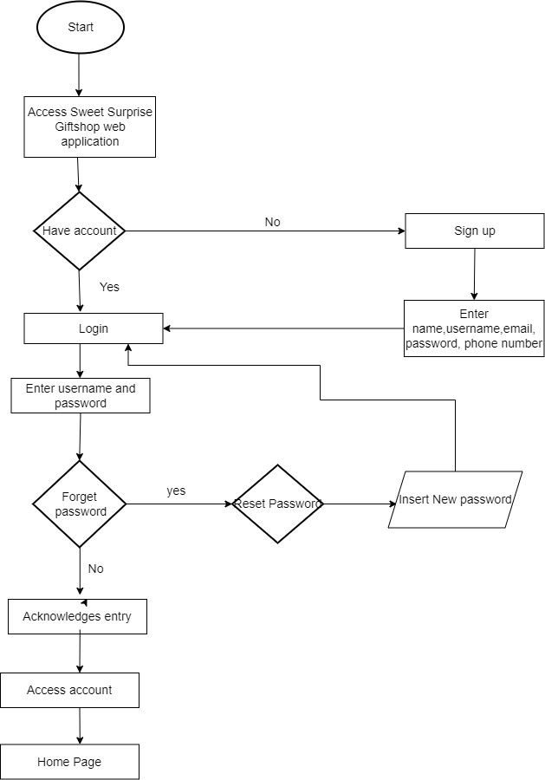

6

1. 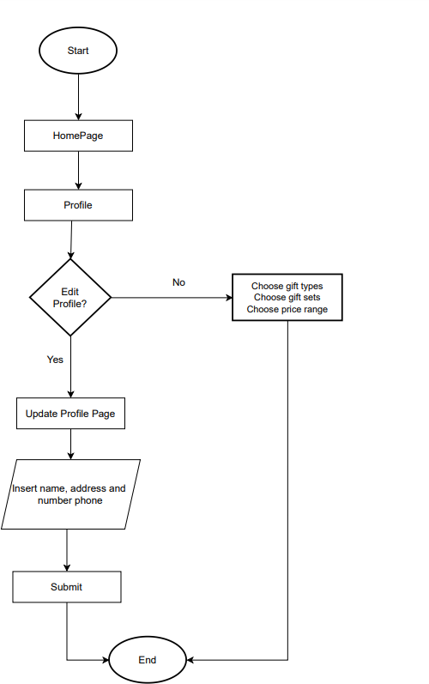User Edit Profile

7

1. User Select Menu

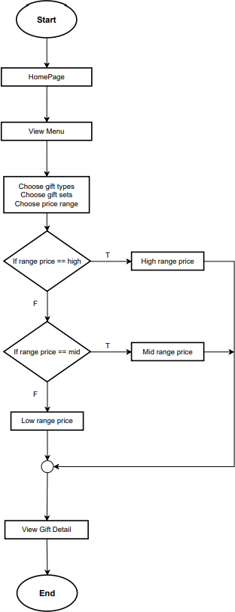

8

1. User Payment

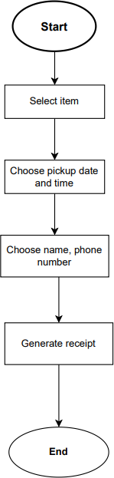

9

1. 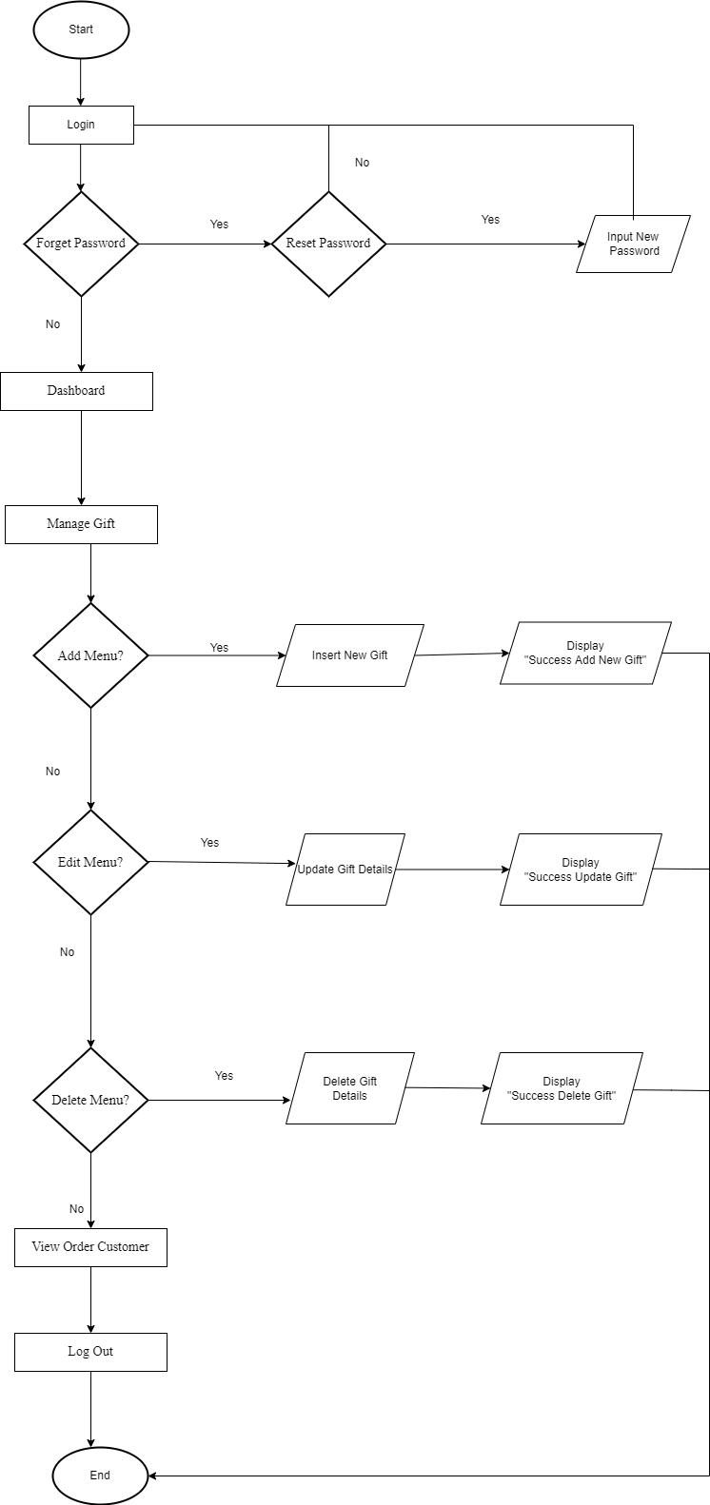**Admin**

10

# Entity Relationship Diagram (ERD)

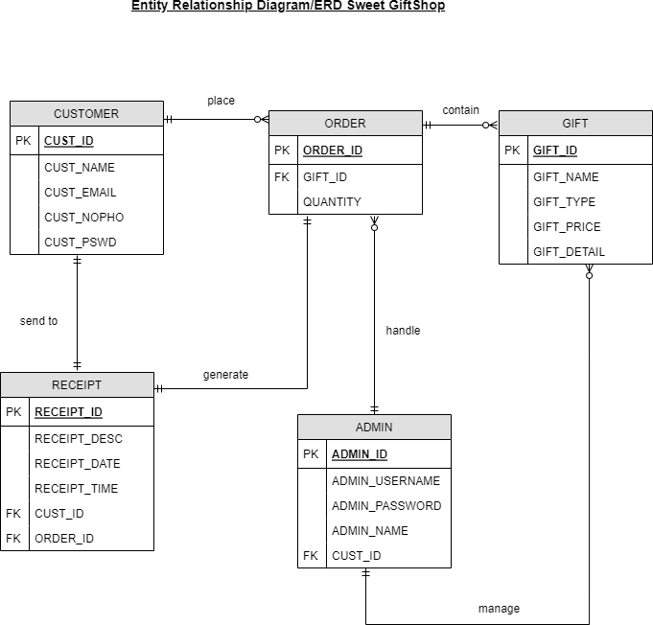

11

* 1. **User Interface**

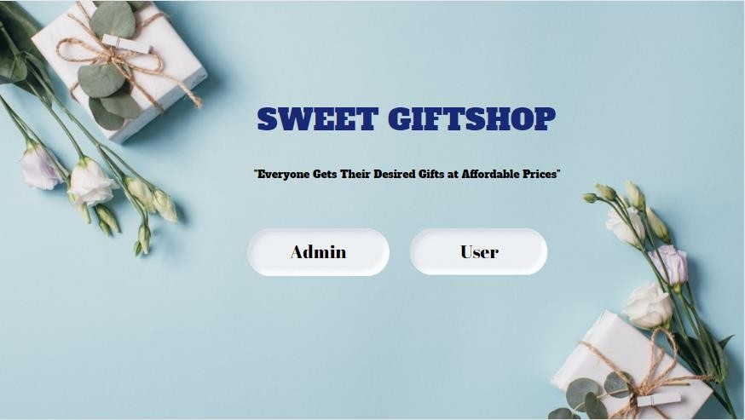**Sweet GiftShop Main Page**

**User**

1. 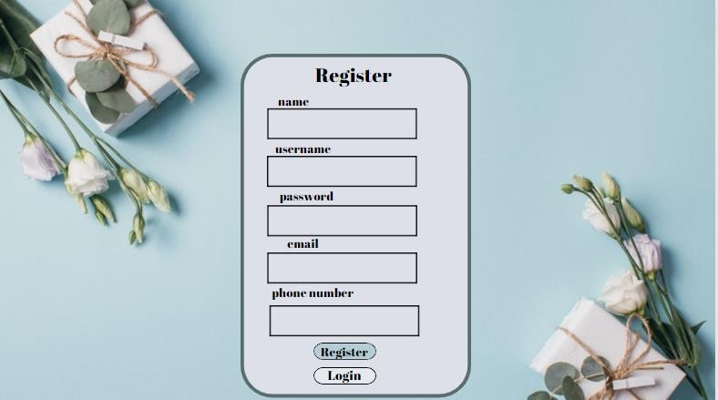Register User

12

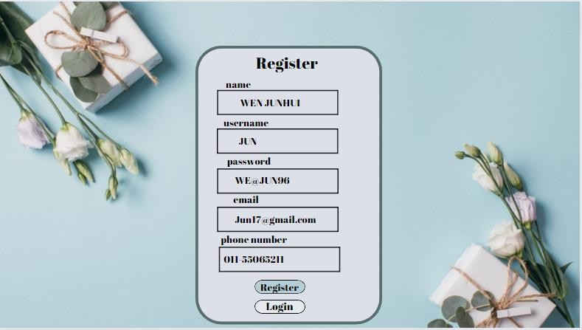

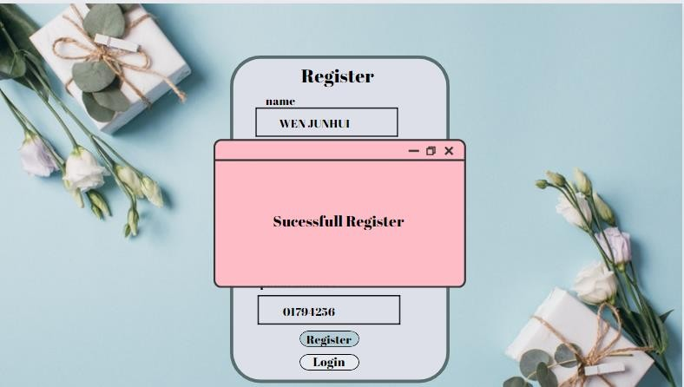

13

1. 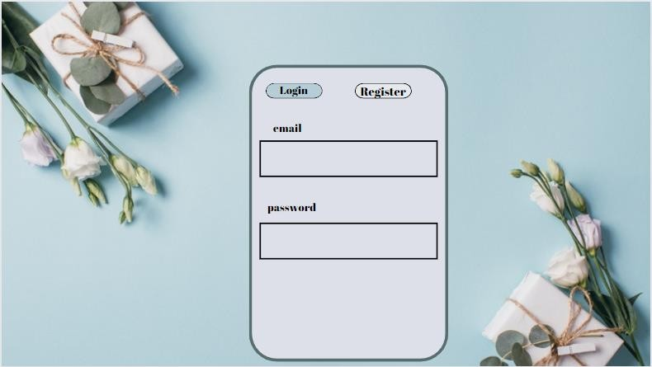Login User

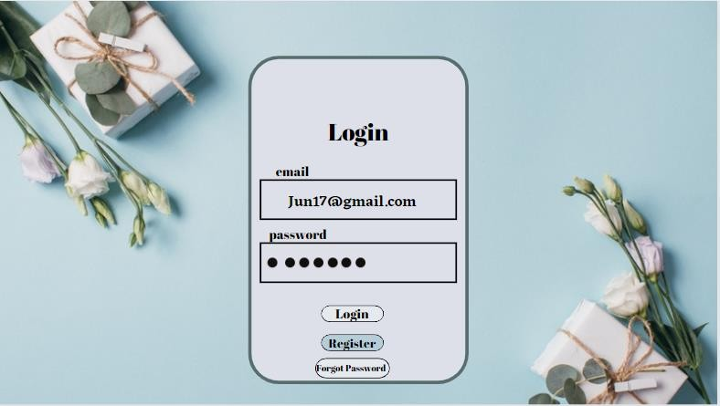

14

1. 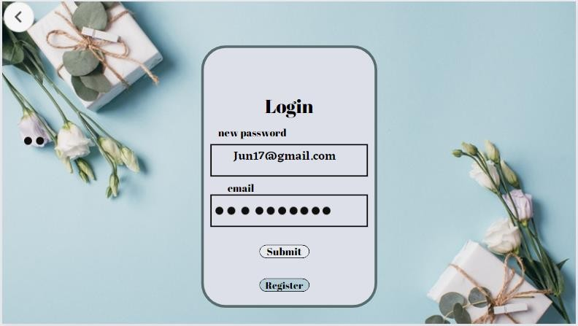Forget Password User

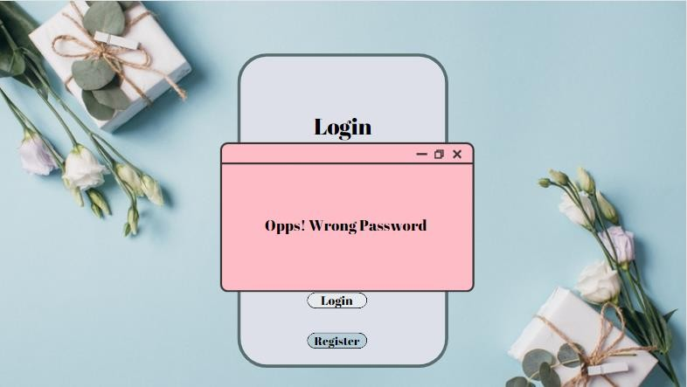

15

1. 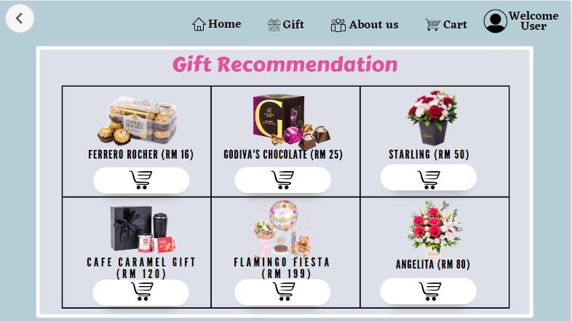User HomePage

16

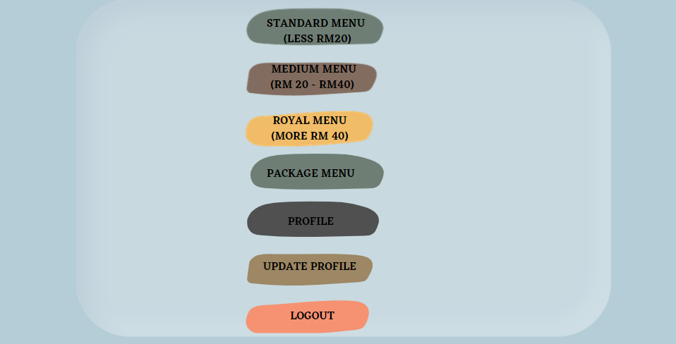

1. Menu
2. Standard Menu

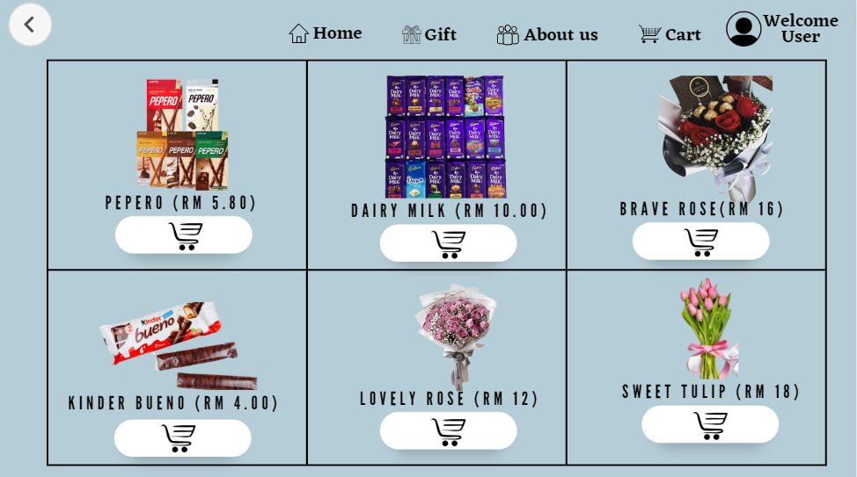

17

1. Medium Menu

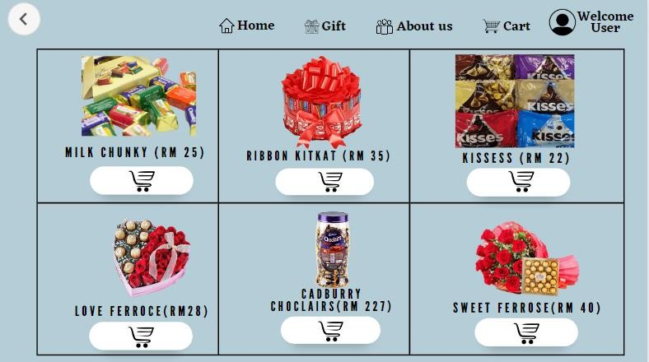

1. Royal Menu

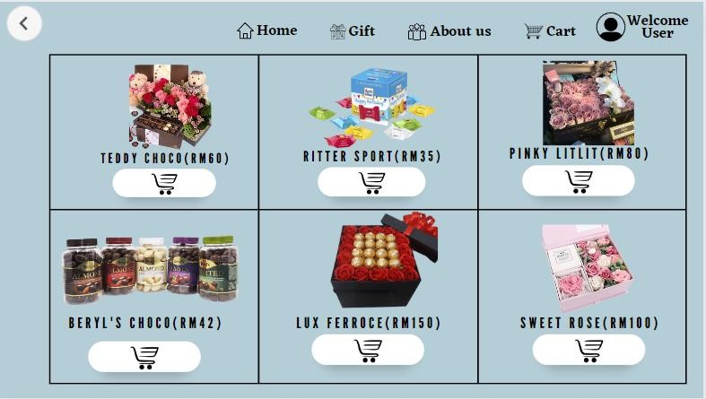

18

1. Package Menu

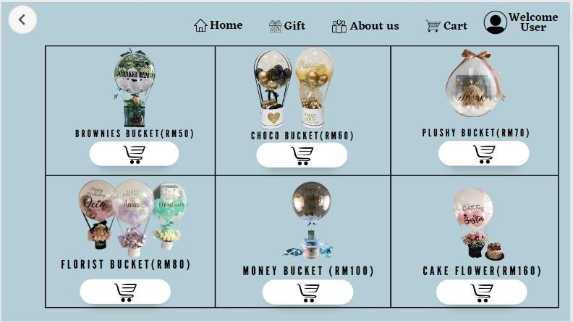

19

v.Edit Profile

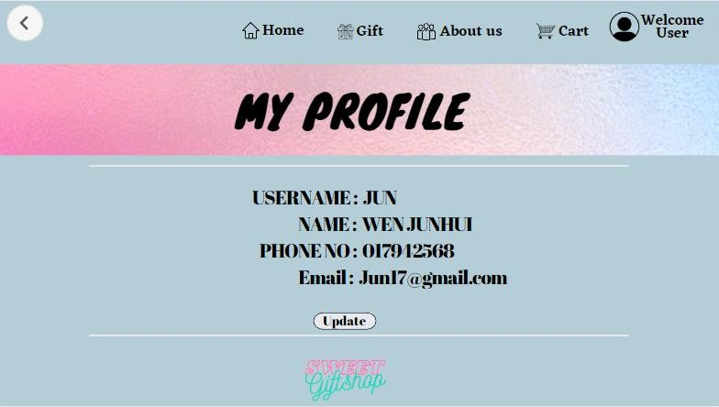

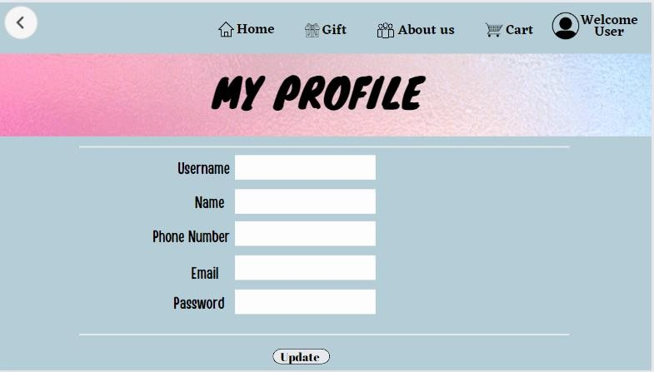

20

1. Order

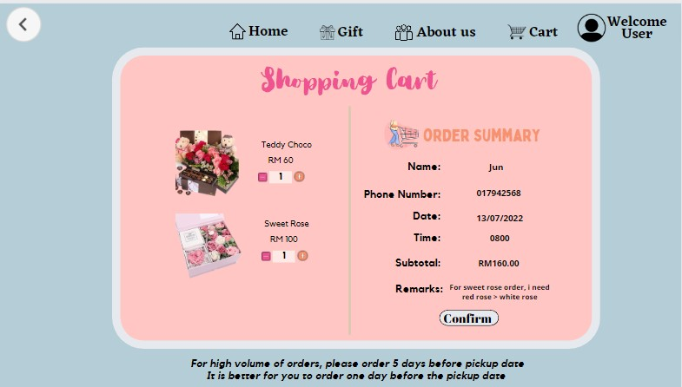

21

1. Payment

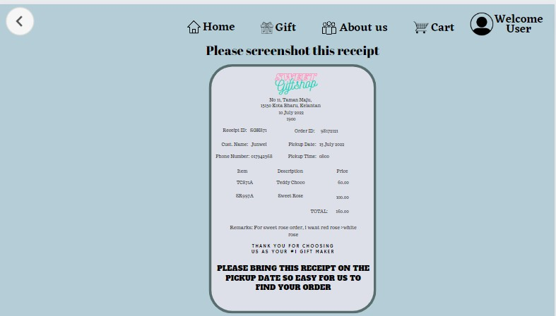

22

**Admin**

1. Login

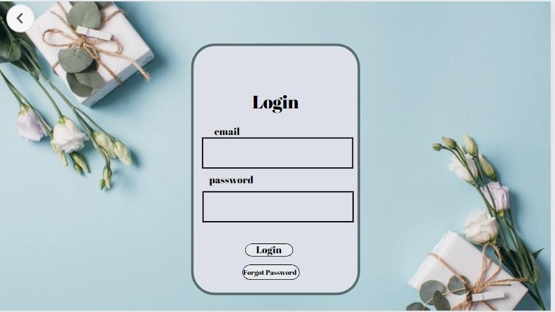

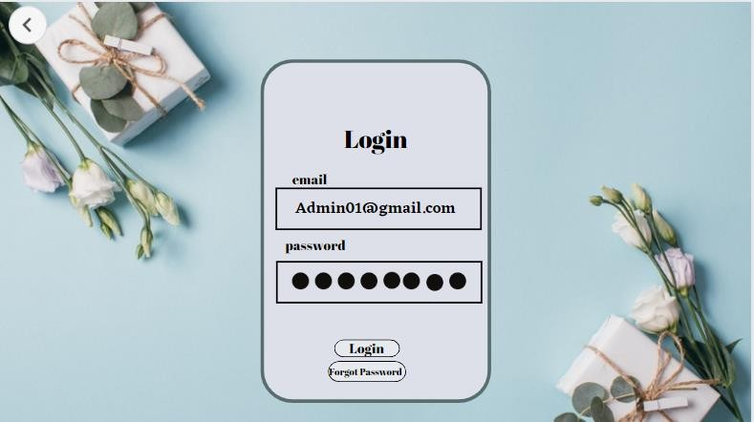

23

1. Forget Password

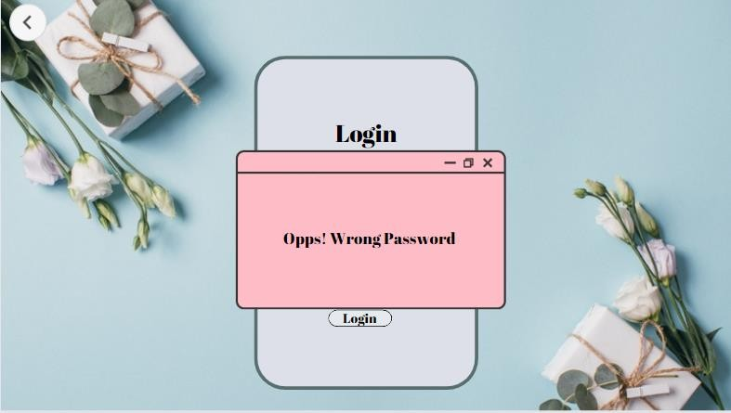

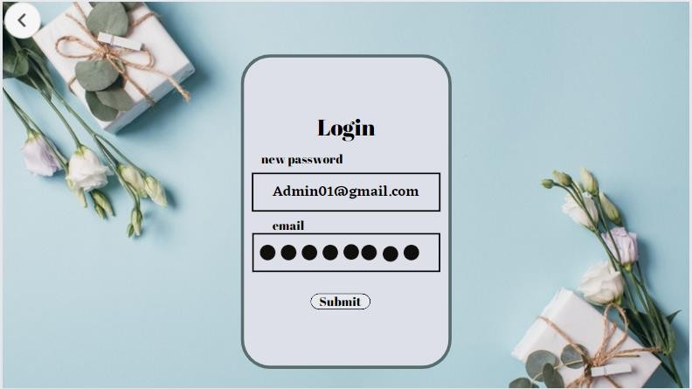

24

1. HomePage Admin

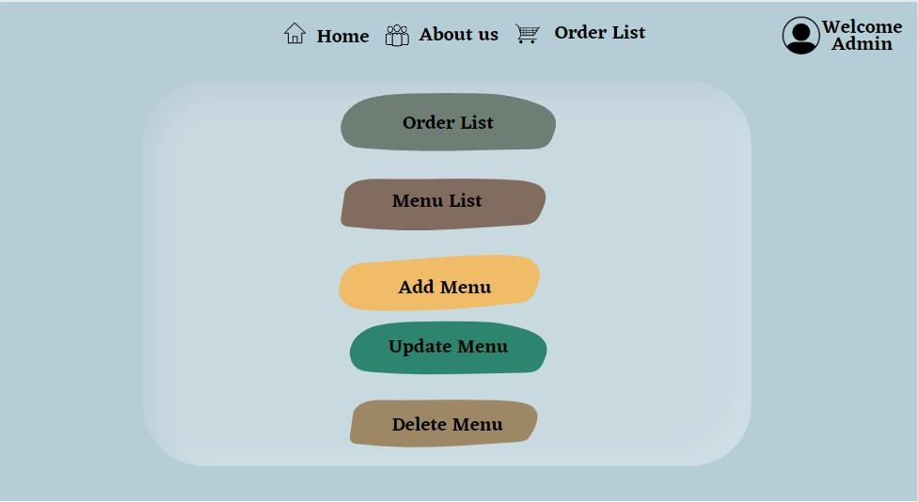

25

1. Order List

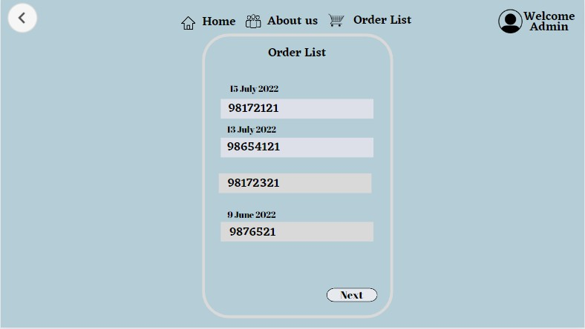

26

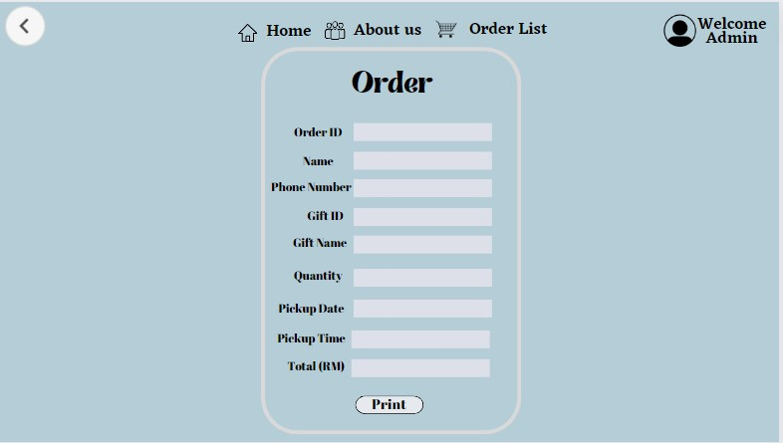

1. Add New Menu

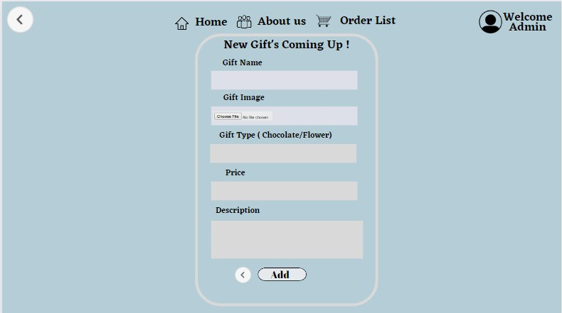

27

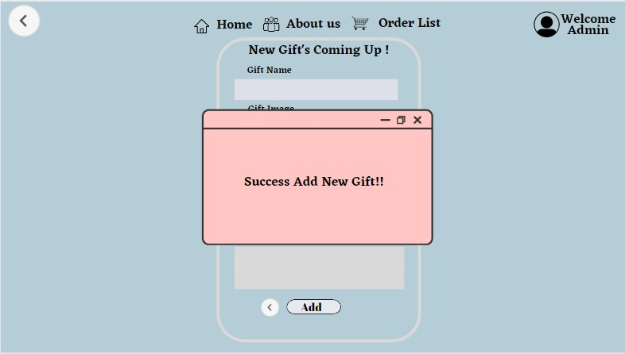

1. Menu Detail

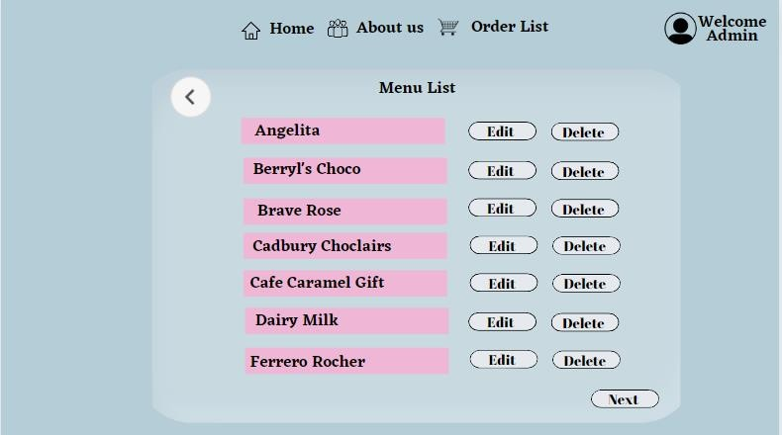

28

1. Edit Menu Detail

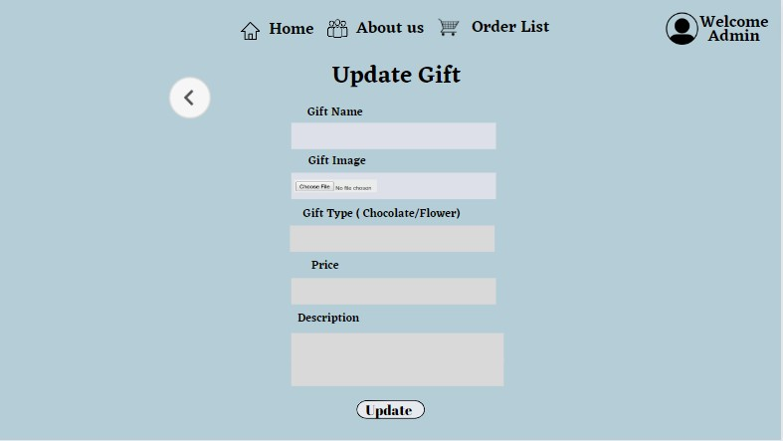

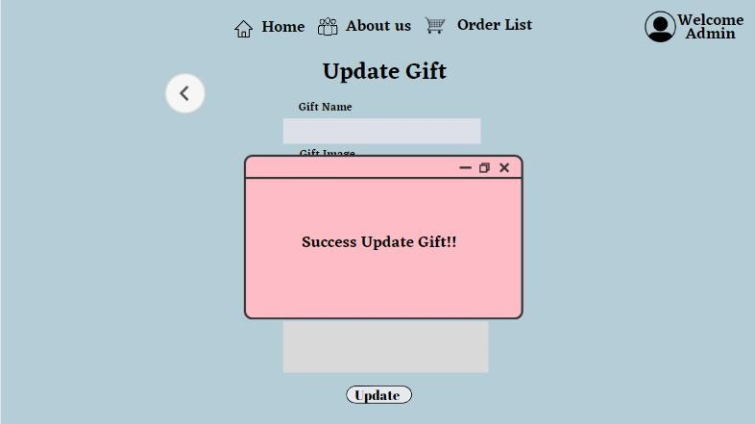

29

30

1. Delete Menu

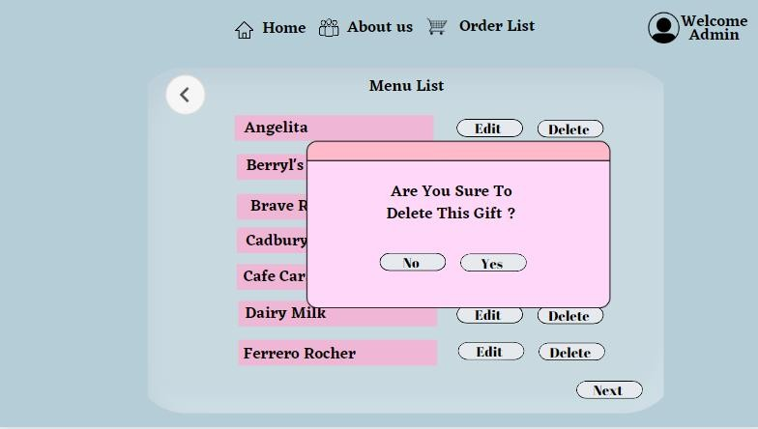

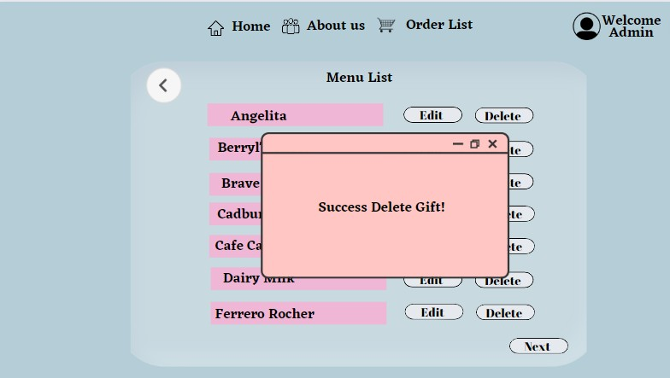

1. Logout

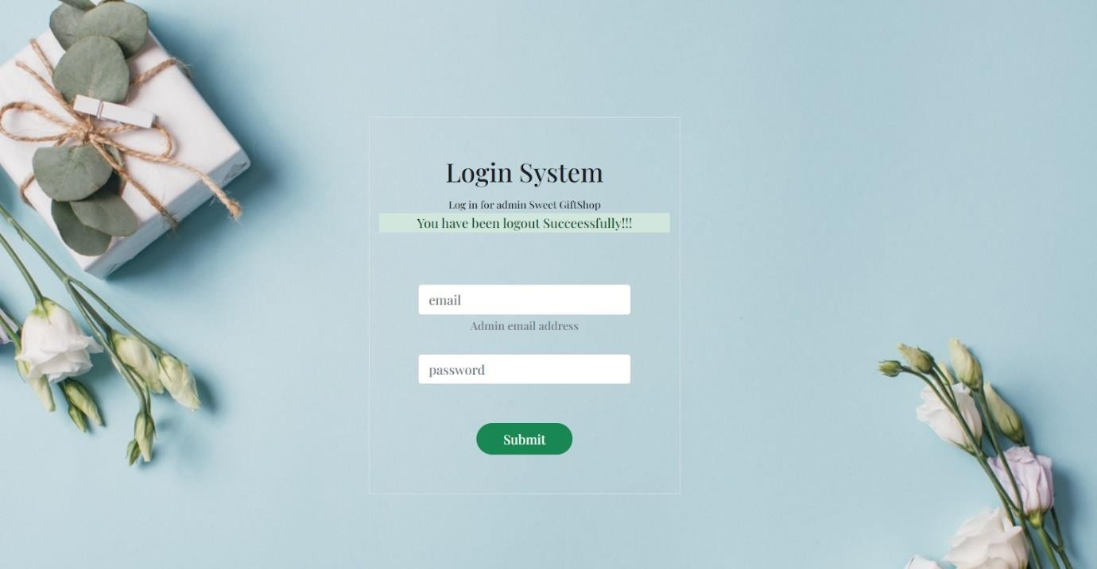

31