Paper Title Here

Alexander R. Towell and Hiroshi Fujinoki

Department of Computer Science
Southern Illinois University Edwardsville
Edwardsville, Illinois 62026-1656, USA
E-mails: {atowell, hfujino}@siue.edu

Abstract

We propose new security architecture, called Fail-Safe Security Architecture (FSSA), which eliminates, or at least minimizes, the chance of privacy leaks for e-commerce customers, protecting their privacy even for the worst cases: the security administrators of the e-commerce servers convert to attackers or the merchants’ servers are hijacked by external attackers, giving the attackers full access to anything in the servers. FSSA is based on a security design that allows each party to access only the information necessary to perform their business and it makes sure no party, except the customer and the law enforcement authority, has access to the complete information of customers’ privacy. We analyzed the types of the security threats FSSA covers. The results of our analyses indicated that, FSSA protects customers’ privacy against the internal attackers (converted administrators and full hijacks), as well as the known security threats by external attackers of eavesdropping, replay, masquerading, man-in-middle, and traffic analyses, except denial of service attacks. Our performance studies suggested that the cost factor of running FSSA is 1.8 (1.8 times more computational power) to achieve the same response time and transaction throughput compared to the existing architecture, where there is no protection against the customers’ private information leaks.

Keywords: search on encrypted data, Bloom filter, perfect filter, n-gram searches, concept searches, information retrieval, cloud security

1. Introduction

It has been quite a while a term “cloud computing” became a buzzword because of its multi-fold advantages. Cost-effectiveness, accessibility, scalability, and reliability are its primary advantages [1]. Despite the advantages, a significant disadvantage to cloud storage is loss of control over confidentiality. An organization loses physical control over a document’s confidentiality when it is hosted in the cloud. Due to the recent escalated concerns against CSP’s insider threats, organizations trust the CSP with storage logistics, but they do not trust the CSP with their need for confidentiality.
The naïve solution to regaining control over confidentiality of cloud-hosted documents is achieved through the use of encryption. Before a document is uploaded into the cloud, it is encrypted. Subsequently, to access this document, clients download it to a trusted machine, which is owned by the organization the document belongs to, for decrypting it [2, 3]. Often, the documents of interest are not known in advance. Consequently, the ability to perform searches over a collection of documents is needed. In the naïve solution, this entails the following sequence of actions: (1) download the collection of encrypted documents to a trusted machine, (2) decrypt the encrypted documents, and (3) search through the decrypted documents using any available search facility.
Unfortunately, this approach breaks down if an organization has a large collection of sensitive documents. It is inefficient having to download the collection of encrypted documents before being able to search them. Moreover, the larger the collection of sensitive documents, the less efficient it becomes. This inefficiency is especially evident on resource-limited machines. Smartphones with limited bandwidth and limited battery power results in slow downloads and decreases operation time since decryption is computationally demanding.
What is sought is some way to allow the CSP to search the encrypted documents on behalf of clients, returning only those documents relevant to client queries [4, 5, 6, 7]. Furthermore, this should be done without revealing the contents of documents (data confidentiality) nor the contents of client queries (hidden queries). In other words, the CSP should be able to perform oblivious searches on behalf of users. Additionally, the CSP should not be able to initiate meaningful searches except on behalf of users. The ability to search over a collection of encrypted documents without needing to decrypt them first is known as encrypted search. In light of the advantages of cloud storage, encrypted search has gained a lot of traction in the research community.
One way to perform encrypted search is by secure indexes [8, 9]. To make an encrypted document searchable, a client must construct a secure index for it. The index will only allow someone who has secret information to meaningfully query it. What follows is the sequence of actions needed to construct a secure index. Once constructed, the secure index may be stored on untrusted systems, such as a CSP using the following procedure. Figure 1 visualizes the procedure of encrypting the document and creating secure search index.
- (1) A client transmits a sensitive document over a secure channel to a document processor. This is most likely a process running on the client’s local machine, but in theory it can reside anywhere. There are compelling reasons to decouple the document processor from the client, e.g., centralized control to enforce uniformity of secure index construction.
- (2) The document processor encrypts the document using whatever cryptographic algorithm is deemed appropriate.
- (3) First, the document processor generates searchable terms for the document. Terms can be anything; the most basic terms are the words contained in the document (keyword search). Second, it concatenates a document id and secret to each term. Third, the concatenation is fed into a cryptographic one-way hash function. Finally, it generates a list of private searchable terms from the output of the one-way hash function and transmits the result to a proxy indexer.
(4) First, the proxy indexer concatenates a secret to the private terms and feeds them into a one-way hash function. Second, the proxy concatenates the document’s id to the outputs of the previous hash function and feeds them into another one-way hash. Third, a secure index is constructed from the hash function’s output. Finally, it transmits the secure index to the CSP. The CSP stores the secure index and its corresponding encrypted document in a database to facilitate encrypted searches in response to client queries.
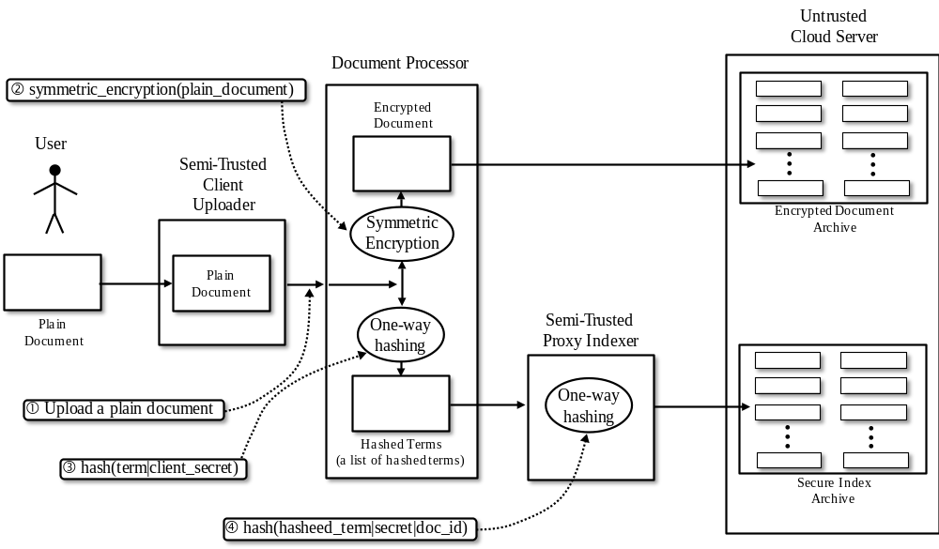

Figure 1 – the procedure of construction of secure search index

The motivation for partitioning secure index construction into two separate stages, a document processor and proxy indexer, is to enable user authorization management—namely, user revocation. Assuming the proxy and users do not collude, neither the proxy nor the users will be able to meaningfully query secure indexes, even if they downloaded copies to their local machines. Specifically, users are only provided with partial secrets. To search a secure index, this information must be cryptographically mingled with the partial secrets provided to the proxy. Neither the users nor the proxy have sufficient information on their own. The reason for the second hash in (3) is to make is to that the same term in one secure index will appear differently than the term in another secure index to prevent correlations between secure indexes from being exposed.
The document processor and proxy indexer may reside on the same machine; indeed, if the client is trusted (rather than semi-trusted) both of them may reside on the client’s local machine. Moreover, the encrypted documents and the secure indexes need not reside on the same server. A secure index and its corresponding encrypted document are independent. The encrypted document, having an independent life from the secure index, can be handled in whatever way is deemed appropriate. Multiple secure indexes may be constructed for a single encrypted document to provide tiered access, e.g., the lowest tier may consist of very coarse blocks and 1-gram terms to facilitate only keyword queries with coarse term proximity, whereas the highest level may include exact phrase matching and wildcard queries. Assuming the secure indexes for a collection of sensitive documents have been constructed and transmitted to the CSP, encrypted search proceeds as described in Figure 2.
A particularly interesting choice for implementing secure indexes is the Bloom filter [10, 11], which supports set membership queries on an approximation of the set (i.e., they permit false positives—but no false negatives). They are interesting because (i) they are reasonably efficient, (ii) they can trade accuracy (false positive rate) for space, and (iii) they leak very little information about the documents they represent [x]. However, as promising as the Bloom filter is, it does not achieve optimal space efficiency for a given false positive rate. The optimal space efficiency is −𝑛 𝑙𝑜𝑔2𝜀, where ε is the false positive rate, but the Bloom filter has a space complexity of −1.44𝑛 𝑙𝑜𝑔2𝜀 [x]. Moreover, while the time complexity is O(1), the Big-Oh notation is hiding a large coefficient.
In place of the Bloom filter, we propose the perfect filter (Pf) [12]. As far as we can determine, this approach has not been explored in encrypted search. It has two primary advantages over the Bloom filter: optimal space efficiency and speed. A Pf is constructed by combining a minimum perfect hash with a cryptographic (one-way) hash. Like the Bloom filter, it can trade accuracy for space-complexity, but it does so in a theoretically optimal way. More importantly, it only requires computing two hash functions. Thus, it has a significant computational advantage over the Bloom filter. Specifically, with the Bloom filter, the number of hash functions (that minimizes the false positive rate) is 𝑘 = −(ln(𝑝) × ln(2)), where p is the desired false positive rate. For instance, if p = 0.001, then approximately k = 10 hash functions are prescribed. Note that the false positive rate of a conjunction of r membership queries is 𝑝′ = 1−(1−p)𝑟. For example, if each individual query has a false positive rate of p = 0.001, then a conjunction of r = 10 queries has a false positive rate of approximately p’ = 0.01. Thus, even a seemingly low false positive rate of p = 0.001 may be inadequate, in which case more than the theoretically optimal number of hash functions may be recommended (which also entails a larger bit array for the Bloom filter). The procedure of performing secure queries is shown below. Figure 2 visualizes the procedure.
- (1) Clients construct queries to find sensitive (encrypted) documents relevant to their information needs. Queries will be sent over a secure channel to the query processor.
- (2) First, the query processor concatenates a secret to each term. Second, it feeds each concatenated term into a one-way hash function. Finally, it generates an intermediate hidden query from the output of the one-way hash function and transmits the result to a proxy query processor.
- (3) The proxy query processor concatenates a secret to each term in the intermediate hidden query with another secret and transmits the resulting hidden query transformation to the CSP. Note that the proxy only observes intermediate hidden queries (it does not know what the client is searching for), thus the proxy need not be fully trusted.
- (4) The CSP iterates through the secure indexes and ranks them according to how relevant (with respect to relevancy measures) they are to a hash of the hidden query concatenated with each respective document’s id.
(5) The CSP returns the top-k ranked list of document IDs (e.g., URLs).

The rest of this paper is organized as follow. Section 2 describes the major related work. In Section 3, searches on encrypted documents using perfect filters is described, focusing on the construction of secure index using the Perfect filter and on the procedure of performing searches on the secure index. The section also discusses the expected advantages and disadvantages of the secure index constructed by perfect filters. Section 4 presents our experiments to compare the performance of ________, Bloom-filter secure index, and perfect filter secure index in terms of index-construction overhead, search overhead, memory space consumption, false positive rate, and accuracy for relevance searches, followed by conclusions and references.

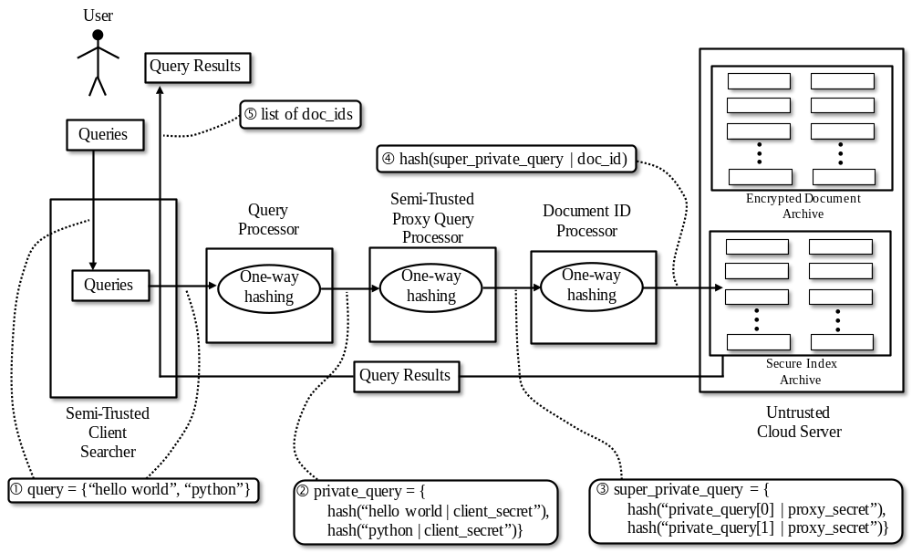
Figure 2 – the procedure of performing secure queries

2. Existing Related Work

This section reviews the existing related work from the viewpoints of the implementations of the searches on encrypted documents and the mapping of queries to encrypted documents.

2.1 Implementations of the searches on encrypted documents

Online searches: Online search [1, 5, 6, 9] performs a sequential search on the document cipher. To be able to perform encrypted searches on such a cipher, a large block cipher may not be used; rather, each term must be encrypted separately to facilitate exact string matches on the encrypted query terms. In which case, this is a simple substitution cipher. These may be broken, or at the very least leak information about the contents.
As pointed out in [18], proposals based on online searching, in light of their sequential time complexity, are not appropriate except in limited contexts. For example, they may be appropriate if the purpose is to allow an email server to obliviously scan the “subject” field of incoming emails for the keyword “urgent”. If detected, the recipient can then be immediately notified.
Their primary advantage is related to their simplicity: one simply iterates through all of the terms and applies a cryptographic hash to each. To permit exact phrase searching, an encrypted query phrase needs only be iteratively compared to the encrypted terms in the cipher. A comprehensive overview of online searching solutions can be found in [5].
Offline searches: Offline indexes [x, x, x, x] are data structures, which store a representation of the document (or documents) in which rapid, efficient retrieval and ranking operations are facilitated. They also have the added benefit that in many cases they are completely isolated from the document they are representing; thus, both can be de-signed and implemented separately and independently. Offline indexes have a few different implementations. For example, they may use independent encryption and compression algorithms, appropriate to their specific needs. Furthermore, they can be independently distributed. In light of these clear advantages, most of the recently proposed encrypted searching constructions are based on offline indexes [13, 19] like the Bloom filter. A comprehensive overview of offline-based solutions can be found in [13].
In [2], a possible approach to a secure index is elaborated. Previously, this index was discussed in the context of using Huffman codes to serve as an efficient substitution cipher. However, other, more secure solutions are possible. If terms, or words, are being stored in the inverted index, then this means an untrusted party may observe the contents of the document directly, and so no data confidentiality is provided. Moreover, even if encrypted, compressed or obfuscated transformations of terms are being stored in the index, it is still potentially vulnerable to cryptanalysis (e.g., frequency analysis). Alternatively, an attacker could try various popular words to mount a pre-image attack on the values in the index. The primary advantage of the inverted index is that it is extremely well-understood (it is the most popular index in the field of information retrieval at large), fast, and space-efficient (especially if a block-level or document-level postings list is used).
A Bloom filter [20] is a probabilistic set, which can trade accuracy for space complexity. It consists of a bit vector of size m (all initially set to 0) and k (cryptographic) hash functions. For each member, use the k cryptographic hash functions to map it to k indexes in the bit vector, setting each bit to 1. To verify an element is a member of the set, check to see if each of its k hash positions is set to one. On the one hand, If any are zero, then it is definitely not a member (false negatives are not possible). On the other hand, if all of them are set to one, we assume that it is a member. However, it is possible, with some false positive probability, that it is not a member; rather, one or more actual members caused those k bit positions to be set to one.
It is straightforward to construct a secure index from a Bloom filter. For each term (words, n-grams, or other searchable term constructions) in the document, insert it into the filter. To prevent unauthorized users from querying the index, do not insert the plaintext terms; rather, insert some transformation of them. Ideally, use a one-way hash function on the term concatenated with a secret, e.g., insert (bloom, hash (terma|secret)).
To harden the Bloom filter from cryptanalysis, e.g., to guard against information leaks possible through correlation analysis, the same terms in separate documents ought to map to different index positions in the Bloom filter. In [13], it is recommended that the document id be appended to the cipher text terms of the document during the construction of the secure index. For example, insert (bloom, hash2 (hash1 (terma|secret)|doc_id). Likewise, during the construction of private queries, the user must apply the same transformations. Since secret is unknown to unauthorized parties, like the server, they are unable to query the secure index, and since the doc_id is different for each document, stronger guarantees on query privacy is provided.
However, do note this construction complicates search queries applied to an entire collection of documents. After all, the server itself cannot transform each of the query terms with the appropriate doc_id. If the users must perform this task, then there will be considerable communications overhead since they will need to send a separate query for each document.
An important feature of Bloom filters, in the context of encrypted searching, is that they leak very little information. In a Bloom filter, not only is it possible for more than one term to map to the same positions, but mappings for different terms overlap and thus one cannot know if a pattern of ones is from a combination of n terms or a single term. This is a reason why Goh [13] argued the Bloom filter is such a strong choice. Additionally, the Bloom filter is space efficient since we may freely trade accuracy (false positives) for space-complexity (number of bit positions in the filter).
The Bloom filter has two notable weaknesses. First, Bloom filters do not identify the position (which is both a blessing and a curse in the context of encrypted search) of the terms (of the encrypted document) inserted into the set; this complicates approximate matching and context-aware searching, which we will elaborate on in the section “How do we map queries to documents.” Second, Bloom filters with the exception of Bloom filter variations like Counting Bloom [20] do not allow removal of members from the set, thus necessitating the Bloom filter’s reconstruction whenever removal is required.

2.2 Query mappings to encrypted documents

The best way to map queries to documents is a very important, often neglected, topic in the encrypted searching community. There are several ways being explored: Boolean keyword matching, conjunctive keyword matching, approximate keyword matching, exact phrase matching, relevancy (context-aware) matching, and semantic matching. This section describes the major query matching methods possibly performed on encrypted documents.
Boolean keyword matching: Boolean keyword matching [Public-key encryption with keyword search, Practical Techniques for Searches on Encrypted Data] looks for a particular words (or more generally, terms). Although the number of words being looked for varies from 1 to a particular number, what is common in this approach is that they perform a Boolean test regarding whether the given set of words appear in a document. This type of search does not keep track of anything other than the Boolean test; either all of the words matched, or none of them did. In addition, while there are some techniques that are tolerant to deviations-like typographical errors, encrypted search must still rely on some form of exact string matching due to both the terms in the query and the document being indexed. For example, the solution proposed by Li [11] addresses tolerance of typographical errors by including all error patterns up to k errors directly in the index, upon which simple exact matching may be performed.
Conjunctive keyword matching: In [7], the authors propose a system which permits secure conjunctive queries for certain keywords (trapdoors) on a given set of fields, like the “From” field in an email. By secure, they mean that given access to a set of indexes for encrypted documents and a freely chosen set of trapdoors, adversaries, like an un-trusted cloud storage provider, must not be able to learn anything about the encrypted documents except whether it matches those specific trapdoors.
Their work demonstrates an improvement over the single keyword searching discussed in [9], but their solution is still rather limited. First, they still only perform exact string matching (instead of approximate string matching). Second, their solution inflexibly requires the document creator to tag specific keyword fields for search-ability—in their case, these field names (although not the actual values) are exposed, which constitutes an information leak. Finally, like most other solutions, they do not consider untrusted parties, which consider historical data [15].
Approximate keyword matching: In [12], the authors point out that, for Google, not returning enough results is not a problem. Their primary problem is finding ways to return fewer, more relevant results so that users do not have to sift through too many results (most users only check the first page of results from Google). Thus, Google is motivated to improve the precision, which is the ratio of relevant documents returned to the total documents returned. However, in vertical search, such as encrypted searching over an enterprise's store of encrypted documents, there is far more concern over not missing or overlooking relevant documents, since there may be so few relevant results to begin with. Thus, vertical search tends to have an objective in direct contrast with Google’s. That is, recall, which is the ratio of relevant documents return to total number of relevant documents, is equally or even important to than precision.
In [11], a mechanism is proposed to address the limitation in which only exact matches on keywords are performed. In particular, they propose a construction that allows for matches on typographical errors or typical spelling variations, e.g., “color” vs. “colour”. To accomplish this, when constructing the index, for each term in the document, add all size k edit distance patterns, where an error is an insertion, deletion, or substitution of a character. For example, for a 1-edit error tolerance, the keyword “age” is expanded to {age, *age, a*ge, ag*e, age*, *ge, a*e, ag*}, where the * represents any character. Thus, if “age” fails to match, the query can be automatically expanded to each of those variations in turn until a match is found.
Wildcard [32] searches can be quite useful. For example, if users are unclear on how to spell a particular word, they can use wildcards to represent their ignorance, e.g., instead of “tomorrow”, they may type “to*row”. Or, as another example, the user may seek multiple variations of a word, e.g., “*night” for “night” or “knight”.
Exact phrase matching (word n-grams): Most searchable encryption schemes only allow matches on keywords, but in [33], a method for secure ex-act phrase matching is elaborated on. Phrase searches consist of approximately 10% of web search queries, so this is an important capability. Unfortunately, they require clients maintain a local dictionary on their computers to facilitate the capability. As long as such data must be maintained locally to perform searches, one may reasonably argue that local searchable indexes should be maintained instead. Local indexes, freed from many of the security concerns, would permit any sort of search operation without the need to communicate with a server until a specific document is desired (thus less information leaks in the form of access patterns).
Relevancy (context-aware) matching: As pointed out in [18], most encrypted searching research focuses on Boolean search, where a document is relevant to a query if and only if all of the terms in the query match. As indicated elsewhere, this has a number of problems with respect to precision and recall. The results in this paper represent an important advance over prior encrypted searching schemes in that it ranks documents (out of a set of documents) ac-cording to estimated relevance to a query.
Buckley proposed weighted keywords matching [27]. Weighted keywords are based on two fundamental insights. First, some of the terms occur more frequently in a document than other terms. When scoring the relevancy of a document, if a frequent term in the document matches a term in the query, it should be given more weight than a less frequent but matching term.
The second insight is that many words (or terms) will be in all, or most, of the documents in the collection. These words, therefore, carry very little meaning; they have no discriminatory power as they appear in nearly every document. Conversely, many words will be very rare or even unique in a collection, and thus they have significant discriminatory power. For example, the word “the” is in nearly every document—it serves as linguistic glue— but the word “acatalepsy” will be found in very few, if any. The heuristic, then, is the more discriminatory power a term has, the more weight it should be given when scoring a document’s relevancy. Buckley proposed to calculate the term weight in collection using formula (1).

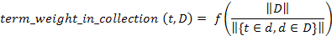 (1)

Combining these two insights, we have tf-idf (term frequency, inverse document frequency) and its variants. An offline index, like a Bloom filter, may be adapted to work with these multiplicity metrics [34]. In tf-idf, both the term frequency within a document and the inverse document frequency within a collection of documents are used to estimate how important a query term is using formula (2).

(2)

Where f is the estimated frequency of term t in document d. A straightforward implementation that uses this heuristic is to simply sum the weights of each query term found in the document.
In [Efficient Text Proximity Search], the importance of proximity of terms in keyword searches is considered. The fundamental principle can be demonstrated by considering the following: given two documents, document1 = “A B C” and document2 = “A D D ... D B C”, document1 should be more relevant than docu-ment2 for the query “A B” even though they both contain the keywords with the same frequency. Put simply, how close together are the terms? The closer, everything else being equals, the better the match.
There are two primary approaches to account for this. The first way is to implicitly model term proximity by represent the documents at finer granularities, e.g., every sequence of N sentences gets a different index. Thus, the size of N can be tuned to provide a desired level of precision and recall: the larger the N, the better the recall but the worse the precision and, likewise, the smaller the N the better the precision but the worse the recall. The second way is to explicitly introduce a proximity measure, e.g., assign larger relevancy scores to matches in which the terms are “closer”. While both approaches tend to involve rather informal, ad hoc decisions, it is necessary to make them to create an effective IR system.
In modern IR systems, scoring the relevancy of a document to a query is, arguably, its most important task. If standard relevancy scoring techniques in IR can be brought to bear on encrypted searching, the utility of encrypted search will be significantly improved. However, encrypted searching poses a number of challenges to standard relevancy metrics in IR. In encrypted search, a server obliviously searches over a collection of encrypted documents; however, the confidentiality guarantees (query privacy and data confidentiality) complicate most of the traditional relevancy scoring techniques found in the IR literature, like tf-idf, unless query confidentiality requirements are relaxed.
For instance, if a particular term maps to a different bit string in each document (to minimize information leakage as explained elsewhere), and no information may be leaked to the server about the query terms, then the user would need to submit a separate query for each document, which would be quite costly. On the other hand, if this requirement is relaxed, much more can be done. In particular, if query terms always map to the same bit string representation, as seen by the server, for every document, then the CSP itself can receive a single query from the user and take it from there.
Semantic matching: In [25], the authors make it clear that every previous search technique, from simple Boolean keyword searching to tf-idf proximity weighted relevancy scoring, are variations of syntactic search in which some form of string matching, combined with various ways to judge how important particular string matches, is being performed. There are two major problems with this string matching approach. First, different words (or phrases) may be used to express similar meanings (depending on the context). This is referred to as synonymy. Second, the same word (or phrase) may be used to express different meanings (depending on the context). This is referred to as polysemy. Both of these problems harm the relevancy of results.
Semantic search takes a different approach. Instead, it asks what the meaning of the text is and whether the query corresponds to a similar meaning. This is a more complicated question. For instance, it may involve natural language processing to perform word-sense disambiguation, part of speech tagging, and named entity recognition. When combining this with ontological and semantic knowledge, the IR system may begin to process queries in a way that resembles a human's ability to understand text.
For instance, if a user asks for “carnivore hunting prey”, one may assume he is also interested in more specific concepts, like “dog chasing cats” and “lions hunting antelopes”. Using part of speech tagging, it can be determined that “carnivore” is the subject, “hunting” is the verb, and “prey” is the object. Using word-sense disambiguation, the word senses can be determined accurately, e.g., “carnivore” maps to “carnivore-1” (word sense 1). Using an ontology (like WorldNet), it can be determined that “carnivore-1” is a concept which includes (more specific concepts) like “dog-1”, “lion-2”, etc. Then, it may be assumed we can expand the subject, “carnivore-1”, to {“carnivore-1”, “dog-1”, “lion-2”, ...}, the verb, “hunting-3”, to {“hunting-3”, “chasing-1”, “preying-4”, ...}, and the object “prey-4” to {“prey-4”, “feline-2”, “antelope-1”, “cat-1”, ...}. Clearly, this is not an easy problem, but this approach has already been put to effective use. There are also statistical techniques to model semantically related terms, like latent semantic indexing (LSI). Unfortunately, there has been very little progress on either of these fronts in relation to encrypted searching. They represent promising future directions.

3. Searches on Encrypted Documents using Perfect Filter Secure Index

3.1 Description of searches on encrypted documents using perfect filter secure index

This section describes construction of perfect filter secure index and the procedure for searches on the perfect filter secure index. First, the document is broken up into N blocks. The choice of N represents a trade-off. Larger blocks are more space efficient, but as a consequence proximity measures are less accurate. Alternatively, if the blocks are too small, hidden queries reveal compromisingly accurate information.
Define (describe) “Perfect filter” in this paragraph.
Next, the blocks are sent to the searchable terms extractor. At this stage, decisions are made with respect to which elements (searchable terms) are extracted from the document and inserted into the Pf in order to facilitate different search modes. For instance, what combination of approximate keyword matching, exact phrase matching, and wildcard matching, should be supported will be chosen. Note that the index itself is agnostic to these questions. Moreover, the size of the Pf is determined only by the number of members and the desired false positive rate, e.g., in the Pf a large string occupies the same (fixed) space as a small string.
Define (describe) “Minimal Approximate Set (MAS)” in this paragraph.
Finally, for each block, a Pf for the searchable terms is constructed. Upon completion, the Pf is added to the secure index. After this process has completed for every block, the secure index computes metadata about itself and the corresponding encrypted document. For instance, a hash of the corresponding encrypted document will be stored in the secure index as metadata. Thus, if the encrypted document is changed, a secure index representing the older version of it will have a mismatched hash with respect to the newer version. After the metadata has been computed, the secure index is integrated into the CSP’s database to enable it to obliviously search the encrypted documents in response to hidden queries. The procedure described above is summarized in Figure 3.
If more fine-grained term frequencies are desired for whatever reason (e.g., for more accurate keyword weighting metrics) without decreasing the block size, then a multiset is a more appropriate data structure. A multiset tracks the multiplicities of its members. Fortunately, it is trivial to extend the Pf to a multiset. This is accomplished by using the minimum perfect hash to index into another vector consisting of r bits per element, which can represent 2𝑟 discrete values. For example, for r = 2, four unique values can be represented. Thus, if it is desired to track the multiplicities of terms in a block, these four discrete values may map to some category. For example, they could map to the four ordinal categories: values, “0” for only one, “1” for between two and four, “2” for between five and ten, and “3” for more than ten. The extra multiplicity information may be used to improve the relevancy of search results.
It should be noted that, while in theory the perfect hash has optimal space complexity given a false-positive rate, implementations in practice do not achieve this limit. In practice, the space-complexity savings over the Bloom filter are less significant, although the reduced time complexity is still a big selling point, especially in the context of encrypted search in which an entire database of documents may need to be queried.
Encrypted search efforts have (with recent exceptions) ignored the thorny though necessary (for commercial appeal) task of trying to match queries to relevant sets of documents. That is, ranking documents by a measure of how “close” they are to matching a user’s search hidden query. In the field of information retrieval, finding effective ways to measure relevancy is probably considered their fundamental objective. To that end, they have devised many clever algorithms and heuristics to rank documents by their estimated relevancy to a query [x]. We will explore enabling some of these relevancy measures within our secure index construction (discussed next) - namely term proximity and keyword weighting (e.g., tf-idf) heuristics to improve accuracy of relevancy scores.

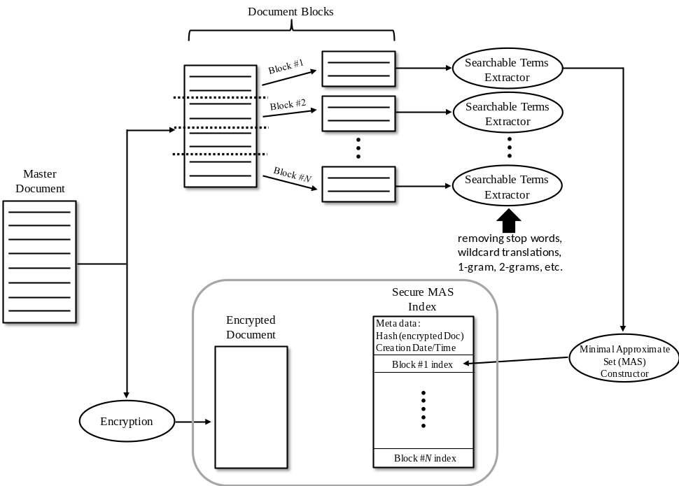

Figure 3 – summary of construction of perfect filter secure index and the procedure for searches on the perfect filter secure index

To calculate term proximity, words are mapped to a set of blocks (rather than a set of positions). Thus, the index quickly and efficiently answers the question, in what blocks does a word occur in? An approximate proximity score can be calculated by determining which blocks the terms of a query reside in combined with the size of the respective blocks. We adopted tf-idf keyword weighting heuristics proposed by Kumar [34].
Even if an encrypted search scheme provides robust data confidentiality and hidden queries, access patterns and implicit information useful for statistical inference may still be leaked. For instance, if the same term in a private query always appears the same, an adversary can build up an encrypted term to encrypted document table. If the adversary has another distribution (a simple text corpus) that models the frequency of plaintext queries, then he or she can assign the encrypted terms to plaintext terms in the distribution in a way that maximizes the likelihood of the assignment ( e.g., if the most common word is “apple” then it is likely that “apple” should be assigned to one of the encrypted query terms that has a high frequency to maximize the likelihood (there are simpler examples, however, e.g., whenever “Bob” does a specific encrypted query, he usually follows that up with a look at some stocks).
With the exception of a paper on oblivious RAM (which is too costly) [x], no encrypted search program sought to mitigate the risk from this subtler form of information leakage. To try to remedy this, experiments will be conducted to mitigate this kind of information leak. In particular, a single query term may have up to have N independent random bit string representations such that a client could issue the same query term N times and the CSP would see a different hidden query term each time (but the user would get the same relevant documents back). This complicates the CSP’s task of generating statistical data about frequencies of hidden query patterns. One approach to this problem is that, for each term, have the proxy indexer hash it with different known concatenations (e.g., repetitions of the secret). However, this approach will consume more space.
The Pf has some disadvantages compared to the Bloom filter. The Bloom filter leaks less information in some respects since there is no possibility of collisions between members in a Pf. However, like with the Bloom filter, each member in a Pf collides with an infinite set of non-members with a false probability rate 𝜀 = 12𝑚, where m is the number of bits allocated per member [x]. Moreover, by constructing fake, random dummy members, the Pf can be seeded with obfuscating garbage. This garbage will only cause false positives on non-member queries equal to the false positive rate decided upon when constructing the Pf. This false positive rate can be reduced as much as needed; each additional bit allocated halves the false positive rate.
Another disadvantage is that the time to construct a Pf is slower compared to a Bloom filter, although it is still linear in the number of members. The Pf is a static (immutable) data structure. Unlike the Bloom filter, once it has been constructed no new elements may be added (or deleted). However, this is not as problematic for encrypted search since most modifications to the original document would entail a Bloom filter reconstruction also.

4. Performance Evaluation

This section describes the performance evaluation conducted to compare the performance of the inverted index, a secure index using the Bloom filter, and a secure index using the Perfect filter. The inverted index leaks too much information and therefore may not be appropriate, but we included the inverted index to our performance study since it is the index popularly used in many applications. We compared the performance of the three offline secure indexes by implementing and executing searches in an isolated host computer for various experiment designs. All the experiments were performed using a Windows-based desktop PC (Windows X, running XX processor with __ GB RAM).

1.1 Controllable inputs and measurable outputs

For the sake of quantifying the performance of each index, several different measurable outputs and controllable inputs have been identified. See Table 1 and 2 for the definition of each output and input parameter. The identified input parameters were varied in a controlled manner for the purpose of measuring the effect they would have on the outputs. Specifically, for each experiment design, the following nine steps were executed. After the sequence of the nine steps was completed, we repeated the whole nine steps until the sequence of values for the inputs were exhausted.
- For each input parameter, a sequence of different values were chosen for the given experiment design.
- An artificial text corpus was constructed with respect to the chosen inputs.
- A set of input queries were generated for the artificial text corpus.
 A non-secure, established IR system was employed to classify the relevancy of each document in the artificial text corpus to each query. That is, a mapping from query to ranked set of documents was generated.
 A secure index of each type for the artificial text corpus was generated with respect to the chosen inputs and experiment design.
 Each secure index construction classified the relevancy of each document in the artificial text corpus to each query.
 The outputs were measured and recorded (a trial run)
 Go back to step three N more times.
 An average of each of the measured outputs was recorded for the given inputs.

Output Parameters | Definition
Secure index database (SID) construction time (T_{C}) | Total time taken to construct SID for artificial text corpus in seconds
SID query lag time (T_{L}) | Total time taken to respond to all generated queries in seconds
Resident SID memory-space  (S_{M}) | Total system memory of resident SID process or processes (for securely indexing a given artificial text corpus) in kilo-bytes
Non-resident SID file-size (S_{F}) | Total file size of SID for artificial text corpus in kilo-bytes
Precision (P) | {retrieved documents AND relevant documents} / {retrieved documents}
Recall (R) | {retrieved documents AND relevant documents} / {relevant documents}
Mean average precision (MAP) (P_{A}) | Since it is trivial to optimize recall by retrieving all document and trivial to optimize precision by retrieving no documents, a more insightful metric is based on the precision-recall curve. Moreover, unlike precision and recall, MAP may take into account the order (how retrieved documents were ranked).  To determine which documents are relevant to specific queries, an existing IR library will be used on the artificially generated text corpuses. The output from this library will serve to “classify” the relevancy of certain documents to certain queries.
Table 1 - Definitions of the output parameters

Input Parameters | Definition
Number of documents (N) | Total number of documents in artificial text corpus
Document size (S_{D}) | Number of words per document
Block size (S_{B}) | Maximum number of words per block
False positive rate (R_{FP}) | The theoretical false positive rate. This ought to have a strong effect on precision output.  For the Perfect filter-based secure index, the false positive rate is determined by the number of bits per hashed index. For the Bloom filter-based secure index, false positive rate is determined by the number of hash functions, h, the number of index positions, m, and the number of members, n.
Number of query terms (Q_{T}) | Number of terms per query. Note: A single term is either a word (1-gram) or a phrase (n-gram).
Number of words per query term (Q_{W}) | The number of words per query term. Number of words per query term can vary from 1 (the term is a single word, or 1-gram) to n (the term is an n-gram).  A term is present or not present in a secure index; approximate term matching is possible (e.g., locality-sensitive hashing techniques like stemming), but will be considered separately to simplify analysis. Likewise, wildcard matching will also be considered separately.
Text corpus class | Artificial text corpuses were generated from a trigram language model. Trigram language models will in turn be generated from typical actual text corpuses. This is done to facilitate precise control over input parameters number of documents and document size while still generating an arbitrary number of plausible SDIs for testing purposes.  Classes are defined by actual text corpuses. Actual text corpuses are defined by word distributions (subject - e.g., general, medical, etc.), the number of words per document, and the number of documents.
Table 2 - Definitions of the input parameters

  - Experiment designs

We developed four different experiments. This section defines and describes each of the four experiments we performed. Each of the four experiments uses the following common parameters: text corpus class, number of documents in the database, number of words per document (N), number of query terms and number of words per query term (Q_{T}, Q_{W}), and false positive rate (R_{FP}). The values applied to these input parameters are summarized in Table 3.

Input Parameters | Values/Settings
Number of documents (N)
Document size (S_{D})
Block size (S_{B})
False positive rate (R_{FP})
Number of query terms (Q_{T})
Number of words per query term (Q_{W})
Text corpus class
Table 3 – A summary of the input values commonly used for the four experiments

Experiment #1 (“the baseline experiment”): A Boolean matching experiment (i.e., a document is relevant or not relevant - no degree of relevancy scoring will be provided) will serve as the baseline experiment. Many existing encrypted search solutions can be represented with this approach. All words in the document (1 block). Since the baseline experiment performs no relevancy scoring, there is no reason to segment documents into multiple blocks for proximity scoring or keyword weighting. The most efficient representation is therefore a single block.
Experiment #2 (“proximity scoring experiment”): Every term will be equally weighted (i.e., no term weighting was applied), but proximity will be taken into consideration. On the one hand, reducing the block size should permit the proximity measure to more effectively rank the relevancy of documents to queries, but on the other hand it will harm the other outputs, e.g., file size, lag time, etc. In particular, depending upon the chosen algorithm for proximity scoring, this could significantly increase the lag time. A sequence of different block sizes will be tried. There will probably be no obviously best block size configuration; it will depend on the importance of the different outputs.
Experiment #3 (“term weighting experiment”): Each term was assigned a different weight while proximity scoring was not applied. A standard heuristic, a tf-idf variant, was employed. On the one hand, reducing the block size should provide the tf-idf metric with more information to more effectively rank the relevancy of documents to queries, but on the other hand it will harm the other outputs, e.g., file size, lag time, etc. In particular, lag time may be significantly increased due to the fact that the entire secure index collection must be queried for term frequencies. Regarding the block size, a sequence of different block sizes were tested (for the exact block sizes applied to this experiment, refer to Table 3).
Experiment #4 (“combined proximity scoring and term weighting experiment”): The combination of proximity scores and non-uniformly weighted keywords was tested. On the one hand, reducing the block size should provide the tf-idf metric and the proximity metric with more information to more effectively rank the relevancy of documents to queries, but on the other hand it will harm the other outputs, e.g., file size, lag time, etc.

• Block size: A sequence of different block sizes will be tried. There will probably be no obviously best block size configuration; it will depend on the importance of the different outputs.

5. Conclusions and Future Work

References

[1] Peter Mell and Timothy Grance, “The NIST Definition of Cloud Computing (NIST SP 800-145),“ National Institute of Standards and Technology, September 2011.
[2] Siani Pearson, Yun Shen, Miranda Mowbray, “A Privacy Manager for Cloud Computing,” Cloud Computing, Lecture Notes in Computer Science, vol. 5931, pp. 90-106, 2009.
[3] Hiroshi Fujinoki and Siamak Mahmoudian Dehkordi, “In-line Auditing and Real-time Lineage Summaries to Maintain Ownership of Information Stored in Cloud Servers,” Journal of Network and Information Security, vol. 2, no. 1, pp. 1-14, 2013.
[1] D. X. Song, D. Wagner, and A. Perri, “Practical Techniques for Searches on Encrypted Data,” Proceedings of the IEEE Symposium on Security and Privacy, pp. 44-55, 2000.
[2] G. Navarro, E. S. de Moura, M. Neubert, N. Ziviani, and R. Baeza-Yates, “Adding Compression to Block Addressing Inverted Indexes,” Information Retrieval, vol. 3, no. 1, pp. 49-77, 2007.
[3] G. G. Langdon, “Huffman codes,” 2000.
[4] M. Mowbray, S. Pearson, and Y. Shen, “Enhancing Privacy in Cloud Computing via Policy-Based Obfuscation,” Journal of Supercomputing, vol. 61, pp. 267–291, 2012.
[5] C. T. a. D. L. Christian Collberg, “A Taxonomy of Obfuscating Transformations,” 1997.
[6] D. Hofheinz, J. Malone-lee, and M. Stam, “Obfuscation for cryptographic purposes,” TCC, pp. 214-232., 2007.
[7] P. Golle, J. Staddon, and B. Waters, “Secure Conjunctive Keyword Search over Encrypted Data,” Applied Cryptography and Network Security, Lecture Notes in Computer Science, vol. 3089, pp. 31-45, 2004.
[8] Z. Wei, Z. Dan-Feng, G. Feng, and L. Guo-Hua, “On Indexing and Information Disclosure Measure for Efficient Cryptograph Query,” Proceedings of the World Scientific and Engineering Academy and Society International Conference on Computers, pp. 476-480, 2009.
[9] C. Dong, G. Russello, and N. Dulay, “Shared and Searchable Encrypted Data for Untrusted Servers,” Data and Applications Security XXII, Lecture Notes in Computer Science, vol. 5094, pp. 127-143, 2008.
[10] M. R. Asghar, G. Russello, B. Crispo, and M. Ion, “Supporting Complex Queries and Access Policies for Multi-User Encrypted Databases,” Proceedings of the ACM Workshop on Cloud Computing Security Workshop, pp. 77-88, 2013.
[11] J. Li, Q. Wang, C. Wang, N. Cao, K. Ren, and W. Lou, “Fuzzy Keyword Search over Encrypted Data in Cloud Computing,” Proceedings of IEEE INFOCOM, 2010.
[12] M. Celikik and H. Bast, “Efficient Fuzzy Search in Large Text Collections,” ACM Transactions on Information Systems, vol. 31, no. 2, pp. 1-59, May 2013.
[13] E.-J. Goh, “Secure Indexes,” Trust, Privacy, and Security in Digital Business, Lecture Notes in Computer Science, vol. 3592, pp. 128-140, 2005.
[14] W. Diffie and M. E. Hellman, “New Directions in Cryptography,” 1976.
[15] B. P. a. T. Reinman, “Oblivious RAM revisited”.
[16] C. Gentry, “Fully Homomorphic Encryption using Ideal Lattices,” Proceedings of STOC, pp. 169-178, 2009.
[17] D. Boneh, G. D. Crescenzo, R. Ostrovsky, and G. Persiano, “Public-key Encryption with Keyword Search,” Proceedings of Eurocrypt, Lecture Nodes in Computer Science, May 2004.
[18] A. Swaminathan, Y. Mao, G.-M. Su, H. Gou, A. Varna, S. He, M. Wu, and D. Oard, “Confidentiality-Preserving Rank-Ordered Search”.
[19] S. Artzi, C. Newport and D. Schultz, “Encrypted keyword search in a distributed storage system”.
[20] A. Broder and M. Mitzenmacher, “Network Applications of Bloom Filters: A Survey,” Internet Mathematics, vol. 1, no. 4, pp. 485-509, 2002.
[21] N. Cao, C. Wang, M. Li, K. Ren, and W. Lou, “Privacy-Preserving Multi-keyword Ranked Search over Encrypted Cloud Data,” Proceedings of IEEE INFOCOM, April 2011.
[22] Y.-c. Chang and M. Mitzenmacher, "Privacy Preserving Keyword Searches on Remote Encrypted Data,” Lecture Notes in Computer Science, vol. 3531, pp. 442-455, 2005.
[23] Q. Liu, G. Wang, and J. Wu, “An Efficient Privacy Preserving Keyword Search Scheme in Cloud Computing,” Proceedings of International Conference on Computational Science and Engineering, vol. 2, pp. 715-720, August 2009.
[24] H. Cao, D. Jiang, J. Pei, E. Chen, and H. Li, “Towards Context-Aware Search by Learning a Very Large Variable Length Hidden Markov Model from Search Logs,” Proceedings of the International Conference on World Wide Web, pp. 191-200, 2009.
[25] F. Giunchiglia, U. Kharkevich, and I. Zaihrayeu, “Concept Search: Semantics Enabled Syntactic Search,” Proceedings of CEUR Workshop, 2008.
[26] R. A. Baeza-yates, “Text retrieval: Theory and practice,” In 12th IFIP World Computer Congress, vol. I, pp. 465-476, 1992.
[27] C. Buckley and G. Salton, “Term-Weighting Approaches in Automatic Text Retrieval,” Information Processing and Management, vol. 24, pp. 513-523, 1988.
[28] H. Cao, D. H. Hu, D. Shen, D. Jiang, J.-T. Sun, E. Chen, and Q. Yang, "Context-Aware Query Classification," Proceedings of the International ACM SIGIR Conference on Research and Development in Information Retrieval, pp. 3-10, 2009.
[29] P. Indyk and R. Motwani, “Approximate Nearest Neighbors: Towards Removing the Curse of Dimensionality,” ???, pp. 604-613, 1998.
[30] Y. Hua, B. Xiao, B. Veeravalli, and D. Feng, “Locality-Sensitive Bloom Filter for Approximate Membership Query,” IEEE Transactions on Computers, vol. 61, no. 6, pp. 817-830, 2012.
[31] R. Krovetz, “Viewing Morphology as an Inference Process,” ???, pp. 191-202, 1993.
[32] R. Brinkman, P. Hartel, W. Jonker and C. Bösch, “Conjunctive Wildcard Search over Encrypted Data,” Proceedings of the VLDB International Conference on Secure Data Management, pp. 114-127, 2011.
[33] Y. Tang, D. Gu, N. Ding, and H. Lu, "Phrase Search over Encrypted Data with Symmetric Encryption Scheme," Proceedings of the International Conference on Distributed Computing Systems Workshops, pp. 471-480, 2012.
[34] A. Kumar, J. J. Xu, J. Wang, and L. Li, "Space-Code Bloom Filter for Efficient Traffic Flow Measurement," Proceedings of the ACM SIGCOMM Conference on Internet Measurement, pp. 167-172, 2003.
[35] Z. Kissel and J. Wang, “Verifiable Symmetric Searchable Encryption for Multiple Groups of Users,” Proceedings of SAM 2013, 2013.
[36] Q. Liu, G. Wang, and J. Wub, “Secure and Privacy Preserving Keyword Searching for Cloud Storage Services,” Journal of Network and Computer Applications, vol. 35, no. 3, pp. 927-933, May 2012.
[37] S. Pearson, Y. Shen, and M. Mowbray, “A Privacy Manager for Cloud Computing,” Cloud Computing, Lecture Notes in Computer Science, vol. 5931, pp. 90-106, 2009.
[38] Y. Lu and G. Tsudik, “Enhancing Data Privacy in the Cloud,” Trust Management V, IFIP Advances in Information and Communication Technology, vol. 358, pp. 117-132, 2011.
[39] R. Latif, H. Abbas, S. Assar, and Q. Ali, “Cloud Computing Risk Assessment: A Systematic Literature Review,” Future Information Technology, Lecture Notes in Electrical Engineering, vol. 276, pp. 285-295, 2014.
[40] S. Mehrotra, C. Li, B. Iyer, and H. Hacigümüş, “Executing SQL over Encrypted Data in the Database-Service-Provider Model,” Proceedings of the ACM SIGMOD International Conference on Management of Data, pp. 216-227, 2002.
[41] B. Zhu, B. Zhu, and K. Ren, “PEKSrand: Providing Predicate Privacy in Public-Key Encryption with Keyword Search,” Proceedings of IEEE International Conference on Communications, pp. 1-6, 2011.
[42] R. Curtmola, J. Garay, S. Kamara, and R. Ostrovsky, “Searchable Symmetric Encryption: Improved Definitions and Efficient Constructions,” Proceedings of the ACM Conference on Computer and Communications Security, pp. 79-88, 2006.
[43] B. Xiang, D. Jiang, J. Pei, X. Sun, E. Chen, and H. Li, “Context-Aware Ranking in Web Search,” Proceeding of the International ACM SIGIR Conference on Research and Development in Information Retrieval, pp. 451-458, 2010.
[44] Y. Shen and J. Yan, “Sparse Hidden-Dynamics Conditional Random Fields for User Intent Understanding,” Proceedings of the International Conference on World Wide Web, pp. 7-16, 2011.
[45] J. Chen, H. Guo, W. Wu, and W. Wang, “iMecho: a Context-Aware Desktop Search System,” Proceedings of the International ACM SIGIR conference on Research and development in Information Retrieval,” pp. 1269-1270, 2011.
[46] M. Naor and M. Yung, “Universal One-Way hash functions and their cryptographic applications,” ???, pp. 33-43, 1989.
[47] R. Schenkel, A. Broschart, S. Hwang, and M. Theobald, “Efficient Text Proximity Search,” Lecture Notes in Computer Science, pp. 287-299, 2007.

