Indexing Alex’s crystal
- Looked at Qx-Qy plane (scattering plane of detector). Could see a lattice of spots, depending on Qz (-0.1926 Å⁻¹ =< Qz =< -0.071 Å⁻¹ shown below), different parts of the lattice got brighter, suggesting there was a scattering plane nearly parallel to the scattering plane of the detector
- Indexed spots with just two indices – some of the low Q spots were inaccessible (indicated by green X below)
Qz = -0.071  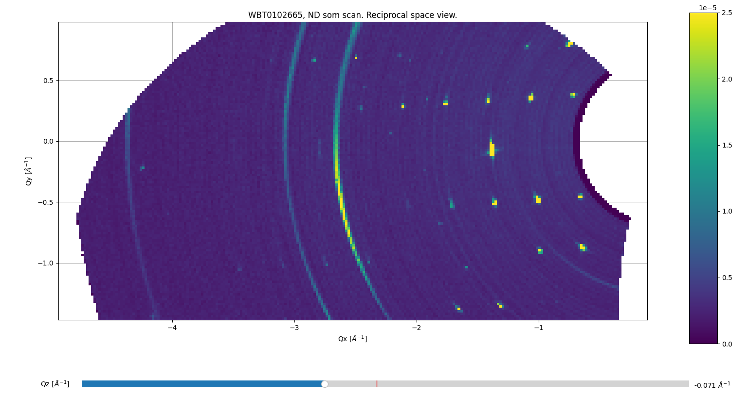  (1, -1)  (1, 0)  (1, 1)  X X  X X  X X  (3,-2) (2,-2)  (6,1) (5,1) (4,1) (3,1) (2,1)  (5,-1) (4,-1) (3,-1) (2,-1)  (4, 0) | Qz = -0.0912  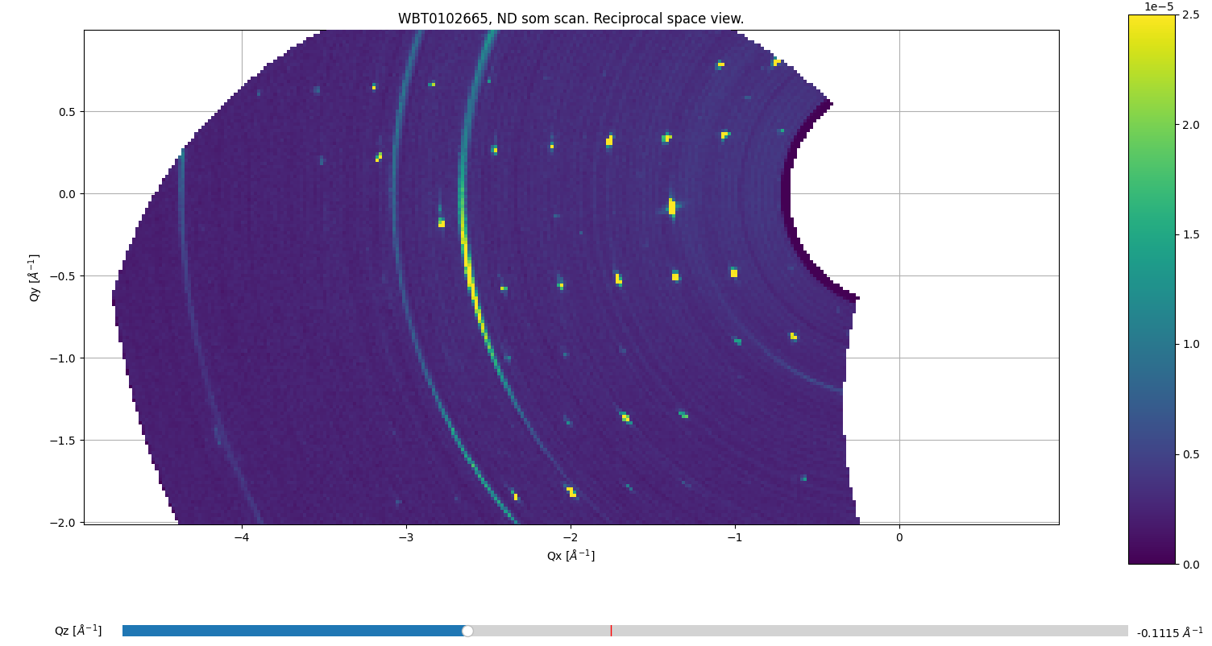  (3,-2) (2,-2)  (5, -3) (4, -3)  (7, -4) (6, -4)  (6, -1) (5,-1) (4,-1) (3,-1)  (10,1) (9,1) (7,1) (6,1) (5,1) (4,1) (3,1)  (8, 0)  (4, 0)
Qz = -0.1521  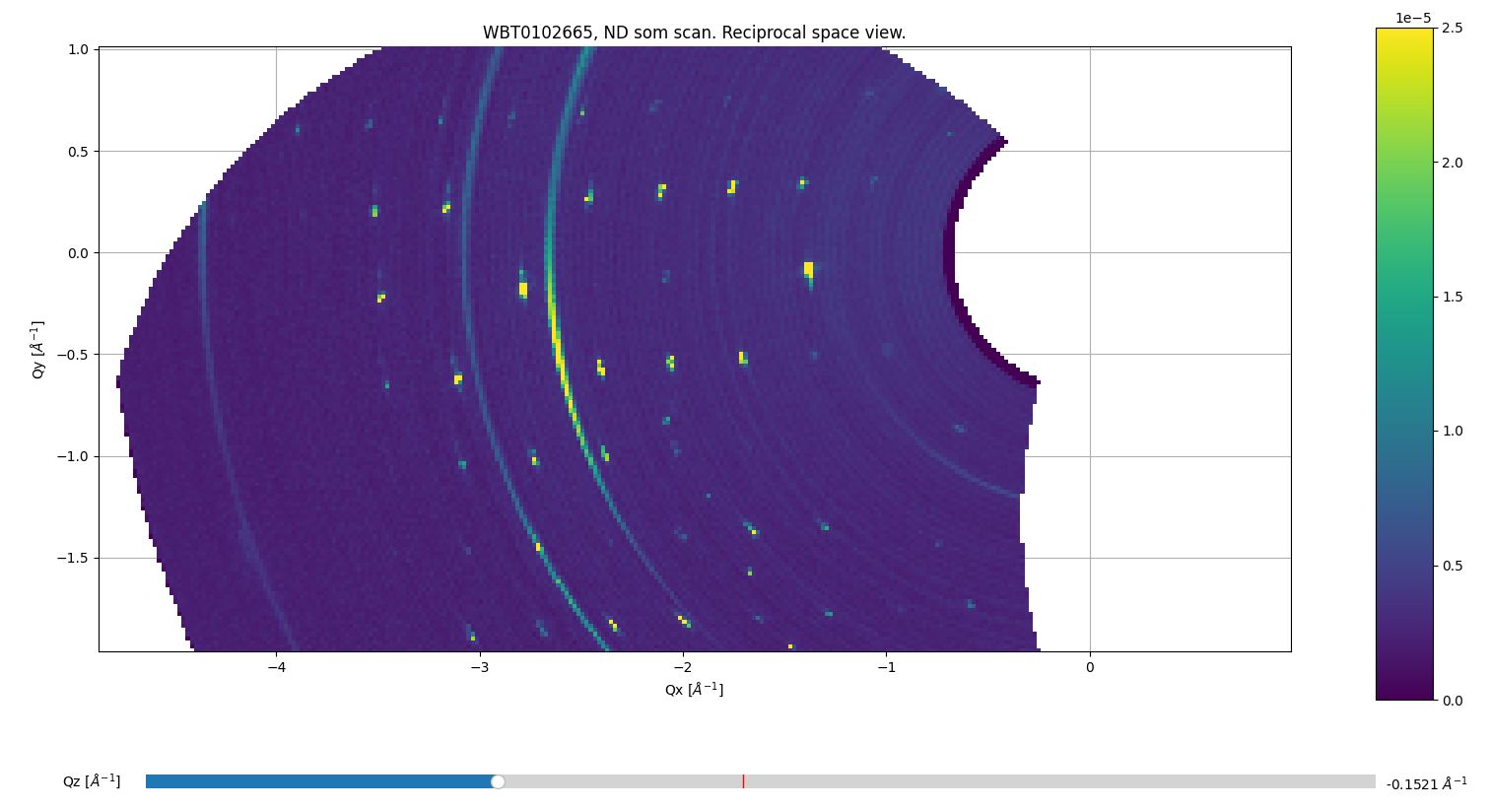  Don’t go here: Twin zone!!!!!  (10,1) (9,1) (7,1) (6,1) (5,1) (4,1)  (9,-1) (7,-1) (6,-1) (5, -1)  (8, 0)  (10, 0)  (6, 0)  (4, 0) | Qz = -0.1926  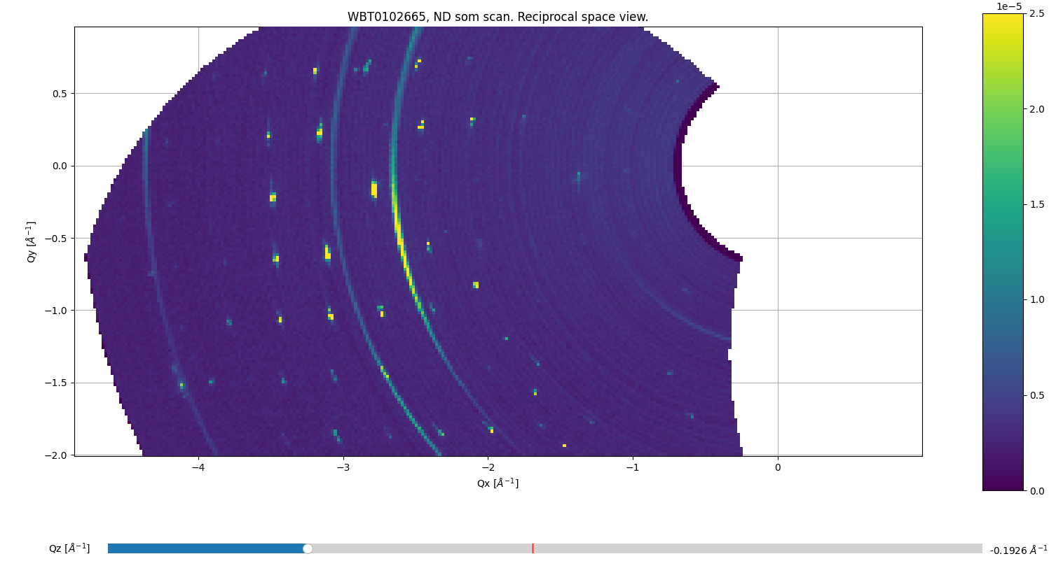  This peak appears to be outside “our” lattice  (10, 0)  (10,1) (9,1) (7,1) (6,1)  (10, -1) (9,-1) (7,-1)  (8, 0)
- Got co-ordinates (Qx, Qy, Qz) of a few of these reflections and added to spreadsheet based on positions in Qx-Qy view shown above.
Based on lattice spacings I could see, I made up some peaks outside the detector range in order to index the real peaks. Fake peaks are green X
- Looked at these reflections AGAIN but in orthogonal Qx-Qz plane, to refine Qz co-ordinate of spots. Where twinning was apparent peaks seemed to split in Qz, I always chose the lower, brighter twin (e.g. below).
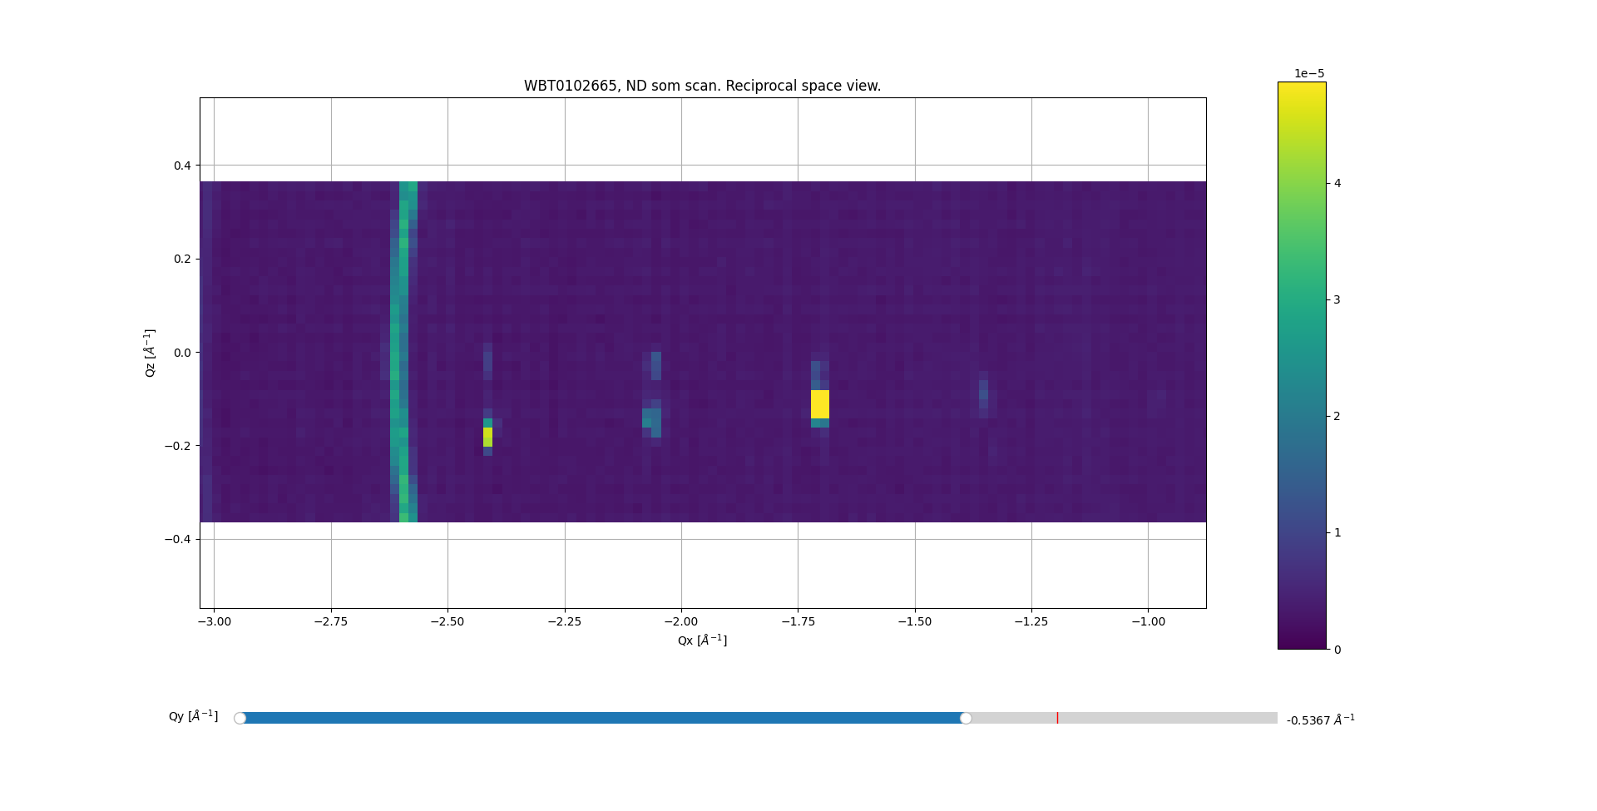
- For UB matrix calculation, we need two spots in (Qx, Qy, Qz) and indexed hkl … I already had two out of three indices I assigned above simply based on counting reflections. To get the third index, I looked at the list of calculated structure factors and compared 2θ, then made a choice based on intensity and hkl. Remember the 2θ of the observed reflection is calculated from (Qx, Qy, Qz) which just comes from the position of my mouse where I think the peak is brightest – so a little inaccurate!
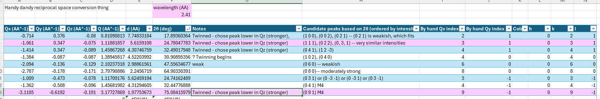
- For example, the peak at 2θ = 17.89° could be (1 0 0), (0 0 2), or (0 2 1). Given I already had “2” and “1” identified by hand, I chose (0 2 1), calculated 2θ = 18.2°. This peak also wasn’t super strong in the Wombat data, whereas (0 0 2) is supposed to be quite a strong reflection.
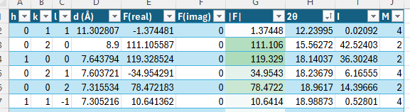
Another example, the peak at 2θ = 30.9° could be (0 3 2), (1 0 2), (0 4 0) or (1 1 2). In the Wombat data, this spot is the brightest of them all, so that narrows it down to (1 0 2) or (0 4 0). Based on my counting of spots in the lattice, I went with (0 4 0), calculated 2θ = 31.4°.
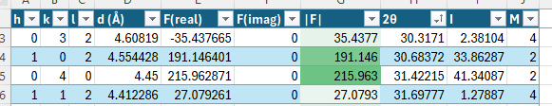
- Now choosing peaks for the UB matrix calculation:
  - We probably only have access to one scattering plane (unless using the Eulerian cradle).
  - We want peaks with not too many zeroes in their hkl, i.e. (0 4 0) would be a bad choice because it doesn’t constrain h or l really at all
    - Ideally we want as many different “numbers” in the hkl, which is a bit constrained by point a.
  - We want peaks that are not on the same line, i.e. (0 1 2) and (0 2 4) together would be bad choices
  - We want peaks that are separated in Q but especially separated in Qz – having a difference in the Qz is important to constrain the tilt of the scattering plane.
    - Looking at the peaks in my list, I deliberately went and found the (0 9 -1) peak (Qz = -0.191 Å⁻¹) as all the other peaks were between Qz = -0.08 Å⁻¹ and -0.129 Å⁻¹ ignoring (0 8 0) as per point b. above.
- I chose (0 3 1) and (0 9 -1):
  - Five different numbers in the hkl – only repeat is one 0, which can’t be helped
  - Not on the same line
  - Separated in Qz by -0.183 Å⁻¹ and separated in Q by 2 Å⁻¹
  - Peaks chosen were from the same twin as far as I could tell.
- Ran code – seemed to get a good result – bulk peaks are in the (0 k l) plane!!!
- When we get Int3D, Int3D will find the centres of peaks in (Qx, Qy, Qz) which will increase the accuracy of the indexing++ (and it can automatically find a UB matrix + refine the unit cell from the peaks it has found).
