Single crystal adventures: Wombat, the Eulerian cradle, and DMCpy
Siobhan

Some examples

Kirrily’s clinoatacamite
- This was the first experiment I did using the Eulerian cradle on Wombat
- Was very much a test run and spent some time testing/fixing limits with Frank and Helen
- Did not have an optimal strategy for data collection
  - Initially was doing 0.01° steps which was ridiculous
  - Then did 10° eom scans with 0.1° steps about random echi and epsi angles…
- Sample mounted on Al pin with blu tac (classy)
- Crystal is small and twinned – didn’t cover enough of Q space to find orientation or seriously identify peaks

Alex’s mysterious ND crystal
- No Eulerian cradle, just sample on Al plate on stick on Wombat sample stage
- Did a long som scan that covered 120° in 0.3° steps
- Crystal is a little bit twinned
- Could probably find orientation of biggest twin?

Federico’s ginormous Y2SiO5 crystal
fdfjlfkj

Software: DMCpy x Wombat

Motivation
- Want a Python script to be able to handle Wombat single crystal data and quickly make projections of data in Qx, Qy, Qz from HDF where steps are of sample rotation angle
- Want to be able to determine rough UB matrix and visualise data in hkl (i.e. r.l.u.)
- Ideally this can handle arbitrary Eulerian cradle angles (!!!)
- Int3D implementation still a work in progress – this is best for quantitative analysis (ellipsoid integration of peaks) however
  - learning curve for users (and instrument scientists)
  - development of software done by Nebil Kaptcho at ILL so hard to make quick changes
  - need to get ANSTO IT to install it on ANSTO machines
  - runs on its own separate python installation and fortran compiler thing (intimidating)
- Several packages out there however
  - Some have dependencies that only work on Linux e.g. hklpy (I tried to make this work!) https://blueskyproject.io/hklpy/
  - Some for x-ray detectors that are point detectors or flat area detectors, or goniometer geometries we don’t have e.g. xrayutilities (Kriegner et al. J. Appl. Cryst. (2013) 46, 1162-1170)
  - Thought about which instruments were most similar to Wombat which lead me to …

DMCpy
sdadfkdlkj

Interactive detector view
Dfsadsds

Reciprocal space view in A-1
Dfadfd

UB matrix determination
Fdfgaf
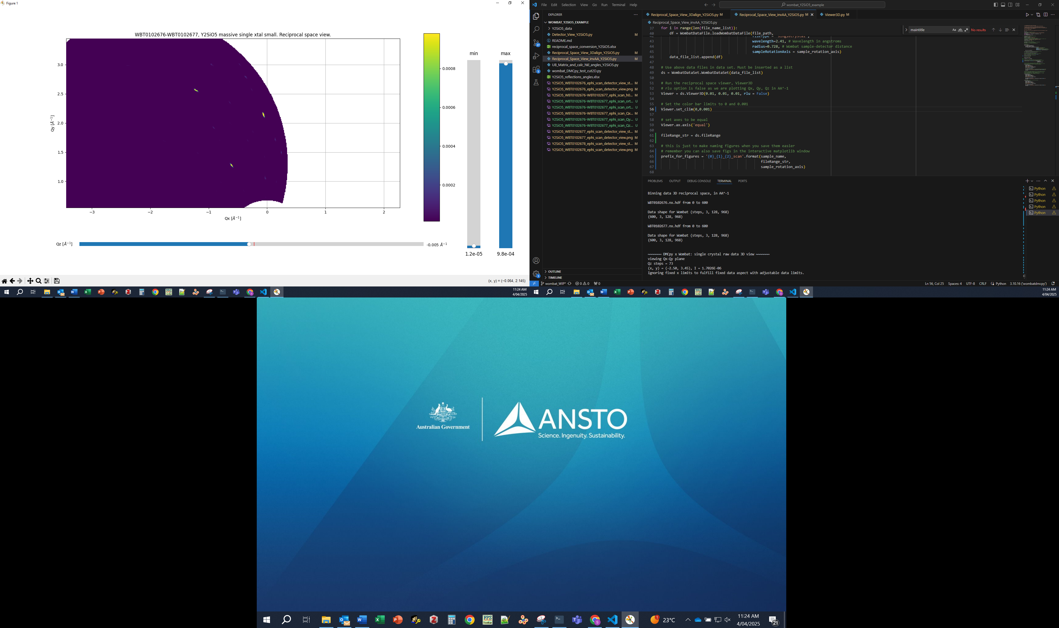
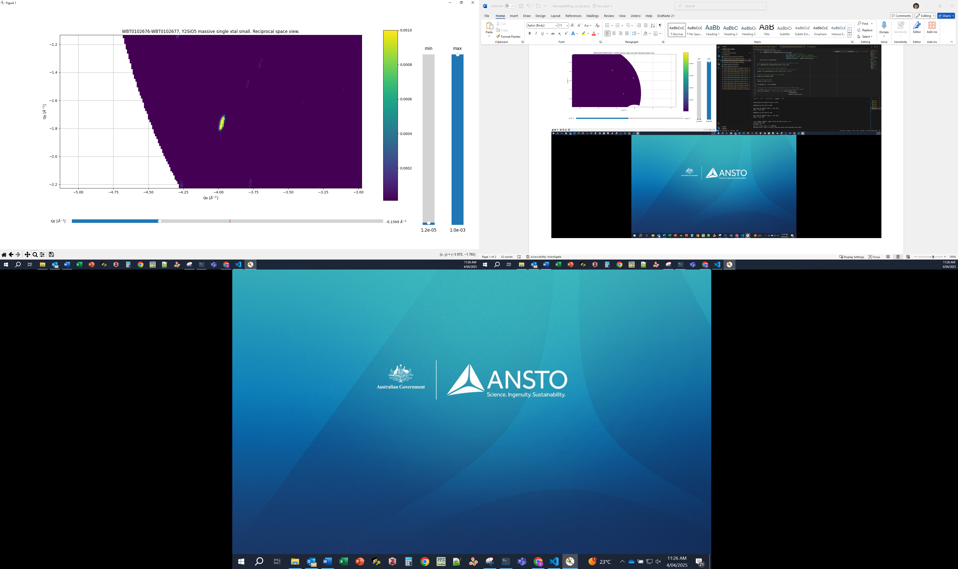

Reciprocal space view in r.l.u.
