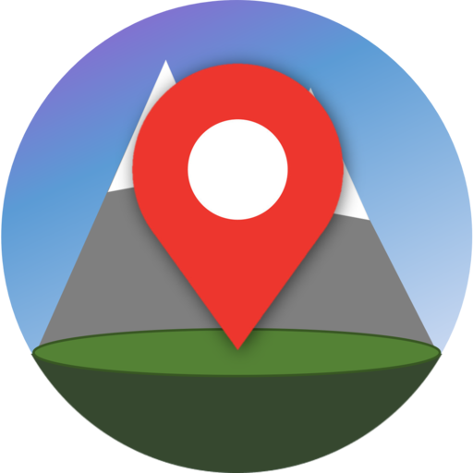

**Geogram**

Geogram is a social media app that allows the user to take pictures and upload it to their own map. Other users can then browse the map and look at the pictures taken by clicking on the markers.

It is a great way to explore new places as you can see the pictures, along with the location where it was taken when browsing other people’s maps.

It can also act as a photo diary, where users can keep track of the places they have been to and relive those moments.

**Features**

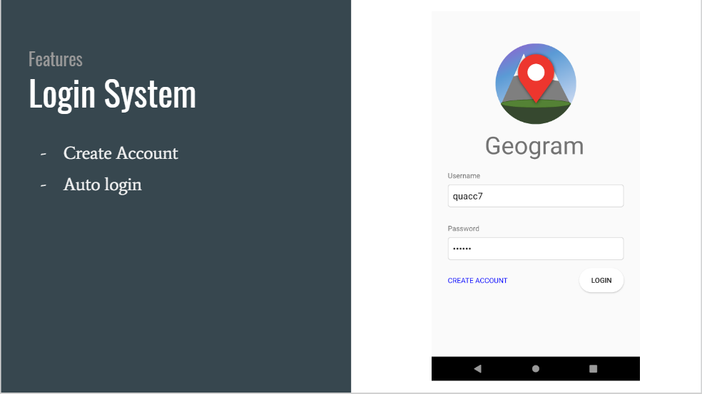

Login system allows users to create an account, and automatically logs in when the user has logged in before.

**User guide to creating an account**:

1. Click “Create Account”
2. Enter your chosen username (Must be at least 6 characters) and password (Must be at least 6 characters and include at least 1 number)
3. Click “Create”.
4. Your account is now created!

**User guide to logging in**:

1. Type in the username and password you have chosen when you were creating your account.
2. Press login.
3. You are now logged in!

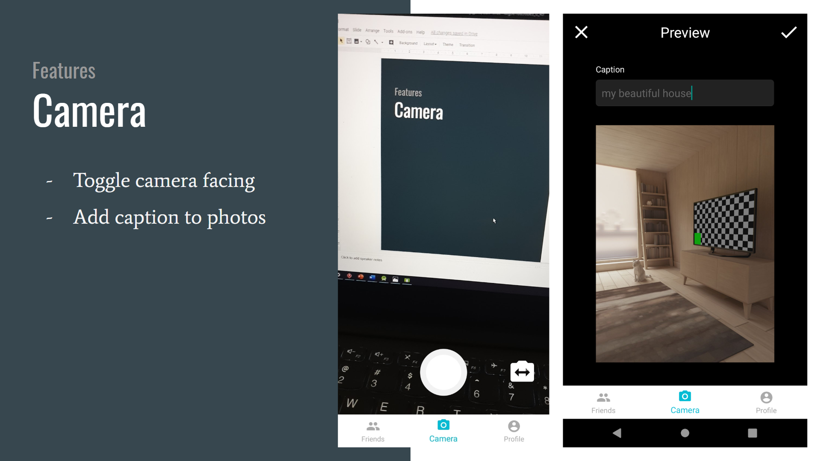

Our camera system has a toggle facing button to give users the ability to take selfies.

The preview page allows users to view the picture they have taken, and add a caption to go along with their picture.

**User guide to taking pictures and uploading to your map**:

1. Click on the camera icon at the bottom of the screen.
2. Take a picture.
3. If you like you can enter a caption, otherwise you can upload your picture by clicking the tick on the top right of the screen.
4. Your picture is now uploaded to your map!

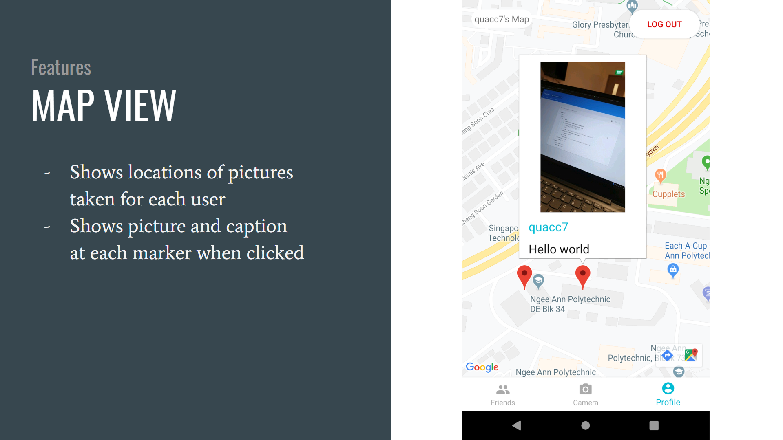

The map view is displayed when a user selects a friend’s map, or his own profile. It shows the locations of all pictures taken for a user, as well as the picture and caption when a marker is clicked.

**User guide to viewing your picture on the map**

1. Click on the profile icon at the bottom of the screen.
2. Click on the marker of the picture you want to see.
3. You can now see your picture!

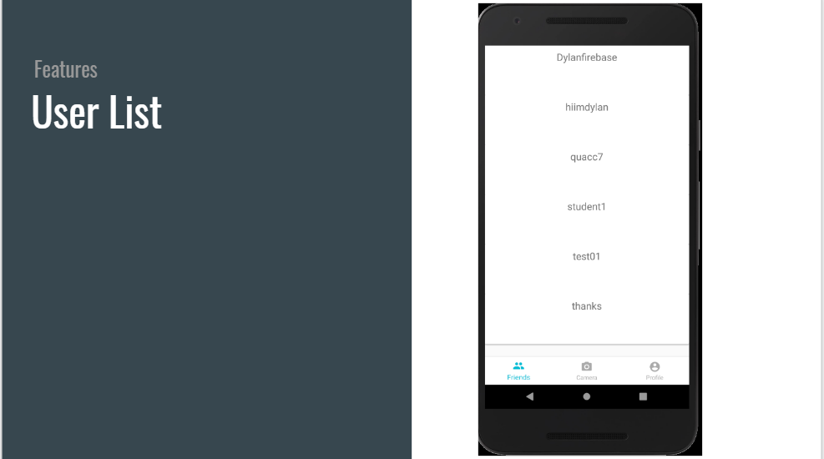

The user list shows all users and allows you to view their maps

**User guide to viewing other users‘ picture on the map**

1. Click on the Friends icon at the bottom of the screen.
2. Click on the name of the user you would like to view.
3. You are now viewing the map of the user!