Bautista, Raquel S. CS122 MTh 10:00-11:00 D324

BSCS I CS122L TF 9:30-11:00 D522

Midterm Homework 2

I.

1. interface

2. octalString = Integer.toOctalString(decimalNumber);

3. binaryString = Integer.toBinaryString(decimalNumber);

4. hexadecimalString = Integer.toHexString(decimalNumber);

5. package numbers;

II. On your document explain how the programs may be modified/improved so that decimal numbers with the decimal point may also be converted. If necessary, include/show codes/program segment in your explanation.

1. Change the data type of decimalNumber to double.

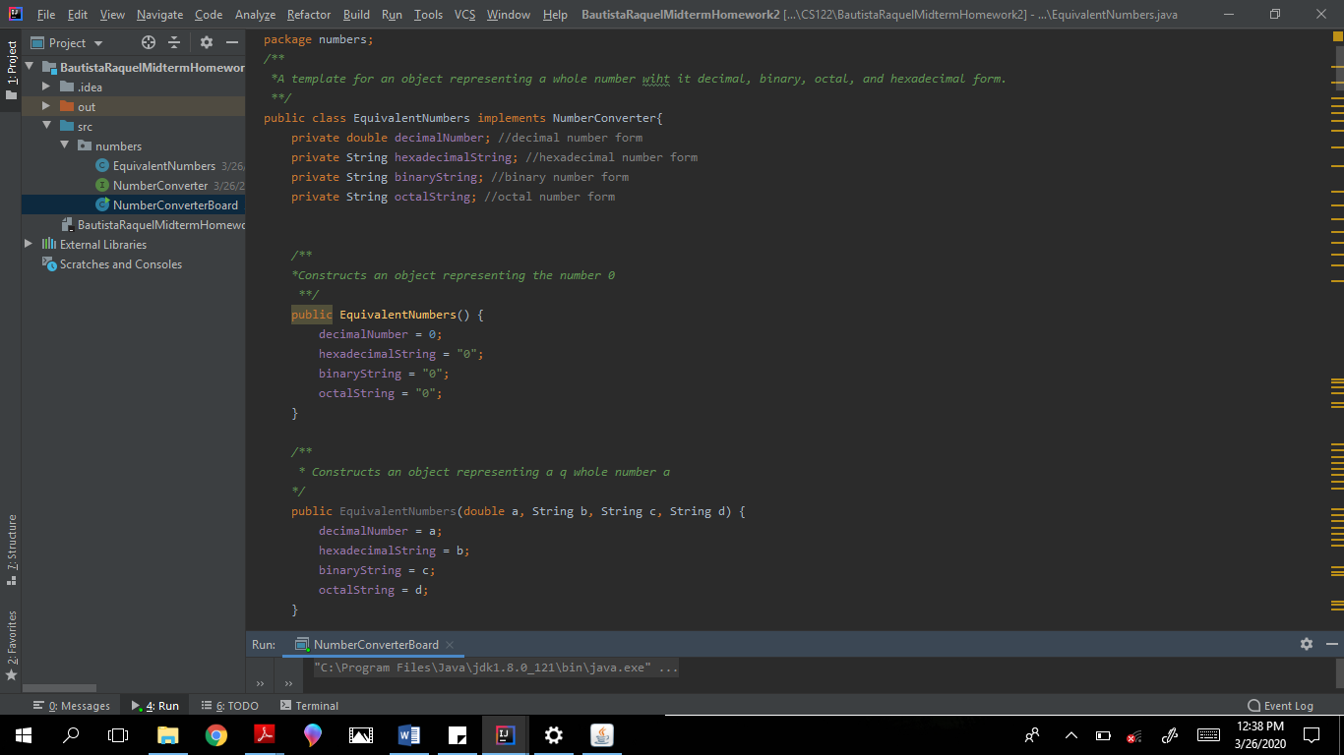

1. Create new methods that will return a binary, octal or hexadecimal string version of a decimal number with a decimal point;

toBinaryString(), toOctalString(), toHexadecimalString().

Convert the whole part to Binary String using the Integer class.

Convert also the fraction part into its binary equivalent.

If the decimal has a fraction part then concatenate it to the binary string of the whole part.

Same algorithm is applied to the other methods.

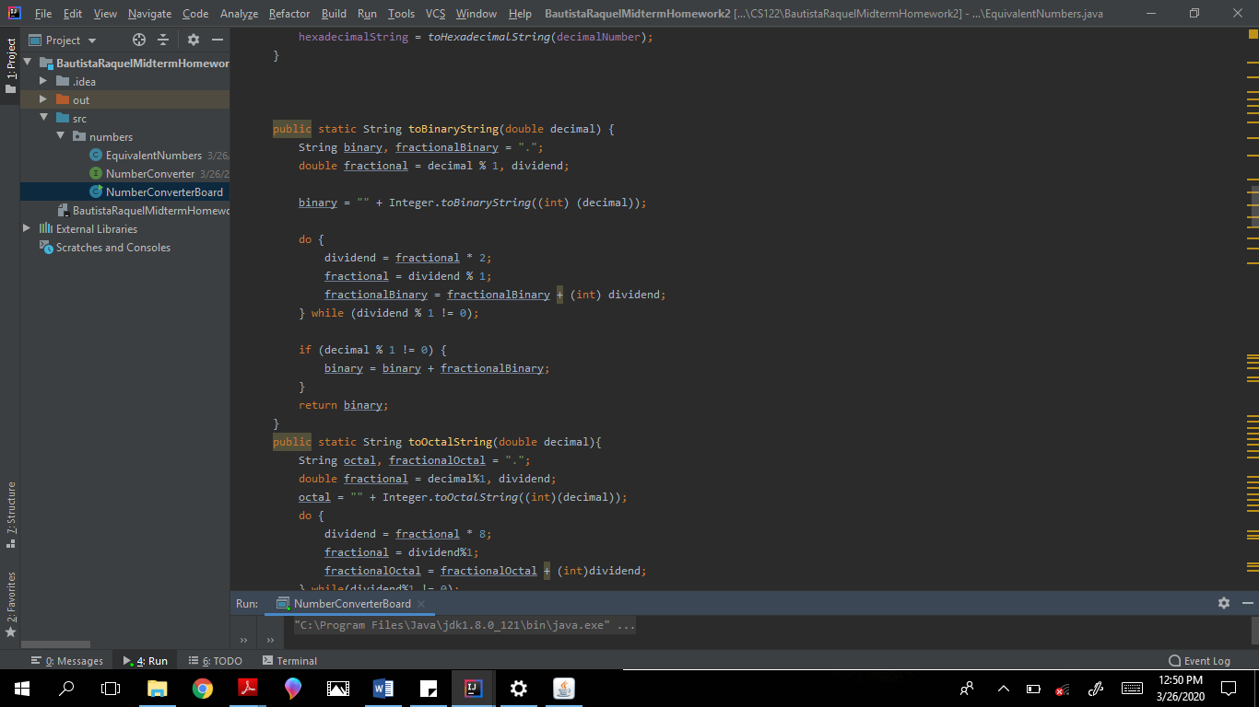

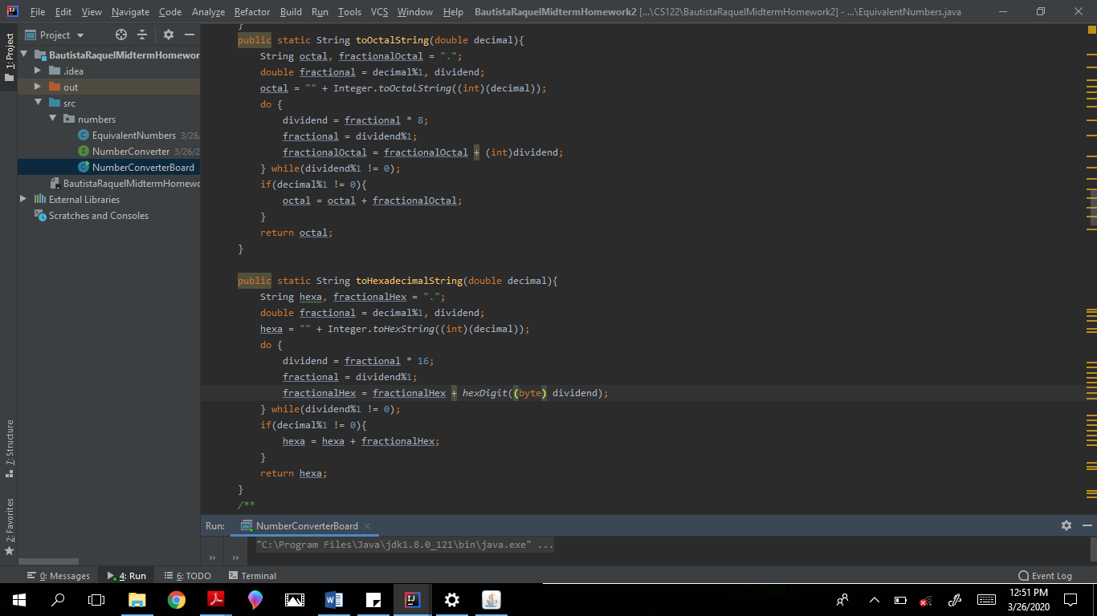

1. Replace the static methods of integer class (that gets the binary, octal and hexadecimal string of a decimal) with invocations of the newly created methods in number 2.

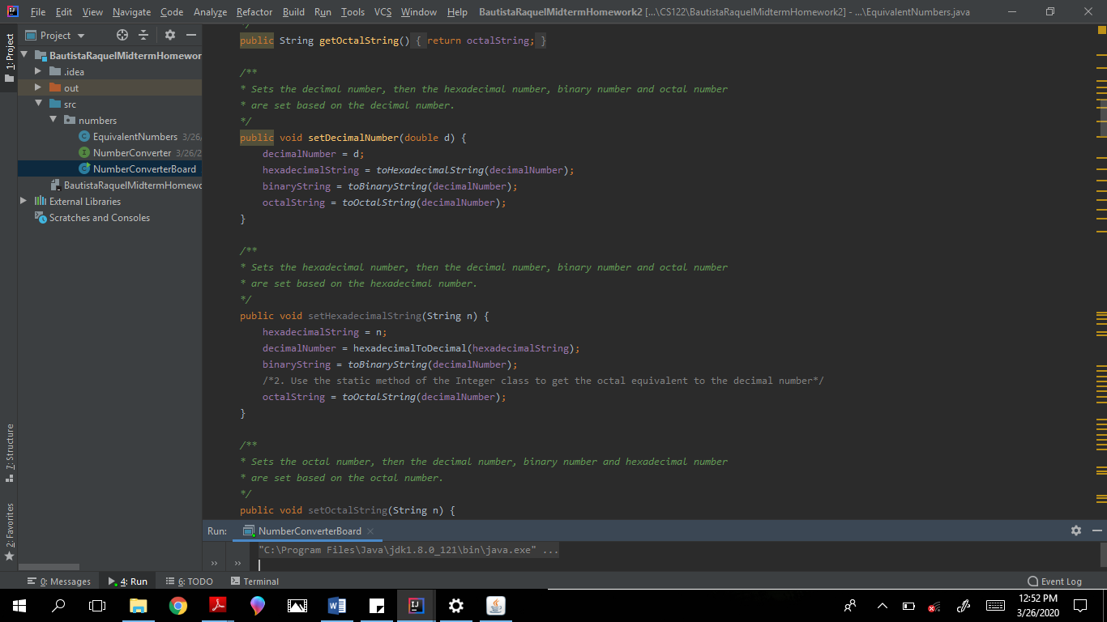

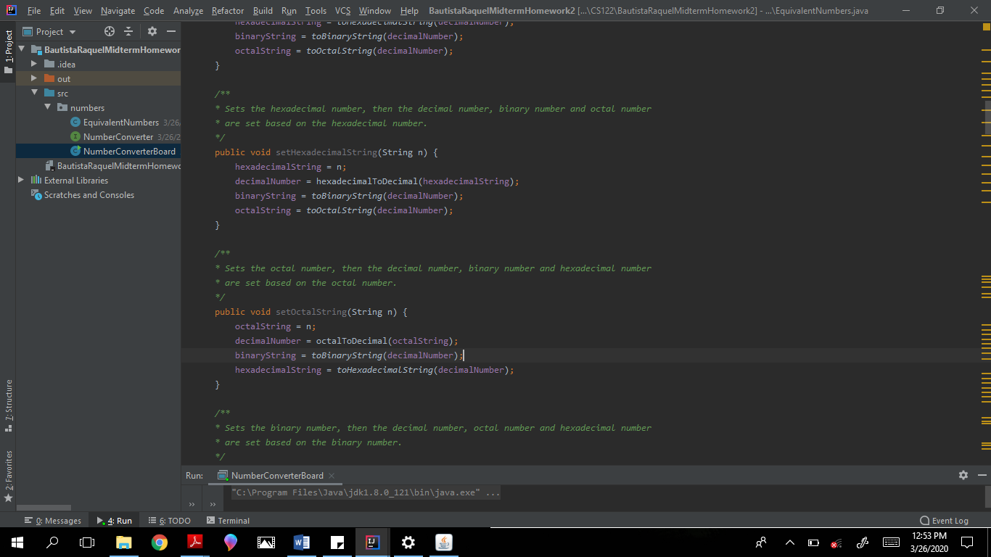



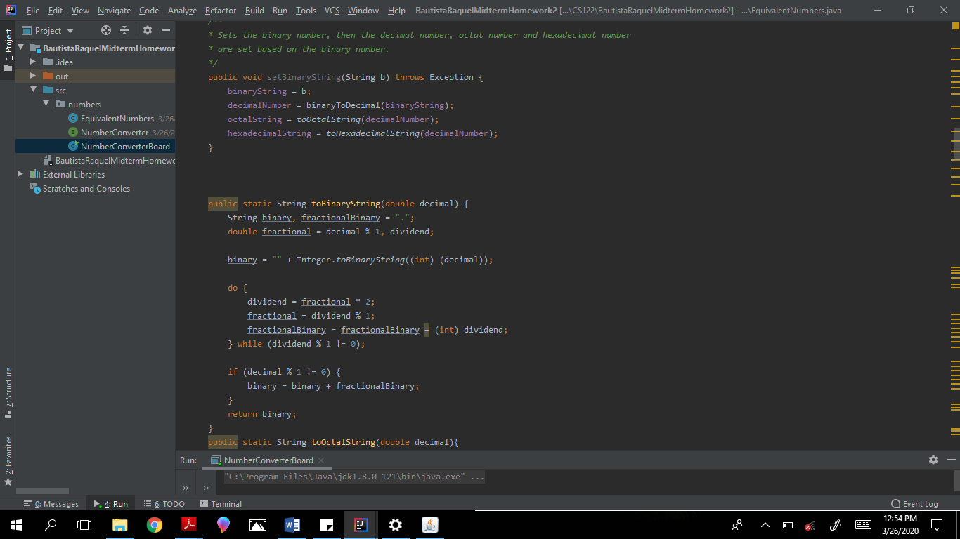

1. Create a new Boolean method hasDecimalPoint() that returns true if a decimal, octal, or hexadecimal number has a decimal point.

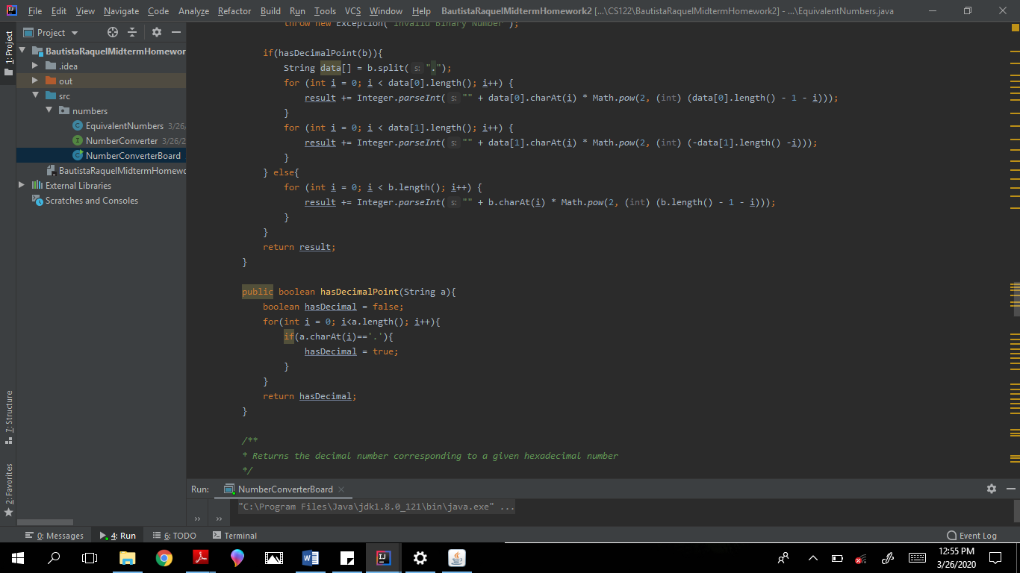

1. Add ‘.’ in the isValidBinaryString() so it doesn’t catch an error.

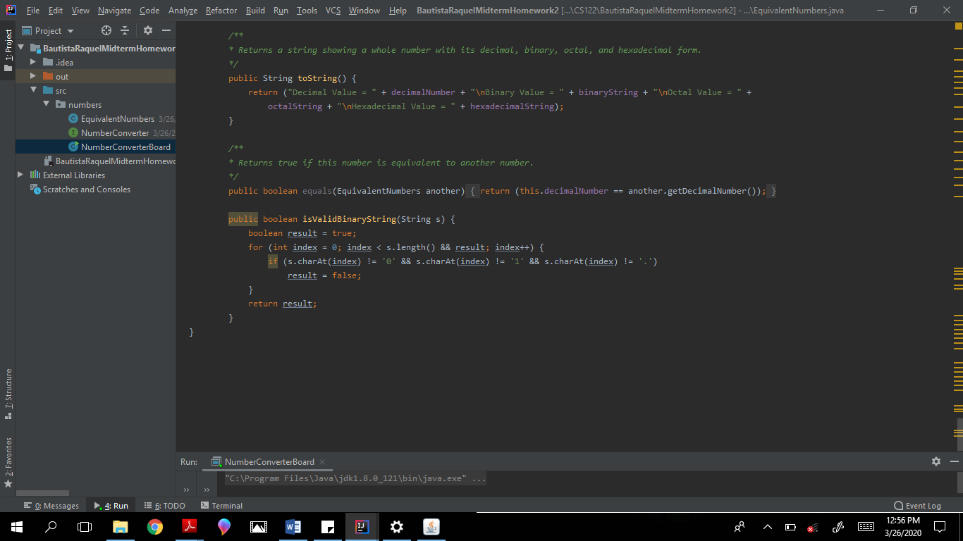

1. Replace int with double.

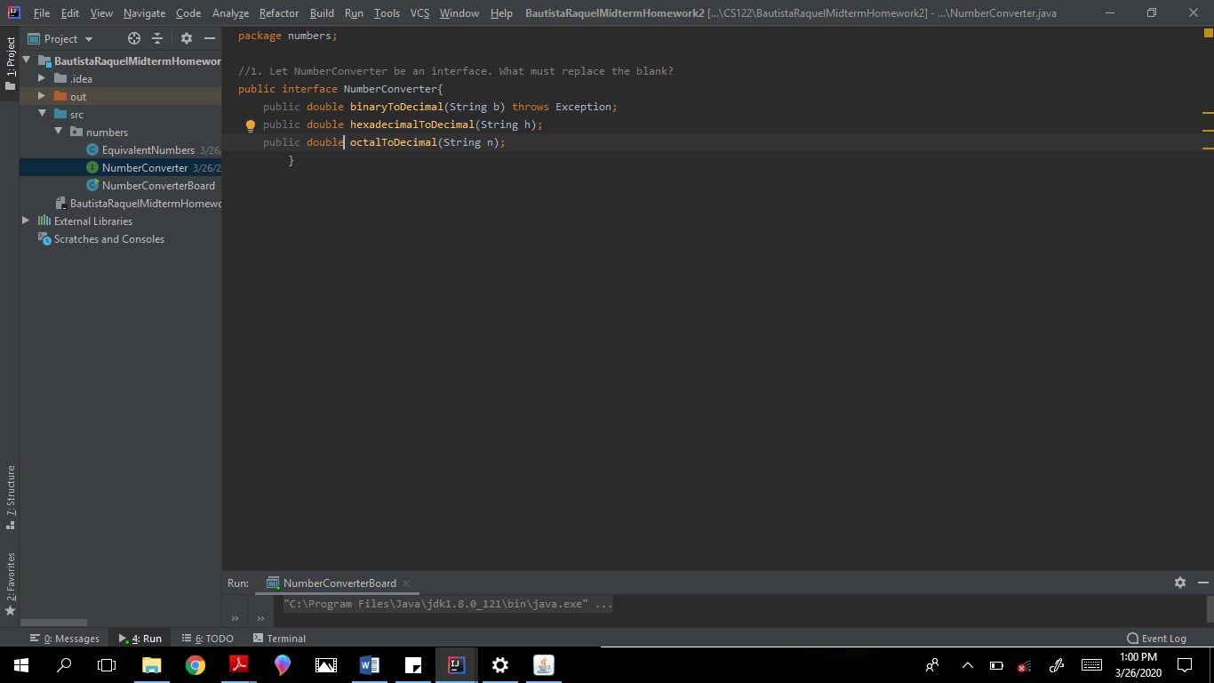

1. Replace the return type to double and modify binaryToDecimal(), octalToDecimal(), and hexadecimalToDecimal() to include the decimal parts. Use the method hasDecimalPoint(). If the binary, octal or hexadecimal number has a decimal point then get the decimal part by splitting the string with “.”. The decimal part will then be converted to its corresponding string value and added to the previously converted result.

An if statement was added to the method binaryToDecimal() method.

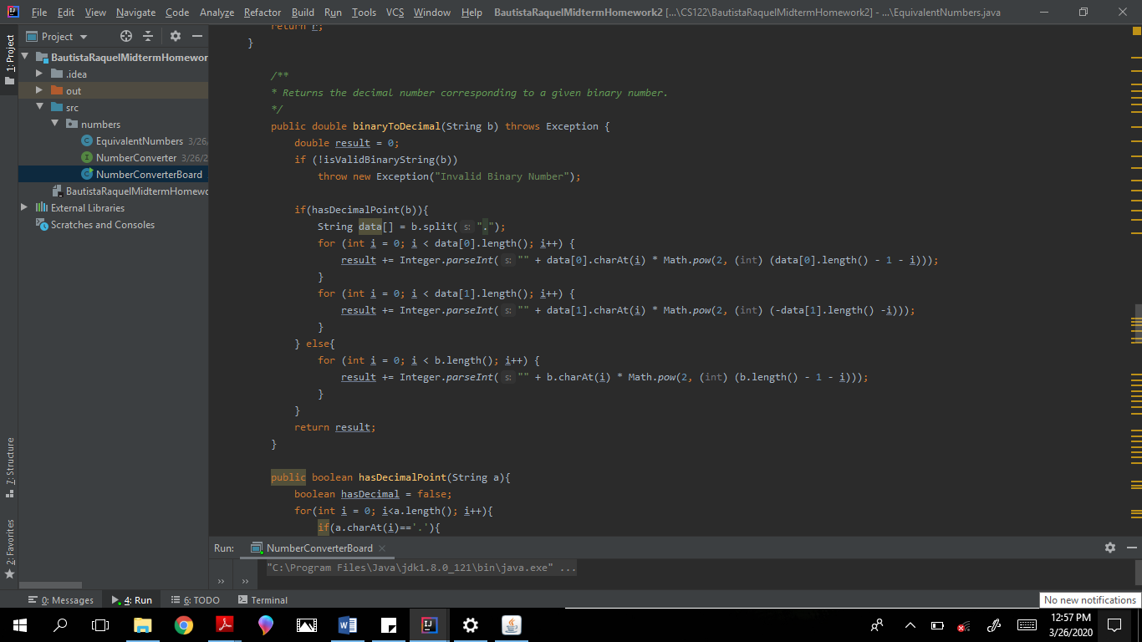

The following if statement was added to the method hexadecimalToDecimal().

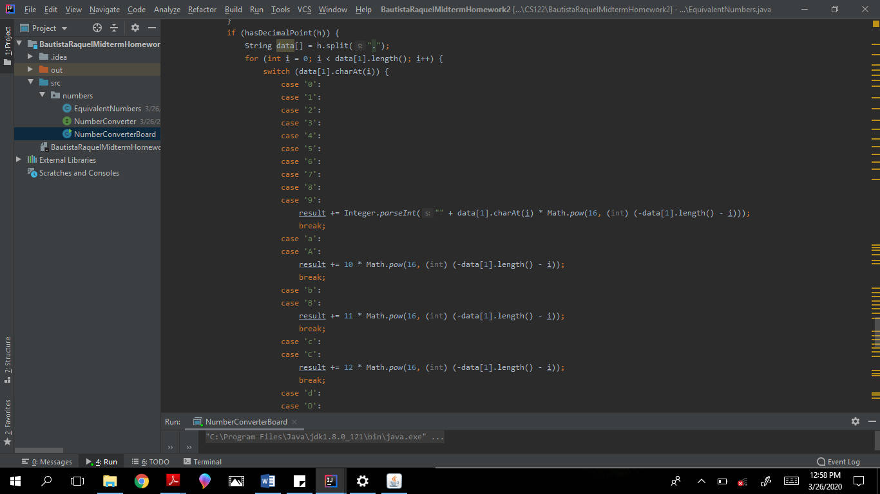

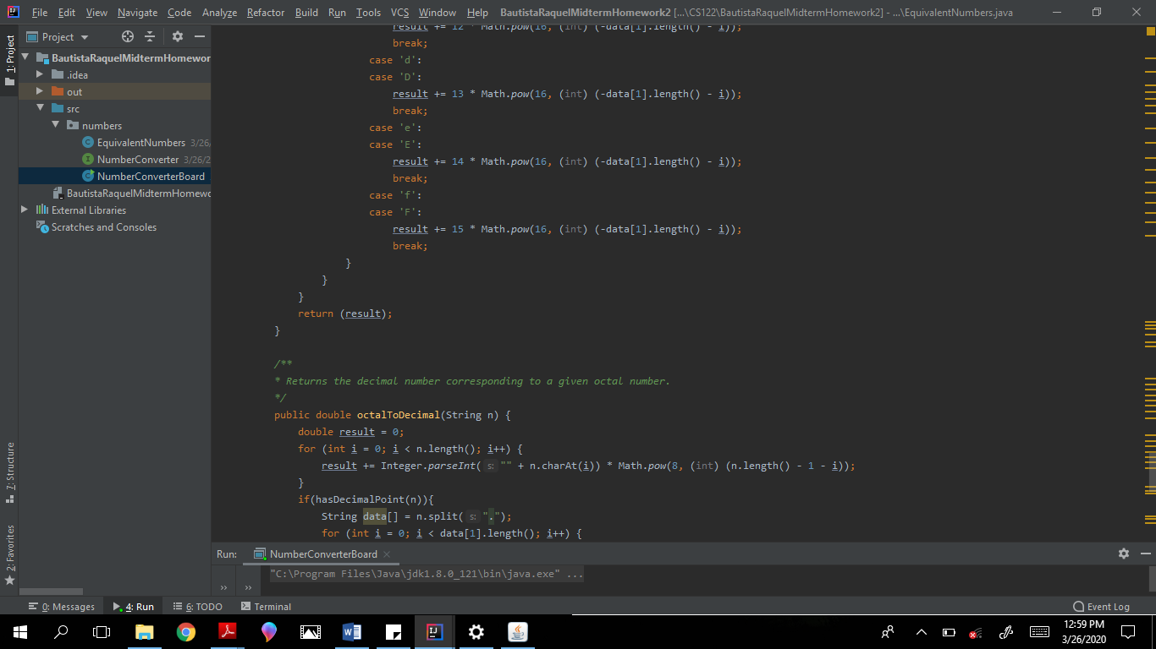

An if statement was added to the octalToDecimal() method.

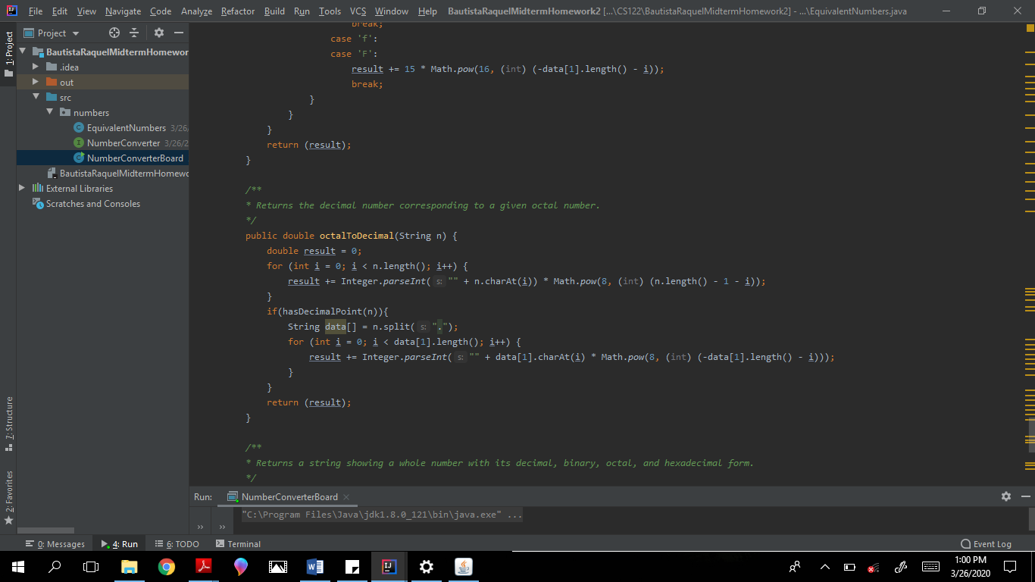

Here is a sample output run of the modified code that allows decimal with decimal point to be converted.

