Fremont Cottonwood demographics and regeneration along the Verde Wild and Scenic River

By: Quentin McCalla

Advised by: Dr. Abe Springer

Committee Members:

Dr. Peter Fule

Dr. David Merrit

Riparian forest along the Verde River. Photo by Quentin McCalla

# Introduction and Background

**Verde River Overview**

The Verde River is in central Arizona and its watershed drains over 4 million acres. Elevations range from over 12000ft ASL in the San Francisco Peaks to about 1300ft ASL at its confluence with the Salt River. The upper reaches of the watershed are largely ephemeral, consisting of the Chino Valley and Big Chino Wash. Perennial flow begins at a series of springs near Paulden, AZ. The river flows through an isolated area until it reaches Cottonwood, Arizona. The river flows then flows through the towns of Cottonwood and Camp Verde, Arizona before it reaches its Wild and Scenic (W&S) designation at Beasley River Access Point (RAP). During this reach the Verde River gains volume from a string of canyons with perennial tributaries. These include Sycamore, Wet Beaver, Oak, and West Clear creeks. These perennial tributaries get large portions of their base flow from springs exposed regional aquifers (Ecological Implications of Verde River Flows, 2008).

Figure 1. Map of the Verde River watershed and study sites

The Verde W&S River extends from Beasley RAP to Sheep Bridge Dispersed Camping area just above Horseshoe Reservoir. During this stretch, the river is isolated and generally inaccessible by road. The region is rugged and arid with Fossil Creek and the intermittent East Verde River contributing flow to the river. After the W&S portion of the river, the Verde enters Horseshoe Reservoir, the first of two large storage reservoirs on the river. Shortly after Horseshoe Reservoir the river flows into Bartlett Reservoir and then joins the Salt River just northeast of the Phoenix metropolitan area.

Although there are no large storage reservoirs above the Verde River Wild and Scenic Corridor, the Verde River is still impacted by human use. Base flow in the upper Verde Valley comes mainly from the Big Chino and Little Chino aquifers (Wirt, DeWitt, and Langenheim 2005). These aquifers are pumped by municipal, irrigation, and domestic wells near in the Little Chino Basin. Perennial flow in the Verde begins about 5 miles lower downstream than it did historically (Ecological Implications of Verde River Flows , 2008). Surface water diversions between Cottonwood and Beasley RAP reduce base flow during the summer when water levels are historically at their lowest. In total, irrigation ditches withdraw about 34,000 acre feet with about half of that being consumed (Alam 1997; Blasch et al. 2006). The Verde Valley also is an agricultural area with land being used for: pasture, pecans, grapes, corn, and vegetables. However, most farms are small both in size and revenue (USDA, 2012)

**Riparian Forest Overview**

Riparian forests in Arizona are disproportionately important to the landscape despite their relatively small geographic area. Riparian forests in Arizona cover only about 0.4% of the land surface area yet support more biodiversity and ecosystem functions than surrounding upland habitat (Ffolliott et al. 2004). In Arizona, 80 percent of all vertebrate species complete a part of their lifecycle in riparian areas (Hubbard, 1977). Riparian forest: support and enhance terrestrial and aquatic habitat, filter upland sediment and nutrients, store water and recharge aquifers and stabilize stream banks among many other functions (Schultz et al. 2009).

Fremont Cottonwood *(Populus fremontii*) and Gooding Willow (*Salix goodingii*) are major components of riparian forests along the Verde River. Tree diversity is low in Verde River riparian forests with Fremont Cottonwood and Gooding Willows being the dominant species. However, age class structure is usually very diverse. Stands of Fremont cottonwood and Gooding willow often occur in spatially separate, but same age cohorts with younger stands closer to the active channel and older stands extending up to 200 meters away (Stromberg, 1993).

The reproductive ecology of these trees influences how and when they regenerate. These trees are pioneer species, meaning they rely on disturbance and large amounts of seeds to establish. Both species produce large amounts (up to 25 million on mature trees) of seeds each spring. The seeds are small and have “tufts'' that are designed for long distance wind and water dispersal. Seeds are released in early spring as winter floods recede (Stromberg, 1993). This allows the seeds to be deposited on bare, moist mineral soil created by high flows. Regeneration of Fremont cottonwoods and Gooding willows are not consistent in Arizona. A study in Southern Arizona showed that regeneration occurred only about every decade and was dependent on strong winter floods to scour vegetation and deposit fine alluvial soils (Cooper et al. 1999; Stromberg, 1997).

Riparian forest regeneration is limited by several natural and anthropomorphic causes. Summer drought, along with summer and fall floods, are leading causes of seedling mortality. Seedling roots must grow fast enough to maintain access to soil water as the water table drops throughout spring and summer and returns to base--flow conditions (Stromberg, 1993). Livestock have been implicated in riparian forest damage and decline. Not only do livestock browse and trample young seedlings, but they also strip banks of other herbaceous plants. Livestock grazing makes the riverbanks become more susceptible to erosion and incision. Erosion lowers the water table and makes it less likely that seedlings can reach the groundwater before they desiccate. Humans altering natural flow regimes have been detrimental to riparian forest regeneration. Water diversions reduce stream flow beginning in spring and continuing through the summer. Stream diversions lower water levels in streams as cottonwood and willow seedlings are trying to reach the water table before they dry out. Further impacts are from dams that trap sediment and reduce the amount and variability of flow during winter floods. These floods are fundamental for carrying sediment and nutrients downstream as well as scouring out new habitat for seeds to germinate on (Stromberg, 1997).

**Relevance to policy**

The Verde River is one of two federally designated Wild and Scenic Rivers in Arizona. The other, Fossil Creek, is also within the Verde River watershed. The Wild and Scenic Rivers Act designated the Verde River for study in 1978 before being officially designated in 1984. To be designated, a river must possess “outstandingly remarkable scenic, recreational, geologic, fish and wildlife, historic, cultural or other similar values” (Wild and Scenic Rivers Act, 1968). Because of this designation, maintaining these values along the Verde are required. Riparian forests along the Verde contribute to all the values listed in the Wild and Scenic Rivers Act. Maintaining and regenerating Fremont cottonwoods along the Verde is crucial to maintain its remarkable values.

In addition to their relevance towards the Wild and Scenic Act, the Verde River’s riparian forests function as designated, critical habitat for the endangered Southwestern Willow Flycatcher (*Empidonax traillii extimus*) and Yellow billed cuckoo (*Coccyzus americanus).* Because these species are listed under the Endangered Species Act (ESA), their preservation is a high priority for both the Federal Government as well as environmental groups. Both species rely on riparian forests heavily for their life cycle (USFWS 2012). The Verde River is listed as critical habitat for both species by the U.S. Fish and Wildlife Service. Maintaining and understanding Fremont Cottonwood regeneration is necessary for the recovery and survival of species.

**Environmental Flows**

Environmental flows are defined as “the water regime provided withing a river, wetland or coastal zone to maintain ecosystems and there benefits where there are competing water uses and where flows are regulated” (Dyson, Bergkamp, and Scanlon 2003). The State of Arizona is currently evaluating water rights claims within the Gila River system, which the Verde River is a part of. The United States Forest Service has applied for a federal reserve water right for the mainstem Verde River as well as its tributaries is filing to cover a wide range of environmental flows. Determining the environmental flows that Fremont Cottonwoods needs will help maintain self-sustaining and healthy riparian forests

**Research Questions**

The purpose of this study is to try and identify environmental and flood flows needed to regenerate and sustain riparian forests. Specific research questions are to:

1. Investigate and quantify 2023 seedling regeneration and survivorship,
2. How are Verde River Fremont cottonwoods growing and what are their ages?
3. When have past regeneration events occurred and what flows caused them.

**Potential Hypothesis**

1. Seedling mortality is naturally high among Fremont cottonwoods. I hypothesize that seedlings will survive in distinct stands where conditions are favorable as opposed to uniformly across the sites.
2. Riparian forests are dependent on large flows to regenerate. Therefore, I hypothesize that minimum tree ages will show distinct cohorts that regenerated in response to large floods over the past century. Finally, even though cottonwoods are phreatophytes and get most of their water from groundwater, I hypothesize that there will be a correlation between ring width and Verde River discharge
3. I hypothesize that flows at or exceeding a 20- year flood will be required to cause regeneration.

# Methods

## Study Area

Access to the Verde River Wild and Scenic Corridor is restricted to a few road access points or from rafting along the river. Because of the limited access, sites were chosen that are logistically feasible and realistic to access on a continuing basis.

Beasley Flat River Access Point (RAP) located downstream of Camp Verde was chosen for our first site. Both seedling mortality as well as tree cores were taken here. Beasley RAP is the official beginning of the Verde Wild and Scenic River

The second site chosen was Childs dispersed camping area, upstream of the confluence of the Verde River with Fossil Creek. Both seedling mortality and tree cores were measured at this site. Childs is in the middle of the Verde Wild and Scenic River just upstream of the Fossil Creek confluence.

A third site at Sheep Bridge River Access Point was used to collect tree cores but was not used for seedling monitoring as it is too remote to access regularly. Sheep Bridge is located just below the Wild and Scenic portion of the Verde but still above the two large storage reservoirs.

All three sites have healthy Fremont Cottonwood-Gooding Willow riparian, gallery forests. In addition, these sites are already the focus of other Forest Service studies. This allows me to incorporate other work, such as river reach models, groundwater wells and water level transducers into my thesis.

## Seedling survivorship

**Field Methods**

The spring floods of 2023 were some of the largest in the past 20 years. The 2023 floods created conditions to recruit and sustain seedlings into the fall for the first time in over 10 years (Merrit and Cooper, personal communication). The establishment event is relevant as Fremont Cottonwood regeneration is sporadic (Stromberg, 1997). Mapping and monitoring seedling survival is important to determine if these seedlings can grow into saplings and establish a new age class.

River reaches at Beasley and Childs were walked and searched for seedlings. If regeneration was found and able to be surveyed, a metal pin was pounded into the ground. An Arrow100 GNSS was used to record the coordinates of the seedlings to less than .60 meters. We determined a radius to encompass all or most of the seedlings. We measured all seedling heights were measured with a ruler or measuring tape to the centimeter and the diameters near the ground were measured with calipers to the nearest millimeter within the determined radius. These data were recorded along with a site ID and brief description of the environmental setting.

If a regeneration area was too large or there were too many seedlings to feasibly measure, the area was sampled using a representative. First the area containing the cottonwood seedling was mapped using the GNSS. After the polygon was created and the area determined to the nearest square meter, a one square meter hoop was used to create sample areas. This hoop was placed in representative areas within the plot. The seedlings within the hoop were then measured and recorded. The goal was to sample 15-30% of the total area containing seedlings. Ten regeneration plots were measured at both Beasley RAP and Childs. Plots were surveyed once in November of 2023 and once again in June of 2024.

Previous Forest Service research had installed shallow groundwater wells into the floodplain. Following 2023 winter floods we attempted to relocate and activate any remaining ones. 2 existing wells were reactivated at Beasley and 1 was reactivated at Childs. One new groundwater well was installed at Beasley near established regeneration plots. To reactivate groundwater well, we filled them with water and stirred using an 8 ft copper grounding rod to agitate the sediment in the casing. A stainless-steel well bailer was then used to remove the water and suspended sediment. This was repeated until the sediment was all removed and the water in the well was clear. HOBO 13-foot Water Level Recorders (resolution of .002 PSI or .005 ft of water) were placed near the bottom to record groundwater level fluctuations at 15-minute intervals.

**Error**

* Extrapolating sampled plots to whole regeneration area (sub-sampling literature)

## Cores

**Field Methods**

To determine the age and growth of Fremont cottonwood and Gooding willow trees, tree cores were collected October 16th-20th of 2023 at all three study sites. Fremont cottonwood and Gooding willow in good health were cored. A variety of size classes across the floodplain were selected for coring.

Cores were collected with a Haglof 16 inch, 2 thread, 5.15mm increment borer attached to Stihl 044 saw motor (Figure 2). The borer was aimed as low on the tree trunk as possible, at an angle perpendicular to the tree’s lean and aimed to be as close to the pith as possible.

Figure 2. Increment borer attached to saw motor. Photo courtesy of Dr. David Merritt.

The borer was then drilled into the tree far enough to ensure that the pith had been passed. This ensured that an age could be estimated. For trees with a radius larger than 16 inches, the borer was inserted all the way to record as many years as possible. After the borer was in the tree, the spoon was inserted into the borer and the core was extracted. While this was being done, another crew member measured the diameter of tree at the elevation the core was taken from. They also recorded a GPS point and make any notes. The core was placed into a paper straw with the tree ID, diameter and species written on it.

**Laboratory Methods**

After I collected the cores, I had to prepare them so that I could date and measure their rings. The cores were air dried for weeks until they were dry enough to be mounted. After drying, cores were glued to grooved wooden mounts and taped so that they would stay in place while the glue dried. The cores were sanded with an electric sander, starting with 120 grit, followed with 240 grit and 400 grit sandpaper. Cores were polished with 1200 grit sandpaper as needed at the dissecting microscope.

The cores were placed under a dissecting microscope and rings were counted and marked. For cores without a pith, a concentric circle ruler was used to estimate position and determine the number of the few missing rings. The Pith Estimator tool in CooRecorder was also used to estimate the distance and age to the pith. Ages of the innermost ring as well as the estimated pith date were recorded. For cores where a pith date could not be estimated, a minimum age was recorded. Some cores were unable to be dated due to fractures, missing segments, rotten wood, or other problems.

To measure the ring widths of each core, the cores had to be scanned and uploaded. Dated cores were placed on an electronic scanner. The cores were scanned to produce an image of 1200 dpi resolution. The scanned images were uploaded into Cybis CooRecorder software. Each ring was marked in the software so that the date could be verified, and ring widths measured. These cores will be uploaded into Cybis Cdendro software for ring width measurement.

**Analysis Methods**

Collections were created so that cores could be analyzed. Dated and scanned cores are saved as a .RWL file and uploaded into Cdendro. Files were separated into 4 different sites: Upper Beasley, Lower Beasley, Childs and Sheep. A mean value collection was created from all the cores in the site. All the cores from that site were then correlated to the mean value collection. Cores that had a correlation value of at or over .3 were then used to create a new collection for analysis

To analyze the collections that were created I imported the collections into R. The dplR package created by Dr. Andy Bunn was used. Collections were first detrended and then mean Ring Width Indices (RWI) were created for each collection.

To cross date cores to create a chronology, both COFECHA and a similar program in the dplR package was attempted. I will use my committee and resources to continue to complete this part of the analysis. Completing this would address dating errors such as missing rings or incorrectly identified rings.

Flows

To attempt to correlate interannual growth and Verde River discharge, mean flows were gathered from the Verde River near Camp Verde (09506000) USGS gauge from 1988-2023. I used data exported from the USGS National Water Information System. I chose this location as it is located near the Wild and Scenic portion of the river and had the longest continuous discharge record. Mean monthly values were used as well as only years with complete records. I created values for:

* Minimum (lowest mean monthly flow of the year)
* Maximum (Month with the highest mean flow)
* Yearly Mean average (Average of all the mean monthly flows)
* Winter (Average flow from November through March)
* Summer (Average flow from June-August)
* Growing Season (Average flow from April through October)

## Arieal imagery

**Laboratory Methods**

Aerial imagery was used locate specific timeframes when scour and regeneration occurred. National Agriculture Imager Program (NAIP) imagery was gathered from the USGS Earth Explorer database. Images containing the whole study site was chosen and was gathered and uploaded into ArcGIS Pro. Forest Service specific missions were collected from the Forest Service Southwest GIS specialist to fill in longer time periods between NAIP missions.

**Analysis Methods**

Images can be visually inspected for changes between photos. Bank geomorphology as well as vegetation changes can be seen between photos. I will then go to the gauge record and attempt to identify a maximum flow that occurred in that reach between the two photos. However, quantifying changes in variables such as: surface water extent, bare soil and vegetation could be useful to see how riparian areas have changed over time. I plan on using ArcGIS Pro to calculate and identify changes over time.

# Current Results

## Seedling mortality

Table 1. Plot densities as well as mean and standard deviations for the two sites.

Seedling densities decreased or stayed the same in 14 of the 20 surveyed plots while 6 plots saw an increase in seedling density between our November 2023 and June 2024 surveys.

Table 2.

Both sites saw in increase in mean seedling height and diameter between the two site visits. However, seedlings at Childs had their diameters increase at over twice the rate as seedlings at Beasley.

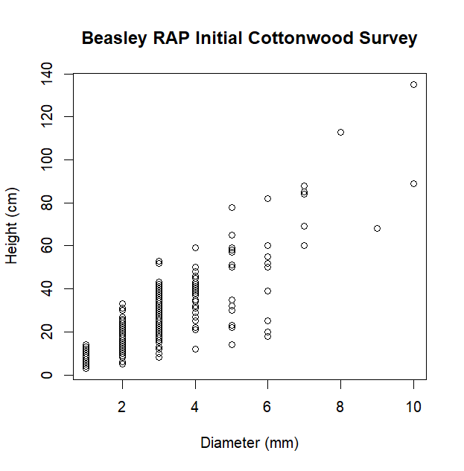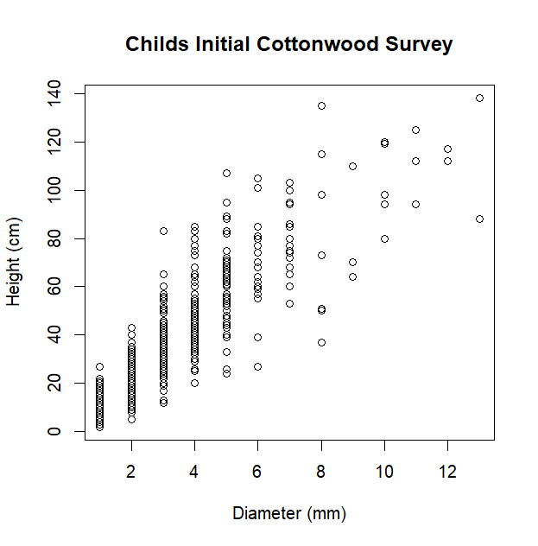

Figure 3. Scatterplots of seedlings measured.

Height and diameter were found to have a strong correlation at both sites. Beasley and Childs had a rsquared value of 0.736 and 0.795, respectively. In addition, two groundwater wells were activated at Beasley RAP and another well at Childs. The Beasley wells were activated when 5 of the 10 plots were inundated by winter flows. Hopefully, the rate groundwater recession will be able to be measured. Currently only one groundwater well at Childs is active.

## Dendrochronology

So far, I have dated 135 tree cores. Of these, 121 have a dateable pith. The other 14 were only able to produce a minimum age. Missing piths or rotten sections made it impossible to get a pith date on these cores. Currently, the average pith date is 2000.

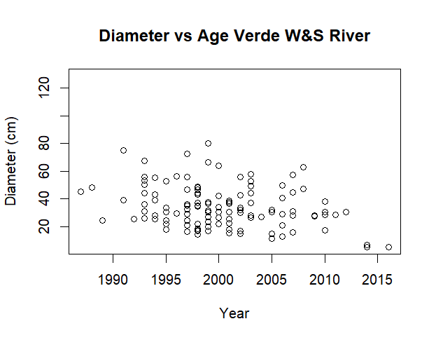

Figure 4. Age versus diameter of trees cores

There seems to be no apparent correlation (r of 0.07) between the size of the tree sampled and its age as shown in Figure 4.

**Growth**

Basal area index and Ring Width Index were calculated for each site as well as an average for all sites.

Figure ??. Ring Width Indices for all 4 sites as well as the average

Figure ??. Basal Area Indices for all 4 sites as well as the average.

Minimum ages

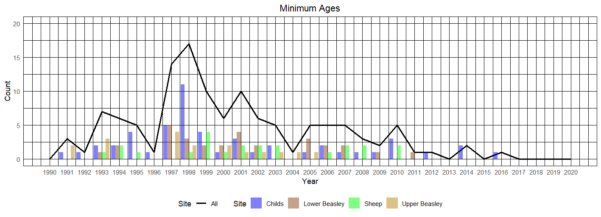

Figure ?? Shows the minimum ages collected

The average minimum age for cores collected and dated is 2000.4 or about 23 years old. Minimum ages peak in 1998 before declining until 2004. Regeneration stays constant until about 2010 before decreasing to about zero.

## Aerial imagery

# Discussion

## Seedling survivorship

* Seedling size as a proxy for seedling health (papers?)
* Densities decreased in most and increased in some
* Multiple year recruitment

Most sites

* 1. Dendrochronology
* Min age does not equal actual age, but rapid growth means that it is probably close
* No regen in the past 10 years
* BAI increasing which means growth is increasing
* RWI decreasing means ring widths are decreasing

**Timeline**

Before end of Fall 2024 semester

* Survey seedling plots again before they drop their leaves
* Have data analysis completed

Things to do

* COFECHA/ build the chronology
* R organization
* Other metrics of seedling health?
* Mount and date cores from float trip
* Groundwater well and cross sections??

Journals

ESA ones

* <https://esajournals.onlinelibrary.wiley.com/>
* Impact scores 1.1-1.4

River Research and Applications

* <https://onlinelibrary.wiley.com/journal/15351467?journalRedirectCheck=true>
* .48

Tree Ring Research

* <https://www.treeringsociety.org/journal.html>

# Works Cited

Alam, J. 1997. “Irrigation in the Verde Valley.” *A report of the irrigation diversion improvement project. Verde Natural Resource Conservation District*.

Blasch, Kyle W, John P Hoffmann, Leslie F Graser, Jeannie R Bryson, and Alan L Flint. 2006. *Hydrogeology of the Upper and Middle Verde River Watersheds, Central Arizona*. U. S. Geological Survey.

Cooper, David J, David M Merritt, Douglas C Andersen, and Rodney A Chimner. 1999. “Factors Controlling the Establishment of Fremont Cottonwood Seedlings on the Upper Green River, USA.” *Regulated Rivers: Research & Management: An International Journal Devoted to River Research and Management* 15(5): 419–40.

Dyson, Megan, Ger Bergkamp, and John Scanlon. 2003. “Flow: The Essentials of Environmental Flows.” *IUCN, Gland, Switzerland and Cambridge, UK*: 20–87.

*Ecological Implications of Verde River Flows*. 2008. Arizona Water Institute, The Nature Conservancy, and Verde River Basin Partnership.

Ffolliott, Peter F, Leonard F DeBano, Malchus B Baker Jr, Daniel G Neary, and Kenneth N Brooks. 2004. “Hydrology and Impacts of Disturbances on Hydrologic Function.” *Riparian Areas of the Southwestern United States: Hydrology, Ecology, and Management; Baker, MB, Ffolliott, PF, DeBano, LF, Neary, DG, Eds*: 51.

Schultz, RC, TM Isenhart, JP Colletti, WW Simpkins, RP Udawatta, and PL Schultz. 2009. “Riparian and Upland Buffer Practices.” *North American agroforestry: An integrated science and practice*: 163–218.

Stromberg, Julie C. 1993. “Fremont Cottonwood-Goodding Willow Riparian Forests: A Review of Their Ecology, Threats, and Recovery Potential.” *Journal of the Arizona-Nevada Academy of Science*: 97–110.

Stromberg, Juliet C. 1997. “Growth and Survivorship of Fremont Cottonwood, Goodding Willow, and Salt Cedar Seedlings after Large Floods in Central Arizona.” *The Great Basin Naturalist*: 198–208.

USDA. 2012. *Yavapai County Profile*. https://agcensus.library.cornell.edu/wp-content/uploads/2012-Arizona-cp04025.pdf.

USFWS. 2012. *Designation of Critical Habitat for Southwestern Willow Flycatcher*.

Wirt, Laurie, Ed DeWitt, and Victoria E Langenheim. 2005. *Geologic Framework of Aquifer Units and Ground-Water Flowpaths, Verde River Headwaters, North-Central Arizona*. US Geological Survey.