Fremont Cottonwood demographics and regeneration along the Verde Wild and Scenic River

A thesis

Submitted in Partial Fulfillment

Of the Requirements for the Degree of Masters in Environmental Science and Policy

By: Quentin McCalla

Advised by: Dr. Abe Springer

Committee Members:

Dr. Peter Fule

Dr. David Merrit

# Abstract

The Verde Wild and Scenic River watershed drains central Arizona and is the state’s longest remaining perennial river. Fremont cottonwoods (*Populus fremontii)* are a dominant riparian tree species in the Southwester and are important habitat for native wildlife, crucial elements of river hydrology and are a designated Outstanding Natural Value by the 1964 Wild Scenic River Act. Fremont cottonwoods along the Verde River are unstudied and their condition and demographics are not yet understood. This study uses seedling plots established after 2023 winter floods and dendrochronology to monitor regeneration and quantify tree age and growth. Fremont cottonwoods along the Verde River are young, with the mean age being 24 years old. They continue to add biomass at an above average rate and their growth is significantly impact by summer temperatures and river flows. Seedlings from the 2023 cohort continue to grow rapidly and are significantly impacted by a diverse set of environmental conditions.

# Acknowledgements

Abstract 1

Introduction and Background 3

Methods 5

Study Area 5

Seedling survivorship and demographics 7

Cores 9

Arieal imagery 11

Current Results 12

Seedling survivorship and demographics 12

Dendrochronology 14

Aerial imagery 16

Discussion 17

Seedling survivorship and demographics 17

Dendrochronology 17

Aerial Imagery 18

Conclusions and Implications 19

Limitations 19

Appendix 20

Works Cited 24

Figure 1 6

# Chapter 1

## Intro

## Introduction and Background

**Verde River Overview**

The Verde River is in central Arizona and its watershed drains over 4 million acres. Elevations range from over 3650 m ASL in the San Francisco Peaks to about 1300ft ASL at its confluence with the Salt River. The upper reaches of the watershed are largely ephemeral, consisting of the Chino Valley and Big Chino Wash. Perennial flow begins at a series of springs near Paulden, AZ. The river flows through an isolated area until it reaches Cottonwood, Arizona. The river flows then flows through the towns of Cottonwood and Camp Verde, Arizona before it reaches its Wild and Scenic (W&S) designation at Beasley River Access Point (RAP). During this reach the Verde River gains volume from a string of canyons with perennial tributaries. These include Sycamore, Wet Beaver, Oak, and West Clear creeks. These perennial tributaries get large portions of their base flow from springs discharging from the regional aquifers (Ecological Implications of Verde River Flows, 2008).

Figure 1. Map of the Verde River watershed and study sites

The Verde W&S River extends from Beasley RAP to Sheep Bridge Dispersed Camping area just below the Wild and Scenic Designation (Figure 1). The river is isolated and generally inaccessible by road along this reach. The region is rugged and arid with Fossil Creek and the intermittent East Verde River contributing flow to the river. After the W&S portion of the river, the Verde enters Horseshoe Reservoir, the first of two large storage reservoirs on the river. Shortly after Horseshoe Reservoir the river flows into Bartlett Reservoir and then joins the Salt River just northeast of the Phoenix metropolitan area.

Although there are no large storage reservoirs above the Verde River Wild and Scenic Corridor, the Verde River is still impacted by human use. Base flow in the upper Verde Valley comes mainly from the Big Chino and Little Chino aquifers (Wirt, DeWitt, and Langenheim 2005). These aquifers are pumped by municipal, irrigation, and domestic wells near in the Little Chino Basin. Perennial flow in the Verde begins about 5 miles lower downstream than it did historically (Ecological Implications of Verde River Flows , 2008). Surface water diversions between Clarkdale and Beasley RAP reduce base flow during the summer when water levels are historically at their lowest. In total, irrigation ditches withdraw about 34,000 acre feet with about half of that being consumed (Alam 1997; Blasch et al. 2006). The Verde Valley also is an agricultural area with land being used for: pasture, pecans, grapes, corn, and vegetables. However, most farms are small both in size and revenue (USDA, 2012)

**Riparian Forest Overview**

Riparian forests in Arizona are disproportionately important to the landscape despite their relatively small geographic area. Riparian forests in Arizona cover only about 0.4% of the land surface area yet support more biodiversity and ecosystem functions than surrounding upland habitat (Ffolliott et al. 2004). In Arizona, 80 percent of all vertebrate species complete a part of their lifecycle in riparian areas (Hubbard, 1977). Riparian forests support and enhance terrestrial and aquatic habitat, filter upland sediment and nutrients, store water and recharge aquifers and stabilize stream banks among many other functions (Schultz et al. 2009).

Fremont Cottonwood *(Populus fremontii*) and Gooding Willow (*Salix goodingii*) are major components of riparian forests along the Verde River. Other important woody riparian plants include: Arizona sycamore (*Platanus wrightii)*, Arizona Ash (*Fraxinus veluntinia)*, seep willow (*Baccharis salicifolia*)*,* coyote willow *(Salix exigua)* and sedges (*Carex).* Tree diversity is low in Verde River riparian forests with Fremont Cottonwood and Gooding Willows being the dominant species. However, age class structure is usually very diverse. Stands of Fremont cottonwood and Gooding willow often occur in spatially separate, but same age cohorts with younger stands closer to the active channel and older stands extending up to 200 meters away (Stromberg, 1993).

The reproductive ecology of cottonwood and willow influences how and when they regenerate. These trees are pioneer species, meaning they rely on disturbance and large amounts of seeds to establish. Both species produce large amounts (up to 25 million on mature trees) of seeds each spring. The seeds are small and have “tufts'' that are designed for long distance wind and water dispersal. Seeds are released in early spring as winter floods recede (Stromberg, 1993). This allows the seeds to be deposited on bare, moist mineral soil created by high flows. Regeneration of Fremont cottonwood and Gooding willow are not consistent in Arizona. A study in Southern Arizona showed that regeneration occurred only about every decade and was dependent on strong winter floods to scour vegetation and deposit fine alluvial soils (Cooper et al. 1999; Stromberg, 1997).

Riparian forest regeneration is limited by several natural and anthropomorphic causes. Summer drought, along with summer and fall floods, are leading causes of seedling mortality. Seedling roots must grow fast enough to maintain access to soil water as the water table drops throughout spring and summer and returns to base--flow conditions (Stromberg, 1993). Livestock have been implicated in riparian forest damage and decline. Not only do livestock browse and trample young seedlings, but they also strip banks of other herbaceous plants. Livestock grazing makes the riverbanks become more susceptible to erosion and incision. Erosion lowers the water table and makes it less likely that seedlings can reach the groundwater before they desiccate. Humans altering natural flow regimes have been detrimental to riparian forest regeneration. Water diversions reduce stream flow beginning in spring and continuing through the summer. Stream diversions lower water levels in streams as cottonwood and willow seedlings are trying to reach the water table before they dry out. Further impacts are from dams that trap sediment and reduce the amount and variability of flow during winter floods. These floods are fundamental for carrying sediment and nutrients downstream as well as scouring out new habitat for seeds to germinate on (Stromberg, 1997).

**Relevance to policy**

The Verde River is one of two federally designated Wild and Scenic Rivers in Arizona. The other, Fossil Creek, is also within the Verde River watershed. The Wild and Scenic Rivers Act designated the Verde River for study in 1978 before being officially designated in 1984. To be designated, a river must possess “outstandingly remarkable scenic, recreational, geologic, fish and wildlife, historic, cultural or other similar values” (Wild and Scenic Rivers Act, 1968). Because of this designation, maintaining these values along the Verde are required. Riparian forests along the Verde contribute to all the values listed in the Wild and Scenic Rivers Act. Maintaining and regenerating Fremont cottonwoods along the Verde is crucial to maintain its remarkable values.

In addition to their relevance towards the Wild and Scenic Act, the Verde River’s riparian forests function as designated, critical habitat for the endangered Southwestern Willow Flycatcher (*Empidonax traillii extimus*) and Yellow billed cuckoo (*Coccyzus americanus).* Because these species are listed under the Endangered Species Act (ESA), their preservation is a high priority for both the Federal Government as well as environmental groups. Both species rely on riparian forests heavily for their life cycle (USFWS 2012). The Verde River is listed as critical habitat for both species by the U.S. Fish and Wildlife Service. Maintaining and understanding Fremont Cottonwood regeneration is necessary for the recovery and survival of species.

**Environmental Flows**

Environmental flows are defined as “the water regime provided within a river, wetland or coastal zone to maintain ecosystems and their benefits where there are competing water uses and where flows are regulated” (Dyson, Bergkamp, and Scanlon 2003). The State of Arizona is currently evaluating water rights claims within the Gila River system, which the Verde River is a part of. The United States Forest Service has applied for a federal reserve water right for the mainstem Verde River as well as its tributaries is filing to cover a wide range of environmental flows. Determining the environmental flows and variables impacting Fremont cottonwood growth will help maintain self-sustaining and healthy riparian forests.

**Research Questions**

The purpose of this study is to identify environmental and flood flows needed to regenerate and sustain riparian forests. Specific research questions are to:

1. Investigate and quantify 2023 flood flow seedling regeneration and survivorship,
2. How are Verde River Fremont cottonwood growing and what are their ages, and
3. When have past regeneration events occurred and what flows caused them?

**Potential Hypothesis**

1. Seedling mortality is naturally high among Fremont cottonwoods seedlings. I hypothesize that seedlings will survive in distinct stands where conditions are favorable as opposed to uniformly across the sites.
2. Riparian forests are dependent on large flows to regenerate. Therefore, I hypothesize that minimum tree ages will show distinct cohorts that regenerated in response to large floods over the past century. Finally, even though cottonwoods are phreatophytes and get most of their water from groundwater, I hypothesize that there will be a correlation between ring width and Verde River discharge.
3. I hypothesize that flows at or exceeding a 20- year flood will be required to cause regeneration.

## Methods

## Study Area

Access to the Verde River Wild and Scenic Corridor is restricted to a few road access points or from rafting along the river. Because of the limited access, sites were chosen that are logistically feasible and realistic to access on a frequent and continuing basis.

Beasley Flat River Access Point (RAP) located downstream of Camp Verde was chosen as one site. Seedling mortality was measured, and tree cores were taken here. Beasley RAP is the official beginning of the Verde Wild and Scenic River.

Figure 2. A site map for Beasley River Access points as well as plot and well sites.

The second site chosen was Childs dispersed camping area, upstream of the confluence of the Verde River with Fossil Creek. Seedling mortality and tree cores were measured at this site. Childs is in the middle of the Verde Wild and Scenic River just upstream of the Fossil Creek confluence.

Figure 3. Site map for Childs. Seedling plots are shown.

A third site at Sheep Bridge River Access Point was used to collect tree cores but was not used for seedling mortality monitoring because it is too remote to access regularly. Sheep Bridge is located just below the Wild and Scenic portion of the Verde but still above the two large storage reservoirs.

Figure 4. An aerial image of Sheeps Bridge. No plots were established here but cores were taken from the site.

All three sites have healthy Fremont Cottonwood-Gooding Willow riparian, gallery forests and are the focus of other Forest Service environmental flow studies. This allows me to incorporate other work, such as river reach models, groundwater wells and water level transducers into my thesis.

# Chapter 2 (Manuscript)

## Seedling survivorship and demographics

**Field Methods**

The spring floods of 2023 were some of the largest in the past 20 years. The 2023 floods created conditions to recruit and sustain seedlings into the fall for the first time in over 10 years (Merrit and Cooper, personal communication). The establishment event is relevant as Fremont Cottonwood regeneration is sporadic (Stromberg, 1997). Mapping and monitoring seedling survival is important to determine if these seedlings can grow into saplings and establish a new age class.

Initial reconnaissance of river reaches at Beasley and Childs were walked and searched for seedlings. If regeneration was found and able to be surveyed, a metal pin was pounded into the ground. An Arrow100 GNSS (Quebec, Canada) was used to record the coordinates of the seedlings to less than 0.60 meters. We determined a radius to encompass all or most of the seedlings. We measured seedling heights with a ruler or measuring tape to the nearest centimeter and the diameters near the ground were measured with calipers to the nearest millimeter within the determined radius. These data were recorded along with a site ID and brief description of the environmental setting.

If a regeneration area was too large or there were too many seedlings to feasibly measure, the area was subsampled. First the area containing the cottonwood seedling was mapped using the GNSS. After the polygon was created and the area determined to the nearest square meter, a one square meter hoop was used to create subsample areas. This hoop was placed in representative areas within the plot. The seedlings within the hoop were then measured and recorded. The goal was to sample 15-30% of the total area containing seedlings. Ten regeneration plots were measured at both Beasley RAP and Childs. Plots were surveyed once in November of 2023 and once again in June of 2024. And once again in October/December 2024.

Previous Forest Service research had installed shallow groundwater wells into the floodplain. Following 2023 winter floods we attempted to relocate and activate these wells. Only two existing wells were reactivated at Beasley, and one was reactivated at Childs. One new groundwater well was installed at Beasley near an established regeneration plot. To reactivate the old groundwater wells, we filled them with water and stirred using an 8 ft copper grounding rod to agitate the sediment in the casing. A stainless-steel well bailer was then used to remove the water and suspended sediment. This was repeated until the sediment was all removed and the water in the well was clear. HOBO 13-foot Water Level Recorders (resolution of 0.002 PSI or 0.005 ft of water) were placed near the bottom to record groundwater level fluctuations at 15-minute intervals.

Other variables

HDR

The height-diameter ratio (HDR) was calculated for each seedling. This was done so that each seedling had a single value describing its size. A higher HDR indicates a taller and slimmer seedling.

Equation 1.

Density

To calculate densities, the number of seedlings in a plot were divided by the area of the plot. In plots where a sampling method was used, an equation was used to extrapolate the density of the sampled area to the density of the entire plot.

Equation 2.

Soil

Soil samples were taken inside the seedling plots using a trowel. Soil samples are from the first few inches of the soil horizon where the cottonwoods originally germinated. The soil samples will then be sieved to get the soil texture in which seedlings germinated.

Light

Light intensity was taken with a Li-COR LI-1500 Light Sensor Logger (Lincoln, NE). The pyranometer sensor was placed in the or near the plot and allowed to acclimate. Then, a reading was taken every minute for 5 minutes. These readings were then averaged to get an average W m-2 value at each plot.

Survey data

Surveyed variables were also measured. Sites at BRAP were surveyed with a Trimble R10 GNSS base and rover (Westminster, CO) with a accuracy of 8mm horizontally and 15 mm vertically. Variables collected were distance to river and distance above river stage. Cross sections and other features were also surveyed. Childs elevation to elevation stage was measured with an Arrow100 GNSS (Quebec, Canada) with precision up to less than 0.60 meters

Herbaceous competition

Herbaceous competition was estimated using the Braun-Blanquet 6 step scale (Braun-Blanquet 1964). Plants within the plots and rooted at the same elevation as the cottonwood seedlings were considered.

**Analysis Methods**

Data collected from the field were transferred to a digital format. A combination of Excel and R were used to calculate summary statistics. Height and diameter values were converted into a single Height-Diameter ratio (HDR). This was done so that each seedling had a single value describing its size. Changes in density and seedling size were determined by subtracting the June 2024 values from the November 2023 values

To measure between significant changes between visit (Fall 2023, Spring 2024 and Fall 2024) and growth (mean height, diameter and HDR) an Analysis of Variance (ANOVA) was used to test for significant changes and then Tukey’s HSD test was used to test for significant changes between variables. A critical P-value of less than or equal to .05 was used to test for significance.

To see if variables were significantly impacting seedling survival, a Spearman correlation test was used. Measured variable values were correlated to the change in seedling density. A critical P-value of less than or equal to .05 was used to test for significance.

## Cores

**Field Methods**

To determine the age and growth of Fremont cottonwood and Gooding willow trees, tree cores were collected October 16th-20th of 2023 at all three study sites. Fremont cottonwood and Gooding willow in good health were cored. A variety of size classes across the floodplain were selected for coring.

Cores were collected with a Haglof 406 mm, 2 thread, 5.15 mm increment borer attached to Stihl 044 saw motor (Figure 5). The borer was aimed as low on the tree trunk as possible, at an angle perpendicular to the tree’s lean and aimed to be as close to the pith as possible.

Figure 5 Increment borer attached to saw motor. Photo courtesy of Dr. David Merritt.

Figure 5.

The borer was then drilled into the tree far enough to ensure that the pith had been passed. This ensured that an age could be estimated. For trees with a radius larger than 40 cm, the borer was inserted all the way to record as many years as possible. After the borer was in the tree, the spoon was inserted into the borer and the core was extracted. While this was being done, another crew member measured the diameter of tree at the elevation the core was taken, a GPS point was recorded, and notes were taken. The core was placed into a paper straw with the tree ID, diameter and species written on it.

**Laboratory Methods**

To prepare the cores for ring measurement, they were air dried for weeks until they were dry enough to be mounted. After drying, cores were glued to grooved wooden mounts and taped so that they would stay in place while the glue dried. The cores were sanded with an electric sander, starting with 120 grit, followed with 240 grit and 400 grit sandpaper. Cores were polished with 1200 grit sandpaper as needed at the dissecting microscope.

The cores were placed under a dissecting microscope and rings were counted and marked. For cores without a pith, a concentric circle ruler was used to estimate position and determine the number of the few missing rings. The Pith Estimator tool in CooRecorder was also used to estimate the distance and age to the pith. Ages of the innermost ring as well as the estimated pith date were recorded. For cores where a pith date could not be estimated, a minimum age was recorded. Some cores were unable to be dated due to fractures, missing segments, rotten wood, or other problems.

To measure the ring widths of each core, the cores had to be scanned and uploaded. Dated cores were placed on an electronic scanner. The cores were scanned to produce an image of 1200 dpi resolution. The scanned images were uploaded into Cybis CooRecorder software. Each ring was marked in the software so that the date could be verified, and ring widths measured. These cores were uploaded into Cybis Cdendro software for ring width measurement.

**Analysis Methods**

**Crossdating**

Collections were created so that cores could be analyzed. Dated and scanned cores are saved as a .RWL file and uploaded into Cdendro. Files were separated into 4 different sites: Upper Beasley, Lower Beasley, Childs and Sheep. All the cores (n=148) were run through COFECHA as a dated series with no undated series. Because of the short nature of the cores, the segment length was set to 30 years and the lag length was set to 15 years. With all the cores run through COFECHA, cores with a correlation coefficient of +0.3 were pulled out to use. This series (n=39) was run through COFECHA again and produced an interseries correlation of +0.395.

Limitations/Assumptions

The series and cores collected are short in nature. This makes it difficult to produce high correlations for crossdating. I used COFECHA to select cores that were correlated to each other and the overall collection of tree cores to use for further analysis. Because Fremont cottonwoods and Gooding willows grow in riparian areas with access to year around water, it is unlikely that rings are missing which means that the trees are likely dated correctly even though it may be difficult to statistically prove that.

Growth

To analyze the collections that were created I imported the collections into R. The dplR package created by Dr. Andy Bunn was used (Bunn 2010). Collections were first detrended using an age-dependent spline method and then mean Ring Width Indices (RWI) were created for each collection as well as an overall mean RWI plot for all the cores collected. The “bai.in” function was used to calculate the Basal Area Increment among the trees in each plot as well as a plot containing all the trees.

Correlation to climate

Three climate variables were used to run a response function analysis and a correlation analysis on my chronologies. Average temperature, Precipitation, and PDSI were all downloaded from the NOAA climate monitoring website (<https://www.ncei.noaa.gov/access/monitoring/climate-at-a-glance/county/time-series/AZ-025/tmin/1/0/1993-2023?base_prd=true&begbaseyear=1901&endbaseyear=2000>). Monthly data was downloaded from 1993 to 2023 for Yavapai County, Arizona.

Flows

To correlate interannual growth and Verde River discharge, mean annual flows were gathered from the Verde River near Camp Verde (09506000) USGS gauge from 1988-2023. I used data exported from the USGS National Water Information System. I chose this location as it is located near the Wild and Scenic portion of the river and had the longest continuous discharge record. This data was then compiled into mean monthly data for analysis.

Response Function Analysis

Response function analysis is used to help determine relationships between climate variables and tree growth. They differ from simple correlations in that they address the autocorrelation that is usually prevalent in both climate and tree growth data. Response functions and their results are more robust than simple correlations. Using the Treeclim package in R (Zang and Biondi 2015) I correlated my chronologies to my 3 climate variables and mean monthly streamflow. Climate variables were downloaded for Yavapai county, Arizona. A critical P-value of less than or equal to .05 was used to determine if a trend was significant and an exact bootstrap method was used. A response function analysis was used for water year (September-October) was used to test against the annual growth for that year.

## Results

## Seedling survivorship and demographics

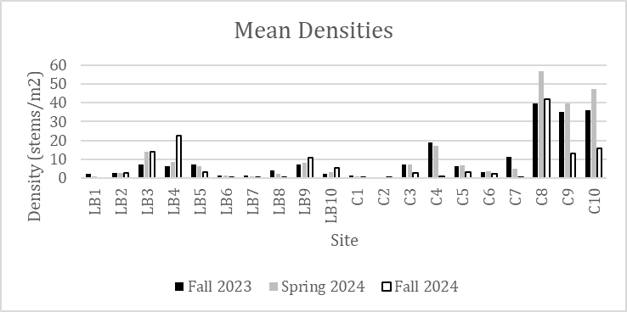

Figure 7. Shows the change in density of individual plots. Many plots increased in density between Fall 2023 and Spring 2024 visits before decreasing in density following the Fall 2024 visit. There is also large variation in plot densities across both sites.

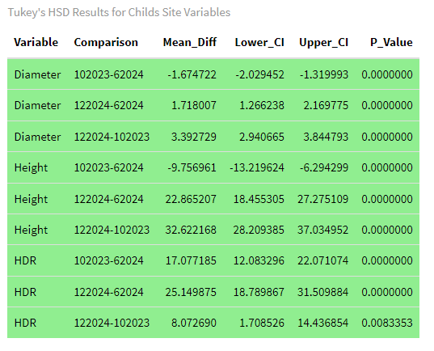

Table 4. Showing significant changes (green).

All variables changed significantly between every visit at Childs while all but 2 variables at Beasley grew significantly. Almost all significant P-values are far less than .001 indicating that the changes are highly significant.

**Survivorship**

BRAP Childs

Table 5. Showing correlations between changes in density and other measured variables. Significant variables are highlighted in green. Percent change in density is the variable tested against so it should be ignored.

At Beasley: Surface water elevation, percent change in HDR, mean HDR and herbaceous competition were all significant variables impacting change in density from Fall 2023 to Fall 2024. At Childs, light availability was the only variable found to significantly impact seedling survivorship.

## Dendrochronology

So far, I have dated 183 tree cores. I estimated the pith date for 130 cores and used minimum ages on the remaining 23. Missing piths or rotten sections made it impossible to get a pith date on some cores. In this instance, the minimum age was measured to the last dateable ring. Currently, the average pith date is 2000.

Table 6. The sites, number of cores taken and the mean diameter of trees taken at each site. The West Clear Creek legacy trees have the largest diameters. Childs had the most and largest trees dated so far.

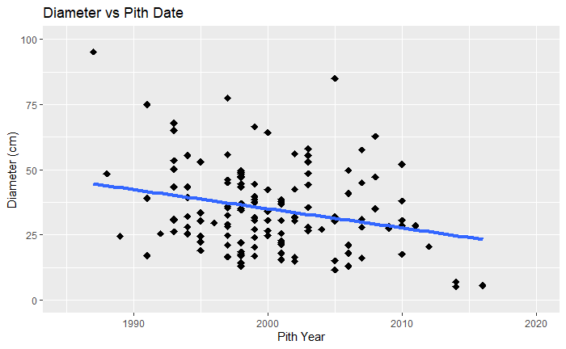

Figure 9. Age versus diameter of trees cores

Figure 4 shows diameter vs age as well as the linear regression model. The R-squared value is 0.06 and the p-value in 0.003. The small R-squared value implies that there is little to no relationship between size and age.

**Minimum ages**

Figure 10. Shows the minimum ages collected. The number of cores increases sharply in the mid-1990s before plateauing around 2010

The average minimum age for cores collected and dated is 2000.4 or about 23 years old. Minimum ages peak in 1998 before declining until 2004. Regeneration stays constant until about 2010 before decreasing to only around 5 trees after 2010.

**Growth**

Basal area index and Ring Width Index were calculated for each site as well as an average for all sites.

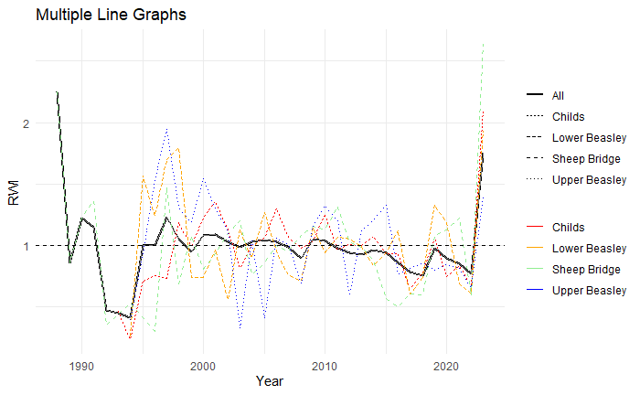

Figure 11. Ring Width Indices for all 4 sites as well as the average. RWI usually declines over time as the trees increase in size.

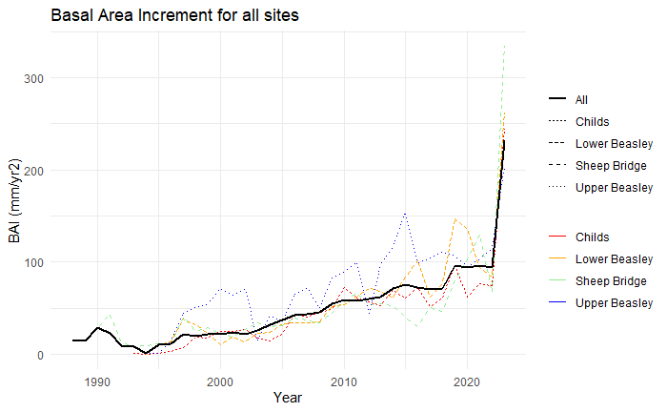

Figure 12. Basal Area Indices for all 4 sites as well as the average. BAI has constantly been rising overall with a sharp increase in 2023.

**Response Function Analysis**

The response function analysis was run using the Treeclim package in R. An exact bootstrap method was used and a critical value of .05 or less was used.

Table 7. Showing site specific and all chronologies for the water year (Oct-Sept). Significant response variables are June, July and September streamflow and October temperature. June PDSI was also significant even though it had a weak correlation value.

## Aerial imagery

Figure 13. Showing land classification changes from 2013 to 2023.

As a percent of each image, shrubland is the largest class. The other classes fluctuate but in general are always below 20 percent of the image.

# Discussion

## Seedling survivorship and demographics

Densities decreased or stayed constant in 80% of plots surveyed across the two sites. However, densities did increase in the remaining 20% of sites. This could indicate that there was recruitment following the seed release in Spring of 2024. Sites that are suitable may be able to recruit seedlings in successive years. Both sites had all three size metrics increase between each visit. Mean density also decreased between all 3 visits. Densities at Childs decreased quickly to about the same level as the densities at seedling plots. Seedlings grow and thin themselves out over time as they get larger. It is expected that they will continue to grow and decrease in density as the seedlings continue to mature. How quickly seedings grow could determine how quickly seedling densities decrease.

Seedling sizes is being used a proxy for seedling health and potential. Seedlings at Childs grew larger than seedlings at Beasley. Seedling sizes may have changed and grown quicker at Childs due to the more disturbance created at this site from 2023 floods. The river now has two active channels near the where the site is and large deposits of flood debris. This added and extra disturbance could create more ideal conditions for seedling growth.

Causes of mortality are difficult to determine. Most sites just had less seedling from before. At some sites the seedlings were showing signs of desiccation while sites LB 3 and LB 4 had encroachment of Common Cocklebur (*Xanthium strumarium*). The Common Cocklebur seems to be most highly concentrated in the sandy center of the depression while Fremont cottonwood seedlings ring the outside of the depression. Fremont cottonwoods within the center were taller as they were forced to grow quickly to compete with the cocklebur. Browsing was infrequently observed and at no plots did browsing seem to be a plot level impact.

Variables impacting survivorship

Each site had different variables significantly impact changes in density. Light availability was the only variable that impacted survivorship at Childs. Meanwhile at Beasley, herbaceous coverage (positive), distance above river stage (positive) and changes in HDR (positive) were all related to seedling survivorship. It is interesting that herbaceous coverage was positively correlated to seedling survivorship. One would expect that more herbaceous competition would negatively impact seedling survival, but the opposite was true. I suspect that herbaceous coverage, including cottonwood seedlings, are highest in sites with favorable conditions. For example, areas near the water table and with lots of sunlight might recruit the most plant material. On the other hand, sites with low herbaceous coverage might be unsuitable for either cottonwoods or their competitors. Distance above river stage was another significant variable. The closer a plot was to the river stage; the higher seedling survival was. This is also consistent with cottonwood ecology as seedlings must be able to reach groundwater to grow and survive in such a hot, arid environment (Cooper et al. 1999; Kalischuk, Rood, and Mahoney 2001). Increases in HDR was also a significant factor for seedling survival at BRAP. As HDR increases, so does survival. A higher HDR indicates that a seedling is taller and narrower. Plots where seedlings grew taller and narrower saw higher survivorship. This could indicate that at some plots, seedling height can help drive survivorship.

Plots at Childs and BRAP had different factors influencing survivorship. The variety of significant variables shows that seedling regeneration and survival is very site and plot specific. Seedlings regenerate in a diverse set of geomorphic settings and can be influenced by anything from light availability to distance from river stage.

## Dendrochronology

**Minimum ages**

Most of the cottonwoods along the Verde River are young. The mean inner pith date goes back to around the year 2000. Very few trees have piths dating after 2010 which means that regeneration has been sparse since the mid-2000s. There has been a relative absence of large winter floods since 2005 (Figure ??). Their young age could also be because of the relatively intact hydrology along the Verde River. Large floods occur frequently enough to constantly remove trees and recruit a younger cohort. The Verde River floodplain has been largely depositional. Tree root collars are submerged under sediment leading to uncertainty about their exact age. However, based on the understanding of Fremont cottonwood ecology and the gauge record, it is likely that most of the cottonwoods cored germinated in winter floods in 1993 or 1995. In two growing seasons, seedling heights reached an average of 36 cm and 64 cm at BRAP and Childs specifically. To get from 1995 to the average inner pith date of 2000 means that the average Fremont cottonwood germinated .9 and 1.60 meters under the current land surface. However, this assumes that seedling growth is linear and constant.

There is also a very weak correlation (r2 = .06) between the age and diameter of cottonwoods cored. With no strong trend between age and diameter, it means that other factors may be influencing size. For example, competition between trees for sunlight may be suppressing smaller trees. Cottonwoods are shade intolerant species and because they tend to regenerate in short, distinct timeframes suppressed trees may be much smaller than dominant trees of the same age.

**Tree growth**

Basal Area Index (BAI) is generally increasing since about 1995. This means that the trees have been adding basal area at an above average rate. Meanwhile, Ring Width Index (RWI) has been generally decreasing since about 2000. This means that tree rings have been getting smaller. This makes sense because as a tree gets taller over time, a larger volume of wood is produced with a smaller ring. The above average BAI suggests that the riparian forests along the Verde River are continuing to grow and are yet to reach a mature, steady state. Although cottonwoods are pioneer species, they are still relatively young at 25-30 years old and continue to grow at a quick rate. Both growth metrics also saw a sharp increase in 2023 where large floods could have cleared out competition or recharged local aquifers.

**Response to climate**

When the water year is considered (Table 7), June, July streamflows, June PDSI, and October temperatures cause a positive response in tree growth. September streamflows and negatively impact growth. Higher October temperatures may help prolong the growing season for riparian trees which would allow them to increase their growth. Higher June and July flows could help alleviate high summer temperatures and recharge the alluvial aquifer that these trees draw water from. These responses are more consistent with the North American Monsoon. In this case, summer precipitation and the monsoon season drives tree growth.

September streamflow and annual growth were negatively correlated and June PDSI positively impacts tree growth which is inconsistent with a monsoon driven system. These are also relatively weak correlations even though they are significant. One would expect September streamflow to positively impact streamflow. June PDSI could positively impact tree growth because if temperatures are higher in June and trees have adequate water, they may be able to grow quicker.

## Aerial Imagery

The largest class in every image is still upland. This makes sense as riparian areas in the southwest make up a small geographic area. Childs seemed to have to most changes in its classes. Changes in the riparian area may be difficult to detect because they occupy such a small area of the image. Small changes on an already small geographic area may be difficult to find or interpret.

## Conclusions and Implications

Fremont cottonwoods that established after the 2023 winter floods continue to grow and reduce in density. Seedling plots seem to be impacted by different variables depending on their location. In addition, the wide variety of significant variables impacting seedling survival shows that a combination of factors is important in maintaining seedlings. Most Fremont cottonwoods on the Verde are relatively young and date about to the year 2000. They continue to grow and add basal area at an increasing rate, suggesting that the forest has yet to reach a mature state. Fremont cottonwood growth appears to be driven by summer streamflow. This also is when streamflows are the lowest. As baseflows continue to decline, their growth and resilience could be at risk. Maintaining higher flows during the summer irrigation season would positively benefit riparian forests. Keeping the natural systems and hydrology along the Verde River is crucial to maintaining and protecting its riparian forests.

## Limitations

Dendrochronology

Riparian floodplain topography is constantly changing with time. Large floods are constantly changing and reshaping floodplain structure. Because of this, the elevation that the cores were taken at in October 2023 are not necessarily the ground elevation that the trees geminated on. This means that there is potentially a segment of tree bole that is not being dated.

Figure 14. A schematic showing how changes in ground surface elevation can impact minimum tree ages

However, because Fremont cottonwoods grow rapidly and ground surface elevations only change occasionally, we are confident that the determined minimum age is close to the actual age of the tree.

For the creation of the chronology, most of the segments for most of the cores were poorly correlated to each other. However, the series for this study are short, with most being less than 30 years old. In addition, traditional chronology building is based on the idea that climate (and usually precipitation) is the strongest factor influencing growth. However, because riparian cottonwoods are phreatophytes and connected to perennial water year around, it is possible that other factors impact tree growth more.

# Chapter 3

## Methods

## **GW Well**

Previous Forest Service research had installed shallow groundwater wells into the floodplain. Following 2023 winter floods we attempted to relocate and activate these wells. Only two existing wells were reactivated at Beasley, and one was reactivated at Childs. One new groundwater well was installed at Beasley near an established regeneration plot. To reactivate the old groundwater wells, we filled them with water and stirred using an 8 ft copper grounding rod to agitate the sediment in the casing. A stainless-steel well bailer was then used to remove the water and suspended sediment. This was repeated until the sediment was all removed and the water in the well was clear. HOBO 13-foot Water Level Recorders (resolution of 0.002 PSI or 0.005 ft of water) were placed near the bottom to record groundwater level fluctuations at 15-minute intervals.

## Arieal imagery

**Laboratory Methods**

Aerial imagery was used to locate specific timeframes when scour and regeneration occurred. National Agriculture Imager Program (NAIP) imagery was gathered from the USGS Earth Explorer database (<https://earthexplorer.usgs.gov/>, August 2024). Images containing the whole study site were chosen, gathered and uploaded into ArcGIS Pro. NAIP imagery was available for all sites in: 2023, 2021, 2019, 2017, 2015, 2013, 2010. Before the year 2010, the classification is unable to be done reliably.

**Analysis Methods**

Images can be visually inspected for changes between photos. Bank geomorphology as well as vegetation changes can be seen between photos. The gauge record can be used to identify a maximum flow that occurred in that reach between the two photos.

Images were clipped to the Verde River floodplain. The Verde River flowline was downloaded from the AzGeo Hub (<https://azgeo-open-data-agic.hub.arcgis.com> ) and a 150 meter buffer was created from that flow line. The area within that polygon was then used for analysis.

Figure 6. Showing the workflow and results of my classification process.

To quantify change over time I used the Classification Tools on ArcGIS Pro. I created 5 classes that a pixel could be classified as. I trained the program by selecting at least10 polygons of each class so that the program has representative data to classify each pixel as.

|  |  |  |
| --- | --- | --- |
| Class | Description | Error |
| Riparian Forest | Riparian vegetation, all included | Different shades of green, includes upland forests or water |
| Water | Water in the channel as well as side channels | Riparian shadows blocking water, changes water reflectance (ripples and rapids) |
| Barren | Scoured and bare soil/rocks along the floodplain | Includes upland bare rock and roads |
| Shadow | Dark areas created by shadows | Doesn’t contribute to change in land type over time, dependent on time of day the photo was taken |
| Shrubland | Generic term for upland areas remaining in the image | Large generic area with variation that could be classified as other classes |
| Upland Forest | Upland forests such as juniper and mesquite | Different shades of green selected, including riparian areas and water |

Table 1. A table of the classification classes as well as errors encountered in the classification.

ArcGIS Pro then creates a table with the amount of each pixel in each class. Because the number of pixels change over time as the resolution becomes finer, the classes are then normalized to a percent out of the total. Then, the change in the number of pixels can be seen over time. In addition, using the pixel size of each mission, a total area of each class was created.

**Statistical Methods**

To test to for significant changes, a Chi-squared test of independence was run. This tests to see if the areas within each class change significantly over time.

**Qualitative Imagery**

Only images after 2010 were able to be classified using ArcGIS Pro so photos from before that period were compiled to observe changes to riparian forests.

In addition, the Friends of the Tonto National Forest (<https://www.friendsofthetonto.org/>) collect repeat photography from defined photo points. Sites that had before and after photos of large floods within the Verde River watershed were examined. Images were inspected visually, and key vegetation changes were noted.

## Results

Figure X. Showing the groundwater level at well 9 from March until December 2024.

The maximum depth to water table between February 2024 and December 2024 was .67 meters while the maximum depth above ground surface was 1.5 meters. The mean water elevation was .32 meters below ground surface. The groundwater well at Beasley was inundated for about 31 days between March 1st 2024 and December 1st 2024.

Aerial Imagery

The Chi-square test on my contingency table produced a p-value of 0.007 which indicates that changes within the sites is significant.

Aerial Imagery Classification

All three sites followed roughly the same ranking of classifications. From most to leas t= Upland, barren or upland forest, riparian forest, water then shadow. In every image, the “Upland” classification was the largest single group by far with a mean coverage of 48% of images across sites. The minimum upland classification was about 42% while the maximum peaked at just over 70%. The smallest class was shadow with an average coverage of about 2.5%. In general, classifications seem to be stable since about 2010. One significant change is in the “Upland forest” classification at Childs. After 2019, the amount of Upland forest at Childs decreased dramatically from 19.5% to just under 2% (Figure X).

Figure X. Image classification for BRAP. Most of the classes stay roughly the same.

Figure ?? Childs

Figure ?? Sheep Bridge

## Discussion

**Groundwater well**

Groundwater levels mimic and reflect the Verde River hydrograph. This indicates that groundwater and surface water within riparian corridors at BRAP are connected. The winter of 2024 was generally above average in the Verde watershed which led to the well be inundated for at least 31 days. It was likely inundated longer as when the well was installed the ground surface was already underwater.

Groundwater at BRAP was usually close to the surface elevation of the well but did vary according to the season.

**Aerial Imagery Classification**

Riparian forests along the Verde River spend most of the 20th century recovering from Euro-American disturbances. Riparian forests increased between 1930 and about 1980 before plateauing (Lopez citation). By classifying the NAIP imagery,

## Appendix

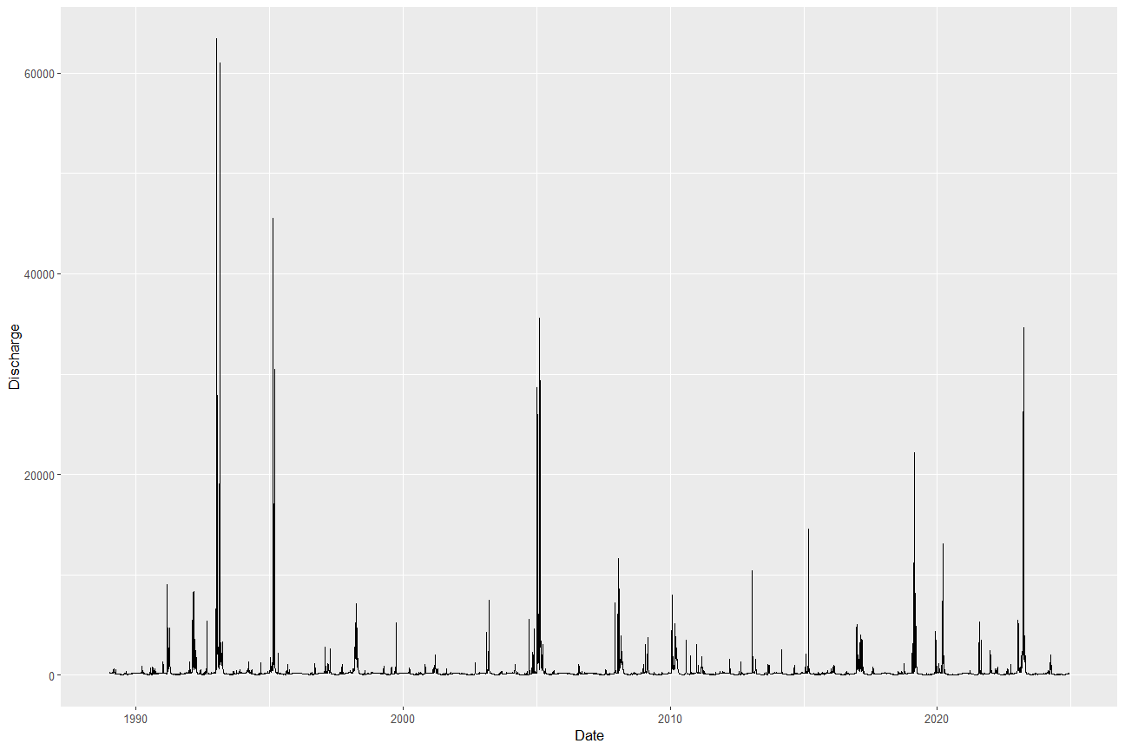

Figure 1 Showing the Below Camp Verde USGS gauge. The hydrograph shows from 1989 to December 2024. Large floods occur in 1993, 1995, 2005 and 2023.

Figure 2. Left showing Common Cocklebur from Beasley Flats while the right shows the Cocklebur overtopping the Fremont cottonwood seedlings during June 2024 visit

Figure 3. Showing the same cocklebur over 1.5 meters tall during the Fall 2024 visit.

# Works Cited

Alam, J. 1997. “Irrigation in the Verde Valley.” *A report of the irrigation diversion improvement project. Verde Natural Resource Conservation District*.

Blasch, Kyle W, John P Hoffmann, Leslie F Graser, Jeannie R Bryson, and Alan L Flint. 2006. *Hydrogeology of the Upper and Middle Verde River Watersheds, Central Arizona*. U. S. Geological Survey.

Braun-Blanquet, J. 1964. *Pflanzensoziologie*. Vienna: Springer Vienna. doi:10.1007/978-3-7091-8110-2.

Bunn, Andrew G. 2010. “Statistical and Visual Crossdating in R Using the dplR Library.” *Dendrochronologia* 28(4): 251–58. doi:10.1016/j.dendro.2009.12.001.

Cooper, David J, David M Merritt, Douglas C Andersen, and Rodney A Chimner. 1999. “Factors Controlling the Establishment of Fremont Cottonwood Seedlings on the Upper Green River, USA.” *Regulated Rivers: Research & Management: An International Journal Devoted to River Research and Management* 15(5): 419–40.

Dyson, Megan, Ger Bergkamp, and John Scanlon. 2003. “Flow: The Essentials of Environmental Flows.” *IUCN, Gland, Switzerland and Cambridge, UK*: 20–87.

*Ecological Implications of Verde River Flows*. 2008. Arizona Water Institute, The Nature Conservancy, and Verde River Basin Partnership.

Ffolliott, Peter F, Leonard F DeBano, Malchus B Baker Jr, Daniel G Neary, and Kenneth N Brooks. 2004. “Hydrology and Impacts of Disturbances on Hydrologic Function.” *Riparian Areas of the Southwestern United States: Hydrology, Ecology, and Management; Baker, MB, Ffolliott, PF, DeBano, LF, Neary, DG, Eds*: 51.

Kalischuk, Andrea R., Stewart B. Rood, and John M. Mahoney. 2001. “Environmental Influences on Seedling Growth of Cottonwood Species Following a Major Flood.” *Forest Ecology and Management* 144(1–3): 75–89. doi:10.1016/S0378-1127(00)00359-5.

Schultz, RC, TM Isenhart, JP Colletti, WW Simpkins, RP Udawatta, and PL Schultz. 2009. “Riparian and Upland Buffer Practices.” *North American agroforestry: An integrated science and practice*: 163–218.

Stromberg, Julie C. 1993. “Fremont Cottonwood-Goodding Willow Riparian Forests: A Review of Their Ecology, Threats, and Recovery Potential.” *Journal of the Arizona-Nevada Academy of Science*: 97–110.

Stromberg, Juliet C. 1997. “Growth and Survivorship of Fremont Cottonwood, Goodding Willow, and Salt Cedar Seedlings after Large Floods in Central Arizona.” *The Great Basin Naturalist*: 198–208.

USDA. 2012. *Yavapai County Profile*. https://agcensus.library.cornell.edu/wp-content/uploads/2012-Arizona-cp04025.pdf.

USFWS. 2012. *Designation of Critical Habitat for Southwestern Willow Flycatcher*.

Wirt, Laurie, Ed DeWitt, and Victoria E Langenheim. 2005. *Geologic Framework of Aquifer Units and Ground-Water Flowpaths, Verde River Headwaters, North-Central Arizona*. US Geological Survey.

Zang, Christian, and Franco Biondi. 2015. “Treeclim: An R Package for the Numerical Calibration of Proxy‐climate Relationships.” *Ecography* 38(4): 431–36. doi:10.1111/ecog.01335.