"Learn from yesterday, live for today, hope for tomorrow. The important thing is not to stop questioning." (Albert Einstein)

"Great achievement is usually born of great sacrifice, and is never the result of selfishness." (Napoleon Hill)

"The greatest accomplishment is not in never falling, but in rising again after you fall." (Vince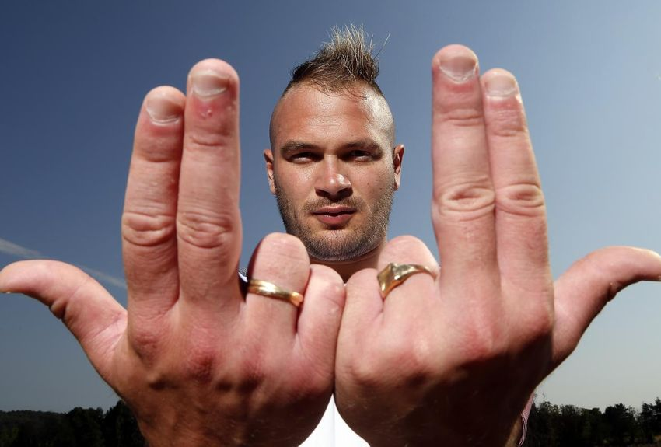 Lombardi)

**"Believe you can and you're halfway there." (Theodor Roosevelt)eqfqdgqdgsdf**