Investigating the Reuse of Biomedical Data Using the Data Citation Corpus
_{Source: Article Notebook}

1. Introduction

1.1. The relevance of investigating dataset reuse
A lot of effort is invested into the sharing of data by researchers by creating infrastructures, developing know-how, and raising awareness. The practice of data sharing is called upon, supported, and sometimes required by funders (Wellcome, n.d.), journals (Loder et al. 2024; PLOS Medicine, n.d.), institutions (The Neuro, n.d.), scientific societies [ref1], and governments (“UNESCO Recommendation on Open Science,” n.d.). Data sharing serves multiple purposes (Gregory et al. 2020; Locher et al. 2023). The availability of data has a positive effect on trust (Rosman et al. 2022), and thus availability of data is a value in itself. However, we see a wide agreement that value is primarily created by data sharing when somebody else takes this data and uses it in some way. To quantify the impact of shared data, we thus focused on its reuse, and, more specifically, on references to dataset reuse in the published literature. Reuse can take place in a lot of ways, and by many actors: in addition to researchers, it could also be by governments, civil society, companies, or other actors. In addition, researchers might reuse data for purposes outside of research, as e.g. teaching (Gregory et al. 2020). Thus, many reuse cases might never find their way into the literature. However, the traces of data reuse in the literature are currently the only way to investigate at scale, whether data is reused. Thus, we focus on references to data reuse in the published literature as a proxy of overall data reuse to investigate the impact of shared data. Ultimately, answering questions around data reuse is central to advance and focus efforts regarding data sharing in the future (EOSC EDEN, n.d.).

1.2. Terminology
We are aware that data reuse is in itself not a self-evident concept, and it has been even argued that it cannot be defined at all (Sandt et al. 2019). Although we argue that such a distinction is intuitive and useful, a line is certainly very difficult to draw. For the purpose of our analysis, we consider every instance where the article reporting data reuse (‘reusing article’) and the article reporting data sharing (‘sharing article’) do not have author overlap. Although this is certainly a simplification, it seems justified and our own analyses show that typically authors see this distinction the way we do, e.g. in that references to what we define as ‘data reuse’ are much more often found outside of data availability statements than references to what we define as ‘own data’. However, this issue warrants its own discussion, and probably a simple dichotomy might not suffice in the long term.
We furthermore only consider reuse of data shared in repositories. Data reuse can also take place within groups, departments, consortia, or in other arrangements, without publication of the data. Based on qualitative sociological research, Barlösius (2023) describes open sharing as only one of three sharing types. This is complemented by “closed communal sharing, based on a feeling of belonging together” and “closed associative sharing, in which the participants act on the basis of an agreement”. “Communal sharing” cannot be assessed using bibliographic methods. While our analysis primarily builds on open sharing of data, it also includes restricted-access sharing via repositories, which could be seen as being an example of “associative sharing”. With regard to mapping data (re)use practices, one of the authors (EB) is involved in the FORCE11 Working Group “Data Usage Typologies” (FORCE11, n.d.), which aims to define types of data (re)use and their respective properties, encompassing any type of data use.
The literature on data use and reuse employs different terms for statements which refer to utilized datasets. We follow the terminology employed by Gregory et al. (2023). Thus, we use the term ‘data citation’ for data objects in reference lists, while the term ‘data mention’ is used for statements in the publication text. As a consequence, the Data Citation Corpus analyzed here is, in this terminology, a corpus of both ‘data mentions’ and ‘data citations’ and, in a summarizing fashion, is denoted as a corpus of ‘data references’. ‘Data citations’ and ‘data mentions’ are synonymous with ‘formal data citations’ and ‘informal data citations’, respectively, as used by Park, You, and Wolfram (2018). The third type of data references which we analyze are ‘indirect data citations’ (Sandt et al. 2019). In our case, this applies to cases where a data article rather than the dataset itself is referenced.

1.3. Institutional dataset reuse as specific application
We were interested in the reuse of data published by researchers from our institution. The primary focus of our study are the questions which datasets have been mentioned in the literature, and how often. In addition, we investigated the characteristics of reuse with regard to properties of data (e.g., whether it is data collected from human participants), properties of metadata (e.g., license), and the time lag between data publication and data reference.
We work at the Charité – Universitätsmedizin Berlin, a large university medical hospital, where very diverse biomedical research is undertaken. The Charité’s researchers published ca. 5,600 reviewed articles in 2023, of which 79% are open access in some form. The research ranges from clinical and epidemiological studies to preclinical studies in animals, cell cultures, and in silico. A smaller subset of publications also stems from views onto medicine from other domains, including sociological, historical, and meta-research approaches. Information on publication access types, as well as several other metrics of open and responsible research can be found in an institutional Responsible Research Dashboard (“Charité Dashboard on Responsible Research,” n.d.).
The list of datasets published by our institution is an outcome of the process of locally monitoring open science practices. We have collected information on the publication of datasets by Charité’s researchers, and thus we know for the period 2020-2023 which datasets have been shared. This list can then be matched to references in the Data Citation Corpus to investigate the reuse of datasets from our institution. The process used to obtain a list of published datasets is briefly described in the methods section, which also provides references to detailed descriptions.

1.4. Data Citation Corpus as data source
The use of references to datasets is complicated by the fact that data reuse is rarely acknowledged by data citations (Ninkov et al. 2021; Gregory et al. 2023). More commonly, data reuse is mentioned in a more or less informal way in different article sections (Park, You, and Wolfram 2018; Sandt et al. 2019). The Data Citation Corpus (DCC) [ref2] is the first comprehensive approach to address this issue by text-mining a large body of the published literature for references to reused data. It includes 4,892,673 dataset citations to 3,092,951 datasets in 1,837 repositories, mentioned in 1,879,482 research articles from 18,677 journals. These and further numbers are displayed in the DCC dashboard [ref3]. Beyond this dashboard, so far only two analyses making use of the DCC have been published to date (Hahnel, Smith, and Campbell 2024; Strecker, Soltau, and Bach 2025). Also, there is no comprehensive validation as yet with regard to the completeness, correctness, or bias within the DCC, although Page (2024) has documented common data quality issues in the DCC. Such a validation could e.g. investigate, whether known cases of data referencing are present in the DCC. However, the lack of large and diverse sets of data references which are in themselves validated precludes an extensive validation of the DCC at the time being.

1.5. Indirect data citations via data articles
In addition to data citations and data mentions, many authors reference not the reused dataset directly, but an article which describes the results derived from the data, given that such an article exists (Callaghan et al. 2012; Gregory et al. 2023; Yoon et al. 2019). Detecting the whole breadth of indirect data references would require investigating every single reference to articles by Charité authors to distinguish between indirect dataset references and references to the content of the research article proper. This can currently not be reliably automated and is not feasible manually, as it would apply to at least a high five-digit number of articles. We thus include in our analysis only citations to (but not mentions of) data articles. This focus on data articles was set as the probability of encountering indirect data citations is substantially higher for data articles than amongst citations to research articles generally. We have used dataset articles in two common data journals to track such indirect data citations. This complements the analysis of the DCC and allows for a more comprehensive picture of dataset reuse.

2. Methods

2.1. High-level overview of the process
The process of cleaning our own source dataset and matching it to entries in the DCC consists of the following steps, described in below sections in more detail:
- Preparation of the DCC for analysis (Section 2.2)
- Preperation of the Charité dataset identifier list for analysis (Section 2.3)
- Matching Charité dataset identifiers with identifiers in the DCC; this way, we determined which publications have referenced datasets underlying publications by Charité authors
This description applies to the analysis of direct dataset references (See Figure 11). For the analysis of indirect data references through data articles, additional steps had to be performed, as described in Section 2.8 (See Figure 12).

2.2. Preparing and quality-checking the Data Citation Corpus
The DCC was downloaded as separate csv files which were then combined into one table. We performed several steps on that table to standardize the DCC for our needs, as well as to quality-check the entries:
- Searching for missing (NA and NULL) values in fields that are relevant for the analysis; no such cases were observed
- Checking whether article publication years are plausible; we found six entries with implausible publication years (e.g., 2104, 2108) and corrected them by replacing the leading “1” with a “0”; these corrected publication years were then manually verified
- Renaming several columns for clarity
- DOIs of datasets deposited in general-purpose repositories (i.e., Zenodo, Figshare, Dryad, OSF, Mendeley, Apollo and Harvard Dataverse) were found to appear in multiple formats within the DCC; to ensure consistency, these DOIs were standardized to a uniform format
- Subsequently, excess characters were stripped from both the dataset and the article DOIs; this included leading and trailing slashes, dots and spaces, together with any other space found within the string value of the dataset or the article DOI; furthermore, commas were replaced with dots
- Version information was removed from all dataset identifiers
- After aforementioned cleaning steps, it could be observed that the DCC included 218,054 cases where the same DOI was listed in both the ‘referencing article’ and ‘referenced dataset’ fields; such cases were removed from the corpus
- Lastly, to exclude preprints from analysis, all cases where the listed repository name contained the suffix “rxiv” (e.g., bioRxiv, medRxiv, arXiv) were removed
Due to the size of the corpus, standardization steps performed were followed by inspection of individual samples rather than comprehensive manual validation. Original values of the DCC were kept in the table in their original respective columns for documentation, while the standardized values were the ones used for analysis.

2.3. Detecting datasets published by our institution

2.3.1. Detecting datasets via text mining of institutional articles with ODDPub
The process through which we obtained the list of shared datasets has been described in detail in our publication Iarkaeva, Nachev, and Bobrov (2024), as well as a detailed protocol (Iarkaeva et al. 2022). Briefly, starting with an institutional bibliography, the steps are the following:
- Downloading of all institutional publication full-texts and conversion of PDFs to text files
- Screening of these texts with the ODDPub text mining tool (Riedel, Kip, and Bobrov, n.d.; NicoRiedel and Nachev 2025) to detect statements indicative of open data
- Manually verifying that the open data cases flagged by ODDPub are indeed open data cases by our definition [ref5]; for this, the tool Numbat [ref4] was used to ensure a standardized verification process
As part of this verification process, we documented the so-called “best identifier” of the dataset, e.g. preferring a DOI over an accession code, where both are available. However, in some instances cleaning of this list was still necessary before a matching with the DCC could take place.

2.3.2. Using datasets detected with ODDPub as seeds to detect additional datasets
In the detection procedure described in Iarkaeva, Nachev, and Bobrov (2024), as well as briefly in Section 2.3.1, we extracted one dataset identifier per repository. However, we had observed that in many cases multiple datasets had been deposed in the same repository, in some cases up to several dozen. Thus, we used the identifiers of datasets which had been referenced in the literature as “seeds” to detect further identifiers. These additional identifiers were only searched for in the text surrounding the seed identifier, as well as any additional sections clearly indicated there as containing further identifiers. We did not use identifiers as seeds if the dataset had not been referenced in the literature, and thus cases of dataset reuse were probably missed.

2.3.3. Detecting dataset references via text mining using DataStet
DataStet (Lopez and L’Hôte, n.d.) is an alternative to ODDPub, which also screens article full-texts to detect dataset references. It includes some functionalities in addition to those offered by ODDPub, including a detection of whether a dataset had been at all created for the study, as well as a probability value for classifying a detected statement as indicative of shared data. For our screening, we used the standard “/service/annotateDatasetPDF” API endpoint to produce JSON files with the identifier names and the information whether there were open data or not. The parameters were set to the default values: disambiguate = 1, verbosity = 0. We used DataStet only for the purpose of detecting any additional datasets which ODDPub might have missed. Unlike the datasets detected with ODDPub (See Section 2.3.1), the datasets detected using DataStet were not used as seeds for further dataset detection (see Section 2.3.2).
In some repositories, the same dataset could be associated with several identifiers. It is possible that our screening using DataStet picked up alternative dataset identifiers for datasets we had already documented using ODDPub and Numbat. Similarly, it is also possible that DataStet might have picked up more than one identifier for the same dataset deposit. We did not perform a consistent disambiguation of such cases, but based on the identifier list it seems very improbable this had a substantial effect.

2.4. Data cleaning and standardization
The list of datasets obtained from all sources had to be cleaned and standardized before matching with the DCC, in order to maximize the probability of matching. This processing included the following steps:
- removal of empty entries, non-identifier entries, and any free text beyond the identifier itself (i.e., DOI, link including an accession code, or link only)
- standardization of identifier notation; an automated function was used, which extracted the accession number part from each given URL of a dataset; e.g., removing “https://www.rcsb.org/structure/” from “https://www.rcsb.org/structure/5MEQ” to yield the accession code “5MEQ”.
- Steps 4-6 of the standardization process described in Section 2.2 were performed for these identifiers values of as well. (AC?) I moved this sentence from being the last sentence of Section 2.3.3 paragraph 1, to keep all cleaning and standardizing statements in one place
- deduplication (i.e., making sure the Charité dataset identifier list contains each identifier only once) (AC?) Might be redundant to report it?

2.5. Matching of institutional and DCC references
Following the preprocessing steps described above, we matched Charité dataset references with entries in the DCC using an inner join by the “dataset” field AC is this too technical?. This resulted in a list of cases from the DCC which had matching dataset identifiers to the ones in the Charité dataset list, and were thus putative examples of references to datasets shared alongside articles by Charité authors. From this list, two types of match were excluded:
- Charité article sharing the dataset and matched referencing article (DCC article) were identical
- Charité article and referencing article had at least one author in common; this cleaning step was based on string matching of authors’ names between the Charité article and referencing article. Authors’ names were extracted from OpenAlex [ref6].
To exclude cases of article author overlap from our definition of data reuse was a methodological decision which can also reasonably be approached differently (see Section 4.5 for a discussion).
For datasets detected with ODDPub, the matching with DCC described above took place using confirmed open data cases. For datasets detected using either the ‘additional datasets’ (see Section 2.3.2) or the DataStet datasets (see Section 2.3.3) this sequence was reversed, however. Thus, identifiers were first matched with DCC, subsequently the cleaning steps described above were applied, and only then were the detected matches manually screened to include only open data cases. While the majority of ‘additional identifiers’ and DataStet identifiers were open data by our definition, this was not the case for all of these datasets. This order was applied since this massively reduced the screening effort. Instead of manually validating the open data status of all ‘additional’ and DataStet identifiers, only those identifiers referenced in the literature by other authors needed to be validated.

2.6. Enrichment of the dataset information
As we were interested in the determinants of data reuse, we manually extracted the following pieces of information for every dataset we found via ODDPub (including ‘additional identifiers’) and DataStet, as well as for a set of 200 randomly drawn comparator datasets which had NOT been referenced in the DCC:
- Was the dataset COVID-related? (yes/no)
- Were the data human data? (yes/no); all data collected with or from humans was pooled into one category, which thus included medical as well as other data, e.g. survey data
- What was the data access status? (open data/restricted access)
- Did the identifier appear in a data availability statement within the Charité article? (yes/no)
- Under which license was the data shared? (Creative Commons license/no Creative Commons license); the license was documented, but the analysis was performed on a dichotomous level
- What was the identifier type? (accession code/DOI)
In all cases, if the answer was “partly yes”, the case in question was counted as a “yes”; if the answer was uncertain, it was counted as “no”. In addition, in cases where the same identifier was extracted from both ODDPub and DataStet but each source linked it to a different Charité article, we documented the determinant information from the Charité article as identified by ODDPub. We made this choice because the DataStet extraction was intended to add datasets not already captured by ODDPub, rather than to replace ODDPub matches, even though there was some overlap between the sources (this is further discussed in Section 3.1). In practice, this situation occurred for 12 identifiers; both sources contained the identifier, but they disagreed on which Charité article shared it. Accordingly, we coded the presence of the data availability statement (yes/no) based on the Charité article listed in ODDPub, even when the Charité article listed in DataStet had an earlier publication date.
Furthermore, we were interested in the development of data references over time as a function of dataset age. The publication years of both Charité articles (which shared datasets) and DCC articles (which referenced datasets) were extracted using OpenAlex. In contrast, the publication years of datasets were extracted manually, and this was not always done in a fully consistent fashion. In the original extraction based on ODDPub, we typically extracted the year of the newest version of the dataset. Sometimes these were versions with changes to the data content while in other cases these were just - from what we could gather - only small changes to the original dataset metadata. In contrast, in the additional screens we performed to include other data sources (DataStet and ‘additional identifiers’), we documented the year in which the dataset was first created, insofar available. However, as described before, we removed version information from dataset identifiers as far as possible before matching them the DCC. Thus, the version originally documented is not expected to have a substantial impact on the detection of dataset references overall, except for rare cases where new versions receive fully new identifiers (as is the case for Zenodo). However, which version and thus which dataset age was documented can have an impact when analyzing dataset citations over time.
With regard to the analysis of dataset references over time, it is important to consider that referenced datasets could have been published before the corresponding Charité article, in some cases up to 10 years earlier. This can appear counterintuitive at first. However, it is explained by our definition of “Charité datasets” (datasets underlying articles with Charité authors). For our analysis, we establish a link between a Charité article and a Charité dataset. However, the information is not available to us whether this is the first time the dataset is shared, or whether it has already been published with another, earlier article (or possibly independently of an article altogether). Related to this case, and not clearly separable from it by our methods, is the alternative case where a dataset had been shared by researchers with no relation to the Charité, and was then reused by Charité researchers who listed one or more of the ‘original’ authors as co-author(s) of their article. This might legitimately be construed as a case of data reuse by Charité authors, but our methods do not allow us to make this disambiguation, and thus it is counted as a Charité dataset. This is not expected to inflate Charité dataset reuse rates, however, as the same effect also occurs the other way around, when Charité researchers become co-authors of studies which reused datasets they had shared earlier. In sum, our methodology leads to a small number of cases, where the dataset was published substantially before the Charité article. In most cases this is because the dataset had already been the basis for other articles which were (co-)authored by the same authors as the Charité article for which we detected data sharing.

2.7. Validation
We conducted iterative checks to confirm that the publication dates of datasets were plausible in relation to the articles referencing them. This was done to validate our analyses of dataset publication year and of the dataset age at the time of reference (‘relative dataset age’). Specifically, we verified that referencing articles were all: (1) published after the dataset, and (2) published after the associated Charité article.
We observed a small number of cases where check (2) above was violated. These required additional validation, as they appear counterintuitive at first, and we checked all these cases manually. However, they are all explained by our definition of “Charité datasets” (see section Section 2.6). This can lead to cases in which the expected order of events is reversed. We validated a subset of such cases to confirm that this was indeed the case. In nearly all cases where this occurred, the apparent contradiction was explained by the sharing of the dataset in question (or an earlier version thereof) having happened substantially before the Charité article publication. The validation additionally yielded one case violating check (1) above, where the referencing article was published before the dataset, and the texts of both articles clearly suggested that the Charité article reported the study in which the dataset had been created, while the referencing article had indeed reused the dataset. This case might be due to a process where the dataset identifier was created and shared with collaborators before the dataset was officially published in the repository and obtained a timestamp.
We concluded the validation step by checking a sample of 20 randomly selected cases out of the final results table. This confirmed that dataset publication years as well as age relations between dataset, Charité article, and referencing article were plausible based on authorship lists in conjunction with our definition of data reuse.
Apart from validating dataset age, the following additional steps were taken during our study to ensure validity:
- a sample of authorship overlap was manually checked
- a sample of open data dectections using ODDPub and Numbat was confirmed by a second rater
- a sample of information collected on reused as well as comparator datasets was confirmed by a second rater
- all putative accession numbers detected by DataStet were classified manually as true cases or false positives; for detections indicative of chemicals or cell lines, we checked for each individual case, whether this name also constituted a database entry with a downloadable sequence, which would then be considered a case of open data

2.8. Indirect citation detection via data articles
The purpose of this analysis was to investigate for a sample of data articles by Charité authors, in how many instances the articles citing these data articles referred to reuse of the presented data. In other words, we aimed at detecting indirect data citations.
Data in Brief and Scientific Data are, to our knowledge, the two most common data journals not specific to any discipline. All Charité articles published in these journals were detected on 16.8.2024 using publication data from Embase and Pubmed for 2016-2020, as well as OpenAlex (“OpenAlex,” n.d.) for 2021 and 2022. For each data article, we determined whether the data presented was deposited in repositories, and if so, under which identifier(s). Of the 28 data articles, seven shared the data exclusively in the article itself or as supplementary materials. These cases were not considered further, as data shared outside of repositories did not comply with our definition of open data. All six data articles published between 2016 and 2018 were part of this set of seven articles without datasets in repositories, and thus the analysis is effectively restricted to data articles from 2019 to 2022. Of the remaining 21 articles with datasets in repositories, some had multiple datasets attributed to them, thus corresponding to 35 unique datasets overall (excluding deposits of the same dataset in two or more repositories).
For each of these articles we used Google Scholar to obtain the list of articles which cited it, applying the “sort by date” function (AC?) maybe too technical? and thus using the most recent citations. From this list, we excluded entries in which the Charité article and the referencing article had at least one author in common, following the same procedure as step (2) in Section 2.5. Subsequently, for each citation of the respective data article within the citing article it was checked whether the reference was indicative of data reuse and thus constituted an indirect data citation. All places where the data article was cited were investigated. We distinguished between cases of dataset reuse (i.e., indirect data citations), and cases where no data reuse took place. These second cases correspond to references to the data article text proper. While we attempted to detect all indirect data citations, we note that references to the text proper could also concur with indirect data citations. We did not distinguish between different purposes of data reuse (e.g., re-analysis, meta-analysis, comparison), or of different contexts for data article references proper (e.g., supportive, contradictory, neutral). A full mapping of the distribution and purposes of data article citations was not in scope for this study.
Determination of the object truly referred to by the authors (article proper vs. shared data) required considerable time investment, and thus we restricted the screening to the maximally 60 most recent citations per data article. Apart from the removal of author overlap cases, articles were ineligible if it was not possible for us to access the citing article full-text and/or the language was not English. In these cases, additional citing articles were added to reach 60, if so many were still available. Out of 21 data articles, four had more than 60 eligible articles citing them on the respective date of checking.
Where the number of citing articles exceeded 60, we extrapolated a number of assumed missed indirect data citations. For this, we calculated the fraction of indirect data citations within the 60 articles screened and multiplied this fraction with the number of articles not screened, after removal of articles with author overlap. This extrapolated number was then added to the confirmed cases to receive an overall estimate of indirect data citations. In this extrapolation, all articles without author overlap were considered, including those which could not be screened for reasons of access or language, assuming there is no systematic relationship between data use and these restrictions.
Some limitations of this analysis need to be mentioned. First, it is based on references found through Google Scholar. Google Scholar has been shown to cover only a part of all dataset citations (Gerasimov et al. 2024). We also noticed that the sorting by date was sometimes erroneous, thus limiting the reproducibility of this step. Second, in some cases we cannot be certain that all references in the article text were checked. This applied in particular to two articles which used numbers to indicate citations. As these numbers appeared in the articles >100 times, a comprehensive check was not feasible. Third, even if it was clearly visible that a dataset had been reused, it was not always possible to determine with clarity, which of several shared copies or versions of datasets had been used. In case of doubt regarding the exact dataset used, we proceeded using the following two principles: (1) if one of the shared datasets had been deposited in a repository and the other on a project website, we reverted to the repository deposit, and (2) if one of the shared datasets was larger than the other, we reverted to the larger dataset, assuming that this was more complete. These two principles resolved all cases we observed. (BI?) were there cases where it was not even clear which dataset had been used? then we need to address it here as well. Lastly, we only examined indirect data citations, and specifically the text passages where these had been placed. We did not examine whether the dataset in question had independently also been cited or mentioned in the same article.
While screening data articles, we detected two Charité datasets which we missed using other sources. As the analysis of data references in the DCC was fully independent of the indirect data citation analysis, we did not include these two additional datasets to the DCC analysis, both for simplicity and to not influence any putative interpretations drawn from our coverage via ODDPub and DataStet.

3. Results
We conducted analyses of two independent sets of dataset references. First, we compiled a list of identifiers of datasets which were shared alongside publications by our institutional authors. This set was based on three sources of dataset identifiers:
- screening of articles using the text-mining algorithm ODDPub followed by a manual check, aiming to extract one identifier per repository (as described in Section 2.3.1)
- extraction of any additional data identifiers mentioned in the surroundings of the identifier which had been documented in step (1); this only took place where the dataset extracted in step (1) had been referenced in the literature (as described in Section 2.3.2)
- screening of articles using the machine learning tool DataStet, followed by manual cleaning (as described in Section 2.3.3)
Second, we screened data articles published by institutional authors, and used Google Scholar to obtain a list of references to these data articles (as described in Section 2.8). This was subsequently screened to distinguish between data article citations proper and indirect data citations. The latter constituted the second set of dataset references. The details for the collation of each datasets are described in the methods section. We present these results separately first, with analyses of their respective properties. Subsequently, we combine the numbers of dataset references to quantify the overall citation impact of institutional datasets.

3.1. Quantification of institutional dataset reuse using the DCC
We started from a set of 15,748 articles (co-)authored by Charité researchers between 2020 and 2023. Not including datasets detected using DataStet, these articles reported the deposition of 2,502 datasets (‘Charité datasets’). We observed that 118 datasets (4.9% of the ODDPub and “additional” datasets) have been referenced at least once. Overall, there were 1,032 references to the datasets, by the time the DCC version used was last updated (Feb. 25th, 2025). These numbers are shown in Figure 11. The fact that only a subset of datasets has so far been referenced is also reflected in the distribution of references per reused dataset. While a small number of datasets has been referenced many times, with a maximum of 142 references, 53 out of 118 cited datasets (44.9%) have been referenced only once (Figure 1), and 2,267 datasets (95.1%) have not been referenced so far. An additional source of datasets were those detected using DataStet. These additional 57 datasets were referenced 465 times (Figure 11). For these, a percentage of datasets referenced cannot be calculated (see Section 2.5 for details). Including these datasets detected using DataStet, we obtained 175 Charité datasets overall which were cited 1,497 times.
For these datasets, we investigated, using the DCC, whether they had been referenced by other articles. (AC?) unclear. maybe a relic from an earlier version?
Figure 6 shows the different data sources, and how they overlap. Here, we pooled in the oval depicting datasets extracted via ODDPub/Numbat data sources (1) and (2), as these are conceptually identical and will in the future be extracted in one step. The number of datasets found using the ODDPub text mining tool with manual validation, plus screening for additional identifiers was 118. This nearly exactly matched the number of identifiers extracted using the DataStet machine learning-based tool, also followed by manual validation, which was 119. A substantial number of dataset identifiers was detected only using one method, and only 35.4% of articles were detected using both approaches.

3.2. Determinants of institutional dataset reuse
To better understand the patterns of institutional dataset reuse, we analyzed in which repositories the reused datasets were deposited. We observed that out of 1,497 dataset references, 845 (56.4%) were to deposits in the Gene Expression Omnibus (GEO) (Figure 2). Overall, references were overwhelmingly to datasets from the fields of genomics and proteomics, i.e., sequences of DNA, RNA, and proteins. The ten most-referenced repositories contain datasets which are predominantly constituted by sequence data. Only 11 of 1,497 data references (0.7%) referred to datasets of other type, deposited in either disciplinary repositories (e.g. Electron Microscopy Data Bank, 4 references) or general-purpose repositories (e.g. Mendeley, 3 references). The overall pattern was very similar when looking at the level of datasets rather than references (Supp. Figure 3). This clearly shows that ‘omics’ fields currently contribute the large majority of data references, and thus at least a major fraction of data reuse cases overall.
We then used a logistic regression to examine which dataset-level characteristics were associated with the likelihood of being reused, defined as inclusion in the DCC in comparison to 200 randomly drawn datasets that were not found to be reused. This analysis examined factors associated with the probability of a dataset to be mentioned. We found out that the use of DOIs is negatively correlated with dataset reuse, as was discovered in a logistic regression (p < 0.001; Odds Ratio = 0.15; Figure 9). (AC?) the follwing sentence was moved here and has been rewritten: The distribution pattern of general-purpose repositories described above could explain this result. Within the top five most-referenced repositories (GEO, PDB, dbGaP, NCBI RefSeq, ENA), only PDB assigns DOIs, and even in this case the reference used in articles is overwhelmingly to the accession code rather than the DOI. General-purpose repositories, which in all cases assign DOIs to datasets, constitute only a small fraction of the DCC, with 4.4% of references belonging to Dryad, Figshare, Mendeley, and Zenodo (Supp. Figure 5). However, even this small number is not reflected in the references to Charité datasets. While datasets in general-purpose repositories constitute 21.2% of shared datasets, they garner only 1.1% of references. Thus, the negative correlation between DOIs and dataset reuse is highly likely a collateral effect of the fact that data from disciplinary repositories is reused far more, and at the same time these repositories currently rarely assign DOIs to datasets. The same effect of disciplinary vs. general-purpose repositories would also explain the observed negative correlation between dataset reuse and the attribution of Creative Commons licenses (p < 0.001; Odds Ratio = 0.29).
We investigated further determinants of dataset reuse and found that human data, which constitutes 77.1% of all checked datasets, is used more often than non-human data (p = 0.01; Odds Ratio = 1.97; See Figure 9). We also observed that data reuse was more probable if data bore a relation to COVID-19 (p = 0.04; Odds Ratio = 2.32; See Figure 9). In addition, the location of data references in the original publication was also significantly correlated with data reuse, in that datasets listed in the data availability statement were less commonly reused (p < 0.001; Odds Ratio = 0.22). However, it should be kept in mind that the Charité article sharing the dataset must not have necessarily been the first article to do so (see Section 2.6), and thus, some datasets might have been found by re-users through other, earlier articles where the dataset was more clearly marked. Also, this analysis does not differentiate between data references outside of a present DAS and articles without a DAS section, and it was based on a very skewed sample, as of 200 datasets not referenced, only 7% were not mentioned in a data availability statement. All p-values in this analysis were adjusted for multiple comparisons using the False Discovery Rate (Benjamini–Hochberg) procedure. Overall, the logistic regression explained meaningful variation in dataset reuse (χ²(5) = 86.59, p < 0.001, AIC = 443.6). However, while the data show reuse to be shaped by data content, the impact of repository practices on reuse is difficult to interpret against the backdrop of the specific practices of a set of highly-used disciplinary repositories.
Figure 10 presents an overall characterization of reused Charité datasets, with a focus on how these different characteristics are interrelated. It can be observed that reused datasets were, in their majority, shared openly, without a CC license as well as a DOI. Restricted-access reused data were mostly shared through dbGaP. Covid-19-related data were mostly shared though GEO, EGA, and PDB.

3.3. Data reuse as a function of dataset age
(AC?) There might be a confusion below? In the age-citation relationship analysis we did not filter by publication year, but rather by age (0-3), so there are identifiers beyond the 2020-2023 range. In the following analysis (Figure 4) we set the limit of 2023 as the year of citation, not of the dataset publication. AC & EB need to look together on exactly which subset was included in which analysis. We investigated whether there is a correlation between dataset age and the number of references. This was done using a generalized linear mixed model (negative binomal) with the dataset’s identifier as a random effect (S = 0.83). This analysis is constrained by the fact that the large majority of datasets was published between 2020 and 2023. In addition, we excluded data from 2023, as the DCC version used did not cover 2023 completely. Datasets published earlier could still be part of the analyzed set, and in this regard it is important to consider, as mentioned earlier, that the analyzed Charité articles were not necessarily the first ones to base their analyses on the respective datasets. Rather, these articles were only the earliest detected out of n≥1 instances where a dataset was, by our definition, shared by Charité authors. The overall development of citations over the first 3 years (Supp. Figure 13) suggests that dataset references do not follow a clear trend in the first three years from the dataset’s publication (IRR = 0.93, 95% CI [0.81-1.05], p = 0.24). However, this analysis is strongly skewed by the datasets which are cited only once. We thus generated a subset containing only datasets referenced at least once in the year the dataset was published and the three subsequent years Figure 7. For this subset, consisting of only seven datasets, we observed a negative correlation, corresponding to a decrease in citations over time. This association was, however, not statistically significant (IRR = 0.78, 95% CI [0.58-1.04], p = 0.09).
However, this analysis is limited by the short time period observed. In addition, the time period covered opens the possibility for a one-off effect of the reuse of Covid-related datasets. Indeed, the two most-referenced datasets were Covid-19 protein structures, which supports such an effect. Taken together, this analysis would support the conclusion that dataset references do not follow a clear trend in the first years after publication, except for particularly timely and highly referenced datasets, which are cited most right after publication. However, this analysis is based on rather limited and presumably not representative data, and thus these trends need to be evaluated on much larger sets of data references. Figure 4 shows a more full picture of citation by dataset year by including all dataset references and not applying a normalization to the year of dataset publication.

3.4. Analysis of references to data articles
In addition to an analysis of data references, we conducted an independent analysis of indirect data citations. As described in detail in the methods section (see Section 2.8), this analysis is based on a set of data articles, for which we first detected all references citing these using Google scholar. Subsequently, we manually detected whether a specific reference was really to the content of the data article itself, or was rather an indirect dataset citation, where the data article citation stood in for the dataset. In this analysis of data articles published between 2019 (i.e., starting a year earlier than the DCC analysis) and 2022 in the journals Scientific Data and Data in Brief (n = 21), we detected 35 shared datasets overall. These articles had been cited 1,722 times. In the 4 cases where data articles were cited >60 times, we restricted manual checks to 60 references. In this “truncated” set, we found that out of 536 references, (BI?) references where in fact indirect data citations X% (BI?). We used this to extrapolate numbers for the additional references to the three most-cited articles for which not all referencing articles could be screened. Adding these extrapolations, we obtained a number of 846 citations for these 35 datasets. Figure 12 summarizes these numbers. Thus, indirect data citations are very common, and if they are not taken into account, a major fraction of institutional dataset references would be missed. In addition, the huge number of references to some datasets, and the fact that they were largely not published in OMICS repositories (only 5 out of 35 datasets were; see Figure 8) suggests a very different pattern of sharing and reuse for datasets presented in data articles.

3.5. Quantification of overall institutional dataset reuse
We report references to Charité datasets detected via two sources: mentions on datasets in the literature on the one hand and indirect data citations on the other. Combining these two sources, we obtain an overall number of 210 Charité datasets which have been referenced 3,219 times. This excludes cases of author overlap while it includes cases extrapolated based on the screen of a subset of citations to data articles. Thus, datasets shared alongside article co-authored by Charité researchers, are referred to (directly or indirectly) on average 804.75 per year. This corresponds to 15.33 references per dataset. However, this number conceals a very high variability, with most datasets not referenced at all and a small fraction referenced up to >100 times. As discussed in detail in section Section 4.3, this is a lower bound estimate of data references, and the number of dataset reuse cases is probably substantially higher.
The two sets we examined are very distinct in their properties. While for data references, data has been deposited overwhelmingly in disciplinary repositories, for indirect data citations general-purpose repositories held most cited datasets (9%; see Figure 8 (AC?) this may need to be updated / verified), and the most-used disciplinary repository was OpenNeuro, rather than an omics repository.

4. Discussion

4.1. Detecting data reuse through the DCC
Using two approaches, we charted the reuse of datasets shared alongside articles published by researchers from our large biomedical research institution, the Charité - Universitätsmedizin Berlin. Our primary approach made use of the Data Citation Corpus (DCC) to detect references to reused datasets. Between 2020 and 2023, Charité researchers published (not considering the author position) 1,583 articles for which at least one dataset was shared, as detected using ODDPub, with 2,385 datasets overall. Out of these plus 119 datasets detected using DataStet, 175 datasets were referenced in the literature, with 1,390 references overall. This is, to our knowledge, the first analysis to quantitatively show at the scale of a research institution, how the datasets produced are reused and enter the published literature. We show that reuse of datasets is common in the biomedical domain. At the same time, 95.1% of datasets detected via ODDPub have not been referenced within the time period in question. While the distribution of dataset citations over time has to our knowledge so far not been investigated, a highly uneven distribution of dataset citations is plausible based on the literature on article citations (Redner 1998; Brzezinski 2015). We did not investigate the fraction of dataset citations out of all dataset references to Charité articles. However, it has been shown repeatedly that the number of data citations alone is low. E.g., Ninkov et al. (2021) show that only ca. 1% of datasets in DataCite had a citation. This is corroborated by the survey of Gregory et al. (2023), which shows that citing the article analyzing the data is much more common than citing the data itself.
It has been described extensively before (e.g. Silvello 2018) that data citations can indicate both the sharing and the reuse of data. Correspondingly, we observed, in addition to 1,497 cases of dataset reuse (also see below for a discussion of data sharing vs reuse), 275 cases where authors mentioned datasets they had themselves created. The definition of “datasets being created by Charité authors” (“Charité datasets”) used here is that a given dataset was mentioned in an article by Charité authors as underlying evidence they had themselves collected. In our screening to detect Charité datasets, we separated between own data and data reuse cases. Data reuse was determined primarily based on statements in the article, with author overlap between article and dataset as an additional indicator of reuse. However, the publication detected must not be the first with which the dataset in question was shared. Thus, we do not make a distinction between the first instance of sharing of own data and the “reuse” of own data published earlier – rather, we pool this in the data sharing category. It is because of the exclusion of articles with author overlap that our results do not contradict [Strecker et al]. They report for the general-purpose repository RADAR that 27.9% of datasets were referenced, with 21.4% of these being data citations. This is far off from the numbers we observe, but is explained by their inclusion of self-references, as only 1.3% of datasets in this repository had been referenced in articles without author overlap.
On a methodological level, we also show that, given a list of dataset identifiers, this can be matched to the DCC to obtain a corresponding list of data citations. As we also describe, this process is far from straightforward, however. Even if the institutional data identifier list is highly standardized, the variability of dataset IDs in the DCC poses considerable challenges. The same dataset can be referred to in several ways, which makes the detection of references to general-purpose repositories particularly complex. Nevertheless, the DCC includes both data citations and data mentions, and thus has a much broader coverage than databases which build on citation metadata only. This is necessarily true for DataCite (analyzed e.g. by Ninkov et al. 2021) which constitutes the subset of data citations within the DCC. It has been shown for datasets in the earth sciences, that proprietary databases, which include additional methods and sources, have better coverage (Gerasimov et al. 2024), and the analysis of Strecker et al has shown a better coverage of Google Scholar and DataCite Event Data compared to the DCC (see Section 4.3 for a discussion). Overall, it is still not sufficiently investigated, how other databases compare to the DCC.
The DCC dashboard indicated as of August 14th 2024, when it displayed numbers pertinent to the DCC v3 used in our analysis, 85% of identifiers in the DCC are accession numbers and 15% are DOIs [AC could you please check and add the most up tp date numbers?]. This is in line with our quantification of the most prevalent repositories in the DCC (figure 5), as disciplinary repositories typically do not assign DOIs. However, there is no large-scale benchmarking of the DCC yet, and thus it is unclear whether the probability of detecting accession number vs. DOI references is representative of the actual body of data references. In the DCC analysis we conducted, only five datasets shared in general-purpose repositories were referenced. At the same time, amongst the datasets shared by Charité researchers in 2023 (ref to dashboard) X% of datasets [Evgeny asked Ana for this number] were deposited in general-purpose repositories. Thus, data in disciplinary repositories are clearly referenced more often. We see two probable primary explanations for this. One explanation could be that datasets in disciplinary repositories are more findable and/or reusable, e.g. due to richer disciplinary metadata. An alternative or additional explanation could be that in biomedical research, disciplinary repositories in their majority represent omics fields, and at the same time reusing data is by far most common in these fields. Further explanations are possible, however. E.g. the expectation of data quality could be higher for disciplinary repositories. The analysis of indirect data citations clearly shows that sharing data in general-purpose repositories is not in itself an obstacle to reuse. We found multiple cases (BI?) of indirect citations where the underlying data had been shared in a general-purpose repository only, and further cases where general-purpose data might also have been used. However, the aforementioned issues of visibility, disciplinary information, and quality-assurance are all simultaneously alleviated when a dataset is accompanied by a reviewed data article.

4.2. Detecting data reuse by indirect citations of data articles
We complemented this approach by an analysis of references to data articles. Data articles or ‘data descriptors’ are a type of article which explains in detail the provenance and properties of a dataset, but does not report results derived from its analysis. We examined a sample of 21 data articles published by Charité researchers between 2019 and 2022 in the two most common, non-disciplinary data journals. These articles shared (BI?) datasets overall. We found (BI?) references to these datasets, including extrapolated references (see below, as well as Section 2.8). Thus, indirect data citations constitute a substantial fraction of all instances, in which data reuse is visible in the literature.
Our analysis has confirmed the finding of Jiao and Darch (2020) that it is common practice in the literature to refer to a data article instead of the data, when actually the data have been used. At the same time, not every reference to a data article indicates a reuse of the data. Jiao and Darch (2020) observed for two journals in the earth as well as physical and chemical sciences that 56% of citations to data articles indicate actual data reuse. In our case, 25.8% of citations to data articles (147 of 570) in fact referred to the underlying dataset (or one of several shared datasets). Thus, studies on the reuse of data need to take such “indirect citations” into account. These constitute a substantial fraction of all dataset references, and could be of particular importance for some purposes of monitoring, as data articles could describe datasets of particular value, especially for communities where data sharing and reuse are not common. Also, we see indications that this sample is characterized by both data types and types of data reuse distinct form the sample found via the DCC. However, this warrants further research.
To extract the information whether a data article reference in fact referred to the underlying data was manual and thus time-consuming. Correspondingly, we had to limit ourselves to extracting up to 60 citations per data article. In four out of 28 cases, the number of citations exceeded this number. In these cases, we have extrapolated the number of expected data uses based on the number of data uses within the 60 citations we analyzed. This extrapolation yielded a staggering number of 695 putative data reuse cases for the most-cited dataset. While there is an certainly an error margin attached to this number, it does clearly indicate the reuse value of certain unique and well-curated datasets.

4.3. Putative invisible data reuse
The numbers on data reuse reported here are probably very substantially underestimated. This is due to several reasons. For further limitations, which do not introduce an obvious directionality by decreasing detected reuse cases, see section 4.5.
- We extracted per article by Charité authors one dataset identifier per repository. However, especially for omics data, which are the most reused in our sample, it is common to share more than one dataset per repository. E.g., if an articles shared 10 datasets in GEO, the probability of detecting a reuse case is thus only 10%, as we extracted only one out of these 10 identifiers (at least under the simplifying assumption that dataset citations are independent of each other). Thus, an unknown but substantial number of datasets is missing from our sample. We extracted ‘additional identifiers’ from articles where reuse had already been detected, but this could not help to pick up the missed cases described here.
- As the basis of data references in the literature, we used the DCC only. Strecker et al. additionally used Google Scholar and DataCite Event Data, and observed that there was little overlap between the sources. In addition, they observed that the DCC had by far the lowest coverage containing only 6.1% of all references detected. We expect that the coverage of the DCC for our use case is far higher, both because of our extensive standardization and cleaning and because of the nature of the references we aimed to detect (mentions of reused data, rather than citations of own data). Nevertheless, the sources of data references in Strecker et al. indicate that a substantial number of references was missed due to incomplete coverage in the DCC.
- The screen for shared datasets on which our analysis relies could not be performed on check ca. 20% (does Vladi have exact numbers) of all research articles published by our institution. These could not be accessed programmatically, either for licensing or for technical reasons.
- While some repositories create versioned identifiers or allow additions to a deposit under the same identifier, in other cases new versions of a dataset receive a fully new identifier. In such cases, detection by our method becomes impossible.
- We searched for references to Charité datasets using exact matching. Thus, we might have missed cases where the dataset references from DCC and the Charité screening pointed to the same dataset, but one referred to the DOI and the other to the accession code. This is possible where repositories as e.g. the Protein Structure Database (PDB) uses both accession codes and DOIs.
- The DCC serves to analyze references to datasets which have identifiers, either persistent identifiers (typically DOIs) or accession codes. However, restricted-access data sharing typically takes place via platforms which do not provide either. In our sample, the only two restricted-access platforms were dbGaP and EGA. Thus, references to restricted-access datasets especially outside of omics fields would not have been detected.
- We only extracted identifiers of shared datasets from the English-language literature.
- In the analysis of indirect references via data articles, we focused on the two most common, non-disciplinary data journals. However, over 30 journals, most of them disciplinary, exist, which offer data articles as a publication type (Data Journals, no date). check In addition, we set a cutoff at 60 references per data article, which was exceeded in 4 cases (relevant enough?)
For the reasons described above, we expect that the actual volume of dataset reuse as reported in the literature is substantially larger than we report. While no number can be attached to it, it is reasonable to assume that the overall number of references in the literature to datasets shared by Charité researchers is several times as large as the number we report.
We searched for reuse of datasets associated with Charité publications starting in 2020. Although some datasets were older, the majority was published in temporal proximity to the article where we detected it. Thus, at the time of the creation of the used DCC version three (check …..2024), most datasets were still comparatively new. The literature on data reuse (Vries, Siegle, and Koch, n.d.) as well as our own analyses (see fig-ref-by-year-top-7) indicate that dataset reuse accumulates over many years and at least for some time the number of citations per year increases. Thus, we would expect an overall number of citations to be substantially larger, if we had screened an earlier section of the Charité literature. Correspondingly, the datasets we analyzed can be expected to accumulate many more references in the future.
On a more general note, the approach we follow can only capture one type of data reuse, namely the reuse which contributes to published research and is considering worthy of mention by researcher. Data referencing practices differ between communities (Gregory et al. 2023), and it has been shown that not all data uses will be references in publication with equal probability (Borgman, 2016; Federer, 2019). For example, use for teaching or calibration might not commonly mentioned in research articles (Gregory et al. 2020). In addition, the literature on publication bias (check ref) suggests that many data reuse cases might not be reported as the project they are part of is itself not published. Lastly, certain reuse purposes, in particular teaching, typically do not contribute to academic publishing, and thus cannot at all be detected.
discuss in DCC article that versioning information is central to what is matched

4.4. Determinants and patterns of data reuse
· Analysis of year since sharing data
· Distribution of referneces across articles – data “uncitedness”
· General-purpose vs disciplinary repositories -> refer to reuse we find by our researchers
· Data from OMICS vs. other data -> clinical data largely not shared!
· Data from covid19 research
· Data with DOI vs no DOI
· (Open vs. restricted-access data)
· (personal vs. non-personal data?)
· No connection to FAIRness of datasets
and authors from our institution shared datasets via these repositories (check numbers) (supplementary Figure… check or refer to FAIR dashboard). Nevertheless, only one out of 65 reused datasets found through the DCC was shared via a general-purpose repository. This is despite extensive standardization of references to general-purpose repositories which we performed after we had observed a considerable variation in them. We also observed that authors sometimes refer to data articles rather than the underlying datasets, where data articles have been published. The corresponding analysis of ‘indirect data citations’ follows further below.

4.5. What is data reuse anyway?
In this article, we have taken a pragmatic approach to data reuse. We have assumed data reuse to have taken place, if three conditions were fulfilled:
(1) a research article referenced a dataset
(2) this dataset is available either openly or with a defined access pathway; for the DCC analysis, a dataset identifier was required
(3) the article referencing the data and the article for which we had originally detected data sharing (or the data article) had no author overlap (or else this was defined as “own data use”)
However, this operationalization is simplified and requires qualification. It has been argued by Sandt et al. (2019) that reuse cannot at all be defined. At the same time, it is common in the research community to distinguish between “own data use” and “data reuse”. Gregory et al. (2023) adopted the definition that “data reuse” means “using data which others have created, for any purpose.” The notion that use and reuse can be distinguished to us seems intuitive as well as useful to inform ways to measure the value created by data sharing. We would argue that it is intuitive based on common notions related to data creation, stewardship, and usage rights. It is also useful to inform policy and support activities. However, a notion being intuitive and useful does not necessarily make it conceptually consistent. On the legal level, data cannot be owned at least in some jurisdictions, as e.g. in Germany (BMWK, n.d.), and “data ownership is an inherently problematic concept from a legal perspective” (Publications Office of the European Union. 2024). Questions of data ownership are linked to the view widely held by researchers that data are intellectual property of some sort (whether this is legally enforceable or not). Taken together, this leaves open whether a clear line between an “owner” (or, possibly, “creator”) and a “non-owner” (or, possibly, “non-creator”) can be drawn, and whether a consistent and at the same time useful definition of what “data reuse” means is achievable.
Beyond the fundamental question of defining own data use vs. data reuse, further practical challenges are posed by our bibliographic approach. Even if “own data use” and “data reuse” can be clearly separated conceptually, the question still remains whether bibliographic information can provide sufficient information to make such a distinction. However useful such a distinction based on bibliographic data might be in practice, it requires additional assumptions which are not necessarily in line with scientific practice, or at least not universally accepted. Consider the real-world case of a database which makes datasets available, but requires that investigators from the original project are included as co-authors on analyses using this data. By our definition, the resulting articles would constitute cases of “own data use”. However, as the article content is based on data shared by investigators not otherwise involved, value has been created by making data available to “others”. Thus, the data sharing constitutes the very link between the core group of investigators and the data contributors. Correspondingly, the notion that “reuse” is “use for a different purpose”, independently of authorship, is also widely held and so intuitive that Gregory et al. (2023), despite the definition given above, also state that “roughly three-quarters of respondents […] reported reusing [sic] their own data multiple times”. We cannot resolve this fundamental tension, but for our analysis, we settled on what we see as a pragmatic position, based on author overlap. The views described above show the need for a community consensus on what constitutes data reuse. The FORCE11 Working Group “Data usage typologies” (FORCE11, n.d.), as of late 2025, works on these questions and aims to support conceptual clarity around data use and reuse.
Data references can be indicative of data reuse, but similar to views or downloads of datasets, they do not constitute data use in themselves, and assumptions have to be made for their interpretation. In the aforementioned criteria for the detection of data reuse cases, we do NOT require that a dataset has been analyzed or in any other way handled on the level of the data files themselves. Thus, we adopt a wide definition of data reuse, which does not require any specific purpose or function. We assume that datasets are most commonly referenced when data have been “used” in the sense that an interaction with at least a subset of files constituting the dataset has taken place. However, there are other ways to make use of datasets (Gregory et al. 2023; Banaeefar et al., n.d.), and data can be referenced without interacting with the data files, e.g. to legitimize own work or leveraging the dataset as support for scientific claims made in research articles. Lafia et al. (2023) analyze in detail, which functions data references serve. Their typology describes five functions of data references, being “critique”, “describe”, “illustrate”, “interact”, and “legitimize”. Whether all of these types of data reference are indicative of data reuse, depends entirely on the definition of data use (and thus, reuse) applied. The observation by Lafia et al. (2023) that only a subset of references indicates “interactions” with the dataset suggests to us that not all references to datasets we observed are indicative of active engagement with the data. An additional consideration then is to assess which kind of value is created by other types of data reuse than “interaction”, and whether these other uses are then still in scope for the monitoring exercise conducted. We assume that every data use has contributed at least some value. While we cannot estimate this value for different types of use, we would like to point out that the same question of case-specific value is also true for article publications. Thus any assessment of the relationship between data references and value creation should be interpreted in light of similar assessments of the relationship between article references and value creation.
Lastly, it is also important to mention that we understand “data” throughout this article as a shorthand for “datasets”. It is datasets which are shared and it is datasets which are reused. Any piece of information which can be used to support a claim can be understood as “data”, but this would not be a useful category for our purposes. In line with this understanding, we have excluded cases of databases which contain “information” as e.g. the association between a certain disease and a certain mutation, but not a “dataset” in the sense of structured information which can be downloaded and processed further. Necessarily, the distinction between data and datasets is a matter of definition and remains contentious, as is the related distinction between data and metadata.

4.6. Limitations
The following restrictions and limitations apply to our analysis:
- We only detect reuse detected through references in the published literature. This excludes many types of data reuse, as described in Section 4.3. In addition, dataset reuse by commercial actors is common and cannot be detected via bibliographic methods (Ross et al. 2024).
- ODDPub has been developed to detect dataset references in article full texts. If shared dataset identifiers were listed in the references list only, and not in the article text, they might not have been detected. However, while formal citation of datasets is best practice, it is still highly uncommon (Ninkov et al. 2021; Park, You, and Wolfram 2018), and thus we do not expect to have missed a substantial number of datasets.
- While we have monitored the sharing of datasets starting with publications from 2016, we have documented the dataset identifier in a consistent way starting with publications from 2020. Thus, we analyze reuse of datasets found through publications from the period 2020-2022. The datasets themselves could have been published earlier, however.
- Over the years, our criteria for inclusion have somewhat changed. For instance, we decided at some point to include a “persistence” requirement, which leads e.g. to the exclusion of deposits on Github. However, given the reuse cases we detected up to now (mostly accession codes in disciplinary repositories), it seems probable that this drift over time did not influence our analysis as described here.
- When we speak of datasets “from our institution”, we refer to datasets underlying articles with at least one co-author from the Charité. This does not imply that the dataset was actually generated or shared by Charité authors. This would be impossible to know from the literature alone.
- The article we determined as sharing data doesn’t have to be the first one to have shared the data, and this is indeed what we observed. We detected one paper from the Charité which shared the data, but it doesn’t have to be the first one.
- Our definition disregards the question of dataset authorship, and we analyze article authorship only. Unfortunately, not all repositories provide authorship information, but where it is available it would be possible to define reuse as a lack of authorship overlap between an article and a dataset. This could be more reflective of actual data sharing and reuse processes, but whether it really is would warrant further investigation.
For steps to ensure the validity of data, see the methods section.

4.7. Outlook
For a wider adoption of the DCC, we suggest additional data cleaning and standardization steps, as well as a documentation of the form into which identifiers from common repositories have been transformed.
Issues with data quality in the DCC have been described before, although not in the reviewed literature (Page 2024). The authors highlighted several issues with the DCC which we also observed, including erroneous attribution of repositories, multiple entries for the same repository with slightly different spelling and in particular many supposed data identifiers actually being links to supplements on publisher websites. The current DCC version is v3, which has already addressed some issues (ref), as indicated by the decrease in the number of entries from 10 Million to 5 Million Between version 1 and 3. It is to be expected that the quality will increase further, both due to feedback from users and, potentially, through the use of more sophisticated algorithms. Nevertheless, the issues with the DCC also highlight the persistent problem of missing citations to datasets in reference lists. In addition, thorough bibliographic studies on the completeness, correctness, and possible biases in the DCC are needed.
To make such analyses comparable we see a need for standard definitions of types of relationship between articles and datasets. -> force 11
[EB1]Check with Iratxe whether DCC builds on Imker HJ, Schackart KE III, Istrate A-M, Cook CE (2023) A machine learning-enabled open biodata resource inventory from the scientific literature. PLoS ONE 18(11): e0294812. https://doi.org/10.1371/journal.pone.0294812
[BE2]I still have to add these references from Gregory et al and check they really say what I claim they do

Plots
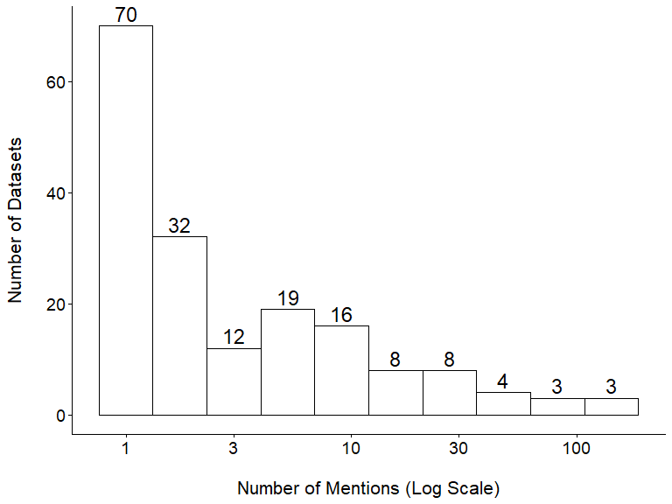
Figure 1: Distribution Frequency of Datasets References (N = 175)
_{Source: plots}
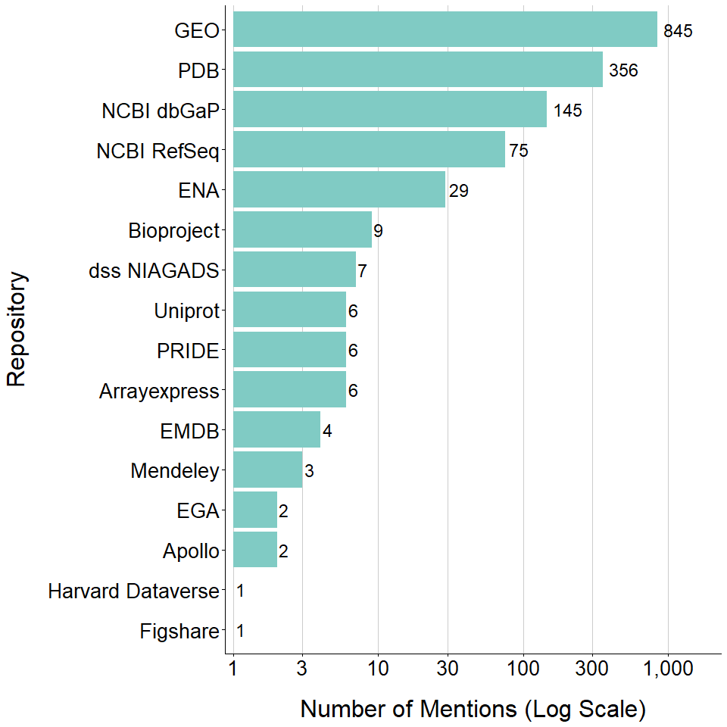
Figure 2: Distribution of References Across Repositories (N = 1,497)
_{Source: plots}
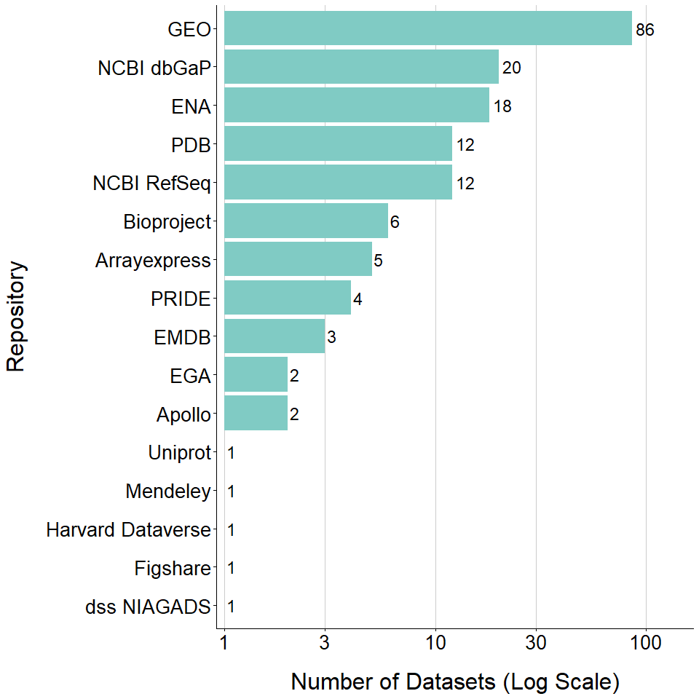
Figure 3: Distribution of Datasets Across Repositories (N = 175)
_{Source: plots}
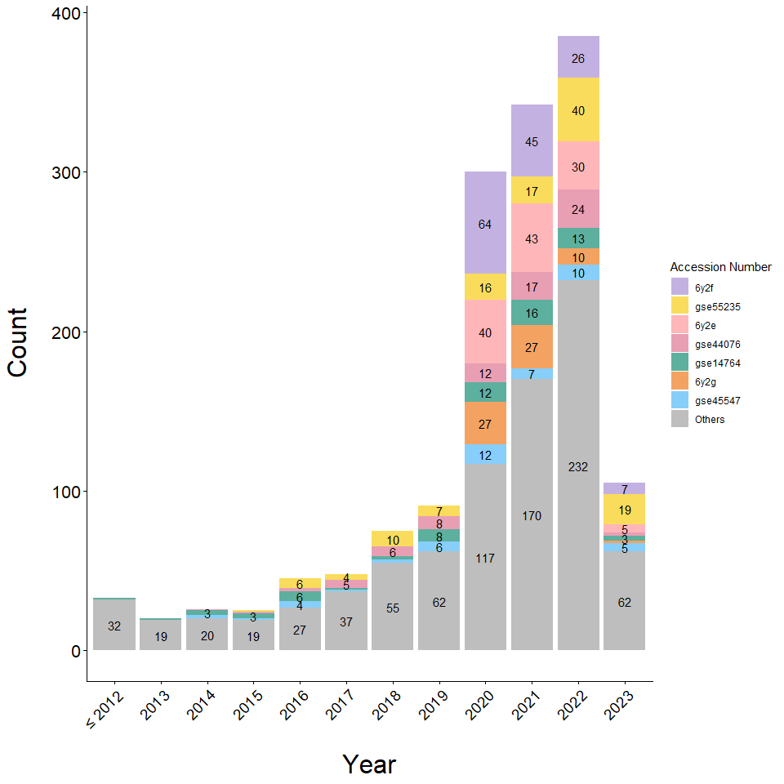
Figure 4: Most Cited Datasets by Year (N = 7)
_{Source: plots}
Note: Year 2024 is not shown in the plot.
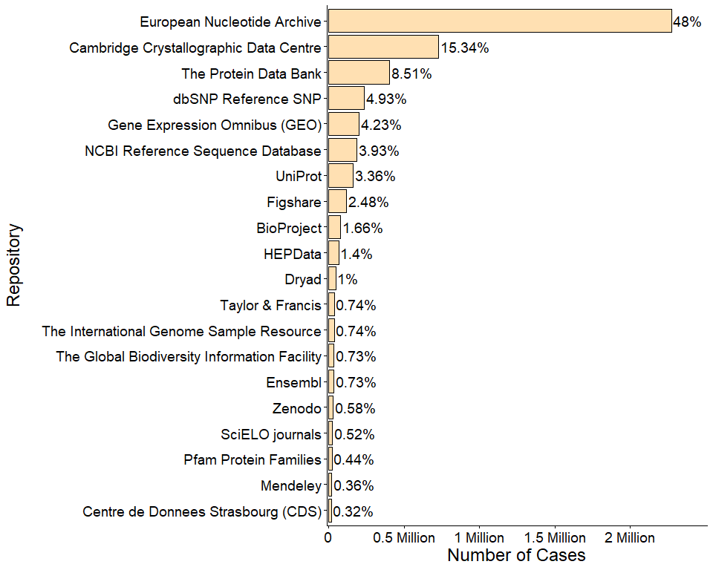
Figure 5: Distribution of the 20 Most Prevalent DCC Repositories (N = 4,742,484)
_{Source: plots}
The raw DCC dataset includes multiple entries as repositories which are in fact publishers and preprint platforms.
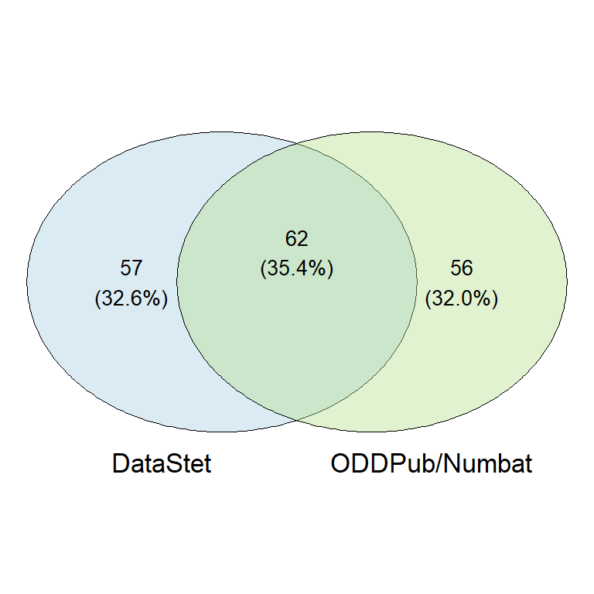
Figure 6: Sources of Matched Identifiers (N = 175)
_{Source: plots}
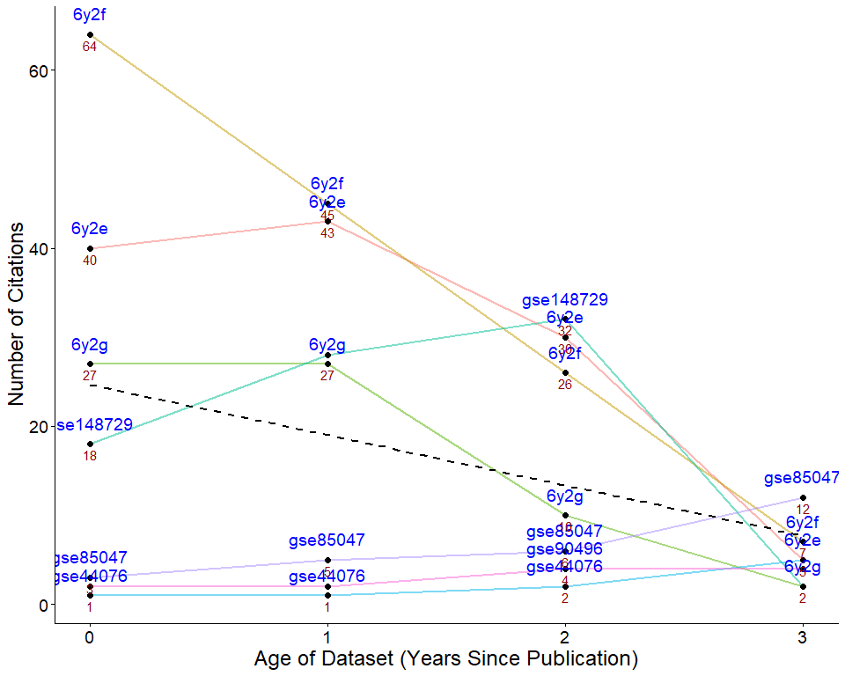
Figure 7: Datasets Citations by Year (N = 7)
_{Source: plots}
This plot shows datasets that were mentioned every year since their publication year until 3 years later.
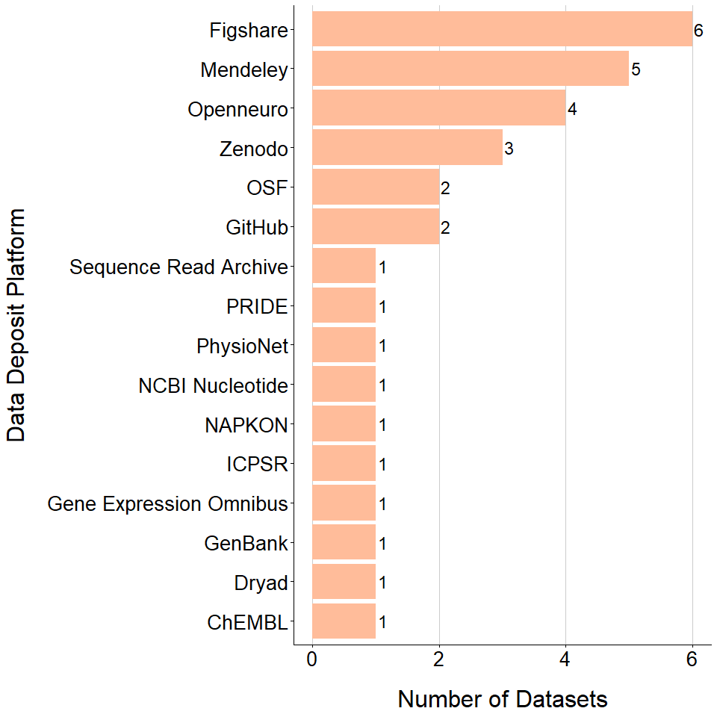
Figure 8: Repositories Distribution of Data Articles identifiers (N = 32)
_{Source: plots}
Note: Two repositories were irretrievable.
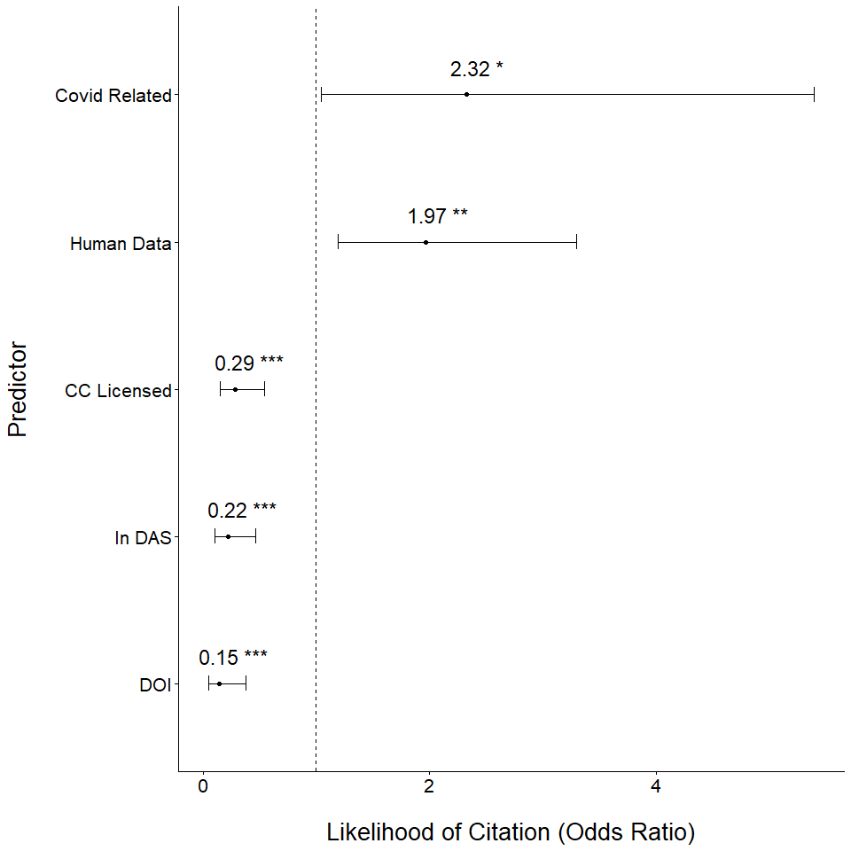
Figure 9: Determinants of institutional dataset reuse (N = 375)
_{Source: plots}

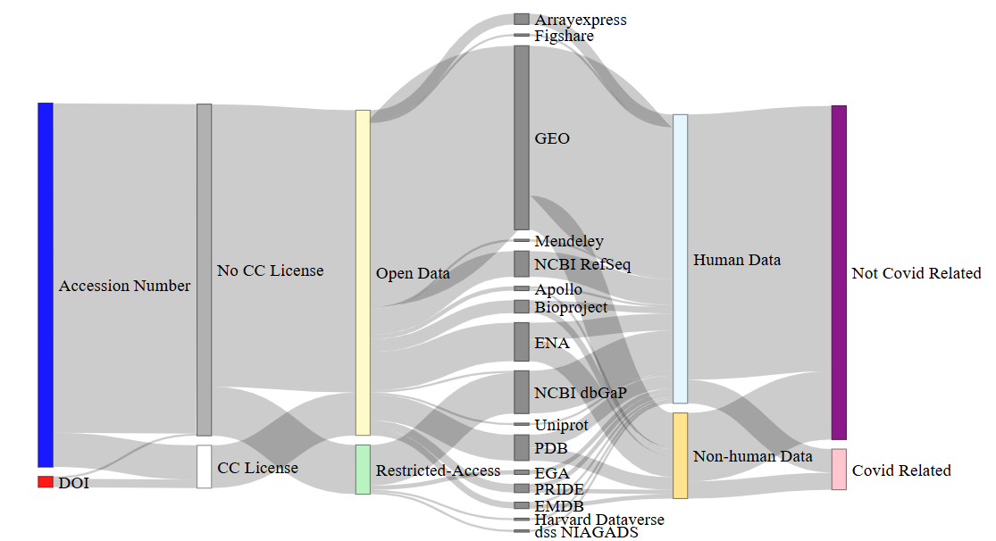
Figure 10: Determinants of institutional dataset reuse (N = 175)

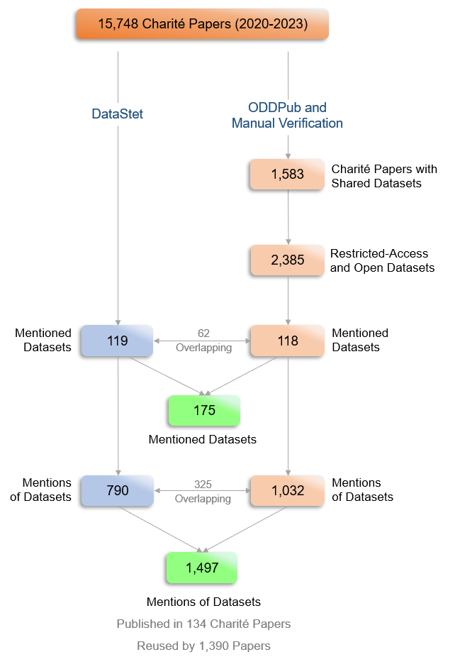
Figure 11: Charité Datasets and Mentions as Detected in DCC

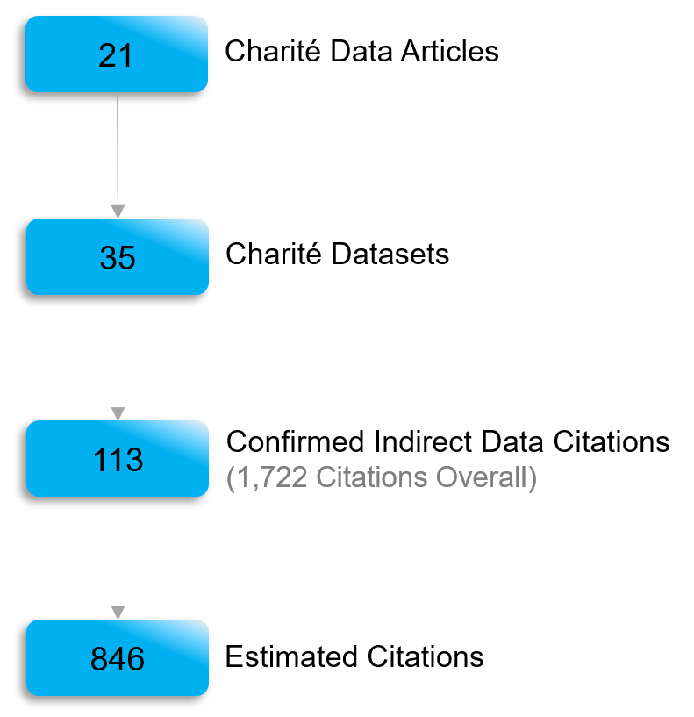
Figure 12: Charité Data Articles Citations Analysis

5. Supplementary Materials:
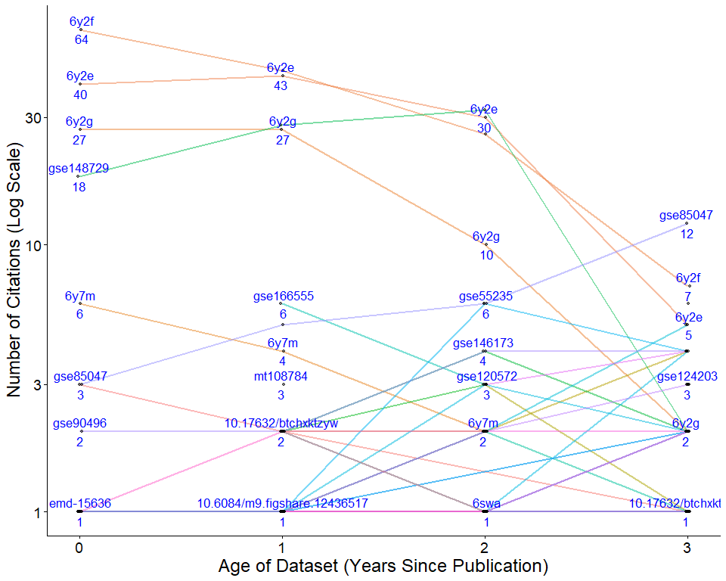
Figure 13: Dataset Citations by Year (N = 123)
_{Source: plots}
This plot shows datasets that were mentioned at any point between 0 and 3 years after their publication.
Banaeefar, Homeyra, Sarah Burchart, Elizabeth Moss, and Eszter Palvolgyi-Polyak. n.d. “Best Practice May Not Be Enough: Variation in Data Citation Using DOIs.” https://doi.org/10.7302/4809.
Barlösius, Eva. 2023. ““We Share All Data with Each Other”: Data-Sharing in Peer-to-Peer Relationships.” Minerva 61 (2): 243–63. https://doi.org/10.1007/s11024-023-09487-y.
BMWK. n.d. “FAQ Datenhoheit.” https://www.digitale-technologien.de/DT/Redaktion/DE/Standardartikel/FAQ-Recht/datenhoheit.html.
Brzezinski, Michal. 2015. “Power Laws in Citation Distributions: Evidence from Scopus.” Scientometrics 103 (1): 213–28. https://doi.org/10.1007/s11192-014-1524-z.
Callaghan, Sarah, Steve Donegan, Sam Pepler, Mark Thorley, Nathan Cunningham, Peter Kirsch, Linda Ault, et al. 2012. “Making Data a First Class Scientific Output: Data Citation and Publication by NERC’s Environmental Data Centres.” International Journal of Digital Curation 7 (1): 107–13. https://doi.org/10.2218/ijdc.v7i1.218.
“Charité Dashboard on Responsible Research.” n.d. https://quest-dashboard.charite.de/#tabStart.
EOSC EDEN. n.d. “Eden Project- about Us.” https://eden-fidelis.eu/about-us.
FORCE11. n.d. “Data Usage Typologies FORCE11.” https://force11.org/group/data-usage-typologies/.
Gerasimov, Irina, Binita KC, Armin Mehrabian, James Acker, and Michael P. McGuire. 2024. “Comparison of Datasets Citation Coverage in Google Scholar, Web of Science, Scopus, Crossref, and DataCite.” Scientometrics 129 (7): 3681–3704. https://doi.org/10.1007/s11192-024-05073-5.
Gregory, Kathleen, Paul Groth, Andrea Scharnhorst, and Sally Wyatt. 2020. “Lost or Found? Discovering Data Needed for Research.” Harvard Data Science Review 2 (2). https://doi.org/10.1162/99608f92.e38165eb.
Gregory, Kathleen, Anton Ninkov, Chantal Ripp, Emma Roblin, Isabella Peters, and Stefanie Haustein. 2023. “Tracing Data: A Survey Investigating Disciplinary Differences in Data Citation.” Quantitative Science Studies 4 (3): 622–49. https://doi.org/10.1162/qss_a_00264.
Hahnel, Mark, Graham Smith, and Ann Campbell. 2024. “The State of Open Data 2024: Special Report Bridging Policy and Practice in Data Sharing.” https://doi.org/10.6084/M9.FIGSHARE.27337476.V2.
Iarkaeva, Anastasiia, Evgeny Bobrov, Jan Taubitz, Benjamin Gregory Carlisle, and Nico Riedel. 2022. “Semi-Automated Extraction of Information on Open Datasets Mentioned in Articles,” May. https://www.protocols.io/view/semi-automated-extraction-of-information-on-open-d-b5vxq67n.
Iarkaeva, Anastasiia, Vladislav Nachev, and Evgeny Bobrov. 2024. “Workflow for Detecting Biomedical Articles with Underlying Open and Restricted-Access Datasets,” January. https://doi.org/10.31222/osf.io/z4bkf.
Jiao, Chenyue, and Peter T. Darch. 2020. “The Role of the Data Paper in Scholarly Communication.” Proceedings of the Association for Information Science and Technology 57 (1): e316. https://doi.org/10.1002/pra2.316.
Lafia, Sara, Andrea Thomer, Elizabeth Moss, David Bleckley, and Libby Hemphill. 2023. “How and Why Do Researchers Reference Data? A Study of Rhetorical Features and Functions of Data References in Academic Articles.” Data Science Journal 22 (April): 10. https://doi.org/10.5334/dsj-2023-010.
Locher, Clara, Gérard Le Goff, Anne Le Louarn, Ulrich Mansmann, and Florian Naudet. 2023. “Making Data Sharing the Norm in Medical Research.” BMJ 382 (July): p1434. https://doi.org/10.1136/bmj.p1434.
Loder, Elizabeth, Helen Macdonald, Theodora Bloom, and Kamran Abbasi. 2024. “Mandatory Data and Code Sharing for Research Published by The BMJ.” BMJ, March, q324. https://doi.org/10.1136/bmj.q324.
Lopez, Patrice, and Anne L’Hôte. n.d. Kermitt2/Datastet. https://github.com/kermitt2/datastet.
NicoRiedel, and Vladislav Nachev. 2025. Quest-Bih/Oddpub: Vulcan Point. Zenodo. https://doi.org/10.5281/zenodo.15555546.
Ninkov, Anton, Kathleen Gregory, Isabella Peters, and Stefanie Haustein. 2021. “Datasets on DataCite - an Initial Bibliometric Investigation,” April. https://doi.org/10.5281/zenodo.4730857.
“OpenAlex.” n.d. https://openalex.org/.
Page, Roderic. 2024. “The Data Citation Corpus Revisited.” https://iphylo.blogspot.com/2024/10/the-data-citation-corpus-revisited.html.
Park, Hyoungjoo, Sukjin You, and Dietmar Wolfram. 2018. “Informal Data Citation for Data Sharing and Reuse Is More Common Than Formal Data Citation in Biomedical Fields.” Journal of the Association for Information Science and Technology 69 (11): 1346–54. https://doi.org/https://doi.org/10.1002/asi.24049.
PLOS Medicine. n.d. “Data Availability.” https://journals.plos.org/plosmedicine/s/data-availability.
Publications Office of the European Union. 2024. What is data ownership, and does it still matter under EU data law?: an exploration of traditional concepts of data ownership, and of the expected impact of the Data Act. LU: Publications Office. https://data.europa.eu/doi/10.2830/052185.
Redner, S. 1998. “How Popular Is Your Paper? An Empirical Study of the Citation Distribution.” The European Physical Journal B - Condensed Matter and Complex Systems 4 (2): 131–34. https://doi.org/10.1007/s100510050359.
Riedel, Nico, Miriam Kip, and Evgeny Bobrov. n.d. “ODDPub a Text-Mining Algorithm to Detect Data Sharing in Biomedical Publications.” https://doi.org/10.1101/2020.05.11.088021.
Rosman, Tom, Michael Bosnjak, Henning Silber, Joanna Koßmann, and Tobias Heycke. 2022. “Open Science and Public Trust in Science: Results from Two Studies.” Public Understanding of Science 31 (8): 1046–62. https://doi.org/10.1177/09636625221100686.
Ross, Karen E, Frederic B Bastian, Matt Buys, Charles E Cook, Peter D’Eustachio, Melissa Harrison, Henning Hermjakob, et al. 2024. “Perspectives on Tracking Data Reuse Across Biodata Resources.” Bioinformatics Advances 4 (1): vbae057. https://doi.org/10.1093/bioadv/vbae057.
Sandt, Stephanie van de, Sünje Dallmeier-Tiessen, Artemis Lavasa, and Vivien Petras. 2019. “The Definition of Reuse.” Data Science Journal 18 (1). https://doi.org/10.5334/dsj-2019-022.
Silvello, Gianmaria. 2018. “Theory and Practice of Data Citation.” Journal of the Association for Information Science and Technology 69 (1): 6–20. https://doi.org/10.1002/asi.23917.
Strecker, Dorothea, Kerstin Soltau, and Felix Bach. 2025. “How Are Research Data Referenced? The Use Case of the Research Data Repository RADAR.” https://doi.org/10.48550/arXiv.2505.08533.
The Neuro. n.d. “Open Science, to Accelerate Discovery and Deliver Cures.” https://www.mcgill.ca/neuro/open-science.
“UNESCO Recommendation on Open Science.” n.d. https://www.unesco.org/en/open-science/about.
Vries, Saskia E. J. de, Joshua H. Siegle, and Christof Koch. n.d. “Sharing Neurophysiology Data from the Allen Brain Observatory: Lessons Learned.” https://doi.org/10.48550/arXiv.2212.08638.
Wellcome. n.d. “Data, Software and Materials Management and Sharing Policy - Grant Funding.” https://wellcome.org/research-funding/guidance/policies-grant-conditions/data-software-materials-management-and-sharing-policy.
Yoon, JungWon, EunKyung Chung, Jae Yun Lee, and Jihyun Kim. 2019. “How Research Data Is Cited in Scholarly Literature: A Case Study of HINTS.” Learned Publishing 32 (3): 199–206. https://doi.org/10.1002/leap.1213.

