dcc_ds_and_added_joined_1_rm_self
Autogenerated data summary from dataMaid
2025-07-15 12:09:21.866567

Data report overview
The dataset examined has the following dimensions:
Feature | Result
Number of observations | 101223
Number of variables | 35

Checks performed
The following variable checks were performed, depending on the data type of each variable:
 | character | factor | labelled | haven labelled | numeric | integer | logical | Date
Identify miscoded missing values | × | × | × | × | × | × |  | ×
Identify prefixed and suffixed whitespace | × | × | × | ×
Identify levels with < 6 obs. | × | × | × | ×
Identify case issues | × | × | × | ×
Identify misclassified numeric or integer variables | × | × | × | ×
Identify outliers |  |  |  |  | × | × |  | ×
Please note that all numerical values in the following have been rounded to 2 decimals.

Summary table
 | Variable class | # unique values | Missing observations | Any problems?
doi_datastet_and_added | character | 473 | 0.00 % | ×
year | integer | 5 | 3.49 %
context | character | 1032 | 3.49 % | ×
extracted_id | character | 920 | 3.49 % | ×
slug_datastet_and_added | character | 4 | 99.99 % | ×
data_id_auto_cleaned | character | 886 | 0.00 % | ×
m_val | character | 17 | 0.00 % | ×
dataset_for_matching | character | 880 | 0.00 % | ×
source_datastet_and_added | character | 2 | 0.00 %
detected_id | character | 41 | 96.51 % | ×
added_id | character | 128 | 96.51 % | ×
validate | character | 1 | 0.00 % | ×
Category | character | 2 | 0.00 %
is_gen_rep | logical | 2 | 0.00 %
in_numbat_or_data_articles | logical | 1 | 0.00 % | ×
id | character | 35241 | 0.00 % | ×
created | Date | 13 | 0.00 % | ×
updated | Date | 45 | 0.00 % | ×
repository | character | 23 | 0.00 % | ×
publisher | character | 221 | 0.00 % | ×
journal | character | 2144 | 0.00 % | ×
title | character | 10 | 0.00 % | ×
dataset | character | 1096 | 0.00 % | ×
data_id_or_acc_nr | character | 880 | 0.00 % | ×
slug_dcc | character | 4 | 99.99 % | ×
doi_dcc | character | 28462 | 0.00 % | ×
publishedDate | Date | 3832 | 2.09 % | ×
source_dcc | character | 3 | 0.00 % | ×
subjects | character | 44 | 0.00 % | ×
affiliations | character | 7 | 0.00 % | ×
affiliationsROR | character | 7 | 0.00 % | ×
funders | character | 2 | 0.00 % | ×
fundersROR | character | 2 | 0.00 % | ×
was_the_id_standardized | logical | 2 | 0.00 %
primary | logical | 1 | 0.00 % | ×

Variable list

doi_datastet_and_added
Feature | Result
Variable type | character
Number of missing obs. | 0 (0 %)
Number of unique values | 473
Mode | “10.1038/s41586-020-2882-8”
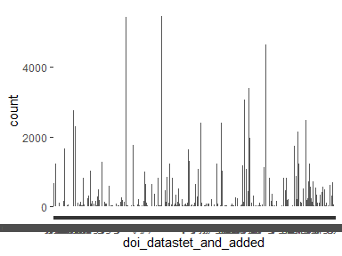
- Note that the following levels have at most five observations: "10.1002/1878-0261.12835", "10.1002/art.41637", "10.1002/eji.202048797", "10.1002/eji.202250059", "10.1002/hbm.26097", …, "10.3390/ijms23042263", "10.3390/microorganisms10081603", "10.3390/pathogens12070967", "10.3390/v14051041", "10.7717/peerj.10373" (146 values omitted).

year
- Note that this variable is treated as a factor variable below, as it only takes a few unique values.
Feature | Result
Variable type | integer
Number of missing obs. | 3535 (3.49 %)
Number of unique values | 4
Mode | “2020”
Reference category | 2020
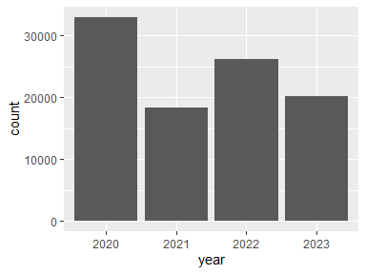

context
Feature | Result
Variable type | character
Number of missing obs. | 3535 (3.49 %)
Number of unique values | 1031
Mode | “b, mrna expression levels of ltb, tnfsf14 and ltbr relative to hprt, determined by qpcr in whole lung from the mice described in a (fa n = 5, cs plus control ig n = 5, ltβr-ig n = 5, ltβr-ig + pri-724 n = 6 and chir99021 n = 5 mice per group).”
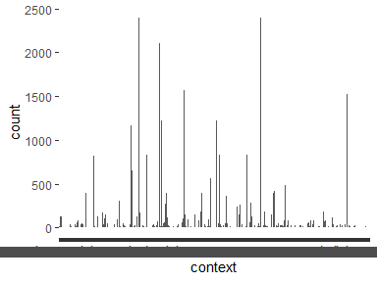
- Note that the following levels have at most five observations: "(1) for the n-terminal low-density lipoprotein class a (ldla, amino acids gly21-gly63), structural information is available (, protein database http://www.rcsb.org id: 2jm4 ).", "(j) in an experiment as in (a) expression levels of transcription factors and surface markers were determined on day 6 after gating on tcf-1 + or tcf-1 à cells (mfi reported as mean ± sd). (k) p14 wt tcf7 gfp cells were transferred into wt recipients followed by lcmv infection as outlined in (e) and stained for st2.", "(p) st2 receptor expression was determined on adoptively transferred p14 wt and p14 ifnar1 à/à cells on day 6 after lcmv infection (p14 il1rl1 à/à cells served as negative controls).", "■ experimental section we reanalyzed the publicly available cid ms -based data from the ribosome data set (pxd011861) and synaptosome (pxd010317 and pxd015160) data set.", "3 genes of interest (hlf, myc and kiaa0101) are differentially expressed both in lgg and gbm.", …, "while the underlying causal variant rs2231142 at abcg2, a missense variant causing reduced function, has been identified , the causal mechanisms underlying the strongest genetic associa- tion signal with serum urate, which maps to the urate transporter gene slc2a9, remain largely unknown .", "whole exome sequencing was performed and yielded the heterozygous start loss variant, c.3g > a, p. met1ile in slc52a1 (nm_017986.4).", "whole genome bisulfite sequencing data for lt-hsc isolated from young mice can be downloaded from the geo under accession number gse52709 (https://www.ncbi.nlm.nih.gov/geo/query/acc.cgi?acc=gse52709).", "within a lentiviral shuttle vector (fugw) , a 785-nt herv-k sequence portion (corresponding to nt 7291-8076 in genbank accession number af074086.2) (51) was subcloned downstream of a nucleus-targeting gfp (nls-gfp) reporter gene that was controlled by a strong synthetic cag promoter.", "wnt pathway target genes were obtained from (58) through the geo database (gse45223)." (421 values omitted).

extracted_id
Feature | Result
Variable type | character
Number of missing obs. | 3535 (3.49 %)
Number of unique values | 919
Mode | “chir99021”
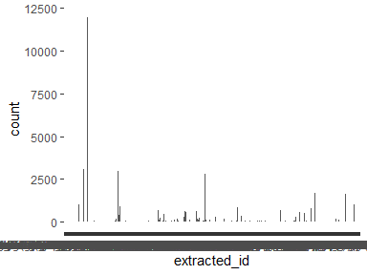
- The following values appear with prefixed or suffixed white space: "// osf.io/ 98j7u/ ", "e-mtab- 2299 ", "e-mtab- 8248 ", "e-mtab-5061 ", "e-mtab-5552 ", …, "st2 ", "st2 ", "st307 ", "st410 ", "st78 " (240 values omitted).
- Note that the following levels have at most five observations: "(1) for the n-terminal low-density lipoprotein class a (ldla, amino acids gly21-gly63), structural information is available (, protein database http://www.rcsb.org id: 2jm4 ).", "// doi. org/ 10. 5281/ zenodo. 60639 05.", "// doi. org/ 10. 7802/ 1460", "// doi. org/ 10. 7802/ 1460.", "// osf.io/ 98j7u/ ", …, "trmt112", "vevo3100", "wbkls0050", "wbluf0500", "wo201505" (425 values omitted).

slug_datastet_and_added
Feature | Result
Variable type | character
Number of missing obs. | 101215 (99.99 %)
Number of unique values | 3
Mode | “8jye2”
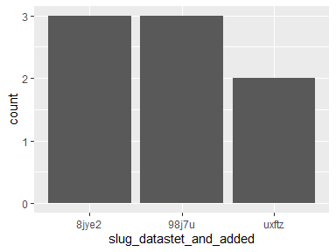
- Note that the following levels have at most five observations: "8jye2", "98j7u", "uxftz".

data_id_auto_cleaned
Feature | Result
Variable type | character
Number of missing obs. | 0 (0 %)
Number of unique values | 886
Mode | “chir99021”
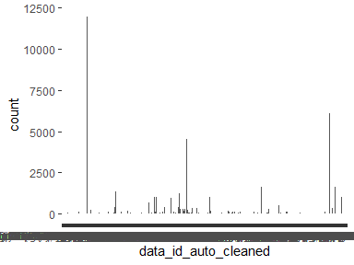
- Note that the following levels have at most five observations: "(1)forthen-terminallow-densitylipoproteinclassa(ldla,aminoacidsgly21-gly63),structuralinformationisavailable(,proteindatabasehttp://www.rcsb.orgid:2jm4)", "//osf.io/8jye2", "//osf.io/98j7u", "//osf.io/uxftz", "10.15154/1519007", …, "trmt112", "vevo3100", "wbkls0050", "wbluf0500", "wo201505" (391 values omitted).

m_val
Feature | Result
Variable type | character
Number of missing obs. | 0 (0 %)
Number of unique values | 17
Mode | “”
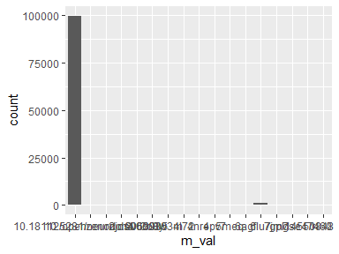
- The following suspected missing value codes enter as regular values: "".
- Note that the following levels have at most five observations: "10.18112/openneuro.ds000030", "10.5281/zenodo.6063905", "2jm4", "2v6c", "4pv7", "5meq", "7jm7".

dataset_for_matching
Feature | Result
Variable type | character
Number of missing obs. | 0 (0 %)
Number of unique values | 880
Mode | “chir99021”
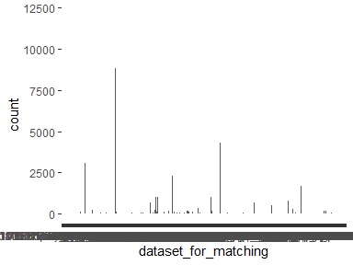
- Note that the following levels have at most five observations: "10.15154/1519007", "10.17632/83rthbp8ys", "10.18112/openneuro.ds000030", "10.5061/dryad.8t8s248", "10.5061/dryad.d9v38", …, "trmt112", "vevo3100", "wbkls0050", "wbluf0500", "wo201505" (390 values omitted).

source_datastet_and_added
Feature | Result
Variable type | character
Number of missing obs. | 0 (0 %)
Number of unique values | 2
Mode | “datastet”
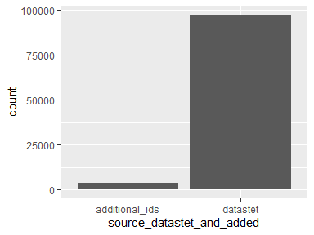

detected_id
Feature | Result
Variable type | character
Number of missing obs. | 97688 (96.51 %)
Number of unique values | 40
Mode | “mt108784”
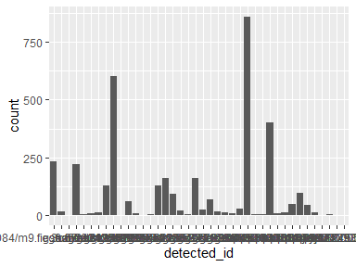
- Note that the following levels have at most five observations: "6swa", "7lm8", "gse153105", "gse158596", "gse160097", …, "on158817", "prjeb37249", "prjeb39750", "prjna579336", "up000005640" (1 values omitted).

added_id
Feature | Result
Variable type | character
Number of missing obs. | 97688 (96.51 %)
Number of unique values | 127
Mode | “MN908947.3”
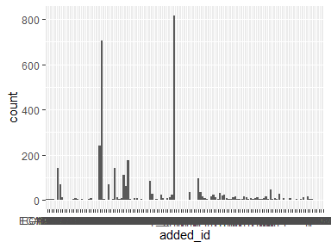
- Note that the following levels have at most five observations: "1K5N", "1UXS", "1UXW", "2A83", "5IB5", …, "phs002068.v1.p1", "PRJEB37677", "PRJEB38742", "PXD013658", "PXD017703" (58 values omitted).

validate
- The variable only takes one (non-missing) value: "TRUE". The variable contains 0 % missing observations.

Category
Feature | Result
Variable type | character
Number of missing obs. | 0 (0 %)
Number of unique values | 2
Mode | “acc_nr”
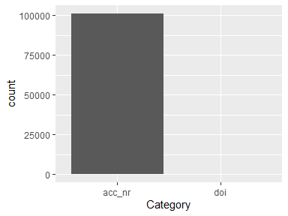

is_gen_rep
Feature | Result
Variable type | logical
Number of missing obs. | 0 (0 %)
Number of unique values | 2
Mode | “FALSE”
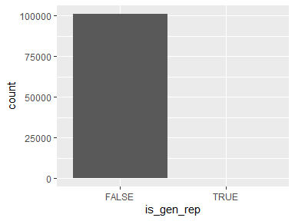

in_numbat_or_data_articles
- The variable only takes one (non-missing) value: "FALSE". The variable contains 0 % missing observations.

id
Feature | Result
Variable type | character
Number of missing obs. | 0 (0 %)
Number of unique values | 35241
Mode | “0045c492-a858-4393-86f1-d9ce1015d218”
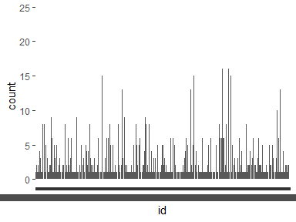
- Note that the following levels have at most five observations: "00005d29-7fce-4afe-a2e3-175eed8f081e", "0000862b-15f6-42b2-8f1c-659ac867863e", "000a0418-b09c-4295-a30c-9c652bf4644c", "000f67d9-f8ab-4fb9-a2d2-bde9151cddf1", "00134122-c415-4cdf-b6a2-bf022d96e353", …, "fff7121a-3113-4af6-b066-974b706b3146", "fff743c2-e143-4918-bd2d-88daa07b305c", "fffac2a1-6733-4751-bd35-2468856f1336", "fffad3bb-7593-4907-a10d-5890da2cec26", "fffbeed0-1206-4e53-ae48-0dcdd675acbb" (30885 values omitted).

created
Feature | Result
Variable type | Date
Number of missing obs. | 0 (0 %)
Number of unique values | 13
Mode | “2023-09-27”
Min. and max. | 2023-06-07; 2025-01-31
1st and 3rd quartiles | 2023-09-26; 2023-09-27
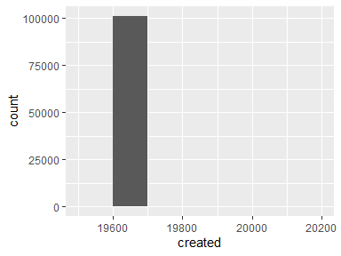
- Note that the following possible outlier values were detected: "2023-06-07", "2023-06-08", "2023-09-28", "2024-07-25", "2025-01-30", "2025-01-31".

updated
Feature | Result
Variable type | Date
Number of missing obs. | 0 (0 %)
Number of unique values | 45
Mode | “2023-09-27”
Min. and max. | 2023-06-07; 2025-01-31
1st and 3rd quartiles | 2023-09-27; 2023-11-14
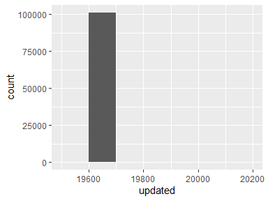
- Note that the following possible outlier values were detected: "2024-07-25", "2025-01-30", "2025-01-31".

repository
Feature | Result
Variable type | character
Number of missing obs. | 0 (0 %)
Number of unique values | 23
Mode | “gene expression omnibus (geo)”
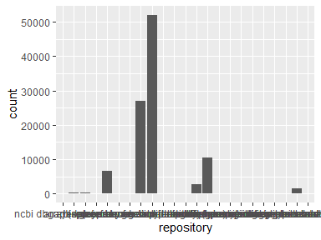
- The following suspected missing value codes enter as regular values: "".
- Note that the following levels have at most five observations: "", "dryad", "gesis data archive", "mendeley", "nimh data repositories", "openneuro", "the electron microscopy data bank (emdb)", "zenodo".

publisher
Feature | Result
Variable type | character
Number of missing obs. | 0 (0 %)
Number of unique values | 221
Mode | “Springer Science and Business Media LLC”
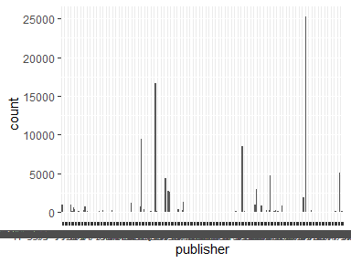
- The following suspected missing value codes enter as regular values: "".
- Note that the following levels have at most five observations: "Academic World Research", "Acta Naturae Ltd", "American Psychological Association (APA)", "AOSIS", "Archives of Endocrinology and Metabolism", …, "University Library System, University of Pittsburgh", "Uppsala Medical Society", "Veterinary World", "VM Media Group sp. z o.o", "Westerdijk Fungal Biodiversity Institute" (79 values omitted).

journal
Feature | Result
Variable type | character
Number of missing obs. | 0 (0 %)
Number of unique values | 2144
Mode | “scientific reports”
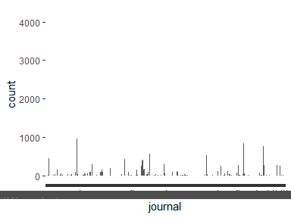
- The following suspected missing value codes enter as regular values: "".
- Note that the following levels have at most five observations: "<![cdata[advances and applications in bioinformatics and chemistry]]>", "<![cdata[aims microbiology]]>", "<![cdata[aims public health]]>", "<![cdata[breast cancer: targets and therapy]]>", "<![cdata[clinical epidemiology]]>", …, "world journal of transplantation", "world psychiatry", "yonsei medical journal", "zeitschrift für psychologie", "动物学研究" (1005 values omitted).

title
Feature | Result
Variable type | character
Number of missing obs. | 0 (0 %)
Number of unique values | 10
Mode | “”
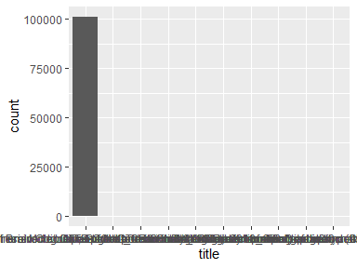
- The following suspected missing value codes enter as regular values: "".
- Note that the following levels have at most five observations: "A spatially resolved timeline of the human maternal-fetal interface", "Adolescent Brain Cognitive Development Study (ABCD) - Annual Release 3.0", "ariercole/UNITE-COVID: Version 3.1.0 release curation pipeline", "Cipriani et al_GRISELDA_Lancet 2018_Open dataset", "Data from: Molecular, spatial and functional single-cell profiling of the hypothalamic preoptic region", "Data from: The functional diversity of retinal ganglion cells in the mouse", "German Index of Socioeconomic Deprivation (GISD) Version 1.0", "UCLA Consortium for Neuropsychiatric Phenomics LA5c Study".

dataset
Feature | Result
Variable type | character
Number of missing obs. | 0 (0 %)
Number of unique values | 1096
Mode | “CHIR99021”
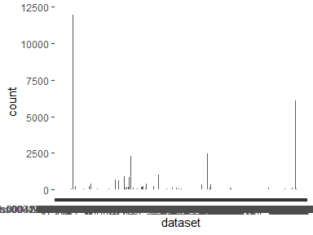
- Note that the following levels have at most five observations: "1K5N", "1UXS", "1UXW", "2A83", "2JM4", …, "TRMT112", "VEVO3100", "WBKLS0050", "WBLUF0500", "WO201505" (563 values omitted).
- Note that there might be case problems with the following levels: "3o8y", "3O8Y", "6lu7", "6LU7", "6y2f", "6Y2F", "6y2g", "6Y2G".

data_id_or_acc_nr
Feature | Result
Variable type | character
Number of missing obs. | 0 (0 %)
Number of unique values | 880
Mode | “chir99021”
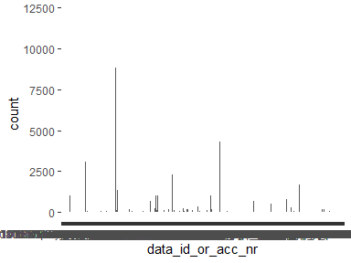
- Note that the following levels have at most five observations: "//osf.io/8jye2", "//osf.io/98j7u", "//osf.io/uxftz", "10.15154/1519007", "10.17632/83rthbp8ys", …, "trmt112", "vevo3100", "wbkls0050", "wbluf0500", "wo201505" (390 values omitted).

slug_dcc
Feature | Result
Variable type | character
Number of missing obs. | 101215 (99.99 %)
Number of unique values | 3
Mode | “8jye2”
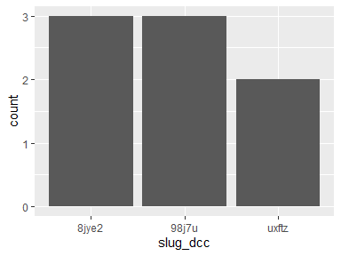
- Note that the following levels have at most five observations: "8jye2", "98j7u", "uxftz".

doi_dcc
Feature | Result
Variable type | character
Number of missing obs. | 0 (0 %)
Number of unique values | 28462
Mode | “10.3390/cancers13092128”
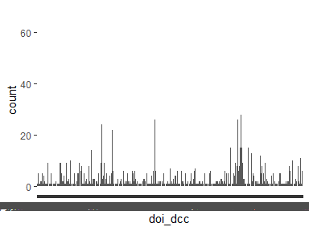
- Note that the following levels have at most five observations: "10.1001/jamahealthforum.2022.1815", "10.1001/jamainternmed.2021.0269", "10.1001/jamanetworkopen.2018.4080", "10.1001/jamanetworkopen.2019.12259", "10.1001/jamanetworkopen.2019.16211", …, "10.7759/cureus.3364", "10.7759/cureus.38627", "10.7759/cureus.4004", "10.7785/tcrtexpress.2013.600272", "10.9758/cpn.2017.15.1.47" (23251 values omitted).

publishedDate
Feature | Result
Variable type | Date
Number of missing obs. | 2115 (2.09 %)
Number of unique values | 3831
Mode | “2021-01-01”
Min. and max. | 1998-07-13; 2023-09-01
1st and 3rd quartiles | 2019-07-10; 2022-05-01
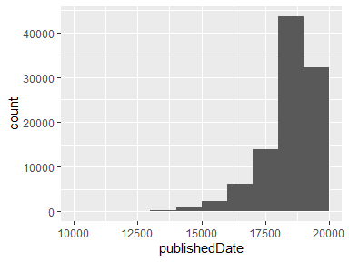
- Note that the following possible outlier values were detected: "1998-07-13", "1999-01-31", "2002-06-01", "2003-01-01", "2003-05-01", …, "2007-11-15", "2023-07-01", "2023-07-18", "2023-08-01", "2023-09-01" (91 values omitted).

source_dcc
Feature | Result
Variable type | character
Number of missing obs. | 0 (0 %)
Number of unique values | 3
Mode | “czi”
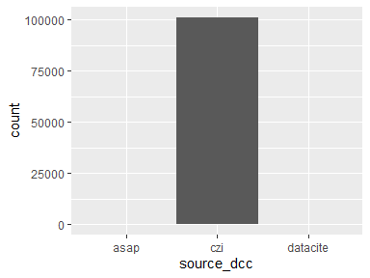
- Note that the following levels have at most five observations: "asap".

subjects
Feature | Result
Variable type | character
Number of missing obs. | 0 (0 %)
Number of unique values | 44
Mode | “biological sciences; basic medicine”
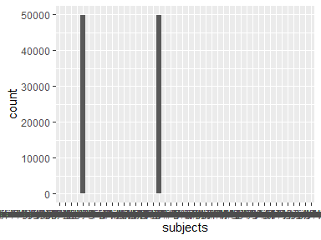
- The following suspected missing value codes enter as regular values: "".
- Note that the following levels have at most five observations: "animal and dairy science; basic medicine; biological sciences", "animal and dairy science; biological sciences; basic medicine", "basic medicine; animal and dairy science; biological sciences", "basic medicine; biological sciences; animal and dairy science", "basic medicine; chemical sciences; biological sciences; health biotechnology", …, "biological sciences; animal and dairy science; basic medicine", "biological sciences; basic medicine; animal and dairy science", "biological sciences; basic medicine; chemical sciences; health biotechnology", "biological sciences; chemical sciences; health biotechnology; basic medicine", "chemical sciences; health biotechnology; basic medicine; biological sciences" (1 values omitted).

affiliations
Feature | Result
Variable type | character
Number of missing obs. | 0 (0 %)
Number of unique values | 7
Mode | “”
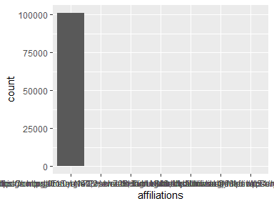
- The following suspected missing value codes enter as regular values: "".
- Note that the following levels have at most five observations: "Bernstein Center for Computational Neuroscience Tübingen https://ror.org/03kfnwp54\“, "Broad Institute https://ror.org/05a0ya142; Howard Hughes Medical Institute https://ror.org/006w34k90\”, "Robert Koch-Institut", "Stanford University", "University of Cambridge https://ror.org/013meh722; Amsterdam UMC; VU University Medical Center https://ror.org/00q6h8f30; Humanitas University; Universiteit Gent", "University of Cambridge https://ror.org/013meh722; VU University Medical Center https://ror.org/00q6h8f30; Universiteit Gent; Humanitas University; Amsterdam UMC".

affiliationsROR
Feature | Result
Variable type | character
Number of missing obs. | 0 (0 %)
Number of unique values | 7
Mode | “”
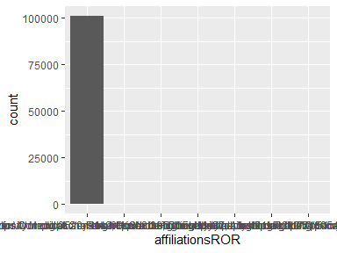
- The following suspected missing value codes enter as regular values: "".
- Note that the following levels have at most five observations: "Bernstein Center for Computational Neuroscience Tübingen https://ror.org/03kfnwp54\“, "Broad Institute https://ror.org/05a0ya142; Howard Hughes Medical Institute https://ror.org/006w34k90\”, "Robert Koch Institute https://ror.org/01k5qnb77\“, "Stanford University https://ror.org/00f54p054\”, "University of Cambridge https://ror.org/013meh722; Amsterdam UMC Location VUmc https://ror.org/00q6h8f30; Ghent University https://ror.org/00cv9y106; Humanitas University https://ror.org/020dggs04; Amsterdam University Medical Centers https://ror.org/05grdyy37\“, "University of Cambridge https://ror.org/013meh722; Amsterdam University Medical Centers https://ror.org/05grdyy37; Amsterdam UMC Location VUmc https://ror.org/00q6h8f30; Humanitas University https://ror.org/020dggs04; Ghent University https://ror.org/00cv9y106\”.

funders
Feature | Result
Variable type | character
Number of missing obs. | 0 (0 %)
Number of unique values | 2
Mode | “”
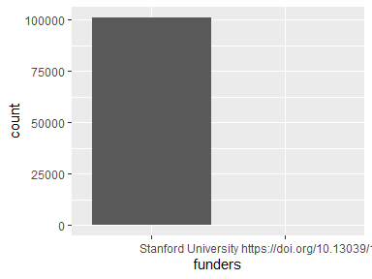
- The following suspected missing value codes enter as regular values: "".
- Note that the following levels have at most five observations: "Stanford University https://doi.org/10.13039/100005492\“.

fundersROR
Feature | Result
Variable type | character
Number of missing obs. | 0 (0 %)
Number of unique values | 2
Mode | “”
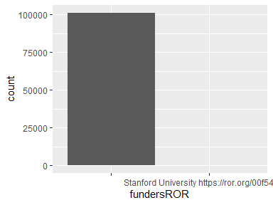
- The following suspected missing value codes enter as regular values: "".
- Note that the following levels have at most five observations: "Stanford University https://ror.org/00f54p054\“.

was_the_id_standardized
Feature | Result
Variable type | logical
Number of missing obs. | 0 (0 %)
Number of unique values | 2
Mode | “TRUE”
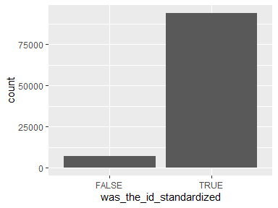

primary
- The variable only takes one (non-missing) value: "TRUE". The variable contains 0 % missing observations.

Report generation information:
- Created by: Cohen, Avihay (username: avco10).
- Report creation time: Tue Jul 15 2025 12:10:17
- Report was run from directory: C:/AVIHAY/git/DCC-v3
- dataMaid v1.4.2 [Pkg: 2025-04-13 from CRAN (R 4.3.3)]
- R version 4.3.3 (2024-02-29 ucrt).
- Platform: x86_64-w64-mingw32/x64 (64-bit)(Europe/Berlin).
- Function call: makeDataReport(data = dcc_ds_and_added_joined_1_rm_self)

