Test 1:

Publisedh messages using Jmeter:

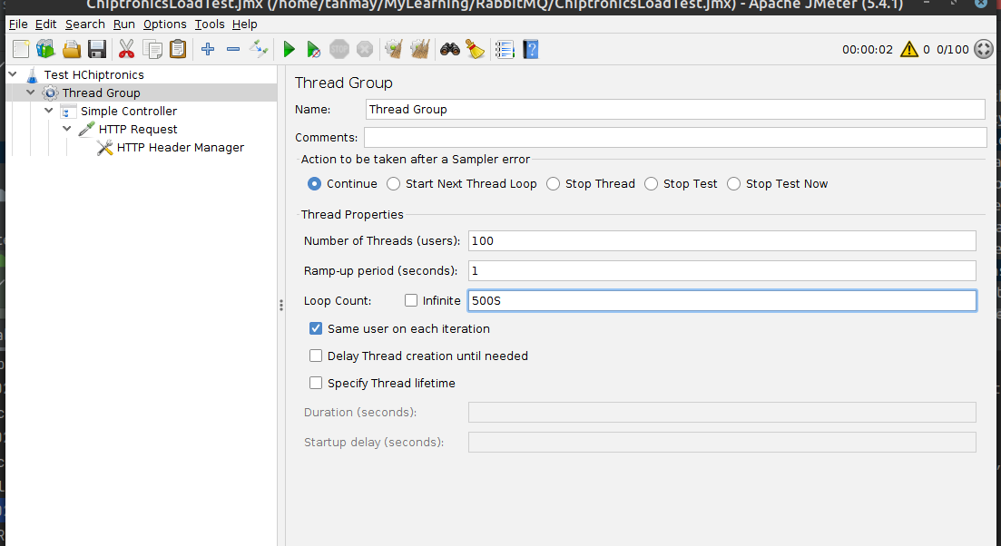

Below scree shot shows that there are 1000 messages in the MQ.

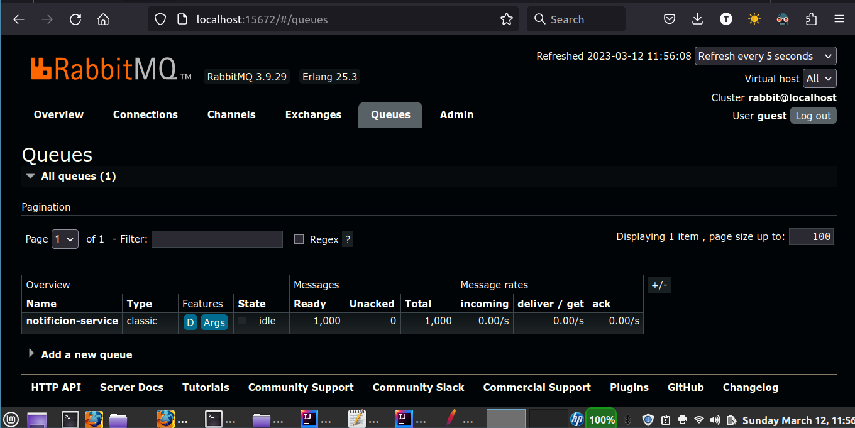

Started Consumer:

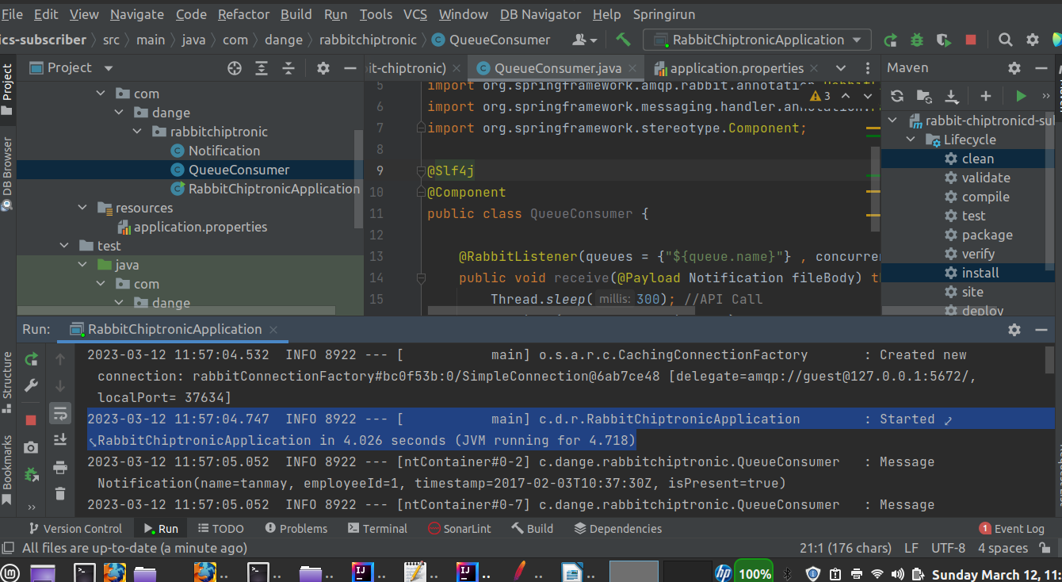

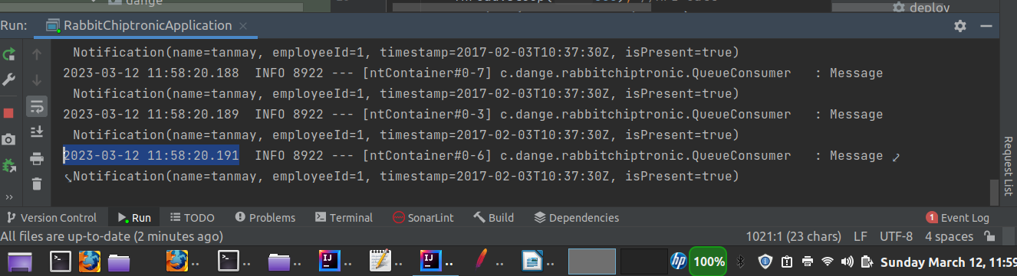

2023-03-12 11:58:20.191

No of Messages: 1000

Start Time: 2023-03-12 11:57:04.747

End Time: 2023-03-12 11:58:20.191

Duration : 1 min 16 seconds

Test2: 50K Messages

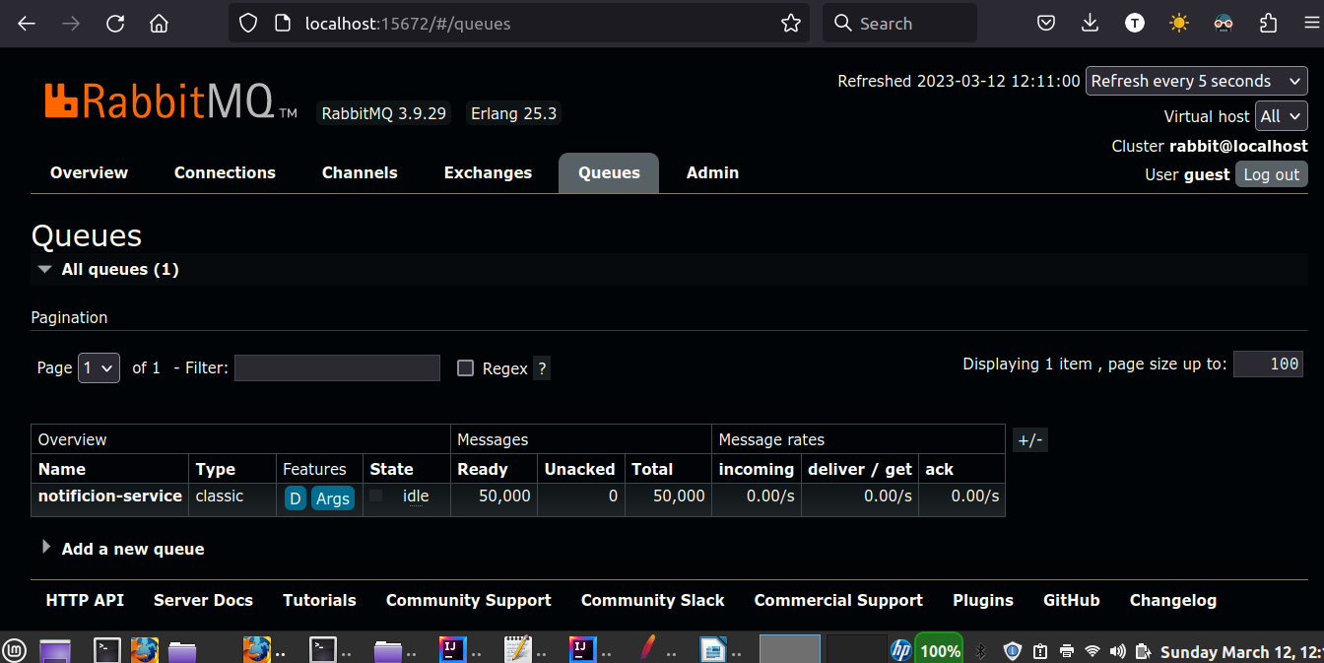

No of Messages: 50000

No. of Treads: 10

Start Time: 2023-03-12 12:12:06.616

End Time: 2023-03-12 12:37:11.626

Duration : 15 mins

Test 3:

No of Messages: 50000

No. of Treads: 25

Start Time: 2023-03-12 12:40:24.153

End Time: 2023-03-12 12:50:26.853

Duration : 10mins 2 sec