***Heart-o-Matic 10***

# User Manual

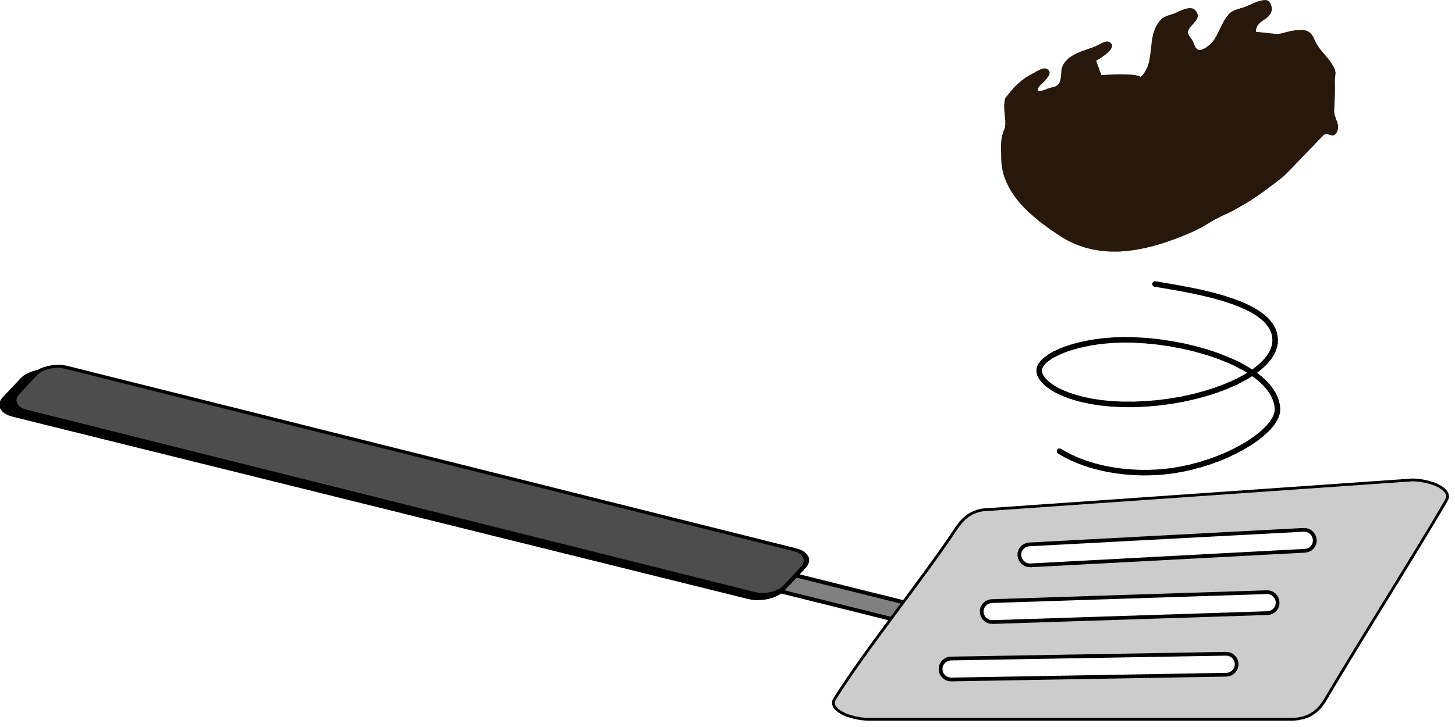

A *Wombatula* product by

Tom Quetchenbach

**Multiple uses**

Christmas ornament

General-purpose knickknack

Oversized necklace pendant

Migraine inducer

Steampunk talisman

Protective amulet

TSA checkpoint conversation starter

# Overview

Slide the power switch to the right to get started.Charging

**Tap to change color**



**Charging port**

Charge from **any USB port**

**Charging indicator**

Red light turns off when battery is

fully charged

**Power switch**

Turn off before storage

**Tap to change pattern**

FAST

SLOW

**Tap and hold both sides at once**

Lock or unlock the setting to  
prevent accidental changes

red flash = locked

green flash = unlocked



**Specifications**

Battery: 400 mAh (1.48 Wh) Li-ion

Full-battery run time: about 16 hours

Operating temperature: -20°C to 45°C (-4°F to 113°F)

**Do not charge below 0°C (32°F)**

Do not crush, drop, or eat

Keep out of reach of dragons

Plug the Heart-o-Matic 10 into **any USB port** to charge. The red light will turn off when the battery is full, after about 3-4 hours. **Any USB cable that fits** can be used for charging. You do not need to use the included one.

You can turn the power on while charging; the LEDs might not turn on immediately. If the heart is turned on while charging, the red charging indicator light might stay on even when the battery is full. It will turn off once you turn off the power switch. Even if this happens, the battery will not be overcharged.

The risk is low, but leaving the Heart-o-Matic 10 unattended while charging is not recommended.

# Troubleshooting

* **Nothing lights up when the switch is turned on.**

Separate touching wires

* + Is the battery charged?
  + Is any part of the heart (other than the hanging loop) touching a metal object? (Remove it, then turn the power switch off and back on.)
  + Are the metal wires at the base of each LED touching each other? Use a small screwdriver or spudger to separate them (as shown at right).



Wires  
should  
meet in the  
middle of the  
black insulated  
section. Bare  
copper wires  
should not touch.

* **The color or pattern changes randomly.**
  + Is anything touching either of the two heart-shaped copper wires?
  + Are the wires touching each other (see diagram at right)? If so, bend the wires so they don’t touch.
* **All the lights flash red when I try to change the setting.**
  + Heart-o-Matic 10 is locked. To unlock, touch and hold both heart-shaped wires at the same time until the lights flash green.

# Safety and handling

* Heart-o-Matic 10 is **not a toy** and should not be used without adult supervision.
* Heart-o-Matic 10 is **not a real heart** and **cannot be used to facilitate blood circulation in the body.**
* Heart-o-Matic 10 is assembled using soft electronics solder (99.3% tin, 0.7% copper, traces nickel and bismuth). **It will not survive being dropped**, stepped on, crushed, violently shaken, or launched into orbit.
* Most components are lead-free. (The resistors used for the hanging loop are of unknown and mysterious origin and may contain lead.)
* The exposed metal parts are part of the electrical circuit. Touching the metal gears or copper wires with a metal object can cause a short circuit. If this happens, the lights will turn off. If the lights do not turn back on when the short is removed, turn the switch off and back on.
* **Heart-o-Matic 10 is not water resistant.** Do not use in the rain. If it gets wet, let dry in a warm (not hot) place. It will probably be fine.
* Use only within the operating temperature range:
  + -20°C to 45°C (-4°F to 113°F) recommended
  + -20°C to 60°C (-4°F to 140°F) short term
  + **Do not charge below 0°C (32°F) or above 45°C (113°F)**
  + Store between -10°C and 35°C (14°F to 95°F)
* Do not expose the battery to high temperatures. Do not store in a hot car or place near a stove or heater.
* If repairs are needed, remove the battery before using heat (solder, hot glue, heat gun).

# Long-term storage (more than 2 weeks)

* **Make sure the power switch is turned off** and the battery is charged before storing. (For the longest battery life, store at 50% charge: fully discharge the battery and then charge for one hour before long-term storage.)
* If the battery is low, the lights will turn off, but other components will continue to consume some power if the power switch is on. Be sure to turn the switch off before storage.
* Ideally, for longest life, check the battery every 6 months. (Charge if the lights don’t turn on.)

# Battery replacement

* Recommended battery replacement: Adafruit part 3898
* Any 3.7 V lithium-ion battery of 300 mAh or more with a JST PH or compatible connector will work. **Double-check the connector polarity** if using a battery other than the recommended model.
* To replace the battery, remove the three screws on the back. Lift off the back cover, then gently pull the battery cable straight out to the right.

# Disposal

* Don’t throw the battery in the trash! Lithium-ion batteries crushed in garbage trucks can start fires.
* Scan one of these QR codes to find a battery recycling location:

|  |  |
| --- | --- |
|  |  |
| search.earth911.com/?what=Lithium-ion+Batteries | call2recycle.org/locator |

# Warranty

If the Heart-o-Matic 10 stops working, and you can safely ship it to me, I will do my best to try to fix it and send it back to you. *Damaged or defective lithium-ion batteries cannot be shipped; if the battery is damaged, remove it first.*

# Programming

Heart-o-Matic 10 is based on the Microchip (formerly Atmel) ATtiny85. There is space for a standard 6-pin AVR ISP header on the PCB. Instead of soldering in a header, I recommend using a pogo pin adapter such as Sparkfun Electronics KIT-23451. You can use any AVR programmer; many Arduino and compatible boards can also be used as an AVR programmer using the ArduinoISP software that comes with the Arduino IDE.

If you choose to solder a header:

* Remove the battery before soldering.
* Good luck getting the hot glue off.
* Replace the foam so that the header pins and through-hole component leads don’t puncture the battery.

Keep in mind the following tips for programming:

* It is not recommended to apply power to the board from the programmer. If you do, be sure the power switch remains off or remove the battery.
* If programming with the battery in place, use 3.3 V power and logic levels. 5 V is OK if the battery is removed and the device is powered from the programmer.
* **Applying 5 V with the battery installed and power switch turned on can result in battery venting and fire.**

Source code is available at https://github.com/quetchen/heart