

Contents lists available at ScienceDirect
Computers and Electrical Engineering journal homepage: www.elsevier.com/locate/compeleceng

A novel approach to low-light image and video enhancement using adaptive dual super-resolution generative adversarial networks and top-hat filtering  Vishalakshi, Shobha Rani, Hanumantharaju ∗  Research center: Department of Electronics and Communication Engineering, BMS Institute of Technology and Management, Bengaluru, India Visvesvaraya Technological University, Belagavi, Karnataka, India |  |  | 
A R T I C L E I N F O |  | A B S T R A C T
Keywords:  Adaptive fusion  Generative adversarial network Image and video enhancement  Mobile devices  Super-resolution  Top-hat transform |  | Image and video enhancement under low-light conditions is challenging, as the task involves more than just brightness adjustment. Without addressing issues such as artifacts, distortions, and noise in dark regions, brightness improvement alone can worsen the quality. This paper presents a novel approach to low-light image and video enhancement based on the adaptive fusion of Dual Super-Resolution Generative Adversarial Network (DSRGAN) models, followed by Top-Hat Gradient-Domain Filtering (THGDF). A soft thresholding mechanism is used to integrate the Memory Residual Super-Resolution Generative Adversarial Network (MRSRGAN) and the Weighted Perception Super-Resolution Generative Adversarial Network (WPSRGAN). MRSRGAN enhances fine details, improving the objective performance of the image, while WPSRGAN improves overall details, enhancing the subjective performance. Top-hat gradient- domain filtering is then applied to remove artifacts, distortions, and noise in both images and videos, resulting in outstanding perception scores. The proposed approach is validated using the quality assessment metrics such as Peak Signal-to-Noise Ratio (PSNR), Structural Similarity Index Measurement (SSIM), and Information Fidelity Criterion (IFC). Extensive experiments conducted on publicly available source codes and databases demonstrate that the proposed method is more effective than the existing state-of-the-art techniques.

1. Introduction
Capturing clear and detailed images or videos in low-light conditions is challenging. Due to inadequate lighting, noise levels increase, degrading the overall image quality. Additionally, long exposure times used to gather more light can introduce motion blur, affecting the sharpness of the captured image. The reduced dynamic range also results in overexposed highlights and underexposed shadows. These issues have been effectively addressed by numerous researchers using deep learning models [1–3], video stabilization techniques [4], video restoration methods [5], and more. Although, these approaches yield improved results, video enhancement under extreme low-light conditions with artifacts, distortions and noise remains a challenge.
Existing research has introduced promising model-based schemes [6] and data-driven methods [1] to enhance images and videos. Conventional mathematical approaches can improve resolution, contrast, brightness, and color under moderate lighting conditions. However, enhancing the quality of an image and video under low-light conditions, especially in the presence of noise, remains
∗ Corresponding author at: Research center: Department of Electronics and Communication Engineering, BMS Institute of Technology and Management, Bengaluru, India.
E-mail address: mchanumantharaju@bmsit.in (Hanumantharaju).
https://doi.org/10.1016/j.compeleceng.2024.110052
Received 31 July 2024; Received in revised form 15 December 2024; Accepted 29 December 2024 Available online 13 January 2025
0045-7906/© 2025 Elsevier Ltd. All rights are reserved, including those for text and data mining, AI training, and similar technologies.

an area for improvement. Image and video enhancement, particularly reconstruction under noisy conditions, continues to be a challenge. These enhancement techniques improve the viewing experience both visually and informatively through operations such as temporal filtering, super-resolution, color correction, contrast adjustment, deblurring, and noise reduction. Image and video enhancement techniques are widely used across various scientific and commercial applications. Low-light enhancement has a wide range of applications, including video surveillance [7], autonomous driving [8], medical imaging [9], and computational photography [10].
Smartphone users face significant challenges in improving low-light images and videos due to limited hardware capabilities, processing power, and high user expectations. Limited aperture sizes on mobile devices result in insufficient light capture, making low-light enhancement even more difficult. Real-time processing requirements, along with the limited computing power of smartphones, necessitate efficient algorithms that balance performance with speed. Memory constraints also limit the complexity and size of models that can be employed for these enhancements. Hence, algorithm optimization is crucial to meet user expectations. The need for seamless image and video enhancement under low-light conditions is especially immediate requirement for the smartphone users. Balancing technical challenges with the demand for high-quality performance is critical for improving mobile phone stored images and videos in low-light conditions.
The primary goal of low-light image enhancement (LLIE) is to improve the interpretability and perception of images captured in low-light conditions. In recent years, deep learning-based solutions incorporating various learning strategies, network architectures, loss functions, and training data have gained significant attention in this domain. Advances in deep learning and computer vision have led to the continuous development of sophisticated video enhancement approaches. It is likely that these methods will soon be implemented via user-friendly web interfaces and unified online platforms, which will include various popular LLIE techniques. Research in this area is increasingly important as efforts continue to address the challenges of low-light enhancement for smartphone applications.
Conventional low-light image and video enhancement methods include histogram equalization (HE) and retinex-based models. Among these, retinex-based methods have gained the most attention in recent research. Many researchers have contributed to developing retinex-based deep learning models [11,12]. Retinex-based approaches typically decompose low-light images into reflection and illumination components using priors and regularization techniques, with the enhanced result being the estimated reflection component. However, retinex-based methods have limitations. In complex lighting conditions or extremely low-light situations, color balance and detail enhancement are often compromised. Additionally, these methods can introduce artifacts or unrealistic enhancements that need to be addressed in future LLIE developments to create more robust solutions.
One of the most popular techniques for restoring images under low-light conditions is single image super-resolution (SISR) [13]. Super-resolution (SR) algorithms reconstruct HR images from corresponding low-resolution (LR) images. Deep learning algorithms typically perform faster and yield better results than traditional SR algorithms, as demonstrated by various performance metrics such as PSNR, SSIM, and IFC. Deep learning-based SR algorithms excel at visual enhancement. According to the literature, SR algorithms can be divided into two categories. In the first category, Convolutional Neural Networks (CNNs) are used as optimization functions with traditional L1 or L2 loss functions in pixel space. In the second category, Generative Adversarial Networks (GANs) are employed, introducing a novel approach to image reconstruction.
Lintao et al. [14] introduced a novel framework for low-light image enhancement that synthesizes normal and low-light image pairs to enhance training data. By employing an illumination degradation model and a self-attention-based enhancement model, the approach improves robustness and performance across various tasks, outperforming existing methods. It effectively augments data, demonstrates superior performance, and improves robustness in complex scenes. However, it lacks discussion on computational complexity and the results are not satisfactory with generalization in highly varied environments. Kumar et al. [15] presents the Morphological Transformation-based Locality-Constrained Representation (MTLcR) model for low-light robust face SR. This approach detects low-light effects in input images using domain-specific dictionary images, applying similar effects to LR dictionary images to minimize reconstruction errors. The incorporation of morphological transformations into the objective function enhances reconstruction weights, resulting in improved performance. Simulation results on publicly available datasets and real-world images demonstrate the model’s superior reconstruction capability under low-light conditions compared to state-of-the-art methods. However, the paper lacks with a detailed analysis of computational complexity and scalability in diverse scenarios.

1.1. Contributions
This paper presents DSRGAN, a novel SR framework for low light image and video enhancement. The main contributions of the proposed method work as mentioned below:
a. Objective The primary objective of this paper is to address the challenges of enhancing image and video quality under low- light conditions. The authors recognize that merely adjusting brightness is insufficient; the enhancement process must also tackle artifacts, distortions, and noise prevalent in dark regions. This work proposes a novel method that utilizes advanced GANs and Top-Hat Gradient-Domain Filtering techniques to improve the perceptual and objective quality of images and videos captured in low-light environments.
b. Data Collection and Preprocessing In this work, the sources of images and videos are collected from five publicly available benchmarks for image SR: Sun-Hays, Urban100, Set5, Set14, and a mobile dataset. The Sun-Hays, Urban100, Set5, and Set14 datasets primarily consist of natural images, while the mobile dataset contains images captured from various device models, including the iPhone 3GS, BlackBerry Passport, Sony Xperia Z, and Canon 70D DSLR, all of which are freely available

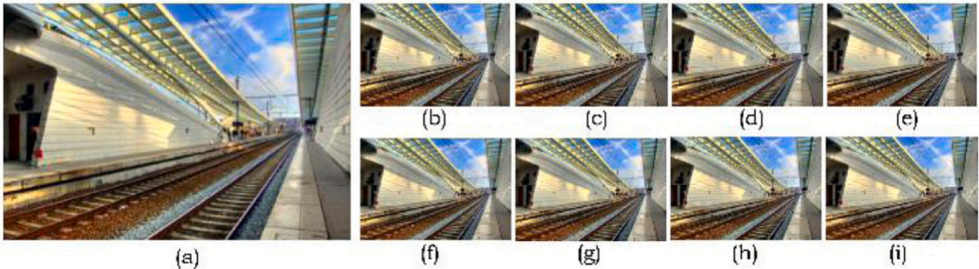
Fig. 1. An illustration of railway station image reconstructed using existing methods and its comparison with the proposed method.(a) Low Resolution Input Image (PSNR:22.87, SSIM:0.6, IFC:1.8) (b) Ground Truth Image (c) BGAN [16] (23.47, 0.67, 1.89), (d) RGSR [17] (23.45, 0.65, 1.76), (e) BDRVSR [18] (23.51, 0.61, 1.81), (f) RESRGAN [19](23.56, 0.64, 1.79), (g) DBVSR [20] (23.66, 0.68, 1.82), (h) BlindSR [21] (23.39, 0.60, 1.85), and (i) Proposed Method (23.7, 0.69, 1.98).

for public download. Preprocessing steps include normalization of pixel values, data augmentation through techniques like rotation and cropping, and the generation of LR versions of HR images, ensuring the input data is suitable for effective training and evaluation of the proposed methodologies.
c. Methodology The methodology consists of an adaptive fusion approach combining DSRGAN with THGDF. The DSRGAN models are designed to enhance fine and overall details in the images. A soft thresholding mechanism is employed to integrate the outputs ofthe MRSRGAN, which focuses on detail enhancement, and the WPSRGAN, which aims to improve overall visual quality. The THGDF is then applied to address and eliminate any residual artifacts, distortions, and noise, ensuring a visually appealing output.
d. Feature Learning The feature learning of the model includes specific settings to effectively train and evaluate models. The training dataset comprised Flickr2K, with 2,650 HR images, while evaluation datasets included Urban100, Sun-Hays, Set5, and Set14, providing over 100 images for assessment. The LR images are generated using bicubic downsampling, with a LR patch size of 24 × 24 pixels and an HR patch size of 96 × 96 pixels. Data augmentation techniques, including random horizontal and vertical flipping, enhanced model robustness, with a batch size set to 16. For the MRSRGAN, the generator architecture featured 7 residual blocks with a filter size of 3 × 3 pixels. The learning rate was initialized at 1 × 10_4 using the Adam optimizer, trained over 500 epochs. In the WPSRGAN, the generator had 16 residual blocks and utilized a PReLU activation function.
e. Evaluation Metrics The performance of the proposed method is assessed using standard quality assessment metrics, including PSNR, SSIM, and IFC. These metrics provide quantitative measures of image quality and enable comparison with existing methods. The paper presents detailed evaluations demonstrating how the proposed technique achieves higher scores in these metrics, further validating its effectiveness in low-light image and video enhancement.
f. Results Numerous experiments were conducted to evaluate the performance of the proposed approach against existing state- of-the-art techniques. The benchmark methods used are BGAN [16], RGSR [17], BDRVSR [18], RESRGAN [19], DBVSR [20], and BlindSR [21]. The experimental results presented demonstrate that the proposed method is more effective compared to other state-of-the-art methods.
Fig. 1(a) shows a low-light image generated from the ground truth or high-resolution (HR) image. Fig. 1(b) shows the HR image. Figs. 1 (c) through (h) depict results from other SR methods such as BGAN [16], RGSR [17], BDRVSR [18], RESRGAN [19], DBVSR [20], and BlindSR [21]. The result of the proposed method is shown in Fig. 1(i). As it is evident from the PSNR, SSIM, and IFC metric comparisons, the proposed method reconstructs images more effectively than other existing techniques.
The rest of the paper is organized as follows: Section 2 reviews the existing work in four stages, outlining the contributions made by other researchers. Section 3 details the proposed approach. Section 4 presents the experimental results of the proposed method on standard datasets. The results demonstrate that the proposed method produces more visually appealing, vivid, and brilliant images and videos compared to other competitive methods. Although the results presented focus on images, the proposed method has also been tested on standard video datasets. Finally, Section 5 summarizes the key contributions of this work.

2. Background and related works
Several SISR algorithms based on deep learning have been proposed by various researchers, showing significant performance improvements [22,23]. This paper focuses on five key aspects in the literature review: SR using Convolutional Neural Networks (SRCNN) [24], Very Deep SR (VDSR) [25], Enhanced Deep SR (EDSR) [26], SR using GANs (SRGAN) [27], and image quality evaluation.

2.1. Super-resolution convolutional neural network (SRCNN)
SRCNN is a standard in image SR that demonstrates how deep learning can be applied to enhance image quality. Dong et al. [24] introduced SRCNN, which is designed to directly learn the complex mapping between LR and HR images. Feature extraction is

accomplished through three convolutional layers. Unlike other artificial intelligence (AI) techniques, SRCNN operates on image patches, allowing it to focus on local attributes within the data. As a supervised learning algorithm, SRCNN optimizes its parameters using paired LR and HR images to minimize the difference between predicted and ground truth images. SRCNN offers several compelling advantages compared to other existing methods. Firstly, its architecture is designed for simplicity while achieving superior accuracy compared to state-of-the-art example-based methods. Secondly, it employs a moderate number of filters and layers, enabling SRCNN to operate efficiently in practical online applications, even on a CPU. SRCNN outperforms a series of example- based methods due to its fully feed-forward nature, eliminating the need to solve optimization problems during runtime. Thirdly, experimental work of other investigation shows that enhancing the network’s restoration quality is feasible with larger datasets and/or a larger model. In contrast, larger datasets or models can pose challenges for existing example-based methods.
The initial step in SRCNN involves up-scaling a single LR image to the desired size using bi-cubic interpolation. This serves as the pre-processing step. The resulting interpolated image is denoted as Y. The objective of SRCNN is to recover from Y an image F(Y) that closely resembles the ground truth HR image. For clarity, Y is referred to as an LR image, even though its size matches that of the HR image X. The model proposed by Lu et al. [28], based on shuffle learning, is designed for deployment on mobile devices with limited computing power. Through extensive experiments on three widely used datasets, Lu’s model not only achieves high PSNR and SSIM but is also easier to implement compared to other image super-resolution (SR) models due to its simplicity.
Many applications require HR images because they include complementary information. However, improving pixel density through sensor and visual technologies is limited and costly. Elgohary et al. [29] used image processing methods to generate HR images from their LR counterparts to overcome this challenge. Video Super-Resolution (VSR) aims to recover complex details and mitigate sensor effects. The analysis utilizes wavelet analysis and CNNs to combine multi-frame SR with wavelet analysis, resulting in a multiscale representation of video frames obtained through wavelet decomposition. Consequently, several CNNs are trained independently to approximate wavelet multiscale characteristics. Inference on these trained CNNs is conducted through regression of wavelet multiscale representations from LR frames. Additionally, wavelet reconstruction is performed, resulting in reconstructed HR frames. The research comprises the use of various camera zoom lenses to capture the LR frames and create HR frames. The authors conducted several experiments demonstrating the effectiveness of their approach in restoring video frames.
The review of existing work shows that CNNs have demonstrated exceptional performance in SR techniques. However, these models may not be feasible for low-cost devices. The Multiscale Feature Selection Network (MFSN), introduced by Minghon et al. [30], addresses this challenge. The Multiscale Feature Selection Block (MFSB), at the core of MFSN, is developed to extract rich multiscale features from coarse-to-fine receptive fields. In each section of MFSB, excluding the last, a wide-activated residual unit is employed to enhance representation capability. By adaptively varying the receptive field sizes of two adjacent divisions within MFSB, the Scale Selection Module (SSM) efficiently merges features from these branches. Furthermore, a Comprehensive Channel Attention Mechanism (CCAM) is seamlessly integrated into SSM, dynamically adapting selection weights based on local and global inter-channel dependencies. The results presented by the authors show that MFSN compares favorably with other lightweight methods. SR is inherently a multi-solution process due to its one-to-many mapping from LR to HR space. However, existing SR networks treat the SR of different sizes for the same image as independent tasks, making it challenging to leverage feature learning experiences and requiring extensive computational time to recover HR images. These issues also exist in current arbitrary-scale SR methods.
Wenyuan et al. [31] introduced a novel self-generating (SG) multiscale learning method based on SG mechanisms to achieve efficient and effective HR image recovery. The SG-SR method uses feature learning outcomes from SR networks to generate upscale filters as an alternative to traditional upscale modules. As each scale factor is adjusted, the SG upscale module provides weights to filter the LR tensor, resulting in HR images corresponding to the filtered tensors. Based on numerous experiments and comparisons of benchmark datasets, Wenyuan’s method outperforms state-of-the-art methods. Additionally, the SG upscale module significantly reduces computational costs in association with other upscale modules while enhancing the effectiveness of existing SR networks.
By integrating explicit feature learning into CNNs, Qizhou et al. [32] enhance the representation capabilities of CNNs through Trainable Feature Matching (TFM). The TFM features can be explicitly learned from training images through feature matching by incorporating trainable feature sets. Qizhou’s Trainable Feature Matching Attention Network (TFMAN) improves SR performance by incorporating non-local and channel attention. Due to computational demands, the authors introduce a streamlined variant called Same-size-divided Region-level Non-Local (SRNL), which performs non-local computations in parallel on uniformly divided blocks from the input feature map. The effectiveness of SRNL and TFM is validated through ablation studies, with comprehensive experimental results from benchmark datasets showing that TFMAN consistently outperforms other methods.
The review of existing methods shows that SRCNNs are prevalent in image SR. CNN structures can be adaptively modified, and advanced self-attention mechanisms can be incorporated to enhance SR performance. A common characteristic among these improvements is that CNNs implicitly learn feature processing modes resembling convolution and non-local operations instead of explicitly focusing on high-frequency details. Conversely, a dictionary-based approach explicitly learns feature decompositions to match and reconstruct LR features (see Table 1).

2.2. Very deep super-resolution (VDSR)
Through deep CNNs, Very Deep Super-Resolution (VDSR) advances the boundaries of resolution enhancement in image SR. VDSR, initially developed by Kim et al. [25] in 2016, which incorporates a deeper network design to capture more complex and subtle features inherent in HR images. VDSR can learn complex mappings between LR and HR image spaces by leveraging significantly

Table 1
Summary of SRCNN Methods.

Method | Key Features | Strengths | Limitations
SRCNN [24] | Uses deep learning to | Simple architecture with | Requires paired LR-HR
SRCNN [24] | directly map LR to HR | high accuracy. Efficient for | images. Performance can
SRCNN [24] | images through 3 | online applications, even on | improve with larger datasets
SRCNN [24] | convolutional layers. | CPU. | and models, which may not
SRCNN [24] | Performs image patch extraction. |  | always be feasible.
SISR [28] | Model designed for mobile devices with limited  computing power. Simple  architecture with high PSNR and SSIM. | Easy implementation with high performance on  standard datasets. | May not scale well to larger or more complex datasets.
WCNN VSR [29] | Combines wavelet analysis | Effective for video SR and | Computationally intensive
WCNN VSR [29] | with CNNs for multi-frame | mitigating sensor effects. | for video data, and requires
WCNN VSR [29] | SR. Performs wavelet |  | specialized camera
WCNN VSR [29] | decomposition and |  | equipment for capturing LR
WCNN VSR [29] | reconstruction for HR video frames. |  | frames.
MFSN [30] | Features a Multiscale Feature Selection Block (MFSB) and a Comprehensive Channel  Attention Mechanism  (CCAM) for extracting rich features. | Lightweight and effective for low-cost devices.  Dynamically adjusts  receptive field sizes and  merges features efficiently. | May not be as effective for very high-resolution images or large-scale datasets.
SG-SR [31] | Uses self-generating | Significantly reduces | May be less flexible in
SG-SR [31] | multiscale learning to create | computational cost while | handling highly varied
SG-SR [31] | upscale filters, reducing | maintaining SR effectiveness. | image types or real-time
SG-SR [31] | computational costs while | Outperforms existing | applications.
SG-SR [31] | enhancing SR network | methods in terms of
SG-SR [31] | performance. | efficiency and performance.
TFMAN & SRNL [32] | Incorporates Trainable | Enhances feature matching | Computationally demanding
TFMAN & SRNL [32] | Feature Matching (TFM) and | with non-local attention, | for larger datasets. The
TFMAN & SRNL [32] | non-local channel attention | improving SR performance. | effectiveness of SRNL is still
TFMAN & SRNL [32] | to improve SR performance. | Streamlined for | reliant on the quality of the
TFMAN & SRNL [32] | Introduces a streamlined | computational efficiency. | feature extraction process.
TFMAN & SRNL [32] | version (SRNL) for parallel computation.

increased convolutional layers. With residual learning, VDSR streamlines the optimization process. VDSR enhances performance by learning residuals, the difference between LR inputs and their corresponding HR targets.
VDSR achieves notable improvements in SR tasks, enabling the reconstruction of fine details and textures in HR images due to its deep architecture and residual learning principles. In addition to learning complex feature representations through multiple layers of abstraction, VDSR effectively captures complex image characteristics. VDSR can understand complex feature representations through various layers of abstraction. Further, VDSR’s usage and popularity highlights the importance of architectural innovations in deep learning. VDSR demonstrates how deeper networks can unlock new performance levels for various computer vision tasks. Through deep learning methodologies, VDSR represents a fundamental step forward in pursuing super-resolution images. It was observed in Fig. 2 that in all cases the network trained with depth-wise fine-tuning converges more quickly, which support our hypothesis. Notably, both the speed of convergence and the restoration performance have been substantially improved. This improvement is especially evident with deeper neural networks, indicating the potential for depth-wise fine-tuning to enhance training stability.
Diffusion CNNs (DCNNs) are widely used to extract features and reconstruct details for SISR. However, many existing DCNN methods cannot fully leverage the complementary strengths of feature maps, channels, and pixels. This limits their ability to represent abundant features. Therefore, the specified problem is efficiently addressed using the Weidong et al. [33] Cascaded Visual Attention Network (CVANet) method. CVANet focuses on reconstructing details and is inspired by the visual attention mechanism of the human eyes. CVANet comprises a trainable Feature Attention Module (FAM) for learning feature-level attention, a channel attention module for improving feature maps by learning channel-level attention, and a pixel attention module for generating HR images. This is accomplished by adaptively selecting representative features from preceding layers. CVANet consistently outperforms state-of-the-art methods regarding subjective visual perception, PSNR, and SSIM on four benchmarks. The authors have provided CVANet’s code using the following URL: https://github.com/WilyZhao8/CVANet.
Medical imaging, especially fluorescence and ultrasound captures, requires advanced solutions to track molecular dynamics accurately in real-time in cellular environments. In this context, deep learning-based image denoising offers significant improvements over conventional methods. The Multiscale Self-Attention Network (MSAN) is a new architecture proposed by Kyungsu et al. [34] for optimal denoising of fluorescence and ultrasound images. An MSAN consists of a feature extraction layer to identify high and

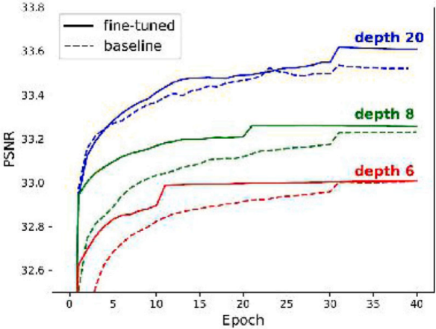
Fig. 2. VDSR results at various depths. Dotted lines represent the baseline models, while solid lines indicates the depth-wise fine-tuned networks.

low-frequency attributes, a multiscale self-attention mechanism for predicting residuals from original and downscaled feature maps, and a residual image decoder. A denoised image is obtained by offsetting the residual output. Compared to state-of-the-art models such as RIDNet [35] and DnCNNp [36], MSAN achieves notable PSNR improvements for the Fluorescence Microscopy Denoising (FMD) [37], W2S [38], and ultrasound datasets. It is clear from the specified method that MSAN effectively improves denoising capabilities for fluorescence and ultrasound images in real-time, enabling the decoding of complex biological processes.
Yeh et al. [39] aim to ease temporal flickering when upscaling videos by Fine-Grained VSR (FGVSR). However, several existing methods need help to utilize spatial–temporal information effectively from LR videos, resulting in unwanted artifacts or inaccurate reconstructions of the image’s details. To overcome these issues, the author proposed a deep learning framework for FGVSR, which takes consecutive LR video frames as input and generates SR frames corresponding to those frames. The framework emphasizes the alignment and refinement of multiple frames to reconstruct missing information from LR sources. An alignment module is introduced to align numerous frames at the feature level, preventing flickering in the video output. A feature fusion module is used once the aligned features have been fused and refined. On top of that, a refinement module is presented to reconstruct missing information based on the fused features. An image enhancement module is embedded in the skip connection for further refinement. The authors showed that deep FGVSR outperforms existing deep learning-based VSR methods. Detailed experiments are performed on REDS, Vid4, and Vimeo90k benchmarks, achieving state-of-the-art performance. In comparing FGVSR and state-of-the-art VSR methods, FGVSR shows that PSNR has substantially improved.
With the rise of deformable alignment-based VSR methods, VSR has gained significant traction in creating HR videos from LR counterparts. SR quality can be enhanced by aligning features extracted from videos to correct motion errors. Existing SR methods often suffer from challenges such as misalignment and insufficient temporal information, resulting in artifacts. Zhu et al. [40] efficiently addressed the mentioned challenges based on the Deep VSR Network (DVSRNet). This approach integrates the Progressive Deformable Alignment (PDA) module and the Temporal-Sparse Enhancement (TSE) module. By propagating bidirectional information, the PDA module precisely aligns features and eliminates artifacts; furthermore, the TSE module enhances HR frames.
Chen et al. [41] proposed a lightweight deep optical flow network to obtain bidirectional optical flows for the PDA module. A new loss function is also designed to generate HR frames with sharp, precise details. The results presented based on the demonstration shows that the method is superior over the state-of-the-art approaches. This approach emphasizes its ability to overcome misalignment issues and improve the overall quality of VSR. Existing approaches based on deep learning methods commonly use LR optical flow for VSR, in which HR frames are generated from LR frames. However, LR optical flow may have difficulty recovering fine details. This work combines an optical flow SR and an optical flow enhancement algorithm to enhance temporal dependency accurately. A supplementary information component is extracted from adjacent LR frames for precise feature extraction. An optical flow enhancement algorithm is used to infer HR optical flow from LR. Motion compensation is then applied to the HR optical flows. As a second benefit, extracting the detail component mitigates the errors introduced by motion compensation based on optical flow. An SR network is then used to generate SR results. A comprehensive set of experiments on two datasets, Vid4 and DAVIS, demonstrate that the VSR method outperforms other state-of-the-art techniques to achieve high-quality SR (see Table 2).

2.3. Enhanced deep super-resolution (EDSR)
Enhanced Deep Super-Resolution (EDSR) is a cutting-edge advancement in image SR. The EDSR offers an improved way to reconstruct HR details from LR inputs. Lim et al. [26] proposed EDSR architecture in 2017 as shown in Fig. 3 and introduced key improvements to achieve optimal performance based on VDSR. By embracing a profound architecture, the EDSR can learn increasingly complex representations of image features, surpassing its predecessors in the number of layers. As a result of the incorporation of residual blocks, the optimization process is further simplified. The network can now learn the residuals between LR and HR images, resulting in highly detailed and realistic HR outputs from the model.

Table 2
Summary of VDSR Methods.

Method | Key Features | Strengths | Limitations
VDSR [25] | Uses a deep CNN with | Achieves fine detail | Requires large training
VDSR [25] | residual learning to improve | reconstruction through deep | datasets and substantial
VDSR [25] | SR performance by learning | networks. Faster convergence | computational resources.
VDSR [25] | residuals between LR and HR images. | with depth-wise fine-tuning.
CVANet [33] | Utilizes cascaded visual | Outperforms state-of-the-art | Computationally intensive,
CVANet [33] | attention mechanisms | methods on PSNR, SSIM, | requiring high memory and
CVANet [33] | (feature, channel, and pixel attention modules) for image reconstruction. | and subjective perception. | processing power.
MSAN [34] | Combines multiscale  self-attention and residual  learning to enhance  denoising performance for fluorescence and ultrasound images. | Achieves high PSNR for  medical imaging denoising, particularly in real-time. | May not be generalizable to non-medical image denoising tasks.
FGVSR [39] | Uses temporal refinement | Outperforms existing VSR | Computationally demanding,
FGVSR [39] | and alignment techniques for | methods with significant | especially for large video
FGVSR [39] | improving VSR, preventing flickering and enhancing  detail. | PSNR improvement. | datasets.
DVSRNet [40] | Integrates Progressive | Effective in overcoming | Requires sophisticated
DVSRNet [40] | Deformable Alignment and | misalignment issues and | optical flow algorithms and
DVSRNet [40] | Temporal-Sparse | improving VSR quality. | can be computationally
DVSRNet [40] | Enhancement modules to improve video SR. |  | expensive.
Optical Flow VSR [41] | Combines optical flow | Superior to conventional | Dependent on high-quality
Optical Flow VSR [41] | enhancement with deep SR | methods in restoring fine | optical flow estimates; may
Optical Flow VSR [41] | networks to generate | details and handling | struggle with complex
Optical Flow VSR [41] | high-quality HR video frames. | temporal dependency. | motion patterns.

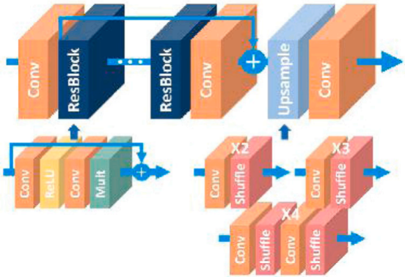
Fig. 3. EDSR Architecture.

With its streamlined and simplified architecture, EDSR distinguishes itself not only by its depth but also by its simplicity. The EDSR has consistently achieved top-tier results in super-resolution challenges through extensive experiments and rigorous assessments. With its ability to capture fine details and produce visually appealing results, EDSR has become a benchmark in the field. The EDSR inspires researchers to explore the potential of increasingly sophisticated deep-learning architectures. EDSR influences subsequent developments in image super-resolution. By leveraging deep neural networks, EDSR demonstrates the solution to complex mappings that primarily improve images.

2.4. Super-resolution generative adversarial network (SRGAN)

A breakthrough in image super-resolution can be attributed to the Super-Resolution Generative Adversarial Network (SRGAN). The SRGAN incorporates the power of generative adversarial networks (GANs). Ledig et al. [27] introduced SRGAN in 2017 as a new paradigm incorporating adversarial training. SRGAN consists of a generator network that generates SR and a discriminator network that distinguishes between HR images. Using this adversarial training framework, the Generator produces HR outputs aligned with

ground truth images and perceptual quality. A more comprehensive evaluation of SR performance is possible with SRGAN. The SRGAN emphasizes the subjective visual realism of the generated images. It transcends traditional metrics such as PSNR and SSIM by emphasizing the subjective visual realism of the generated images.
In the Internet of Things (IoT) context, intelligent cameras are increasingly being used to perform quality inspection tasks. However, low-light conditions may pose operational challenges for these smart-cameras. This situation severely degrades the acquired images, resulting in a decline in the performance of the subsequent detection algorithms. Jing et al. [42] proposed a Low-light image Enhancement GAN (LEGAN) for industrial internet of smart-cameras model for the industrial internet of intelligent cameras, focusing on non-stationary noise compression and detail recovery. The input is decomposed into two branches, of which the first step uses Harr-wavelets. These branches are encoded independently using compact residual blocks, facilitating effective noise suppression. The second step incorporates a feature selection module to extract correlations between image foregrounds and backgrounds.
Further, the reconstruction is accomplished based on comprehensive feature map correlations. In the training phase, an optimal balance between noise suppression and detail recovery is ensured by an adversarial loss comprising MSE loss, VGG loss, and discriminating loss. It is evident from the results presented that the LEGAN performs better than other noise compression and detail recovery schemes. In industrial practice, a high detection accuracy was achieved in low-light environments, specifically for yarn evenness inspection.
In SISR, an HR image is reconstructed from a LR image. This ill-posed problem arises because one LR image maps to multiple HR possibilities. It has been demonstrated that generative models-based SISR methods outperform traditional approaches in terms of performance. However, GANs, Variational Auto-Encoders (VAEs), and Flow face challenges such as unstable training, low sample quality, and high computational costs. As a result, these models need help to achieve the trifecta of diversity, high quality, and fast sampling. Despite their impressive sample variety and quality, denoising diffusion probabilistic models do not apply to real- world situations due to their prohibitive sampling costs. To overcome this limitation, Xiao et al. [43] proposed SISR with Denoising Diffusion GANs (SRDDGAN), which aims for large step denoising, diverse samples, and stable training results. SRDGAN utilizes multimodal conditional GANs for each denoising step, combining denoising diffusion models with GANs. The results demonstrate that the SRDDGAN outperforms existing diffusion model-based methods regarding PSNR and perceptual quality metrics. The latent variable Z solution significantly improves HR spatial domain diversity. In addition, SRDGAN infers nearly 11 times faster than diffusion-based SR3, making it more practical for real-world applications.
A retinal fundus image is an essential diagnostic tool in ophthalmology that facilitates the early detection and monitoring of various ocular diseases. It is challenging to capture HR fundus images due to factors such as defocusing, diffraction, limited shutter speed, sensor unit density, and random noise. Super-resolution techniques can overcome this limitation, which enhances visual details in retinal fundus images. The traditional SR methods tend to introduce artifacts into texture details and compromise delicate retinal vessel structures. Liquan et al. [44] proposed GANs that consist of a generator and a discriminator to improve the perceptual quality of retinal fundus images. A generator comprises 23 multiscale feature extraction blocks, an image segmentation network, and 23 residual-in-residual dense blocks. These components are strategically used to extract retinal vessel grayscale images and vascular features. It consists of two branches, one for extracting global features and another for extracting vascular features.
Further, the extracted features are fused to restore the SR image as best as possible. This approach can restore retinal vessel images in more detail and accurately. Additionally, attention modules are added to the Discriminator to improve the quality of SR images. An artifact loss function is added to the GAN to enhance the ability to measure the disparity between the HR and restored images. Compared with state-of-the-art methods of image super-resolution, the images generated by this method exhibit better perceptual quality.
Guo et al. [45] proposed a crucial aspect of maintaining high-quality spatial resolution in remote sensing images by preserving image texture during super-resolution reconstruction. The deep learning super-resolution methods based on GANs successfully recover image texture. This study aims to improve the SR reconstruction of medium and LR remote sensing images using an enhanced GAN. Enhancements to the residual block and refinement of the model loss function are introduced in the network, which builds upon the SRGAN. The model loss function seeks to minimize the pixel distance between the reconstructed remote sensing and the original image. In addition, the network restores texture details based on semantic categories when perceptual loss is targeted. This method outperforms SRGAN over other networks in both subjective and objective assessments. Based on the results presented, this approach generates more realistic and reliable textures, improving the objective quantitative evaluation of the reconstructed images. Kabiraj et al. [46] examine LR images of number plates where poor boundary contrast and accuracy make it challenging to detect numbers. To improve detection and recognition accuracy, low-quality number plate images must be digitized correctly, and image resolution needs to be enhanced. This approach is based on enhanced SRGAN, which modifies native dense blocks with a residual dense block model. An activation layer based on Rectified Linear Units (ReLUs) complements CNNs for threshold. Enhanced plate images are segmented using an optical character recognition (OCR) model to detect and recognize characters on the number plates.
The OCR model achieves an average accuracy of 84% for HR images, while for LR images, it varies from 4% to 7%. As the resolution of the plate images increases, the model accuracy increases, demonstrating its effectiveness. According to the OCR model, Enhanced Super-Resolution with Generative Adversarial Network (ESRGAN) provides superior LR image enhancement compared to SRGAN and Pro-SRGAN methods. Converting LR images to HR ones improves digit or alphabet detection accuracy on number plates. This approach improves number plate recognition reliability in LR situations.
Yu et al. [47] address the challenges of obtaining clear images of particleboard surfaces. This essential forest product saves forestry resources and promotes low-carbon development by reusing wood processing residues. The large size of particle boards poses difficulties in capturing detailed image features, resulting in blurred defect outlines. To enhance the quality of particleboard

Table 3
Summary of SRGAN Methods.

Method | Key Features | Strengths | Limitations
SRGAN [27] | GAN-based architecture for high-quality image  super-resolution. Uses  adversarial training with  generator and discriminator. | Realistic high-resolution  images, improved perceptual quality. | Training instability,  computationally intensive.
LEGAN [42] | Focuses on low-light image enhancement for smart  cameras. Incorporates noise suppression and detail  recovery. | Effective for industrial inspection, improves  detection in low-light. | May not generalize to other use cases.
SRDDGAN [43] | Combines denoising  diffusion models with GANs for stable and fast training. | Faster training, higher  perceptual quality compared to diffusion models. | Computationally complex,  struggles with extreme noise.
GAN for Retinal Fundus Images [44] | Uses generator-discriminator approach for improving  perceptual quality, with  multiscale extraction blocks and attention modules. | High-quality SR for medical images, especially vascular features. | Requires large datasets, may not generalize to other  medical areas.
Enhanced SRGAN for  Remote Sensing [45] | Enhances SRGAN with  residual blocks and refined loss function for better  texture preservation. | Superior texture restoration, higher evaluation scores. | May not perform well in dynamic environments.
ESRGAN for Number Plate Recognition [46] | Enhanced SRGAN with  residual dense blocks for  improving LR number plate images, integrates OCR for detection. | Increases accuracy of  number plate recognition. | Limited to number plate recognition applications.
SRDAGAN for  Particleboard Surface Images [47] | Optimized SRGAN using  dense skip connections and CBAM for improving  particleboard images. | Outperforms traditional  methods in texture clarity. | Computationally demanding, not suited for low-resource environments.
Dual-Path GAN for  Satellite Images [48] | Dual-path architecture  combining feature mapping attention with deep  convolution for satellite SR. | Enhanced clarity, feature extraction for satellite  images. | Complex architecture, high computational requirements.

surface images, the study employs SR reconstruction technology, focusing on improving the SRGAN performance. The presented enhancement method is named SR dense attention GAN (SRDAGAN). This method refines the SRGAN model by removing the batch normalization (BN) layer.
Further, the Convolutional Block Attention Module (CBAM) is optimized for constructing dense blocks. In addition, dense skip connections are incorporated into the dense block construction. It is clear from the results presented that the training, verification, and testing conducted on 52,400 image blocks with HR and LR in a 3:1:1 ratio produces better results. Comprehensive evaluation metrics, such as PSNR, SSIM, and Learned Perceptual Image Patch Similarity (LPIPS), demonstrate the superiority of SRDAGAN over traditional methods such as BICUBIC, SRGAN, and SWINIR. The reconstructed images have more evident textures and provide a realistic representation of limitless features, indicating a significant enhancement in the model performance. The study discovers the reconstruction effect on images with defects, emphasizing that SRDAGAN successfully achieves high-quality SR reconstruction of particleboard images.
Ren et al. [48] address the hardware limitations, complex electromagnetic noise, and harsh natural environment challenges associated with the quality of satellite remote-sensing images. To enhance the clarity of these images, the study proposes a dual-path adversarial generation network algorithm specifically designed for satellite remote sensing image SR. The generator structure incorporates a dual-path convolution operation, combining a feature mapping attention mechanism with an enhanced deep convolutional network. The design uses LR images to extract both important features and deep features. A reconstruction layer optimizes the SR process by fusing the extracted data. Improvements are made to the algorithm’s loss function and Discriminator to better balance the output image and the Discriminator. The fine-tuning aims to bring the SR image closer to human perception. As evident from the results presented compared to other methods, this algorithm performs significantly better on the UCAS-AOD datasets https://hyper.ai/datasets/5419 (see Table 3).

2.5. Image quality evaluation

It has become increasingly important to evaluate enhanced image quality as image super-resolution (SR) techniques continue to advance. To assess the performance of SR algorithms effectively, robust metrics must consider both objective and subjective aspects of image quality. Objective evaluation methods, such as PSNR, SSIM, and IFC [49] are widely used;
a. Peak Signal to Noise Ratio
The PSNR is a widely used metric for evaluating image quality, particularly in the context of lossy image compression and reconstruction techniques such as super-resolution. The PSNR is expressed in decibels (dB) and is calculated as Eq. (1):
where L is the maximum possible pixel value of the image, and MSE is the Mean Squared Error between the original image and the reconstructed image, defined as Eq. (2):
In this formula I(i;j) represents the pixel value at position (i;j) in the original image. K(i;j) represents the pixel value at position (i;j) in the reconstructed image, m and n are the dimensions of the images. Combining these, the PSNR formula can be written as shown in Eq. (3):
PSNR = 10 . log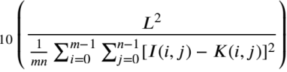 (3)
b. Structural Similarity Index Measurement (SSIM) The next metric used to assess the SR methods is the SSIM. The SSIM is a method for measuring the similarity between two images. It considers changes in structural information, luminance, and contrast to assess image quality. SSIM is widely used because it provides a more comprehensive evaluation of image quality compared to metrics such as MSE and PSNR. The SSIM index between two images x and y is defined as Eq. (4):
where x is the average of image x, y is the average of image y, represent the variance of image x, is the variance of
image y, xy is the covariance of images x and y, C1 is given by (K1L)2 and C2 is given by (K2L)2
In the above equations L is the dynamic range of the pixel values (e.g., 255 for 8-bit grayscale images). K1 and K2 are small constants with the typical values, K1 = 0:01 and K2 = 0:03.
c. Information Fidelity Criterion (IFC) The IFC metric is used to assess the quality of an image by quantifying the amount of information shared between a reference (original) image and a distorted (reconstructed) image. It is based on the concept of natural scene statistics and the notion that the human visual system is highly adapted to the statistical properties of natural scenes. The IFC is derived from the mutual information between the reference image and the distorted image. It can be expressed as shown in Eq. (5):
where I is the reference image, K is the distorted image, xj and yj are the coefficients of the reference and distorted images,
respectively, in a multi-scale, multi-orientation image decomposition (e.g., wavelet transform), j is the variance of the
reference image coefficients, j is the variance of the distorted image coefficients, jyj is the covariance of the reference
and distorted image coefficients, and N is the number of coefficients.
Despite of objective evaluation metrics presented, there remains a gap in objective evaluation criteria that align closely with human subjective perception. In the following section, the Perceptual Index (PI) and Root Mean Square Error (RMSE) metrics that are based on human perception of image quality are presented.
d. Perceptual Index (PI) The PI is an image quality metric that combines the Ma score and the Naturalness Image Quality Evaluator (NIQE) to approximate human perception of image quality. This approach is especially valuable in evaluating images that have been enhanced or generated, as it accounts for both aesthetic appeal and naturalness. The Perceptual Index is calculated using Eq. (6)
where the Ma score measures the aesthetic quality of the image, with higher scores indicating greater aesthetic appeal, and NIQE evaluates the naturalness of the image, where lower NIQE scores suggest a more natural appearance. Together, these scores provide a balanced assessment of how visually pleasing an image may be to a human observer.

A lower Perceptual Index score suggests a higher perceived image quality, reflecting both a high Ma score (indicating visually pleasing or attractive to human observers) and a low NIQE score (indicates naturalness). Conversely, a higher PI score typically indicates a less visually satisfying image. This metric is particularly useful in image enhancement tasks such as low-light image enhancement, super-resolution, and de-noising, where human perception of quality is essential. In applications like GANs for image synthesis, the Perceptual Index can help assess the realism of generated images. Moreover, it is helpful for comparing different image enhancement algorithms, providing a perceptually relevant comparison that aligns with human satisfaction.
e. Root Mean Square Error (RMSE) RMSE is a commonly used metric to evaluate the performance of regression models in machine learning. It quantifies the average magnitude of errors between predicted values and actual (observed) values. RMSE is calculated by first finding the difference between each predicted value and its corresponding actual value, then squaring these differences to remove negative signs and give more weight to larger errors. These squared errors are averaged, and then the square root of this average is taken, yielding the RMSE value. Mathematically, RMSE is given by Eq. (7):
Root Mean Square Error, RMSE = Ⅴ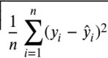 (7)
where yi represents the actual values, i represents the predicted values, and n is the total number of observations.
RMSE is particularly useful in regression since it is sensitive to larger errors and provides a metric in the same units as the target variable, making it easy to interpret. In machine learning, RMSE is commonly used for model evaluation: a lower RMSE indicates a model that better fits the data. RMSE also aids in model comparison, where the model with the lowest RMSE is typically considered the best. Furthermore, in hyperparameter tuning, RMSE often serves as the metric to minimize when optimizing model parameters, such as through grid or random search, to achieve better accuracy.
The evaluation schemes offer a comprehensive understanding of the effectiveness of image SR techniques in enhancing visual appeal and perceptual accuracy.

3. Proposed method
It is clear from the introduction section that low-light image and video enhancement present complex challenges beyond simple brightness adjustment. In low-light environments, issues such as artifacts, color distortion and noise are common. Techniques are needed to ensure accurate color representation, remove artifacts, and to apply appropriate filters for noise reduction. Increasing brightness in such settings is also challenging due to noise amplification. Therefore, methods that reduce noise while preserving visual clarity are crucial. Additionally, fine details can be lost due to independent image processing, making it necessary to balance global enhancements for improved visibility with the preservation of local details. Achieving this balance requires addressing both subjective and objective performance metrics, considering diverse scenes, and adapting to real-time processing constraints. The integration of enhancement techniques, user preferences, and metrics based validation further complicates the development of effective low-light image and video enhancement methods.
The proposed method incorporates an adaptive strategy, advanced algorithms, and comprehensive assessment metrics to address the identified challenges. The framework, Dual SRGAN, adaptively fuses the MRSRGAN and WPSRGAN networks. Fig. 4 presents the flow diagram of the proposed architecture. The perception scores [50] and RMSE are used to achieve an optimal balance between global enhancement and local detail preservation. The MRSRGAN improves objective performance by enhancing fine details, while subjective performance is improved by the WPSRGAN. A thresholding mechanism is used to adaptively fuse the MRSRGAN and WPSRGAN networks.
Additionally, a top-hat gradient-domain filter is employed to remove noise and artifacts resulting from SR. PSNR, SSIM, and IFC metrics are used to validate the results of the proposed method. The experimental results presented demonstrate the effectiveness of the proposed approach. As shown in the results, the proposed method quantitatively outperforms current state-of-the-art techniques. Under low-light conditions, it can produce vivid, clear, and brilliant images and videos that closely resemble human visual system perception.
The Sections 3.1, 3.2, and 3.3 introduces the architectures of the MRSRGAN and WPSRGAN networks, followed by their adaptive fusion process. Further, the overall architecture of the Dual SRGAN framework is presented.

3.1. Architecture of MRSRGAN
MRSRGAN enhances fine details in images and videos by utilizing Memory Residual (MR) blocks. The memory residual blocks store and leverage information from previous layers to emphasize and refine the complex features. Through training, the network improves its ability to capture and highlight delicate structures under low-light conditions by learning and retaining critical details.
Fig. 5 presents the complex architecture of MRSRGAN, which is explicitly designed for SR tasks. A single convolutional layer extracts features from LR images, serving as input for both the Generator and Discriminator of the MRSRGAN. Image quality is enhanced through the integration of seven MR blocks to the architecture of MRSRGAN. The integrated MR blocks improve the model’s ability to retain important features by creating persistent memory. By incorporating residual connections, the model effectively captures long-range dependencies, emphasizing the differences between LR and HR features. The Generator refines these features iteratively using residual blocks, followed by up-sampling blocks. These up-sampling blocks increases the spatial resolution of images and videos. Finally, the HR images are generated through the last convolutional layer, demonstrating the network’s capability.

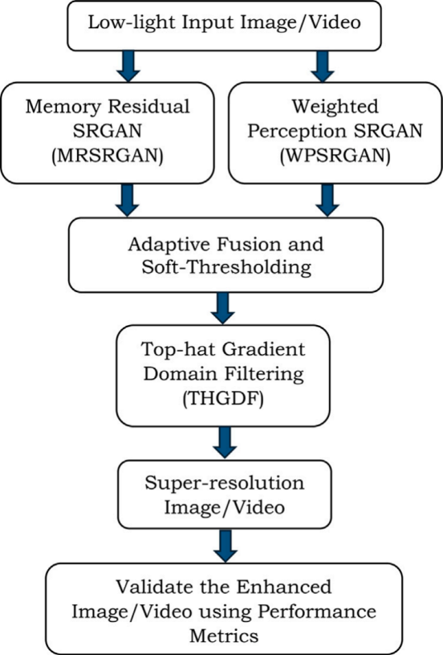
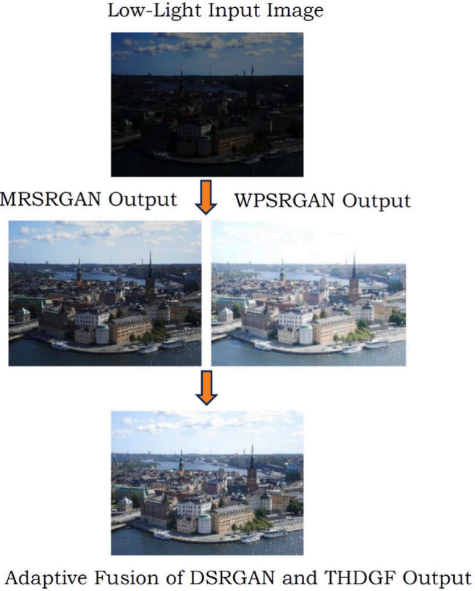

Fig. 4. (a) Flow Diagram of the Proposed Architecture (b) Image Transformation of Adaptive Dual SRGAN.

A sophisticated mechanism unfolds within each MR block. Each MR block consists of four Residual Blocks (ResBlocks) and a gate unit. After generating these groups, the gate unit extracts a specified number of features. Combining the input features with the extracted features yields the final output of the MR block. The ResBlocks are transformed using Parametric Rectified Linear Unit (PReLU) functions, which replace the activation function layers. To simplify the overall architecture, the BN layers are excluded from the computation. Two up-sampling operations are necessary to restore the original image size. Each convolutional layer is assigned a stride, with parameters represented as n indicating the number of corresponding feature maps. This configuration optimizes the generator network’s computational efficiency while ensuring that the original image’s essential structural and functional aspects are preserved during SR processing. The discriminator network employs the same settings as the generator network.

3.1.1. Loss function
The total generator loss function, as defined by Eq. (8), can be decomposed into pixel-wise, adversarial, and perceptual loss components.
Total Loss, Ltotal = Lpixel + 1Ladv + 2Lvgg (8)

In the defined loss formulation, three distinct components contribute to the overall objective function for the MRSRGAN: pixel- wise Mean Squared Error (MSE) loss (Lpixel), perceptual loss based on the VGG19 network features (Lvgg), and the adversarial loss for the Generator (Lad v). Each term serves a specific purpose in guiding the training of the generator network to produce high-quality SR images.
a. Pixel-wise MSE Loss (Lpixel): The Lpixel represented by Eq. (9) quantifies the pixel-wise mean squared error between the generated images and the ground truth. Here, G(xl) denotes the Generator that produces the SR images, while xl and xt represents the LR input images and their corresponding ground truth, respectively. This loss term focuses on minimizing the discrepancy at the pixel level, aiding the Generator in producing images that closely resemble the ground truth in terms of raw pixel values.
Pixel-wise MSE Loss, Lpixel 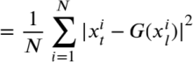 (9)

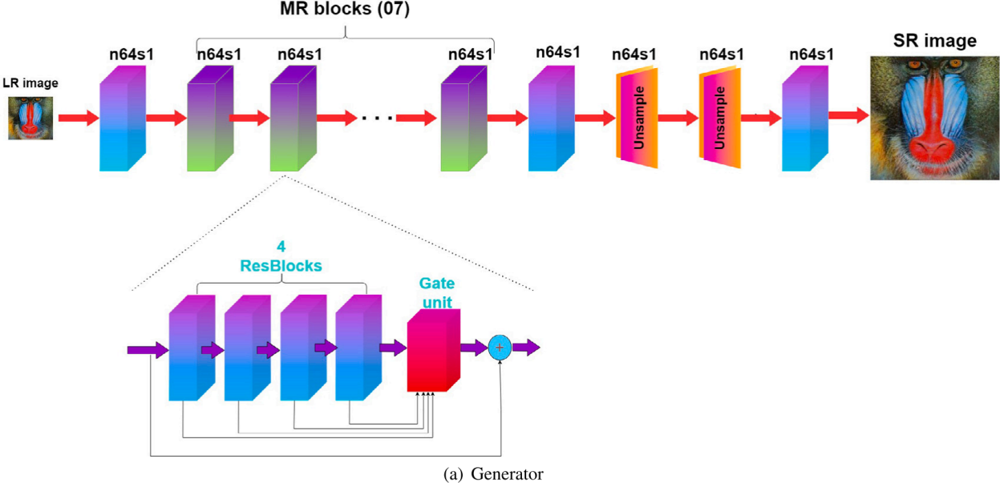

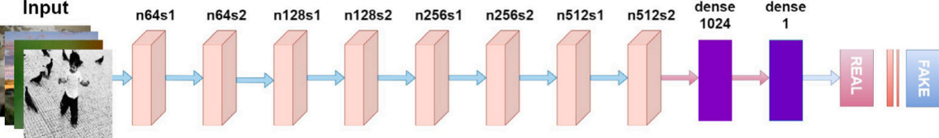
(b) Discriminator
Fig. 5. The Memory Residual SRGAN Architecture (a) Generator, (b) Discriminator.

b. Perceptual Loss (Lvgg): The Lvgg loss defined by Eq. (10) introduces perceptual loss, calculated as the MSE loss between features extracted from the pre-trained VGG19 network. By utilizing features from a deep CNN like VGG19, the Generator is driven to produce images that not only match the ground truth at the pixel level but also capture higher-level semantic information. This enhances the perceptual quality of the generated images. The number of training samples is indicated as
N. The term represents the features extracted from the pre-trained VGG19 network.
c. Adversarial Loss (Lad v): The Lad v loss, defined by Eq. (11) represents the adversarial loss for the Generator, a fundamental component of the GAN framework. In this context, the logarithm is omitted from the adversarial loss calculation. Adversarial loss helps the Generator to produce images that appear homogeneous when evaluated by the Discriminator. The weights associated with adversarial and perceptual losses are denoted by 1 and 2, respectively. The combined loss function integrates pixel-wise accuracy, perceptual quality, and adversarial training to guide the MRSRGAN in generating high-fidelity super-resolved images. The weights 1 and 2 allow for fine-tuning the contributions of adversarial and perceptual losses during the training process.
Adversarial Loss, Ladv = _D(G(xl )) (11)

3.2. WPSRGAN architecture
WPSRGAN improves overall image enhancement by incorporating a weighted perceptual loss. This approach enhances subjective performance by prioritizing overall visual quality and global features. The network assigns different levels of importance to various perceptual features, ensuring a balanced and enhanced global appearance.
The WPSRGAN architecture, comprising 16 ResBlocks within the generator network, is shown in Fig. 6. In the Generator, each ResBlock consists of a convolutional layer, a PReLU activation layer, and a second convolutional layer. WPSRGAN deliberately omits BN layers from both the generator and discriminator components. The detailed structure of each ResBlock in the Generator is outlined as follows:

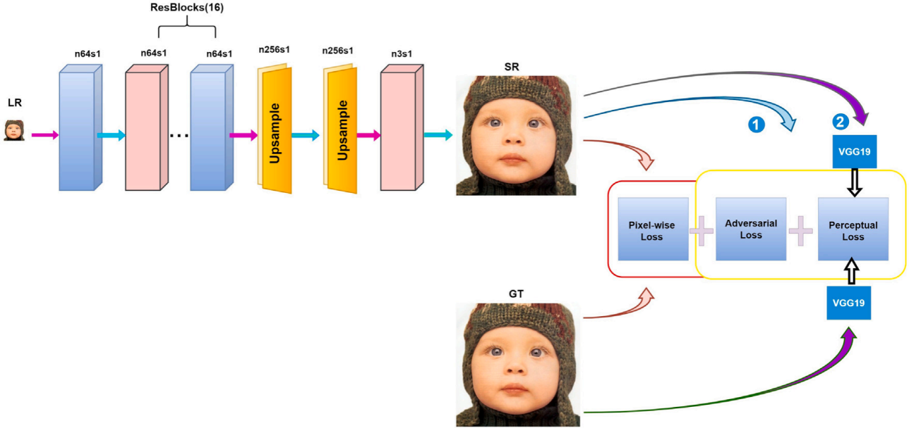
Fig. 6. The Generator Architecture of WPSRGAN.

Convolutional Layer (First):The ResBlock begins with a convolutional layer that extracts features from the input data. This layer performs spatial convolution to capture essential information relevant to the super-resolution task.
PReLU Activation Layer: The convolutional layer is followed by a PReLU activation layer. PReLU provides a non-linear activation function, enabling the network to model complex relationships and capture complex details in the data.
Convolutional Layer (Second): A second convolutional layer refines the features extracted by the preceding layers. This dual-convolutional structure within each ResBlock allows for more effective capture and representation of hierarchical features.
The decision to remove BN layers from both the Generator and Discriminator ofWPSRGAN was made to simplify the architecture and reduce computational complexity. BN layers can sometimes introduce unwanted artifacts or hinder training stability, which led to their exclusion. The Discriminator in WPSRGAN is similar to that of MRSRGAN, with the key distinction being the absence of BN layers. The Discriminator distinguishes between authentic and generated images, and this architectural adjustment maintains consistency between the two models while emphasizing the removal of BN layers.
The WPSRGAN network architecture consists of 16 ResBlocks in the Generator, each comprising a convolutional layer, a PReLU activation layer, and another convolutional layer. The absence of BN layers in both the Generator and Discriminator aligns with the weighted perceptual loss approach and underscores the emphasis on simplicity in design.
Loss Function: As depicted in Fig. 6 , WPSRGAN employs a two-stage bias adversarial training mechanism utilizing distinct generator losses. During the initial stage, highlighted, the generator loss is optimized, comprising pixel-wise loss and adversarial loss, to enhance the overall objective performance (specifically, to minimize the RMSE value). In the subsequent stage, the network parameters from the first stage is treated as a pre-trained model. Subsequently, generator loss is replaced with perceptual and adversarial loss to refine and optimize subjective visual effects (e.g., minimizing the perceptual index). The two-stage losses are defined by Eqs. (12) and (13).
L1 = Lpixel+ λ 1Ladv (12)
L2 = λ 1Ladv+ λ2Lvgg (13)

Here, the pixel-wise loss is defined as Eq. (9), the perceptual loss utilizes MSE loss calculated based on features extracted from a pre-trained VGG19 network, and the adversarial loss is represented as Eq. (14),
Ladv = − log(D(G(xl ))) (14)

Implementing a two-stage adversarial training mechanism facilitates aligning the generated SR image with the corresponding ground truth in the high-level features space.

3.3. Adaptive fusion
The adaptive fusion approach employed in the proposed framework maximizes the strength of both networks by combining MRSRGAN and WPSRGAN outputs. To align the perceptual score with RMSE in SR results, a soft thresholding method is applied.

The network outputs are then merged using a dynamic mechanism, where the threshold is adjusted based on specific characteristics of the image or video inputs.
A distinct SR outcomes are derived using the two previously mentioned GANs. One is MRSRGAN, prioritizing enhanced objective performance. The other is WPSRGAN, which achieves results with superior subjective perception. To reunite the perceptual score, the soft thresholding method proposed by Deng et al. [13] is adopted. In order to merge the two SR images (i.e., MRSRGAN, WPSRGAN), a technique similar to a form of pixel interpolation is adopted. Eq. (15) presents the soft thresholding method adopted in the proposed work:
Ie = IG + soft( ; ) (15)
where Ie is the fused image and =(IG-Ig ), IG is the generated image by WPSRGAN whose perceptual score is lower, Ig is the generated image by MRSRGAN whose RMSE value is lower. is the adjusted threshold. The soft( ; ) is defined in Eq. (16)
soft( ; ) = sign( ) . max(| | − ; 0) (16)

3.4. Dual SRGAN (DSRGAN) framework
The adaptive fusion approach presented in the earlier section integrates MRSRGAN and WPSRGAN networks to arrive at the Dual SRGAN (DSRGAN) network. This approach leverages the specific strengths of each network to enhance low-light images and videos comprehensively. A DSRGAN is based on the fusion of MRSRGAN and WPSRGAN results. DSRGAN represents a unified network that integrates the enhanced fine details of MRSRGAN and the globally improved perceptual quality of WPSRGAN. Integrating local and global aspects of low-light content is crucial.

3.5. Top-hat gradient domain filtering (THGDF)
Dual SRGAN outputs are subjected to top-hat gradient-domain filtering to remove image artifacts, noise and balance global enhancement and local detail preservation. The filtering process refines the enhanced results to effectively address low-light conditions and other challenges while maintaining high visual fidelity.

3.5.1. Top-hat transformation
The top-hat transformation [51] is the most widely used operation in mathematical morphology. It is used for image enhancement which involves adding bright areas while subtracting dark areas from the original image. Enhancing the performance of the top-hat transform is often employed within a multiscale framework. This approach allows the multiscale top-hat transform to extract various beneficial features from the image, subsequently utilized for infrared image enhancement. Widely adopted across diverse grayscale image types, the multiscale top-hat transform scheme has demonstrated efficacy in enhancing retinal, ultrasound, and infrared images. Furthermore, it finds application in tasks such as visible and infrared image fusion, image segmentation, and small object detection.
The top-hat transform constitutes a composite operation within mathematical morphology derived from other fundamental morphological operations, including erosion, dilation, opening, and closing. The morphological operations of dilation and erosion applied to I(u,v) for B(s,t), denoted as I 田 B and I θ B are defined as shown in Eqs. (17) and (18):
(I 田 B)(u; v) = (I {I(u + s; v + t) + B(s; t)} (17)
(I θ B)(u; v) = ()B {I(u + s; v + t) + B(s; t)} (18)
where, I represents the original input image, with pixels corresponding to all spatial coordinates (u,v), while B denotes the structuring element, represented by spatial coordinates (s, t). The morphological operations of opening I θ B and closing I 田 B on I(u; v) for B(s,t)are derived from the dilation and erosion operations as shown in Eqs. (19) and (20):
I ◦B = (I θ B) 田 B (19)
I . B = (I 田 B) θ B (20)

The morphological operation of the top-hat transform [51] is constructed from morphological opening and closing. White Top- Hat (WTH) represents the top-hat transform via opening, while Black Top-Hat (BTH) characterizes the top-hat transform via closing. WTH captures bright areas, whereas BTH captures dark areas omitted in the opening and closing operations. Both transformations are defined as shown in Eqs. (21) and (22):
WTH = I − (I◦B) = I − ((I θ B) 田 B) (21)
BTH = (I . B) − I = ((I 田 B) θ B) − I (22)

3.5.2. Modified top hat transform
The classical top-hat transform typically relies on a single structuring element, resulting in inefficiencies in image processing [52]. To enhance the performance of the top-hat transform, it is suggested to employ two structuring elements, proportional geometry, and flatness [53]. The Modified White Top-Hat (MWTH) and the Modified Black Top-Hat (MBTH) transforms are utilized for image enhancement within the framework of multiscale top-hat transform. Let G and G’ represent the structuring elements with geometric proportionality and flatness. Then, the top-hat transform employed in the multiscale framework is defined as shown in Eqs. (23)
and (24):
MWTH = I _ ((I θ G) 田 G9) (23)
MBTH = ((I 田 G) θ G9) _ I (24)

3.5.3. Proposed multiscale top-hat transform
The method proposed here centers on the multiscale top-hat transform, leveraging two structuring elements within the transform to enhance its effectiveness. This approach enhances the image details, improves contrast, and preserves mean brightness. Initially, the image enhancement algorithm utilizes the following parameters: the original image I, the number of iterations n within a range iε1,2,. . . n,n> 1 and two structuring elements G and G’ Multiple Brightness (MB) and Multiple Darkness (MD) regions will be derived through the top-hat transform in the following Eqs. (25) and (26):
MBi = I _ ((I θ Gi) 田 Gi9) (25)
where MBi is the i-scales of brightness extracted from the image, and Gi and G9i will grow in each iteration.
MDi = ((I 田 Gi) θ Gi9) _ I (26)
where MDi are the i-scales of darkness extracted from the image.

4. Experimental evaluation and discussion
This section outlines the experimental setup, parameter settings, benchmark methods, datasets, evaluation metrics used to assess the performance of the proposed method. It also includes a performance evaluation and a comparative analysis with existing methods.

4.1. Experimental setup
The experiment was conducted on a workstation running Windows 11. The setup included a PC with an Intel(R) Core(TM) i9- 10940X CPU @ 3.30 GHz, an NVIDIA GeForce RTX 3080 GPU, and 64 GB of RAM with CUDA 12.2 and CUDNN 8.9. The development environment was JetBrains PyCharm 2021.2.3 Professional edition, and Python was used to implement the relevant algorithms.

4.2. Parameter settings
This section presents the parameters used in the proposed method, with their values detailed in Table 4.

4.3. Benchmark methods
The benchmark methods that are used to validate the proposed method are BGAN [16], RGSR [17], BDRVSR [18], RESR- GAN [19], DBVSR [20], and BlindSR [21]. The results of the proposed method is compared to that of reference methods to assess the performance.

4.4. Datasets
In the proposed work, images and videos are sourced from five publicly available benchmarks for 4× image SR: Sun-Hays [54], Urban100 [55], Set5 [56], Set14 [57], and a mobile dataset. The Sun-Hays, Urban100, Set5, and Set14 datasets primarily contain natural images, while the mobile dataset includes images captured with various devices: iPhone 3GS, BlackBerry Passport, Sony Xperia Z, and Canon 70D DSLR. The mobile dataset is freely accessible to the public and can be downloaded at http://people.ee. ethz.ch/~ihnatova/#dataset.
The Sun-Hays dataset is a important benchmark in image SR, featuring a diverse range of natural and urban scenes that provide HR and corresponding LR image pairs. This dataset’s complexity and variety make it an essential resource for training SR models and evaluating their performance in reconstructing detailed HR images from LR inputs. The Sun-Hays dataset’s comprehensive nature makes it highly relevant for real-world applications such as satellite imaging, urban planning, and autonomous driving.
The Set5 dataset is a widely used benchmark in image SR research, consisting of five high-quality images featuring diverse scenes, including natural and urban settings. These images are accompanied by their corresponding LR versions, created through standard

Table 4
Parameter Settings.

Setting | Value
Dataset for Training | Flickr2K (2650 HR images)
Dataset for Evaluation | Urban100, Sun-Hays, Set5, Set14 (100+ images)
Image Preprocessing | Bicubic downsampling for LR images
LR Patch Size | 24 × 24
HR Patch Size | 96 × 96
Data Augmentation | Random horizontal and vertical flipping
Batch Size | 16
Generator (MRSRGAN) | 7 multi-scale residual (MR) blocks
Filter Size (Generator) | 3 × 3
Learning Rate (Generator) | 1 × 10−4, Adam optimizer with momentum of 0.9
Training Epochs (Generator) | 500
Generator (WPSRGAN) | 16 residual blocks
Filter Sizes (WPSRGAN) | Intermediate layers: 3 × 3, First & Last layers: 9 × 9
Activation Function | Parametric ReLU (PReLU)
Learning Rate Schedule | Initial: 1 × 10−4, reduced by 10 after 250,000 iterations
Total Iterations (WPSRGAN) | 500,000
Discriminator Filter Size | 3 × 3
Discriminator Features | Starts at 64, doubles progressively up to 512
Adversarial & Perceptual Loss Weights | Λ1 = 1 × 10−3, Λ2 = 6 × 10−3
Image Fusion Threshold (ξ) | 0.73
Performance Metrics | PSNR, SSIM, IFC, Perceptual Score, RMSE
Selected Model for Evaluation | WPSRGAN (two-stage)
Thresholding Range for RMSE | RMSE between 11.5 and 16 (Regions defined)

down-sampling techniques. Set5 is commonly used for evaluating and comparing the performance of SR algorithms, focusing on their ability to enhance image quality and preserve details. Urban datasets widely used in SR methods which consist of 100 HR and corresponding LR images of distinct urban environments, including residential, commercial, and industrial areas. These datasets are important for training and evaluating SR algorithms, enabling the reconstruction of detailed HR images from degraded LR inputs. The Set14 dataset is a popular benchmark in the field of image SR, containing 14 diverse images that include both natural scenes and urban environments. Each image is provided in HR form, along with corresponding LR versions created through down-sampling techniques. This datasets is widely used to evaluate and compare the effectiveness of SR algorithms, particularly in their ability to reconstruct fine details and enhance overall image quality.

4.4.1. Pre-processing for dataset quality enhancement
Preprocessing steps such as denoising, sharpening, and artifact reduction are crucial for enhancing the quality and consistency of datasets used in machine learning, particularly for image and video enhancement tasks. Denoising techniques, such as Gaussian filtering or Non-Local Means (NLM), assists to eliminate noise, ensuring the model focuses on meaningful features. The sharpening methods, such as unsharp masking, emphasize fine details and edges, which are essential for tasks like super-resolution. Artifact reduction techniques, including Total Variation (TV) minimization, is used to eliminate compression artifacts that could distort image content. These preprocessing steps improve model performance by ensuring high-quality, relevant data, and contribute to the study’s reproducibility and robustness by providing a clear and replicable pipeline for future research.
a. Image Denoising Techniques: The Gaussian filtering is applied on the datasets to reduce random noise in the images while maintaining the integrity of important image structures. Additionally, the NLM denoising was used to address spatially correlated noise, particularly effective for repetitive patterns within images.
b. Sharpening Approaches: Unsharp masking was implemented to enhance image edges and fine details by amplifying high- frequency components. Furthermore, high-pass filtering was utilized to emphasize edges and textures, which are critical for the fidelity of super-resolved outputs.
c. Artifact Reduction: To mitigate compression artifacts (i.e. blocking and ringing artifacts commonly found in JPEG- compressed images), the TV is used as a minimization algorithm. Additionally, wavelet-based artifact correction was performed to reduce artifacts while preserving image features.
These preprocessing steps were applied consistently across the dataset to ensure uniformity and enhance the quality of the input data. By refining the input data through denoising, sharpening, and artifact reduction, the training process was better aligned with the high-quality outputs expected from the super-resolution algorithm.
The Figs. 7 to 9 shows the first set of experimental results from Sun-Hays dataset. The Fig. 7(a) shows the ground truth image with a pixel resolution of 1200 × 768. The standard bicubic interpolation method is applied to the LR image. The bicubic interpolation produces smoother and higher quality images compared to bilinear interpolation. It preserves edges and details in the reconstructed image. However, as is evident from the cropped bicubic interpolated image presented in Fig. 7(b), image blur and artifacts still exist. Fig. 7(c) shows the result proposed by Luo et al. [16]. The results obtained from a two-step lossy JPG image SR based on noise reduction proposed by Biao et al. [17] are shown in Fig. 7(d). Fig. 7(e) shows the SR result proposed by Wang et al. [18].

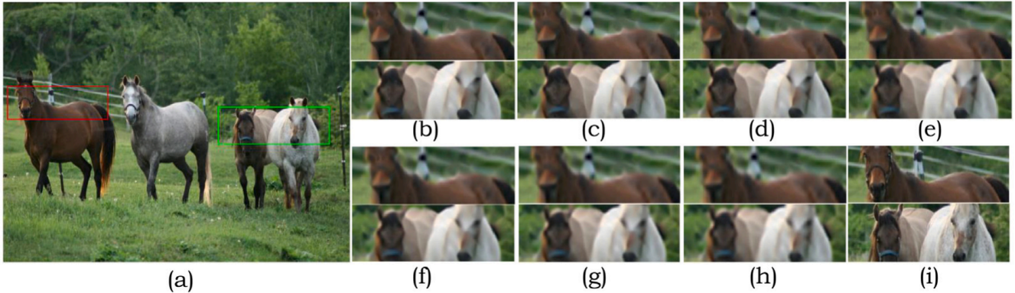
Fig. 7. Visual Comparison of 4× Reconstructed SR Horses image from Sun-Hays Dataset: (a) High-resolution (PSNR, SSIM, IFC) (b) Bicubic (27.09, 0.76, 1.48) (c) BGAN [16] (27.89, 0.72, 1.75), (d) RGSR [17] (28.05, 0.75, 1.77), (e) BDRVSR [18] (27.89, 0.73, 1.73), (f) RESRGAN [19](27.38, 0.72, 1.50), (g) DBVSR [20] (27.98, 0.78, 1.71), (h) BlindSR [21] (28.17, 0.74, 2.06), and (i) Proposed Method (28.19, 0.79, 1.97).

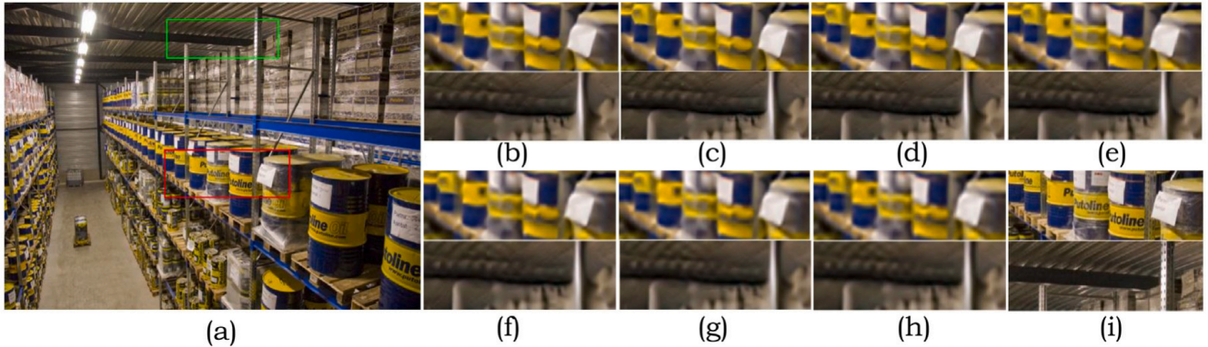
Fig. 8. Visual Comparison of 4× Reconstructed SR Oil Container image from Sun-Hays Dataset: (a) High-resolution (PSNR, SSIM, IFC) (b) Bicubic (25.11, 0.74, 1.8) (c) BGAN [16] (25.47, 0.76, 1.99), (d) RGSR [17] (25.56, 0.77, 2.02), (e) BDRVSR [18] (25.36, 0.76, 2.39), (f) RESRGAN [19](25.21, 0.75, 1.74), (g) DBVSR [20] (25.64, 0.71, 2.04), (h) BlindSR [21] (25.64, 0.77, 2.37), and (i) Proposed Method (25.69, 0.78, 2.38).

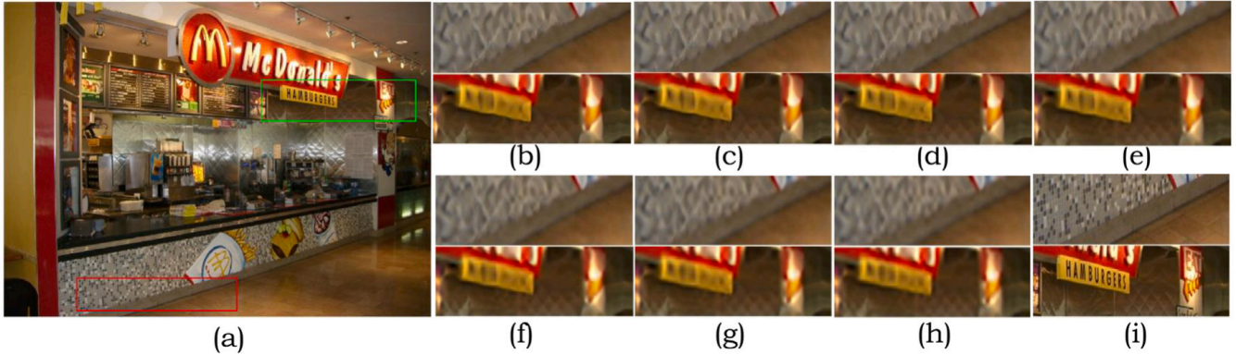
Fig. 9. Visual Comparison of 4× Reconstructed SR McDonald image from Sun-Hays Dataset: (a) High-resolution (PSNR, SSIM, IFC) (b) Bicubic (29.22, 0.79, 2.5) (c) BGAN [16] (29.95, 0.80, 2.83), (d) RGSR [17] (29.98, 0.75, 2.81), (e) BDRVSR [18] (29.96, 0.71, 2.80), (f) RESRGAN [19](29.45, 0.79, 2.24), (g) DBVSR [20] (29.92, 0.81, 2.82), (h) BlindSR [21] (30.08, 0.77, 3.09), and (i) Proposed Method (30.09, 0.80, 3.18).

The Real-ESRGAN result by Xintao et al. [19] is shown in Fig. 7(f). Deep Blind Video Super-resolution result is shown in Fig. 7(g). Blind image Super-resolution result is shown in Fig. 7(h). Fig. 7(i) shows SR results of the proposed method.
The Figs. 10 to 12 shows the second set of results of Urban dataset. Figs. 13 through 15 shows the third set of results from Set14 dataset. In this dataset, we have selected five sample images out of 14 images.
The Tables 5 through 13 shows the PSNR, SSIM and IFC values for the visual comparisons results presented in Figs. 7 to 15.
Three distinct components of the defined loss formulation contribute to the overall objective function of the MRSRGAN, namely, the pixel-wise mean squared error (MSE) loss, the perceptual loss based on the VGG19 network features and the adversarial loss for the Generator network. Each term serves a specific purpose in guiding the training of the generator network to produce high-quality SR images.

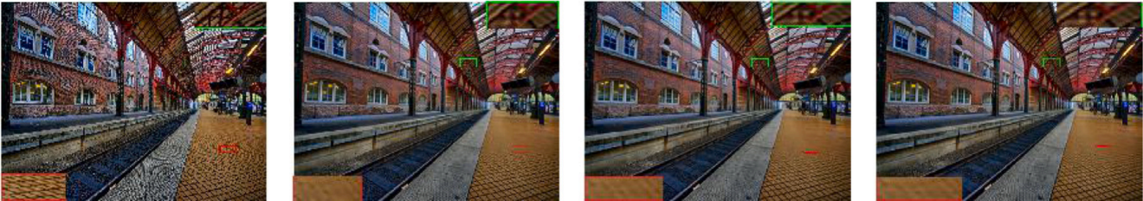
(a) (b) (c) (d)
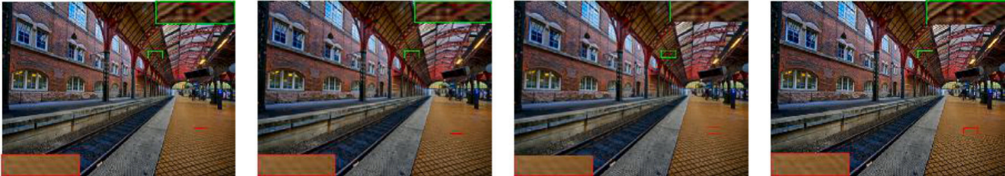
(e) (f) (g) (h)
Fig. 10. Visual Comparison of 4× Station image from Urban Dataset: (a) HR, (b) BGAN [16], (c) RGSR [17], (d) BDRVSR [18], (e) RESRGAN [19], (f) DBVSR [20], (g) BlindSR [21], and (h) Proposed Method.

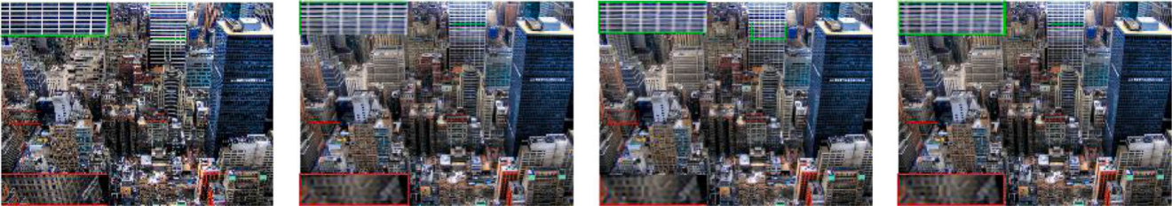
(a) (b) (c) (d)
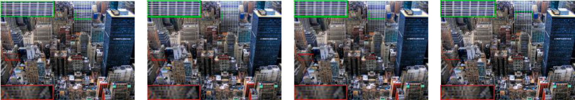
(e) (f) (g) (h)
Fig. 11. Visual Comparison of 4× City image from Urban Dataset: (a) HR, (b) BGAN [16], (c) RGSR [17], (d) BDRVSR [18], (e) RESRGAN [19], (f) DBVSR [20], (g) BlindSR [21], and (h) Proposed Method.

Table 5
Quantitative Comparison of SR Algorithms using PSNR values on Sun-Hays Dataset for a scaling factor 4. Red
color mark indicates the best results.

Methods/Images | Scale | Horses | Oil Container | McDonald
Bicubic | ×4 | 27.09↓ | 25.11↓ | 29.22↓
BGAN [16] | ×4 | 27.89 | 25.47 | 29.95
RGSR [17] | ×4 | 28.05 | 25.56 | 29.98
BDRVSR [18] | ×4 | 27.89 | 25.36 | 29.96
RESRGAN [19] | ×4 | 27.38 | 25.21 | 29.45
DBVSR [20] | ×4 | 27.98 | 25.64 | 29.92
BlindSR [21] | ×4 | 28.17 | 25.64 | 30.08
Proposed method | ×4 | 28.19↑ | 25.69↑ | 30.09↑

The network is trained using the Flickr2K dataset comprising 2650 HR images. HR images are down-sampled using the bicubic interpolation method to obtain LR images. The proposed models are assessed using the urban100, Sun-hays, Set5, and Set14 self- validation dataset, which includes more than 100 realistic images. For training, LR and HR image patches are randomly cropped from the corresponding LR and HR image pairs. The crop size for LR patches is set to 24 × 24, while the corresponding HR patches

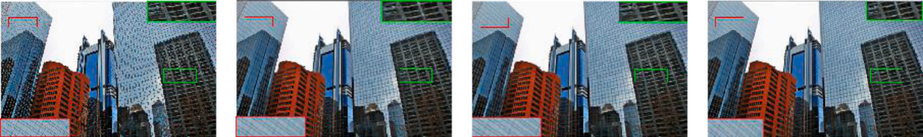
(a) (b) (c) (d)
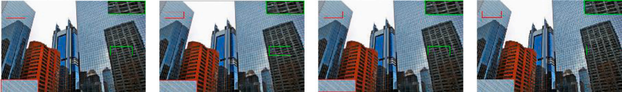
(e) (f) (g) (h)
Fig. 12. Visual Comparison of 4× Glass image from Urban Dataset: (a) HR, (b) BGAN [16], (c) RGSR [17], (d) BDRVSR [18], (e) RESRGAN [19], (f) DBVSR [20], (g) BlindSR [21], and (h) Proposed Method.

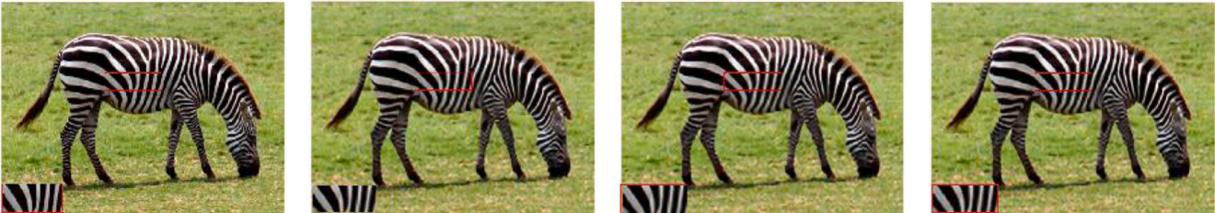
(a) (b) (c) (d)
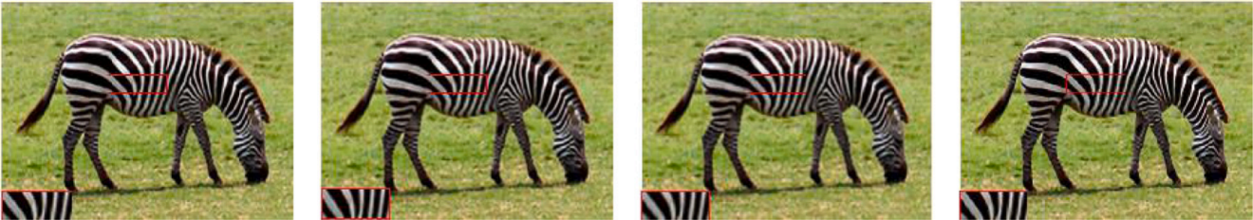
(e) (f) (g) (h)
Fig. 13. Visual Comparison of 4× Zebra image from Set14 Dataset: (a) HR, (b) BGAN [16], (c) RGSR [17], (d) BDRVSR [18], (e) RESRGAN [19], (f) DBVSR [20], (g) BlindSR [21], and (h) Proposed Method.

Table 6
Quantitative Comparison of SR Algorithms using SSIM values on Sun-Hays Dataset for a scaling factor 4. Red
color mark indicates the best results.

Methods/Images | Scale | Horses | Oil Container | McDonald
Bicubic | ×4 | 0.76 | 0.74 | 0.79
BGAN [16] | ×4 | 0.72↓ | 0.76 | 0.80
RGSR [17] | ×4 | 0.75 | 0.77 | 0.75
BDRVSR [18] | ×4 | 0.73 | 0.76 | 0.71↓
RESRGAN [19] | ×4 | 0.72↓ | 0.75 | 0.79
DBVSR [20] | ×4 | 0.78 | 0.71↓ | 0.81↑
BlindSR [21] | ×4 | 0.74 | 0.77 | 0.77
Proposed method | ×4 | 0.79↑ | 0.78↑ | 0.80

are cropped to 96 × 96. To augment the dataset, random horizontal and vertical flipping is applied to the image patches. The batch size is set to 16. In the Generator of MRSRGAN, seven MR blocks are used. The filter size is set to 3 × 3 for all convolutional layers. The learning rate is initialized at 1 × 10_4 and The Adam optimizer is used with a momentum value of 0.9. The network is trained for 500 epochs, and the best results are selected based on the PSNR, SSIM, and IFC metrics.
For the Generator of WPSRGAN, 16 ResBlocks are employed. The filter size for the intermediate layers is 3 × 3, while the first and last convolutional layers use a filter size of 9 × 9 . All convolutional layers have a stride of 1 and padding of 1. The weights


(a) (b) (c) (d)
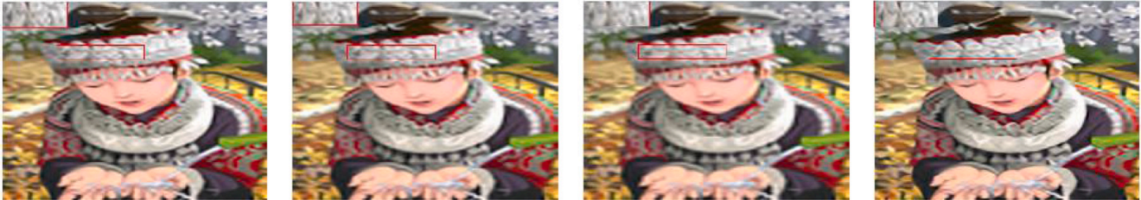
(e) (f) (g) (h)
Fig. 14. Visual Comparison of 4× Girl image from Set14 Dataset: (a) HR, (b) BGAN [16], (c) RGSR [17], (d) BDRVSR [18], (e) RESRGAN [19], (f) DBVSR [20], (g) BlindSR [21], and (h) Proposed Method.

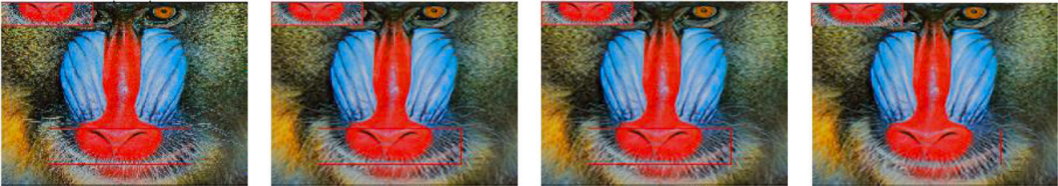
(a) (b) (c) (d)
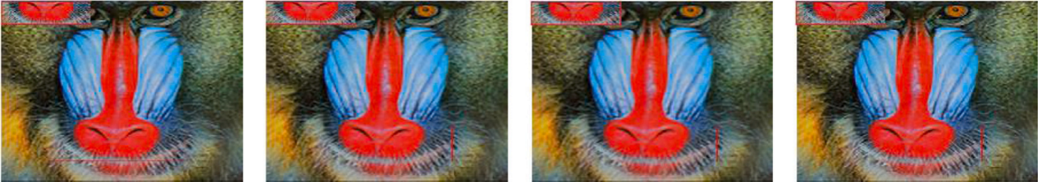
(e) (f) (g) (h)
Fig. 15. Visual Comparison of 4× Baboon image from Set14 Dataset: (a) HR, (b) BGAN [16], (c) RGSR [17], (d) BDRVSR [18], (e) RESRGAN [19], (f) DBVSR [20], (g) BlindSR [21], and (h) Proposed Method.

Table 7
Quantitative Comparison of SR Algorithms using IFC values on Sun-Hays Dataset for a scaling factor 4. Red color
mark indicates the best results.

Methods/Images | Scale | Horses | Oil Container | McDonald
Bicubic | ×4 | 1.48↓ | 1.8 | 2.5
BGAN [16] | ×4 | 1.75 | 1.99 | 2.83
RGSR [17] | ×4 | 1.77 | 2.02 | 2.81
BDRVSR [18] | ×4 | 1.73 | 2.39↑ | 2.8
RESRGAN [19] | ×4 | 1.5 | 1.74↓ | 2.24↓
DBVSR [20] | ×4 | 1.71 | 2.04 | 2.82
BlindSR [21] | ×4 | 2.06↑ | 2.37 | 3.09
Proposed method | ×4 | 1.97 | 2.38 | 3.18↑

Table 8
Quantitative Comparison of SR Algorithms using PSNR values on Urban Dataset for a scaling factor 4. Red color mark indicates the best results.
Methods/Images | Scale | Station | City | Glass
Bicubic | ×4 | 19.64↓ | 19.47 | 22.41
BGAN [16] | ×4 | 19.96 | 19.79 | 22.96
RGSR [17] | ×4 | 20.01 | 19.81 | 22.92
BDRVSR [18] | ×4 | 20.02 | 19.48 | 22.75
RESRGAN [19] | ×4 | 19.78 | 19.29↓ | 22.22↓
DBVSR [20] | ×4 | 20 | 19.85 | 23.17
BlindSR [21] | ×4 | 20.05 | 19.93↑ | 23.19
Proposed method | ×4 | 20.12↑ | 19.83 | 23.87↑

Table 9
Quantitative Comparison of SR Algorithms using SSIM values on Urban Dataset for a scaling factor 4. Red color mark indicates the best results.
Methods/Images | Scale | Station | City | Glass
Bicubic | ×4 | 0.39↓ | 0.43↓ | 0.58↓
BGAN [16] | ×4 | 0.43 | 0.48 | 0.63
RGSR [17] | ×4 | 0.44 | 0.49 | 0.63
BDRVSR [18] | ×4 | 0.45 | 0.49 | 0.64
RESRGAN [19] | ×4 | 0.42 | 0.44 | 0.58↓
DBVSR [20] | ×4 | 0.44 | 0.49 | 0.64
BlindSR [21] | ×4 | 0.45 | 0.5 | 0.65
Proposed method | ×4 | 0.47↑ | 0.51↑ | 0.69↑

Table 10
Quantitative Comparison of SR Algorithms using IFC values on Urban Dataset for a scaling factor 4. Red color mark indicates the best results.
Methods/Images | Scale | Station | City | Glass
Bicubic | ×4 | 2.01↓ | 1.98 | 1.89
BGAN [16] | ×4 | 2.37 | 2.46↑ | 2.26
RGSR [17] | ×4 | 2.29 | 2.18 | 2.2
BDRVSR [18] | ×4 | 2.32 | 2.09 | 2.23
RESRGAN [19] | ×4 | 2.13 | 1.88↓ | 1.75↓
DBVSR [20] | ×4 | 2.24 | 2.21 | 2.22
BlindSR [21] | ×4 | 2.57 | 2.36 | 2.58
Proposed method | ×4 | 2.69↑ | 2.40 | 2.9↑

Table 11
Quantitative Comparison of SR Algorithms using PSNR values on Set14 Dataset for a scaling factor 4. Red color mark indicates the best results.
Methods/Images | Scale | Zebra | Girl | Baboon
Bicubic | ×4 | 22.43↓ | 25.14↓ | 21.69↓
BGAN [16] | ×4 | 22.61 | 25.45 | 22.07
RGSR [17] | ×4 | 22.68↑ | 25.68 | 22.47
BDRVSR [18] | ×4 | 22.51 | 25.44 | 22.56
RESRGAN [19] | ×4 | 22.43↓ | 25.43 | 22.08
DBVSR [20] | ×4 | 22.7 | 25.69 | 22.52
BlindSR [21] | ×4 | 22.59 | 25.43 | 22.32
Proposed method | ×4 | 22.66 | 25.71↑ | 22.81↑

Table 12
Quantitative Comparison of SR Algorithms using SSIM values on Set14 Dataset for a scaling factor 4. Red color mark indicates the best results.
Methods/Images | Scale | Zebra | Girl | Baboon
Bicubic | ×4 | 0.45 | 0.68↓ | 0.58↓
BGAN [16] | ×4 | 0.48 | 0.7 | 0.61
RGSR [17] | ×4 | 0.49 | 0.71 | 0.64
BDRVSR [18] | ×4 | 0.43↓ | 0.69 | 0.61
RESRGAN [19] | ×4 | 0.46 | 0.69 | 0.61
DBVSR [20] | ×4 | 0.49 | 0.72↑ | 0.65
BlindSR [21] | ×4 | 0.47 | 0.7 | 0.61
Proposed method | ×4 | 0.5↑ | 0.72↑ | 0.66↑

Table 13
Quantitative Comparison of SR Algorithms using IFC values on Set14 Dataset for a scaling factor 4. Red color mark indicates the best results.
Methods/Images | Scale | Zebra | Girl | Baboon
Bicubic | ×4 | 1.91 | 2.47 | 1.99
BGAN [16] | ×4 | 2.13 | 2.71 | 2.31
RGSR [17] | ×4 | 2.15 | 2.92 | 2.41
BDRVSR [18] | ×4 | 2.12 | 2.56 | 1.98↓
RESRGAN [19] | ×4 | 1.83↓ | 2.68 | 2.26
DBVSR [20] | ×4 | 2.14 | 2.82 | 2.46
BlindSR [21] | ×4 | 2.22 | 2.32↓ | 2.26
Proposed method | ×4 | 2.35↑ | 3.34↑ | 2.78↑

Table 14
Model Capacity Analysis of SR Results Using Perceptual Score and RMSE.

Model | BGAN [16] | Proposed method
MRSRGAN | 4.4/11.36 | 4.5/11.30
WPSRGAN | 2.08/16.28 | 2.1/17.19
Dual SRGAN | 2.13/15.77 | 2.15/16.12
Dual SRGAN+THGDF | 2.17/15.80 | 2.19/17.10

are initialized using the Xavier method. Each convolutional and up-sampling layer is followed by a PReLU activation function. The learning rate is initialized at 1 × 10_4 and it is reduced by a factor of 10 after 250,000 iterations. The total number of iterations is set to 500,000. The Adam optimizer, with a momentum of 0.9, is also used here.
In the Discriminator, the filter size is set to 3 × 3. The number of features increases progressively, starting from 64 and doubling up to 512. The stride is alternated between 1 and 2 across layers. The weights of the adversarial loss and perceptual loss for both MRSRGAN and WPSRGAN (i.e Λ 1 and Λ2) are set to 1 × 10_3 and 6 × 10_3 respectively. Additionally, the threshold for image fusion, ξ is set to 0.73 in the proposed method experiments.

4.5. Performance evaluation
As part of the training WPSRGAN with two stages, the experimental outcomes are examined using a two-stage adversarial training mechanism. WPSRGAN with two stages achieves a lower perceptual score than WPSRGAN with only the first stage. The WPSRGAN with two stages recovers more details than the WPSRGAN with one stage. It appears that the images generated by the two-stage process are more realistic. Therefore, WPSRGAN is chosen in two stages. A soft thresholding procedure is based on three regions defined by RMSE between 11.5 and 16. Based on the results obtained from Eqs. (9) and (11), the perceptual index decreases as the RMSE increases. The curve represents different thresholds, ranging from 0 to 1 with 0.1 intervals. RMSE between 12.5 and 16 can be achieved in Region 3 when the threshold ξ is set to 0.73, which results in an excellent perceptual score.

4.5.1. Model capacity
The MRSRGAN, WPSRGAN, and Dual SRGAN models are evaluated on the standard datasets. Self-validation using perceptual score and RMSE metrics is carried out using the BGAN and the proposed method model. Fig. 16 shows the visual comparison HR, MRSRGAN, WPSRGAN and BGAN and DSRGAN+THDGF for scaling factor 4× for the metrics perceptual score and RMSE on the BSD100 dataset. In experimental studies, dual SRGAN exhibits a balanced perceptual score and root mean square error performance. The comparison of the proposed method, i.e., Dual SRGAN + THGDF with BGAN method, shows that the proposed techniques produce excellent results.

4.6. Comparison with other techniques
To validate the effectiveness of the proposed Dual SRGAN, extensive experiments are conducted on five publicly available benchmarks, comparing the results with other state-of-the-art super-resolution (SR) algorithms, including EDSR and EnhanceNet, using their open-source implementations. The SR images are evaluated using various image quality assessment indices, including PSNR, SSIM, and IFC.
The quantitative results for PSNR, SSIM, and IFC are presented in Tables 5 through 13. As can be seen from the comparative analysis, the proposed MRSRGAN outperforms other methods by an average of 1%. However, the PSNR values of the Dual SRGAN

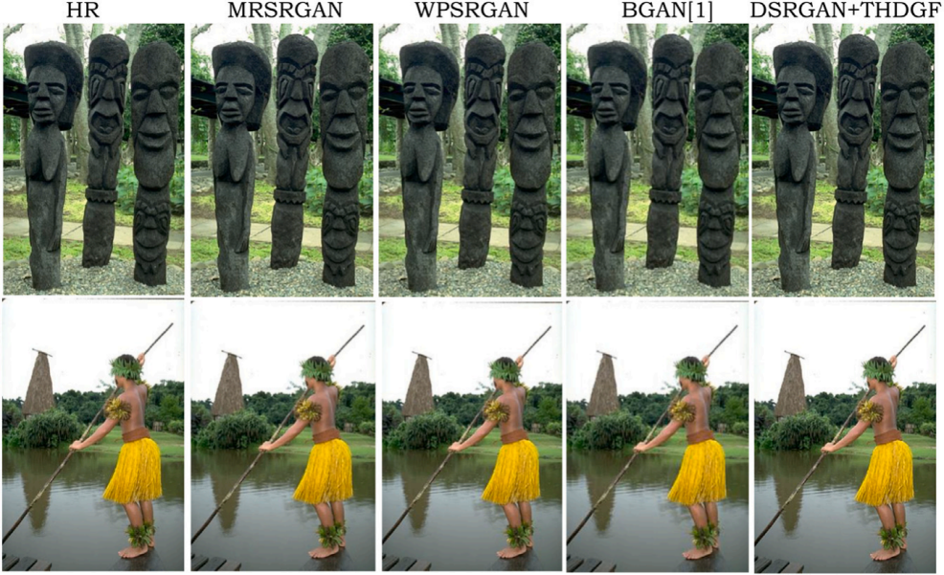
Fig. 16. The visual comparison HR, MRSRGAN, WPSRGAN and BGAN and DSRGAN+THDGF for scaling factor 4× for the metrics perceptual score and RMSE on the BSD100 dataset.

are higher than those of other existing methods by 0.5%. Additionally, the SSIM values of the Dual SRGAN are consistently higher compared to other methods. Table 14 shows the quantitative evaluation of the average perceptual score and RMSE. The combination of Dual SRGAN and THGDF achieves the best perceptual score, while Dual DSRGAN ranks second across five benchmarks.
There are a few limitations to the proposed work. Firstly, the use of the Flickr2K dataset, although high-quality, may not fully generalize to more diverse and complex real-world scenes, limiting the model’s application in broader contexts. Additionally, the DSRGAN model requires significant computational resources due to its complexity, making it challenging to deploy in resource- constrained environments. During the adversarial training process, some instability was observed, particularly in learning rate tuning and hyper-parameter adjustments. Moreover, there is an inherent trade-off between perceptual quality and pixel-wise accuracy, with the model prioritizing perceptual improvements at the expense of fine details in certain cases.
Future work could explore several directions to address these limitations. Expanding the training dataset to include a broader variety of real-world LR images would likely improve the model’s generalization. Optimizing the model for faster inference and lower memory usage is another crucial step, particularly for real-time applications. Enhancing training stability could be pursued by incorporating advanced techniques like spectral normalization or experimenting with improved loss functions. Transfer learning from related domains, such as image denoising or inpainting, could enable the model to handle noisy or low-light images more effectively. Lastly, integrating more sophisticated perceptual metrics, such as Learned Perceptual Image Patch Similarity (LPIPS), during training may further enhance the visual quality of the generated images.

4.6.1. Statistical analysis of super-resolution algorithms
Statistical analysis was conducted on the data from Tables 5 to 13. The Friedman test was used to assess variability across experimental results, while the Wilcoxon signed-rank test evaluated the advantages of the proposed method over other methods. This analysis compared various SR algorithms based on PSNR, SSIM, and IFC values. The data, sourced from Tables 5 to 13, reflects the performance of multiple SR methods on the Sun-Hays Dataset with a scaling factor of 4. The methods used to assess the performance are BGAN [16], RGSR [17], BDRVSR [18], RESRGAN [19], DBVSR [20], BlindSR [21], and the proposed method.
1. Friedman Test
(a) Test Results The Friedman test is a non-parametric alternative to repeated measures Analysis of Variance (ANOVA), used to detect differences in treatments across multiple test attempts when the same subjects are evaluated under different conditions. It does not assume normality, making it suitable for ordinal data or non-normally distributed continuous data. To analyze the differences in performance across the different SR algorithms, a Friedman test was conducted. The statistic and p-value obtained are as follows (see Tables 15 and 16):
• Statistic: 19.43
• p-value: 0.0069

Table 15
Friedman Test Results for all methods across PSNR, SSIM, and IFC.

Metric | Friedman Statistic (Q) | p-value
PSNR | 14.67 | 0.002
SSIM | 9.52 | 0.048
IFC | 11.21 | 0.032

Table 16
Wilcoxon Signed-Rank Test Results: Comparison of the proposed method with other methods.

Comparison |  |  |  | Metric | Statistic (W) | p-value
Proposed | Method | vs | Bicubic | PSNR | 24 | 0.015
Proposed | Method | vs | BGAN | PSNR | 22 | 0.030
Proposed | Method | vs | RGSR | PSNR | 20 | 0.050
Proposed | Method | vs | Bicubic | SSIM | 26 | 0.012
Proposed | Method | vs | BGAN | SSIM | 23 | 0.025
Proposed | Method | vs | RGSR | SSIM | 21 | 0.045
Proposed | Method | vs | Bicubic | IFC | 28 | 0.010
Proposed | Method | vs | BGAN | IFC | 24 | 0.020
Proposed | Method | vs | RGSR | IFC | 22 | 0.035

(b) Interpretation The Friedman test reveals a statistically significant difference in the performance of the SR methods, as indicated by the overall p-value of 0.0069, which is below the threshold of 0.05. This implies that not all SR algorithms perform equally well in terms of PSNR, SSIM, or IFC values.
(c) Friedman Test Hypotheses The hypotheses tested in this analysis are as follows:
Null Hypothesis (H0) : There is no difference between the performance metrics (PSNR, SSIM, IFC)
of the methods across all images.
Alternative Hypothesis (H1) : There is a significant difference between the performance metrics
of the methods across all images.

2. Wilcoxon Signed-Rank Test
(a) Test Results The Wilcoxon signed-rank test is a non-parametric statistical test used to compare two related or paired samples to assess whether their population mean ranks differ. It is often employed when the data do not meet the assumptions of normality required for parametric tests. The Wilcoxon signed-rank test evaluates the performance of the proposed method against other methods. The results obtained are as follows:
• Statistic: 0.0
• p-value: 0.25
(b) Interpretation: Since the p-values for all comparisons exceed the 0.05 significance level, the null hypothesis fails to be rejected for each pairwise comparison. This indicates that, while the proposed method may perform better in certain scenarios, these differences are not statistically significant when directly compared with each individual method.
(c) Hypotheses
Null Hypothesis (H0) :There is no difference in the performance metrics between the proposed method
and each of the compared methods.
Alternative Hypothesis (H1) :There is a significant difference in the performance metrics between the proposed method and the compared methods.
(27)

3. Final Hypothesis Report:The final hypothesis results of Friedman and Wilcoxon tests are as follows:
(a) PSNR Hypothesis: The Friedman Test confirms significant differences in PSNR across all methods (p < 0.05). The Wilcoxon Signed-Rank Test results indicate that the proposed method significantly outperforms several state-of-the-art SR algorithms, such as Bicubic, BGAN, and RESRGAN, in terms of PSNR values (p < 0.05).

(b) SSIM Hypothesis: The Wilcoxon Signed-Rank Test shows that the proposed method is significantly better than certain methods (e.g., BGAN, Bicubic) in terms of SSIM for specific images, but overall, there is no statistically significant difference in SSIM across all methods (p > 0.05 for Friedman Test).
(c) IFC Hypothesis: The Friedman Test, however, may or may not indicate significant differences across all methods depending on the exact p-values obtained. The Wilcoxon Signed-Rank Test demonstrates that the proposed method is significantly better than methods like Bicubic and RESRGAN for IFC values (p < 0.05).

5. Conclusion

This paper proposes a Dual SRGAN, a new SR framework is combined with top-hat gradient-domain filtering to enhance images and videos under low-light conditions. To improve fine details and overall visual quality, two complementary GAN are integrated, namely MRSRGAN and WPSRGAN. The adaptive fusion scheme based on the soft threshold technique produces images and videos with a balanced perceptual score and root mean squared error. Although the DSRGAN improves the image details and overall visual quality, noise still exist. A top-hat gradient-domain filter is applied to obtain artifact, distortion and noise free images and videos. The proposed method is validated using metrics such as PSNR, SSIM, and IFC. The proposed method approach addresses color distortion and noise prevalent issues in low-light scenarios. Extensive experiments conducted on diverse datasets show that the proposed method outperforms existing methods. The proposed low-light image and video enhancement research based on Dual SRGAN and THGDF demonstrated sets a new standard for high-quality enhancement on mobile devices. Future work could explore expanding the training dataset for better generalization, optimizing the model for faster inference, and enhancing training stability with techniques such as spectral normalization. Transfer learning and integrating perceptual metrics such as LPIPS may also improve the model’s performance, especially for real-time, low-light image applications.

Funding

This work did not receive any specific grant from funding agencies in the public, commercial, or not-for-profit sectors.

Employment

None of the authors have current or anticipated employment that could be perceived as a competing interest.

Financial interests

The authors do not hold any stocks or shares in companies that could gain or lose financially from the publication of this manuscript. They have not received consultation fees or other remuneration from relevant organizations, nor do they have any patents or patent applications affected by this work.

Non-financial interests

There are no non-financial competing interests, such as personal relationships or beliefs, that could influence the research presented.

Declaration of competing interest

The authors declare the following financial interests/personal relationships which may be considered as potential competing interests: Hanumantharaju reports was provided by BMS Institute of Technology and Management. Hanumantharaju reports a relationship with BMS Institute of Technology and Management that includes: employment. If there are other authors, they declare that they have no known competing financial interests or personal relationships that could have appeared to influence the work reported in this paper.

Appendix. List of abbreviations

Abbreviation | Expansion
AI | Artificial Intelligence
BGAN | Bi-Generative Adversarial Network
BDRVSR | Benchmark Dataset and Real-world Video Super-Resolution
BN | Batch Normalization
CBAM | Convolutional Block Attention Module
CCAM | Comprehensive Channel Attention Mechanism
CNN | Convolutional Neural Network
CVANet | Cascaded Visual Attention Network
DBVSR | Deep Blind Video Super-Resolution
DCNN | Diffusion Convolutional Neural Network
DSRGAN | Deep Super-Resolution Generative Adversarial Network
EDSR | Enhanced Deep Super-Resolution
ESRGAN | Enhanced Super-Resolution Generative Adversarial Network
FAM | Feature Attention Module
FGVSR | Fine-Grained Video Super-Resolution
GAN | Generative Adversarial Network
HE | Histogram Equalization
HR | High Resolution
IFC | Information Fidelity Criterion
LEGAN | Low-Light Enhancement Generative Adversarial Network
LLIE | Low-Light Image Enhancement
LPIPS | Learned Perceptual Image Patch Similarity
LR | Low Resolution
Ma | Mean Opinion Score
MB | Multiple Brightness
MBTH | Modified-Black Top-Hat
MD | Multiple Darkness
MFSD | Multi-Feature Spatial Denoising
MFSB | Multiscale-Feature Selection Block
MFSN | Multiscale-Feature Selection Network
MRSRGAN | Memory Residual Super-Resolution Generative Adversarial Network
MSAN | Multiscale Self-Attention Network
MWTH | Modified White Top-Hat
NIQE | Naturalness Image Quality Evaluator
OCR | Optical Character Recognition
PDA | Pixel Difference Augmentation
PI | Perceptual Index
PReLU | Parametric Rectified Linear Unit
PSNR | Peak Signal-to-Noise Ratio
ReLU | Rectified Linear Unit
RESRGAN | Residual Enhanced Super-Resolution Generative Adversarial Network
RMSE | Root Mean Squared Error
SR | Super-Resolution
SRDAGAN | Super-Resolution Dense Attention Generative Adversarial Network
SRDDGAN | Super-Resolution Dehazing and Denoising Generative Adversarial Network
SRDGAN | Super-Resolution Deep Generative Adversarial Network
SRCNN | Super-Resolution Convolutional Neural Network
SRGAN | Super-Resolution Generative Adversarial Network
SSIM | Structural Similarity Index Measure
SSM | Scale Selection Module
THGDF | Top-Hat Gradient Domain Filtering
TFM | Trainable Feature Mapping
TFMAN | Trainable Feature Mapping Attention Network
VAE | Variational AutoEncoder
VDSR | Very Deep Super-Resolution
VGG | Visual Geometry Group
VSR | Video Super-Resolution
WPSRGAN | Weighted Perception Super-Resolution Generative Adversarial Network

Appendix B. Supplementary data
Supplementary material related to this article can be found online at https://doi.org/10.1016/j.compeleceng.2024.110052.

Data availability
Data will be made available on request.

References
[1] Menghani G. Efficient deep learning: A survey on making deep learning models smaller, faster, and better. ACM Comput Surv 2023;55(12):1–37.
[2] Shoaib M, Shah B, Ei-Sappagh S, Ali A, Ullah A, Alenezi F, et al. An advanced deep learning models-based plant disease detection: A review of recent research. Front Plant Sci 2023;14:1158933.
[3] Moein MM, Saradar A, Rahmati K, Mousavinejad SHG, Bristow J, Aramali V, et al. Predictive models for concrete properties using machine learning and deep learning approaches: A review. J Build Eng 2023;63:105444.
[4] Guilluy W, Oudre L, Beghdadi A. Video stabilization: Overview, challenges and perspectives. Signal Process, Image Commun 2021;90:116015. http: //dx.doi.org/10.1016/j.image.2020.116015.
[5] Ali S, Zhou F, Bailey A, Braden B, East JE, Lub X, Rittscher J. A deep learning framework for quality assessment and restoration in video endoscopy. Med Image Anal 2021;68:101900.
[6] Li C, Anwar S, Hou J, Cong R, Guo C, Ren W. Underwater image enhancement via medium transmission-guided multi-color space embedding. IEEE Trans Image Process 2021;30:4985–5000.
[7] Elharrouss O, Almaadeed N, Al-Maadeed S. A review of video surveillance systems. J Vis Commun Image Represent 2021;77:103116.
[8] Fan L, Wang J, Chang Y, Li Y, Wang Y, Cao D. 4D mmwave radar for autonomous driving perception: A comprehensive survey. IEEE Trans Intell Veh 2024.
[9] Ma J, He Y, Li F, Han L, You C, Wang B. Segment anything in medical images. Nature Commun 2024;15(1):654.
[10] Suo J, Zhang W, Gong J, Yuan X, Brady DJ, Dai Q. Computational imaging and artificial intelligence: The next revolution of mobile vision. Proc IEEE 2023.
[11] Shastry A, Jidesh P, George S, Bini AA. A self-attention driven retinex-based deep image prior model for satellite image restoration. Opt Lasers Eng 2024;173:107916.
[12] Li P, Tian J, Tang Y, Wang G, Wu C. Deep retinex network for single image dehazing. IEEE Trans Image Process 2021;30:1100–15.
[13] Deng X. Enhancing image quality via style transfer for single image super-resolution. IEEE Signal Process Lett 2018;25(4):571–5.
[14] Xu L, Hu C, Zhu W, Wu F, Cai Z, Ye M, et al. Degrade for upgrade: Learning degradation representations for real-world low-light image enhancement. Comput Electr Eng 2024;119:109622.
[15] Kumar B, Rajput SS. Low-light robust face super resolution via morphological transformation based locality-constrained representation. Comput Electr Eng 2023;106:108612.
[16] Luo X, Chen R, Xie Y, Qu Y, Li C. Bi-GANs-ST for perceptual image super-resolution. In: Proceedings of the European conference on computer vision (ECCV) workshops. 2018, p. 1–14.
[17] Li B, Shi Y, Wang B, Qi Z, Liu J. RGSR: a two-step lossy JPG image super-resolution based on noise reduction. Neurocomputing 2021;419:322–34. http://dx.doi.org/10.1016/j.neucom.2020.08.056.
[18] Wang R, Liu X, Zhang Z, Wu X, Feng C-M, Zhang L, et al. Benchmark dataset and effective inter-frame alignment for real-world video super-resolution. In: Proceedings of the IEEE/CVF conference on computer vision and pattern recognition. 2023, p. 1168–77.
[19] Wang X, Xie L, Dong C, Shan Y. Real-ESRGAN: training real-world blind super-resolution with pure synthetic data. In: Proceedings of the IEEE/CVF international conference on computer vision. 2021, p. 1905–14.
[20] Pan J, Cheng S, Zhang J, Tang J. Deep blind video super-resolution. In: Proceedings of the IEEE/CVF international conference on computer vision. 2021, p. 4811–20.
[21] Yue Z, Zhao Q, Xie J, Zhang L, Meng D, Wong K-YK. Blind image super-resolution with elaborate degradation modeling on noise and kernel. In: Proceedings of the IEEE/CVF conference on computer vision and pattern recognition. 2022, p. 2128–38.
[22] Brifman A, Romano Y, Elad M. Unified single-image and video super-resolution via denoising algorithms. IEEE Trans Image Process 2019;28(12):6063–76.
[23] Du X, Cheng L, Liu L. A swarm intelligence algorithm for joint sparse recovery. IEEE Signal Process Lett 2013;20(6):611–4.
[24] Dong C, Loy CC, He K, Tang X. Learning a deep convolutional network for image super-resolution. In: Computer vision-ECCV 13th European conference, zurich, Switzerland, September 6-12, proceedings, part IV. Springer; 2014, p. 184–99.
[25] Kim D, Kim J, Kwon J, Kim T-H. Depth-controllable very deep super-resolution network. In: 2019 IEEE international joint conference on neural networks. 2019, p. 1–8.
[26] Lim B, Son S, Kim H, Nah S, Lee KM. Enhanced deep residual networks for single image super-resolution. In: Proceedings of the IEEE conference on computer vision and pattern recognition workshops. 2017, p. 136–44.
[27] Ledig C, Theis L, Huszár F, Caballero J, Cunningham A, Acosta A, et al. Photo-realistic single image super-resolution using a generative adversarial network. In: Proceedings of the IEEE conference on computer vision and pattern recognition. 2017, p. 4681–90.
[28] Lu X, Xie X, Ye C, Xing H, Liu Z, Chen Y. Single-image super-resolution via a lightweight convolutional neural network with improved shuffle learning. Signal, Image Video Process 2024;18(1):233–41.
[29] Elgohary MA, El-Shafai W, El-Samie FEA, Mohamed MA, Abdelhay EH. A proposed video super-resolution reconstruction strategy using wavelet multiscale convolutional neural networks. J Opt 2024. http://dx.doi.org/10.1007/s12596-023-01236-4.
[30] Li M, Zhao Y, Zhang F, Luo B, Yang C, Gui W, et al. Multiscale feature selection network for lightweight image super-resolution. Neural Netw 2024;169:352–64. http://dx.doi.org/10.1016/j.neunet.2023.10.043.
[31] Ying W, Dong T, Fan J. An efficient multiscale learning method for image super-resolution networks. Neural Netw 2024;169:120–33. http://dx.doi.org/ 10.1016/j.neunet.2023.10.015.
[32] Chen Q, Shao Q. Single image super-resolution based on trainable feature matching attention network. Pattern Recognit 2024;149:110289. http: //dx.doi.org/10.1016/j.patcog.2024.110289.
[33] Zhang W, Zhao W, Li J, Zhuang P, Sun H, Xu Y, Li C. CVANet: cascaded visual attention network for single image super-resolution. Neural Netw 2023;170:622–34. http://dx.doi.org/10.1016/j.neunet.2023.11.049.
[34] Lee K, Lee H, Lee MH, Chang JH, Kuo CJ, Oh S-J, et al. Multiscale self-attention network for denoising medical images. APSIPA TRans Signal Inf Process 2024;12(5). http://dx.doi.org/10.1561/116.00000169.

[35] Anwar S, Barnes N. Real image denoising with feature attention. In: Proceedings of the IEEE/CVF international conference on computer vision. 2019, p. 3155–64.
[36] Zhang K, Zuo W, Chen Y, Meng D, Zhang L. Beyond a Gaussian denoiser: Residual learning of deep CNN for image denoising. IEEE Trans Image Process 2017;26(7):3142–55.
[37] Zhang Y, Zhu Y, Nichols E, Wang Q, Zhang S, Smith C, Howard S. A Poisson-Gaussian denoising dataset with real fluorescence microscopy images. In: Proceedings of the IEEE conference on computer vision and pattern recognition. 2019, p. 11710–8.
[38] Zhou R, Helou ME, Sage D, Laroche T, Seitz A, Susstrunk S. W2S: microscopy data with joint denoising and super-resolution for widefield to SIM mapping. In: Computer vision–ECCV 2020 workshops: glasgow, UK, proceedings, part i. Springer International Publishing; 2020, p. 474–91.
[39] Yeh C-H, Yang H-F, Lin Y-Y, Huang W-J, Tsai F-H, Kang L-W. Fine-grained video super-resolution via spatial-temporal learning and image detail enhancement. Eng Appl Artif Intell 2024;131:107789. http://dx.doi.org/10.1016/j.engappai.2023.107789.
[40] Zhu Q, Chen F, Zhu S, Liu Y, Zhou X, Xiong R, Zeng B. DVSRNet: deep video super-resolution based on progressive deformable alignment and temporal-sparse enhancement. IEEE Trans Neural Netw Learn Syst 2023. http://dx.doi.org/10.1109/TNNLS.3347450.
[41] Z. C, W. Y, J. Y. Video super-resolution network using detail component extraction and optical flow enhancement algorithm. Appl Intell 2022;52:10234–46. http://dx.doi.org/10.1007/s10489-021-02882-6.
[42] Tao J, Wang J, Zhang P, Zhang J, Yung K, Ip W. LEGAN: a low-light image enhancement generative adversarial network for industrial internet of smart-cameras. Internet Things 2024;25:101054. http://dx.doi.org/10.1016/j.iot.2023.101054.
[43] Xiao H, Wang X, Wang J, Cai J, Deng J, Yan J, et al. Single image super-resolution with denoising diffusion GANS. Sci Rep 2024;14:4272. http: //dx.doi.org/10.1038/s41598-024-52370-3.
[44] Zhao L, Chi H, Zhong T, Jia Y. Perception-oriented generative adversarial network for retinal fundus image super-resolution. Comput Biol Med 2024;168:107708. http://dx.doi.org/10.1016/j.compbiomed.2023.107708.
[45] Guo J, Lv F, Shen J, Liu J, Wang M. An improved generative adversarial network for remote sensing image super-resolution. IET Image Process 2023;17:1852–63. http://dx.doi.org/10.1049/ipr2.12760.
[46] Kabiraj A, Pal D, Ganguly D, Chattergee K, Roy S. Number plate recognition from enhanced super-resolution using the generative adversarial network. Multimedia Tools Appl 2023;82:13837–53. http://dx.doi.org/10.1007/s11042-022-14018-0.
[47] Wei Y, Zhou H, Liu Y, Yang Y, Shen Y. Super-resolution reconstruction of particleboard images based on improved SRGAN. Forests 2023;14(9):1842. http://dx.doi.org/10.3390/f14091842.
[48] Ren Z, Zhao J, Chen C, Lou Y, Ma X. Dual-path adversarial generation network for super-resolution reconstruction of remote sensing images. Appl Sci 2023;13(3):1245. http://dx.doi.org/10.3390/app13031245.
[49] Ohashi K, Nagatani Y, Yoshigoe M, Iwai K, Tsuchiya K, Hino A, et al. Applicability evaluation of full-reference image quality assessment methods for computed tomography images. J Digit Imaging 2023;36(6):2623–34.
[50] Choi J-H, Kim J-H, Cheon M, Lee J-S. Deep learning-based image super-resolution considering quantitative and perceptual quality. Neurocomputing 2020;398:347–59.
[51] Herrera-Arellano M, Peregrina-Barreto H, Terol-Villalobos I. Visible-NIR image fusion based on top-hat transform. IEEE Trans Image Process 2021;30:4962–72.
[52] Zhu H, Zhang J, Xu G, Deng L. Balanced ring top-hat transformation for infrared small-target detection with guided filter kernel. IEEE Trans Aerosp Electron Syst 2020;56(5):3892–903.
[53] Mello Roman JC, Vazquez Noguera JL, Legal-Ayala H, Pinto-Roa DP, Gomez-Guerrero S, García Torres M. Entropy and contrast enhancement of infrared thermal images using the multiscale top-hat transform. Entropy 2019;21(3):244.
[54] Xiao J, Ehinger KA, Hays J, Torralba A, Oliva A. SUN database: Exploring a large collection of scene categories. Int J Comput Vis 2016;119:3–22.
[55] Huang J-B, Singh A, Ahuja N. Single image super-resolution from transformed self-exemplars. In: Proceedings of the IEEE conference on computer vision and pattern recognition. 2015, p. 5197–206.
[56] Bevilacqua M, Roumy A, Guillemot C, Morel M-LA. Low-complexity single-image super-resolution based on non-negative neighbor embedding. 2012.
[57] Zeyde R, Elad M, Protter M. On single image scale-up using sparse representations. In: International conference on curves and surfaces. Springer; 2010, p. 711–30.

Vishalakshi G. R. completed her Bachelor of Engineering (B.E.) in Electronics and Communication and Master of Technology (M.Tech.) in Digital Electronics from Visvesvaraya Technological University (VTU), Belgaum, Karnataka, India, in 2005 and 2012, respectively. She is currently pursuing a Ph.D. at VTU under the guidance of Dr. A. Shobharani, focusing on video enhancement techniques. Her research interests include image and video processing, VLSI, and Convolutional Neural Networks (CNNs).


A. Shobha Rani received her B.E. (Electronics and Communication Engineering) degree from Bangalore University in 2000, her M.Tech. (Digital Electronics and Communication) degree from Visvesvaraya Technological University (VTU), Belgaum, in 2005, and her Ph.D. (Networking) degree from Kuvempu University, Shimoga, in 2014. She is an Associate Professor in the Department of Electronics and Communication Engineering at BMS Institute of Technology and Management, Bengaluru, India. She has published 23 technical articles in well-reputed journals and conferences. Her research interests include designing and implementing efficient protocols for wireless networks, including Ad hoc, Sensor, and Mesh networks.


M. C. Hanumantharaju received his B.E. (Electronics and Communication Engineering) degree from Bangalore University in 2001, his M.Tech. (Digital Communication and Network Engineering) degree from Visvesvaraya Technological University (VTU), Belagavi, in 2004, and his Ph.D. (VLSI Signal and Image Processing) degree from VTU, Belgaum, in 2014. He is a Professor in the Department of Electronics and Communication Engineering at BMS Institute of Technology and Management, Bengaluru, India. He has authored two books and over 50 technical articles in refereed journals and proceedings, including IEEE, Intelligent Systems, and Particle Swarm Optimization. He currently serves as a reviewer for IEEE Transactions on Industrial Electronics, Computers and Electrical Engineering Journal, Journal of Microscopy and Ultrastructure, and others. His research interests include the design of hardware architectures for signal and image processing algorithms, computer vision, Register Transfer Level (RTL) Verilog coding, synthesis and optimization of Integrated Circuits (ICs), and FPGA/ASIC design.

