题目要求:
王者农药商城
1.键盘输入商品名称:狄仁杰皮肤，花木兰皮肤，鲁班皮肤
2.输入各商品的价格:200,448,128
3.购买数量都默认一个
4.输入折扣
5.打印购买清单
6.输入支付金额
7.计算会员积分(100积1分)
···············································································
If练习：
1、编写程序：由键盘输入三个整数分别存入变量num1、num2、num3，对它们进行排序(使用 if-else if-else),并且从小到大输出。

2、需求说明
抽奖规则：会员号的百位数字等于产生的随机数字即为幸运会员
Math.random()产生一个0-1随机数

3、需求说明
录入会员信息,如果会员号没有四位数，则显示录入失败。否则显示已录入信息

4.菜单选择
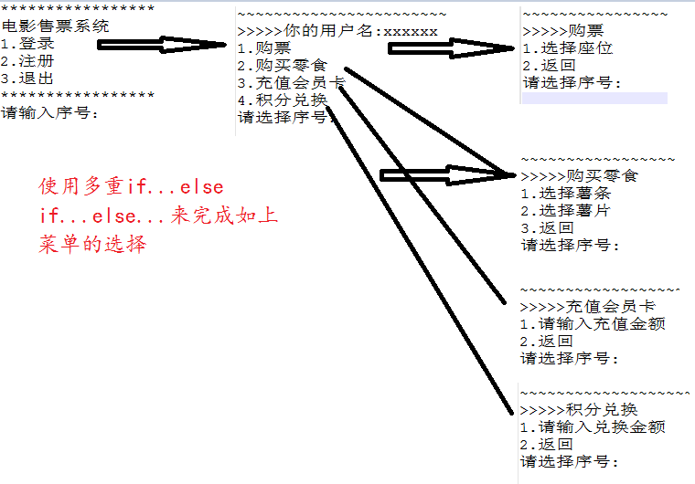
````````````````````````````````````````````````````````````````````````````````````````````````````````````````````````````````
Switch练习：
