  **Blog**

| **Title** | RB5 Gstreamer Plugin use cases |
| --- | --- |
| **Author** | ***Chaya H S, hs.chaya*@globaledgesoft.com**  ***Senior Software Engineer, Global Edge Software Ltd***  *Working as Senior Software Engineer with nearly 3 years of experience in building computer vision solutions using openCV, fastCV and other image processing libraries.* |
| **Post Date** | *(please provide final approved (by legal and trademarks) content one week prior to launch date on QDN)* |
| **Tags** | Gstreamer, Multimedia Applications |
| **Meta Description** | Example for gstreamer plugins on rb5 |
| **Categories** |  |
| **Image Source** | *(All blogs on QDN should include an image that is the property of Qualcomm. If you do not have an image for the blog, Marketing can help create a graphic from existing data, or we can pull a generic image from the Qualcomm photo library)* |

**Here is the table for gstreamer plugins on RB5 and brief description of application**

| **Gstreamer Plugin On RB5** | **Description** |
| --- | --- |
| qtiqmmfsrc | For capturing video frames |
| qtimletflite and qtimlesnpe | For AI and ML use, These plugins can be configured to run on CPU, GPU or DSP |
| qtivdec | For decoding video |
| omxh264enc | For video encode |
| omxaacenc | For audio encode |
| waylandsink | For video sink |
| qtivtransform | For resize, flip, rotate, and color converting of video frames |
| qtivcomposer | For mixing of one or more input video streams |
| qtioverlay | For drawing and bliting the RGB or YUV frames |

Use the gst-inspect-1.0 tool with plugin name as argument to get information about a plugin.

**Steps to set up display on RB5 to use gstreamer waylandsink plugin**

The waylandsink element is a video sink element that uses the Wayland's Weston compositor implementation. To use the waylandsink plugin, you need to set up HDMI on RB5.

**Steps to setup HDMI**

1. Connect RB5 and monitor or TV with HDMI cable.

2. Pull the switch to OFF as shown in the following figure.

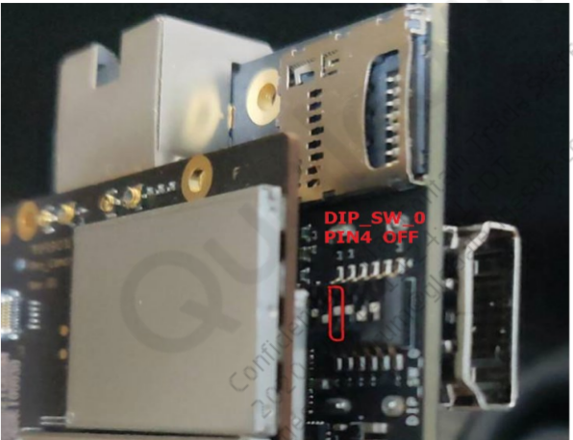

3. Entering to Fastboot

Gstreamer a. Press and hold VOL-key then press power ON to enter fastboot mode

b. Alternatively “adb reboot bootloader” from the command prompt

#fastboot oem select-display-panel none

4. Power OFF and power ON the device

5. Check HDMI display after the device boots up:

#cd /usr/bin

#./modetest -M msm_drm -c

#./modetest -M msm_drm -s 29:1920x1080x60x148500vid

Following figure display the HDMI display output

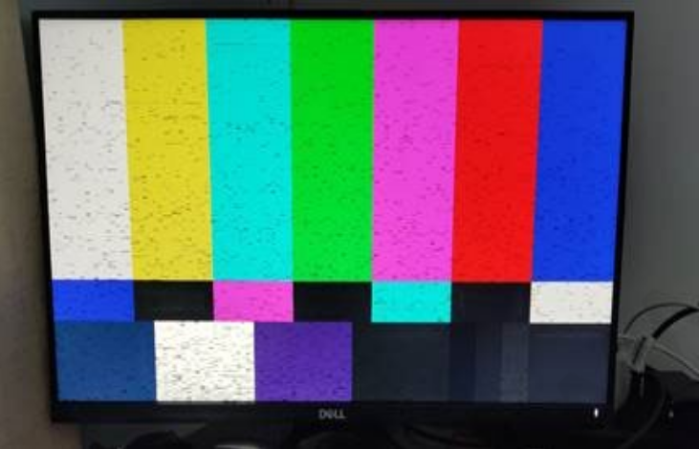

**Run the following commands to launch the Weston desktop application**

First check if Weston server is running on the target using the following command:-

# ps | grep weston

If it is not running, then use the following set of commands to start it.

Before running the following commands, ensure that the external display monitor is connected via HDMI.

adb shell mount -o remount,rw /

adb shell

export XDG_RUNTIME_DIR=/dev/socket/weston

mkdir -p /dev/socket/weston

/usr/bin/weston --tty=1 --idle-time=0 &

Then open another terminal and launch the weston prior to running waylandsink plugin

export XDG_RUNTIME_DIR=/dev/socket/weston

Following figure display the waylandsink plugin display output

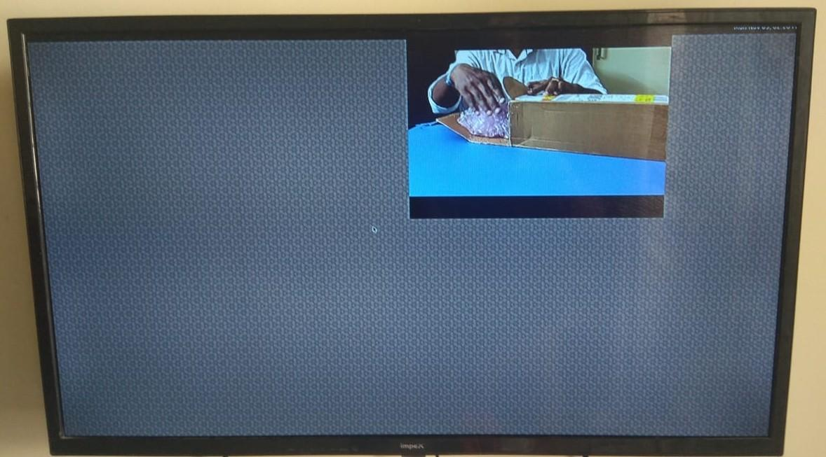

**qtivdec plugin on RB5**

QTI's qtivdec GStreamer element is a V4L2-based video decoder that uses QTI's video hardware cores for decoding video. The Qualcomm RB5 platform has a video processing unit (VPU) for hardware decoding and encoding. The video decode (qtivdec) GStreamer plugin uses V4L2 IOCTLs to decode the H264/H265 bit stream. This plugin is mainly used for playback and transcode use cases.

Example for qtivdec

gst-launch-1.0 filesrc location=sample_video.mp4 ! qtdemux ! queue ! h264parse ! qtivdec ! waylandsink x=960 y=0 width=3840 height=2160

**qtimletflite plugin on RB5**

QRB5165 has support to accelerate TFLite models on Hexagon DSPs, GPU, and CPU via NNAPI. qtimletflite plugin loads and executes TFLite models and supports preprocessing and postprocessing functionality. The preprocessing supports downscale, color convert, mean subtraction, and padding. The postprocessing supports the most popular model types as classification, detection, and segmentation. The postprocessing result is attached as MLMeta to the GST buffer.

Example for static image inferencing with tflite model

Push sample image to /data folder on rb5

Download the sample tflite model coco ssd mobilenet model on your workstation from here.

[https://storage.googleapis.](https://storage.googleapis.com/download.tensorflow.org/models/tflite/coco_ssd_mobilenet_v1_1.0_quant_2018_06_29.zip%20%20-outfile%20coco_ssd_mobilenet_v1_1.0_quant_2018_06_29.zip)

Unzip the file

Push the detect.tflite and labelmap.txt to /data/misc/camera folder on rb5

Make sure weston server is running as per weston desktop application launching then run below command

export XDG_RUNTIME_DIR=/usr/bin/weston_socket && gst-launch-1.0 filesrc location=/data/nv12_sample_image.yuv ! videoparse width=3264 height=2448 format=nv12 ! qtimletflite config=/data/misc/camera/mle_tflite.config model=/data/misc/camera/detect.tflite labels=/data/misc/camera/labelmap.txt postprocessing=detection ! queue ! qtioverlay ! waylandsink x=960 y=0 width=960 height=540 async=true sync=false enable-last-sample=false