 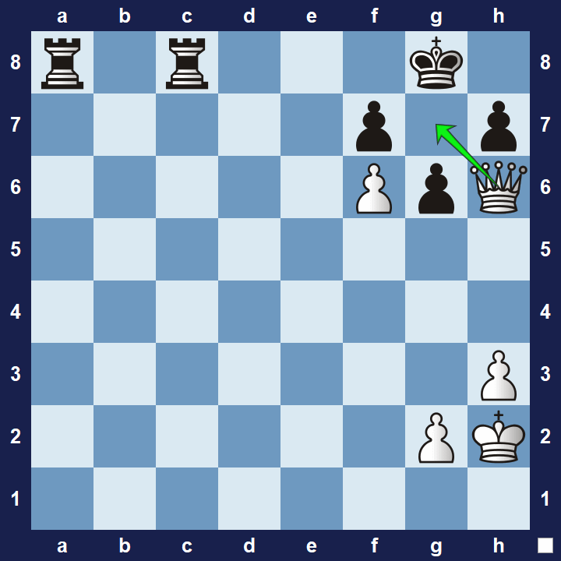

**Fill in the blanks**  
_. Arabian’s mate

_. Back Rank Mate

_. Anastasia’s mate

_. Smothered Mate

_. Blind Swine Mate

_. Hook Mate

_. Boden’s mate

_. Lolli’s mate

_. Opera mate

_. Corner Mate

_. Ladder Mate

_. Morphy’s Mate

_. Damiano’s Mate

_. Greco’s Mate  
  
_. Kill Box Mate

_. Vukovic Mate  
  
_. Suffocation Mate

**6**

**7**

**8**

**9**

**10**

**1**

**2**

**3**

**4**

**5**

