QuickFIX Log Viewer
www.quickfixengine.org
ask@quickfixengine.org

The QuickFIX log viewer is designed to parse FIX messages out of a given file. It is not tied to any one FIX engine or log file format. The parser is smart enough to pull out FIX messages from files, even if there are other comments or message types in the same file. This way you can use the log viewer on a wide variety of log files produced by commercial vendors, proprietary systems, and of course the open source QuickFIX engine.

The log viewer is loaded by running quickfix_logviewer.bat on windows, or quickfix_logviewer.sh on unix based systems. The FILE menu has commands for opening and closing files. If multiple files are opened, you can switch between them using tabs at the top of the view.

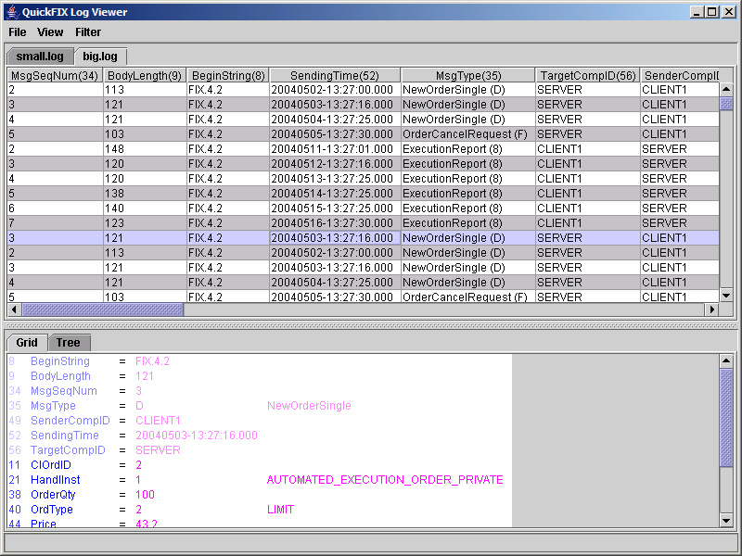

The main application window is a screen that is divided with a horizontal splitter. The upper pane is a message grid which displays an aggregate view of all your messages. The lower pane displays a single message in full detail. Any place that a field or enumeration is displayed, both the tag/value number and text name will be provided. For example, for an order side label you would see Side(54), and for the value you might see BUY(1).

Aggregate View
Since it is often desirable to browse through logs which contain multiple message types, a solution is needed for a single display that can handle all of these types. The aggregate view solves this problem by creating a grid containing all the fields appearing in the logged messages. This allows messages that share fields to be listed within the same column, while also displaying fields which are unique to a message.

While the aggregate view will display all header, body, and trailer fields: it will not display fields contained within a repeating group. Displaying all of these fields in the view would potentially require thousands of columns and would be difficult to aggregate across messages. To view values within a repeating group, you will need to view its details.

A message’s details can be viewed by simply selecting the message on the grid. The message will be displayed in the lower pane in a more compact format. Here you will be able to view everything, including repeating groups.

Files
The FILE menu contains the commands for opening and closing files. Opening a file will bring up a file selection dialog. This dialog is a typical selection dialog except for the additional Time Range option at the bottom.

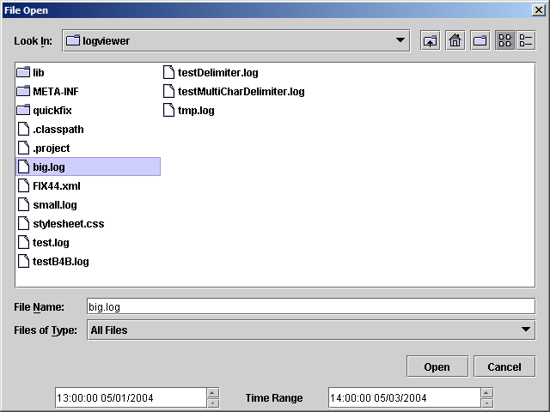

When you click on a file, the time range will display the times at the start and the end of the log file. This range can be adjusted to load only part of a file. This is particularly useful if you have a large file spanning multiple days and don’t want to parse the entire file.

Opening a file will create a new tab above the aggregate view. To close a file, select a tab to make it active and run the Close command.

The Export menu item can be used to export the file to another format. Currently supported formats are FIX, XML, and CSV. An Export item is also available under the VIEW menu for exporting only what is displayed in the grid after filtering.

This menu also allows you to toggle Trace functionality. When trace is enabled, the logviewer will monitor for changes in all open files every 5 seconds. If there are any new messages, they will automatically be pulled into the aggregate view.

Autosizing
Under the VIEW menu, there are a couple of commands for sizing the visible columns. You can choose from Autosize Columns, or Autosize And Hide Columns.

The Autosize Columns command will make each column as wide as necessary to accommodate the longest value in that column. Autosize And Hide Columns option will also minimize any column which contain no values.

Filtering
Sometimes you may need to find a specific message or group of messages based on certain characteristics. The log viewer provides several options for drilling down to the messages of interest. The options provided under the FILTER menu are:

All Messages
Displays every single message found in the log. This is the default filter whenever you open a new file.

Administrative Messages
Display only administrative messages such as Logons, Heartbeats, TestRequests, and ResendRequests. This is often useful if you are trying to track down session level problems and want to filter out application level messages.

Application Messages
Likewise when tracking down application level problems, administrative messages can get in the way. With this you can concentrate on business messages such as NewOrderSingle and ExecutionReport.

Categories
Categories group messages that operate in a particular business process. The categories available in the menu are the same ones defined by the FIX specification. Some examples of categories are: Single/General Order Handling, Market Data, and Settlement Instructions.

Custom Filter
This is the most powerful filter as it allows you to filter messages based on the contents of one or more fields. For instance, you can find an order and all its execution reports by filtering on OrderID. Or you can find all cancels entered by trader ABC for symbol DEF.

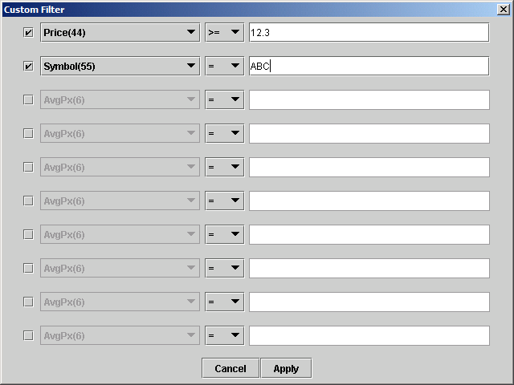

The Custom Filter dialog presents a list of field/value pairs which, when enabled, hides all the messages not meeting all the criteria. For instance, in the above screen capture, only messages where the Price field is “12.3” or greater, and the Symbol is “ABC” will be visible after the filter is applied.

To enable a line in the dialog, click on the checkbox to the far left. This signifies that the viewer will use this line as part of the filter. The combobox on the left is used to specify which field to filter on. Only fields that are used within the log file will be presented, so you will not need to scroll through all possible FIX fields. Any user-defined fields will also be shown here, however they may not be named if they do not appear in the data dictionary.

Finally, the textbox on the right contains the value the field must contain. In most cases this should contain the exact value you are searching for. In the case of enumerations, you can use the value or it’s descriptive text. With OrdType, for instance, you would be able to use either “1” or “LIMIT”. These values would both return the exact same result.

You can also add fields to your filter right from the aggregate view by double clicking a cell. This will add the correct field type to be filtered, as well as the value of the field from the message.

