Motivation. Remanufacturing aims to retain material value with minimal new resources, but decisions depend on uncertain product condition, feasible recovery routes, production-system behaviour and resource impact. These aspects are currently handled by separate model classes: discrete-event simulation (DES) for factory dynamics, multibody dynamics (MBS) and other solvers for physical behaviour, neural models for task-specific prediction, and symbolic models for production-system knowledge. Their separation prevents consistent reasoning across product, process and factory scales and limits closed-loop optimisation.
Concept. The proposed group will establish Agentic Multi-Fidelity Simulation for Resource-Efficient Remanufacturing. Its central objective is to transform heterogeneous engineering models of nonlinear physical and production dynamics into physical world models (PWM) that can be internally used by a large language model (LLM) agent for evaluating future states, with symbolic models encoding engineer semantics, objectives and constraints.
The first research objective is to establish a symbolic representation of the engineering context with Asset Administration Shells. It will represent products, processes, resources, states, objectives and constraints, together with the semantics, interfaces and validity ranges of available PWMs. We will investigate how these structured semantics can be encoded into neural representations aligned with the LLM latent space, so that symbolic engineering knowledge becomes directly accessible to neural reasoning.
The second research objective is to transform conventional engineering solvers into internal PWMs for LLM agents. Initial research will focus on DES and MBS, representing complex production-system dynamics and nonlinear product/equipment behaviour, while remaining extensible to further physics solvers. We will investigate how solver states, parameters and predicted trajectories can be mapped into neural representations as PWMs aligned with the LLM latent space, enabling the agent to internally reason over physically feasible alternative futures across multiple fidelity levels.
The third research objective is to establish an LLM-agent closed optimisation loop that jointly uses symbolic context and PWMs. We will investigate how to create a closed loop of symbolic reasoning, physics prediction and neural optimisation within the LLM forward pass. This allows the agent to reason over engineering objectives, constraints and predicted system evolution, generate and evaluate alternative actions, and iteratively optimise decisions for resource-efficient remanufacturing.
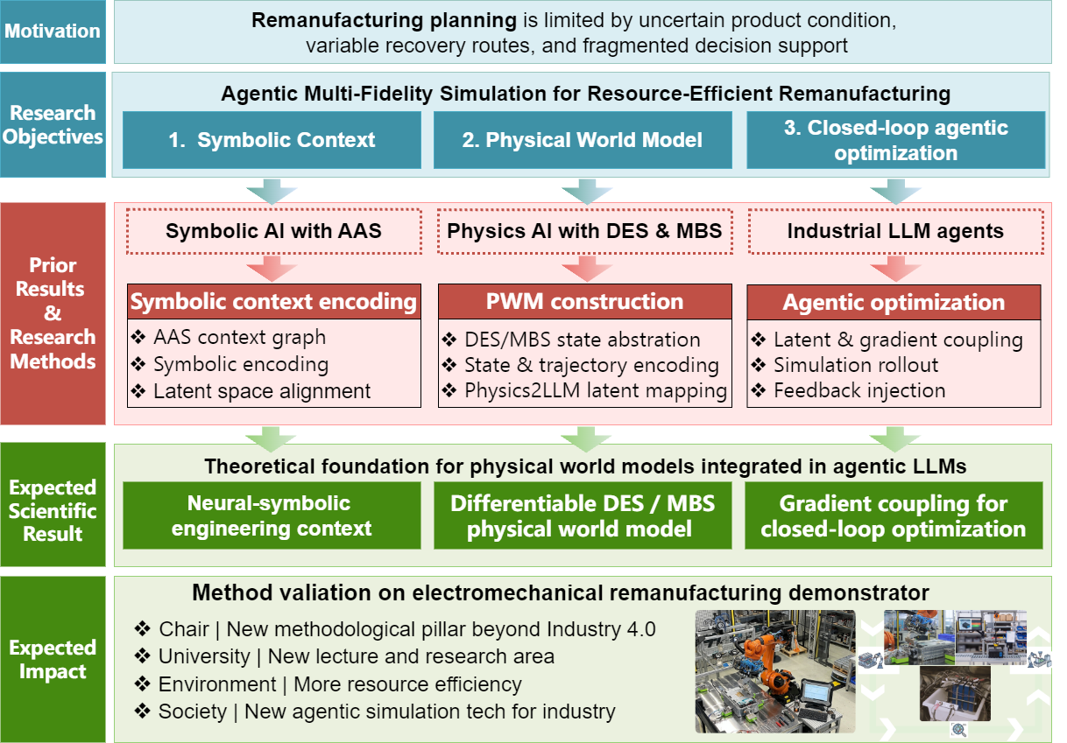
Validation. The methods will be validated on an electro-mechanical drivetrain, incl. inspection, disassembly, re-assembly and functional test.
Expected results are an agentic simulation optimiser with multi-fidelity PWMs and Symbolic engineering context.
Longer-term vision. It aims to establish a novel engineer modeling approach that fuses symbolic and physical repre-sentation with neural infe-rence. It can be generalized to other paradigms.

