C:\Users\raquibul.hasan>cd C:\MyWork\Akka\quickstartall-akka-iot\quickstartall-akka-iot

C:\MyWork\Akka\quickstartall-akka-iot\quickstartall-akka-iot>sbt "set offline := true" run

Java HotSpot(TM) 64-Bit Server VM warning: ignoring option MaxPermSize=256m; support was removed in 8.0

[warn] Executing in batch mode.

[warn] For better performance, hit [ENTER] to switch to interactive mode, or

[warn] consider launching sbt without any commands, or explicitly passing 'shell'

[info] Loading global plugins from C:\Users\raquibul.hasan\.sbt\0.13\plugins

[info] Updating {file:/C:/Users/raquibul.hasan/.sbt/0.13/plugins/}global-plugins...

[info] Resolving org.fusesource.jansi#jansi;1.4 ...

[info] Done updating.

[info] Loading project definition from C:\MyWork\Akka\quickstartall-akka-iot\quickstartall-akka-iot\project

[info] Updating {file:/C:/MyWork/Akka/quickstartall-akka-iot/quickstartall-akka-iot/project/}quickstartall-akka-iot-build...

[info] Resolving org.fusesource.jansi#jansi;1.4 ...

[info] Done updating.

[info] Set current project to quickstartall-akka-iot (in build file:/C:/MyWork/Akka/quickstartall-akka-iot/quickstartall-akka-iot/)

[info] Defining \*:offline

[info] The new value will be used by \*:ivyConfiguration, \*:updateSbtClassifiers::ivyConfiguration

[info] Reapplying settings...

[info] Set current project to quickstartall-akka-iot (in build file:/C:/MyWork/Akka/quickstartall-akka-iot/quickstartall-akka-iot/)

[info] Updating {file:/C:/MyWork/Akka/quickstartall-akka-iot/quickstartall-akka-iot/}quickstartall-akka-iot...

[info] Resolving jline#jline;2.12.1 ...

[info] Done updating.

[info] Compiling 6 Scala sources to C:\MyWork\Akka\quickstartall-akka-iot\quickstartall-akka-iot\target\scala-2.11\classes...

[info] Running com.quickstartall.akka.iot.TemperatureQueryApp

[success] Total time: 13 s, completed Jun 10, 2017 11:23:07 PM

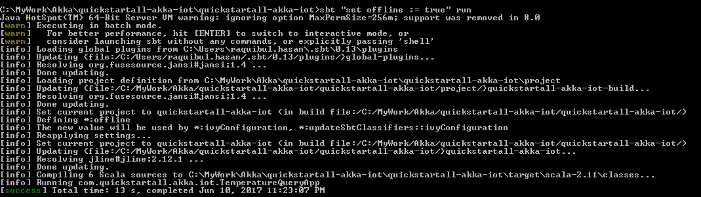

C:\MyWork\Akka\quickstartall-akka-iot\quickstartall-akka-iot>sbt "set offline :=true" test

Java HotSpot(TM) 64-Bit Server VM warning: ignoring option MaxPermSize=256m; support was removed in 8.0

[warn] Executing in batch mode.

[warn] For better performance, hit [ENTER] to switch to interactive mode, or

[warn] consider launching sbt without any commands, or explicitly passing 'shell'

[info] Loading global plugins from C:\Users\raquibul.hasan\.sbt\0.13\plugins

[info] Loading project definition from C:\MyWork\Akka\quickstartall-akka-iot\quickstartall-akka-iot\project

[info] Set current project to quickstartall-akka-iot (in build file:/C:/MyWork/Akka/quickstartall-akka-iot/quickstartall-akka-iot/)

[info] Defining \*:offline

[info] The new value will be used by \*:ivyConfiguration, \*:updateSbtClassifiers::ivyConfiguration

[info] Reapplying settings...

[info] Set current project to quickstartall-akka-iot (in build file:/C:/MyWork/Akka/quickstartall-akka-iot/quickstartall-akka-iot/)

[info] Compiling 1 Scala source to C:\MyWork\Akka\quickstartall-akka-iot\quickstartall-akka-iot\target\scala-2.11\test-classes...

[INFO] [06/10/2017 23:30:30.747] [AkkaIOTTestCases-akka.actor.default-dispatcher-4] [akka://AkkaIOTTestCases/user/$a] Device actor group-device started

[INFO] [06/10/2017 23:30:30.763] [AkkaIOTTestCases-akka.actor.default-dispatcher-4] [akka://AkkaIOTTestCases/user/$a] Recorded temperature reading 24.0 with 1

[INFO] [06/10/2017 23:30:30.778] [AkkaIOTTestCases-akka.actor.default-dispatcher-4] [akka://AkkaIOTTestCases/user/$a] Recorded temperature reading 55.0 with 3

[INFO] [06/10/2017 23:30:30.887] [AkkaIOTTestCases-akka.actor.default-dispatcher-5] [akka://AkkaIOTTestCases/user/$b] Device actor group-device started

[INFO] [06/10/2017 23:30:30.887] [AkkaIOTTestCases-akka.actor.default-dispatcher-5] [akka://AkkaIOTTestCases/user/$c] DeviceGroup group started

[INFO] [06/10/2017 23:30:30.887] [AkkaIOTTestCases-akka.actor.default-dispatcher-5] [akka://AkkaIOTTestCases/user/$c] Creating device actor for device1

[INFO] [06/10/2017 23:30:30.903] [AkkaIOTTestCases-akka.actor.default-dispatcher-2] [akka://AkkaIOTTestCases/user/$c/device-device1] Device actor group-device1 started

[INFO] [06/10/2017 23:30:30.919] [AkkaIOTTestCases-akka.actor.default-dispatcher-2] [akka://AkkaIOTTestCases/user/$c] Creating device actor for device2

[INFO] [06/10/2017 23:30:30.919] [AkkaIOTTestCases-akka.actor.default-dispatcher-2] [akka://AkkaIOTTestCases/user/$c/device-device2] Device actor group-device2 started

[INFO] [06/10/2017 23:30:30.919] [AkkaIOTTestCases-akka.actor.default-dispatcher-2] [akka://AkkaIOTTestCases/user/$c/device-device1] Recorded temperature reading 1.0 with 0

[INFO] [06/10/2017 23:30:30.919] [AkkaIOTTestCases-akka.actor.default-dispatcher-2] [akka://AkkaIOTTestCases/user/$c/device-device2] Recorded temperature reading 2.0 with 1

[INFO] [06/10/2017 23:30:30.934] [AkkaIOTTestCases-akka.actor.default-dispatcher-4] [akka://AkkaIOTTestCases/user/$d] Device actor group-device started

[WARN] [06/10/2017 23:30:30.934] [AkkaIOTTestCases-akka.actor.default-dispatcher-4] [akka://AkkaIOTTestCases/user/$d] Ignoring TrackDevice request for wrongGroup-device.This actor

is responsible for group-device.

[WARN] [06/10/2017 23:30:31.449] [AkkaIOTTestCases-akka.actor.default-dispatcher-6] [akka://AkkaIOTTestCases/user/$d] Ignoring TrackDevice request for group-Wrongdevice.This actor

is responsible for group-device.

[INFO] [06/10/2017 23:30:31.979] [AkkaIOTTestCases-akka.actor.default-dispatcher-6] [akka://AkkaIOTTestCases/user/$e] DeviceGroup group started

[INFO] [06/10/2017 23:30:31.979] [AkkaIOTTestCases-akka.actor.default-dispatcher-6] [akka://AkkaIOTTestCases/user/$e] Creating device actor for device1

[INFO] [06/10/2017 23:30:31.979] [AkkaIOTTestCases-akka.actor.default-dispatcher-6] [akka://AkkaIOTTestCases/user/$e/device-device1] Device actor group-device1 started

[INFO] [06/10/2017 23:30:31.995] [AkkaIOTTestCases-akka.actor.default-dispatcher-3] [akka://AkkaIOTTestCases/user/$f] DeviceGroup group started

[INFO] [06/10/2017 23:30:31.995] [AkkaIOTTestCases-akka.actor.default-dispatcher-3] [akka://AkkaIOTTestCases/user/$f] Creating device actor for device1

[INFO] [06/10/2017 23:30:31.995] [AkkaIOTTestCases-akka.actor.default-dispatcher-6] [akka://AkkaIOTTestCases/user/$f/device-device1] Device actor group-device1 started

[INFO] [06/10/2017 23:30:31.995] [AkkaIOTTestCases-akka.actor.default-dispatcher-6] [akka://AkkaIOTTestCases/user/$f] Creating device actor for device2

[INFO] [06/10/2017 23:30:31.995] [AkkaIOTTestCases-akka.actor.default-dispatcher-6] [akka://AkkaIOTTestCases/user/$f/device-device2] Device actor group-device2 started

[INFO] [06/10/2017 23:30:32.011] [AkkaIOTTestCases-akka.actor.default-dispatcher-3] [akka://AkkaIOTTestCases/user/$g] DeviceGroup group started

[INFO] [06/10/2017 23:30:32.011] [AkkaIOTTestCases-akka.actor.default-dispatcher-3] [akka://AkkaIOTTestCases/user/$g] Creating device actor for device1

[INFO] [06/10/2017 23:30:32.011] [AkkaIOTTestCases-akka.actor.default-dispatcher-6] [akka://AkkaIOTTestCases/user/$g/device-device1] Device actor group-device1 started

[INFO] [06/10/2017 23:30:32.011] [AkkaIOTTestCases-akka.actor.default-dispatcher-5] [akka://AkkaIOTTestCases/user/$g] Creating device actor for device2

[INFO] [06/10/2017 23:30:32.011] [AkkaIOTTestCases-akka.actor.default-dispatcher-5] [akka://AkkaIOTTestCases/user/$g/device-device2] Device actor group-device2 started

[INFO] [06/10/2017 23:30:32.026] [AkkaIOTTestCases-akka.actor.default-dispatcher-4] [akka://AkkaIOTTestCases/user/$g/device-device1] Device actor group-device1 stopped

[INFO] [06/10/2017 23:30:32.026] [AkkaIOTTestCases-akka.actor.default-dispatcher-5] [akka://AkkaIOTTestCases/user/$g] Device actor for device1 has been terminated

[INFO] [06/10/2017 23:30:33.293] [AkkaIOTTestCases-akka.actor.default-dispatcher-5] [akka://AkkaIOTTestCases/user/$m] DeviceGroup group started

[INFO] [06/10/2017 23:30:33.293] [AkkaIOTTestCases-akka.actor.default-dispatcher-5] [akka://AkkaIOTTestCases/user/$m] Creating device actor for device1

[INFO] [06/10/2017 23:30:33.293] [AkkaIOTTestCases-akka.actor.default-dispatcher-3] [akka://AkkaIOTTestCases/user/$m/device-device1] Device actor group-device1 started

[INFO] [06/10/2017 23:30:33.293] [AkkaIOTTestCases-akka.actor.default-dispatcher-3] [akka://AkkaIOTTestCases/user/$m] Creating device actor for device2

[INFO] [06/10/2017 23:30:33.293] [AkkaIOTTestCases-akka.actor.default-dispatcher-3] [akka://AkkaIOTTestCases/user/$m/device-device2] Device actor group-device2 started

[INFO] [06/10/2017 23:30:33.293] [AkkaIOTTestCases-akka.actor.default-dispatcher-2] [akka://AkkaIOTTestCases/user/$m] Creating device actor for device3

[INFO] [06/10/2017 23:30:33.293] [AkkaIOTTestCases-akka.actor.default-dispatcher-2] [akka://AkkaIOTTestCases/user/$m/device-device3] Device actor group-device3 started

[INFO] [06/10/2017 23:30:33.293] [AkkaIOTTestCases-akka.actor.default-dispatcher-6] [akka://AkkaIOTTestCases/user/$m/device-device1] Recorded temperature reading 1.0 with 0

[INFO] [06/10/2017 23:30:33.293] [AkkaIOTTestCases-akka.actor.default-dispatcher-6] [akka://AkkaIOTTestCases/user/$m/device-device2] Recorded temperature reading 2.0 with 1

[INFO] [06/10/2017 23:30:33.355] [AkkaIOTTestCases-akka.actor.default-dispatcher-8] [akka://AkkaIOTTestCases/user/$a] Device actor group-device stopped

[INFO] [06/10/2017 23:30:33.355] [AkkaIOTTestCases-akka.actor.default-dispatcher-8] [akka://AkkaIOTTestCases/user/$b] Device actor group-device stopped

[INFO] [06/10/2017 23:30:33.355] [AkkaIOTTestCases-akka.actor.default-dispatcher-8] [akka://AkkaIOTTestCases/user/$d] Device actor group-device stopped

[INFO] [06/10/2017 23:30:33.371] [AkkaIOTTestCases-akka.actor.default-dispatcher-2] [akka://AkkaIOTTestCases/user/$g/device-device2] Device actor group-device2 stopped

[INFO] [06/10/2017 23:30:33.371] [AkkaIOTTestCases-akka.actor.default-dispatcher-8] [akka://AkkaIOTTestCases/user/$m/device-device1] Device actor group-device1 stopped

[INFO] [06/10/2017 23:30:33.371] [AkkaIOTTestCases-akka.actor.default-dispatcher-4] [akka://AkkaIOTTestCases/user/$m/device-device2] Device actor group-device2 stopped

[info] DeviceTest:

[info] A device

[info] - should reply with latest temperature reading

[info] A Device

[info] - should reply to registration requests

[info] A DeviceManager

[info] - should be able to register a device actor

[info] A DeviceManager

[info] - should ignore wrong registration requests

[info] A DeviceManager

[info] - should return same actor for same deviceId

[info] A DeviceManager

[info] - should be able to list active devices

[info] A DeviceManager

[info] - should be able to list active devices after one shuts down

[info] A DeviceQueryGroup

[info] - should return temperature value for working devices

[info] A DeviceQueryGroup

[info] - should return TemperatureNotAvailable for devices with no readings

[info] A DeviceQueryGroup

[info] - should return DeviceNotAvailable if device stops before answering

[info] A DeviceGroupQuery

[info] - should return temperature reading even if device stops after answering

[info] A DeviceGroupQuery

[info] - should return DeviceTimedOut if device does not answer in time

[info] A DeviceGroupQuery

[info] - should be able to collect temperatures from all active devices

[info] Run completed in 4 seconds, 269 milliseconds.

[info] Total number of tests run: 13

[info] Suites: completed 1, aborted 0

[info] Tests: succeeded 13, failed 0, canceled 0, ignored 0, pending 0

[info] All tests passed.

[success] Total time: 13 s, completed Jun 10, 2017 11:30:33 PM

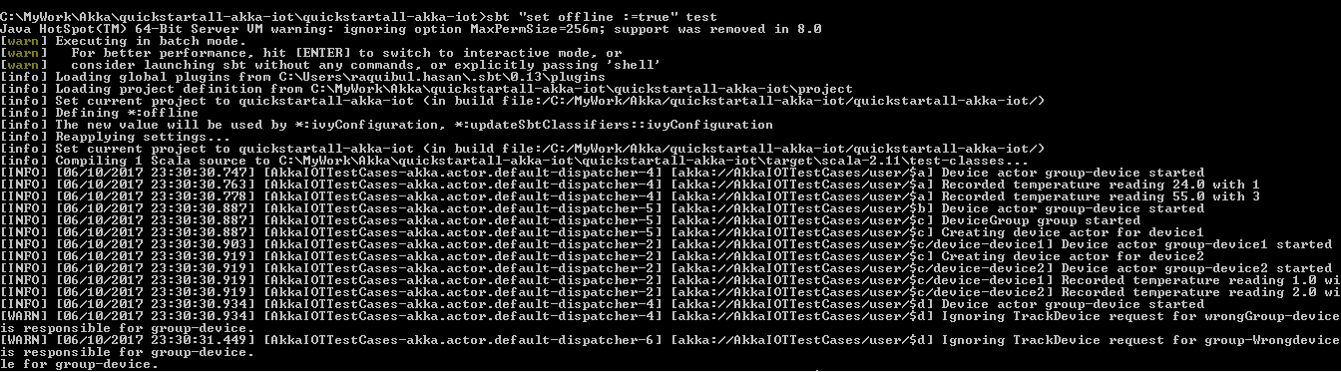

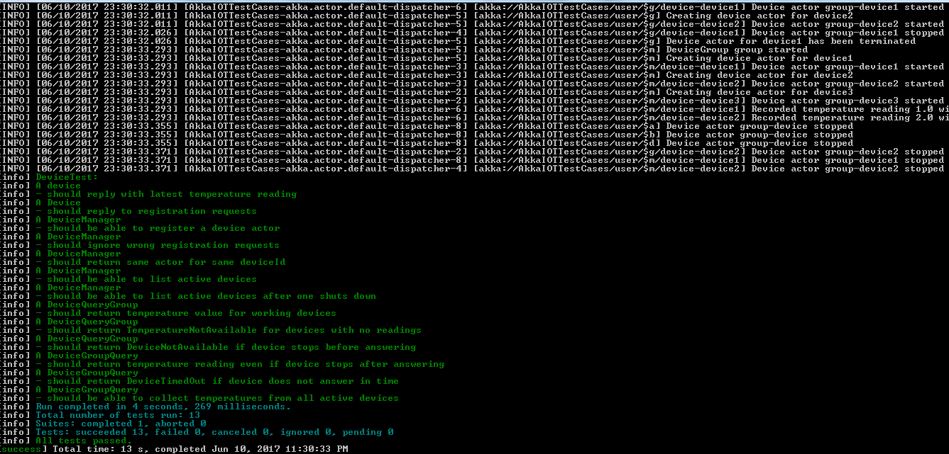

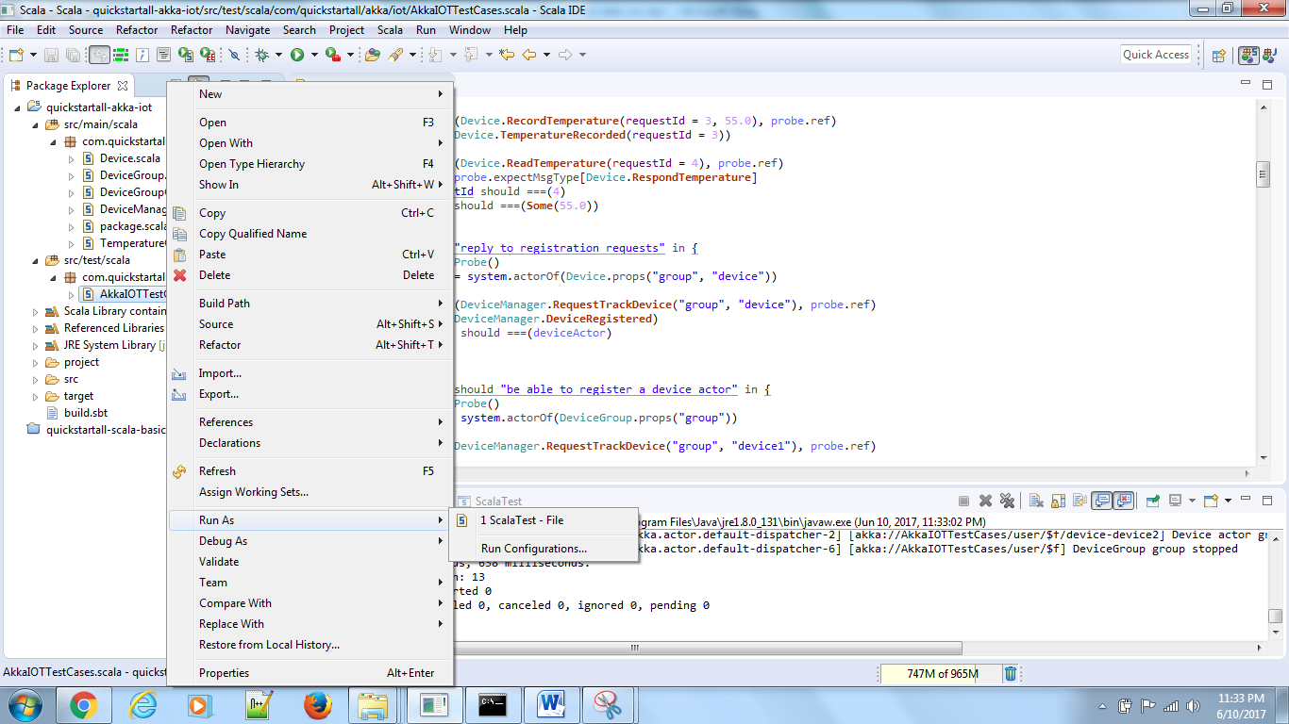

un starting. Expected test count is: 13

DeviceTest:

A device

[INFO] [06/10/2017 23:33:04.272] [AkkaIOTTestCases-akka.actor.default-dispatcher-3] [akka://AkkaIOTTestCases/user/$a] Device actor group-device started

[INFO] [06/10/2017 23:33:04.287] [AkkaIOTTestCases-akka.actor.default-dispatcher-3] [akka://AkkaIOTTestCases/user/$a] Recorded temperature reading 24.0 with 1

[INFO] [06/10/2017 23:33:04.303] [AkkaIOTTestCases-akka.actor.default-dispatcher-3] [akka://AkkaIOTTestCases/user/$a] Recorded temperature reading 55.0 with 3

- should reply with latest temperature reading

A Device

[INFO] [06/10/2017 23:33:04.334] [AkkaIOTTestCases-akka.actor.default-dispatcher-7] [akka://AkkaIOTTestCases/user/$b] Device actor group-device started

- should reply to registration requests

A DeviceManager

[INFO] [06/10/2017 23:33:04.397] [AkkaIOTTestCases-akka.actor.default-dispatcher-6] [akka://AkkaIOTTestCases/user/$c] DeviceGroup group started

[INFO] [06/10/2017 23:33:04.397] [AkkaIOTTestCases-akka.actor.default-dispatcher-6] [akka://AkkaIOTTestCases/user/$c] Creating device actor for device1

[INFO] [06/10/2017 23:33:04.397] [AkkaIOTTestCases-akka.actor.default-dispatcher-6] [akka://AkkaIOTTestCases/user/$c/device-device1] Device actor group-device1 started

[INFO] [06/10/2017 23:33:04.397] [AkkaIOTTestCases-akka.actor.default-dispatcher-3] [akka://AkkaIOTTestCases/user/$c] Creating device actor for device2

[INFO] [06/10/2017 23:33:04.397] [AkkaIOTTestCases-akka.actor.default-dispatcher-3] [akka://AkkaIOTTestCases/user/$c/device-device2] Device actor group-device2 started

- should be able to register a device actor

A DeviceManager

[INFO] [06/10/2017 23:33:04.397] [AkkaIOTTestCases-akka.actor.default-dispatcher-6] [akka://AkkaIOTTestCases/user/$c/device-device1] Recorded temperature reading 1.0 with 0

[INFO] [06/10/2017 23:33:04.397] [AkkaIOTTestCases-akka.actor.default-dispatcher-6] [akka://AkkaIOTTestCases/user/$c/device-device2] Recorded temperature reading 2.0 with 1

[INFO] [06/10/2017 23:33:04.412] [AkkaIOTTestCases-akka.actor.default-dispatcher-3] [akka://AkkaIOTTestCases/user/$d] Device actor group-device started

[WARN] [06/10/2017 23:33:04.412] [AkkaIOTTestCases-akka.actor.default-dispatcher-3] [akka://AkkaIOTTestCases/user/$d] Ignoring TrackDevice request for wrongGroup-device.This actor is responsible for group-device.

[WARN] [06/10/2017 23:33:04.927] [AkkaIOTTestCases-akka.actor.default-dispatcher-6] [akka://AkkaIOTTestCases/user/$d] Ignoring TrackDevice request for group-Wrongdevice.This actor is responsible for group-device.

- should ignore wrong registration requests

A DeviceManager

[INFO] [06/10/2017 23:33:05.457] [AkkaIOTTestCases-akka.actor.default-dispatcher-7] [akka://AkkaIOTTestCases/user/$e] DeviceGroup group started

[INFO] [06/10/2017 23:33:05.457] [AkkaIOTTestCases-akka.actor.default-dispatcher-7] [akka://AkkaIOTTestCases/user/$e] Creating device actor for device1

[INFO] [06/10/2017 23:33:05.457] [AkkaIOTTestCases-akka.actor.default-dispatcher-2] [akka://AkkaIOTTestCases/user/$e/device-device1] Device actor group-device1 started

- should return same actor for same deviceId

A DeviceManager

[INFO] [06/10/2017 23:33:05.473] [AkkaIOTTestCases-akka.actor.default-dispatcher-3] [akka://AkkaIOTTestCases/user/$f] DeviceGroup group started

[INFO] [06/10/2017 23:33:05.473] [AkkaIOTTestCases-akka.actor.default-dispatcher-3] [akka://AkkaIOTTestCases/user/$f] Creating device actor for device1

[INFO] [06/10/2017 23:33:05.474] [AkkaIOTTestCases-akka.actor.default-dispatcher-3] [akka://AkkaIOTTestCases/user/$f/device-device1] Device actor group-device1 started

[INFO] [06/10/2017 23:33:05.474] [AkkaIOTTestCases-akka.actor.default-dispatcher-7] [akka://AkkaIOTTestCases/user/$f] Creating device actor for device2

[INFO] [06/10/2017 23:33:05.474] [AkkaIOTTestCases-akka.actor.default-dispatcher-2] [akka://AkkaIOTTestCases/user/$f/device-device2] Device actor group-device2 started

- should be able to list active devices

A DeviceManager

[INFO] [06/10/2017 23:33:05.536] [AkkaIOTTestCases-akka.actor.default-dispatcher-4] [akka://AkkaIOTTestCases/user/$g] DeviceGroup group started

[INFO] [06/10/2017 23:33:05.536] [AkkaIOTTestCases-akka.actor.default-dispatcher-4] [akka://AkkaIOTTestCases/user/$g] Creating device actor for device1

[INFO] [06/10/2017 23:33:05.536] [AkkaIOTTestCases-akka.actor.default-dispatcher-5] [akka://AkkaIOTTestCases/user/$g/device-device1] Device actor group-device1 started

[INFO] [06/10/2017 23:33:05.536] [AkkaIOTTestCases-akka.actor.default-dispatcher-7] [akka://AkkaIOTTestCases/user/$g] Creating device actor for device2

[INFO] [06/10/2017 23:33:05.536] [AkkaIOTTestCases-akka.actor.default-dispatcher-7] [akka://AkkaIOTTestCases/user/$g/device-device2] Device actor group-device2 started

[INFO] [06/10/2017 23:33:05.536] [AkkaIOTTestCases-akka.actor.default-dispatcher-3] [akka://AkkaIOTTestCases/user/$g/device-device1] Device actor group-device1 stopped

[INFO] [06/10/2017 23:33:05.568] [AkkaIOTTestCases-akka.actor.default-dispatcher-5] [akka://AkkaIOTTestCases/user/$g] Device actor for device1 has been terminated

- should be able to list active devices after one shuts down

A DeviceQueryGroup

- should return temperature value for working devices

A DeviceQueryGroup

- should return TemperatureNotAvailable for devices with no readings

A DeviceQueryGroup

- should return DeviceNotAvailable if device stops before answering

A DeviceGroupQuery

- should return temperature reading even if device stops after answering

A DeviceGroupQuery

- should return DeviceTimedOut if device does not answer in time

A DeviceGroupQuery

[INFO] [06/10/2017 23:33:07.018] [AkkaIOTTestCases-akka.actor.default-dispatcher-5] [akka://AkkaIOTTestCases/user/$m] DeviceGroup group started

[INFO] [06/10/2017 23:33:07.018] [AkkaIOTTestCases-akka.actor.default-dispatcher-5] [akka://AkkaIOTTestCases/user/$m] Creating device actor for device1

[INFO] [06/10/2017 23:33:07.018] [AkkaIOTTestCases-akka.actor.default-dispatcher-2] [akka://AkkaIOTTestCases/user/$m/device-device1] Device actor group-device1 started

[INFO] [06/10/2017 23:33:07.018] [AkkaIOTTestCases-akka.actor.default-dispatcher-4] [akka://AkkaIOTTestCases/user/$m] Creating device actor for device2

[INFO] [06/10/2017 23:33:07.018] [AkkaIOTTestCases-akka.actor.default-dispatcher-2] [akka://AkkaIOTTestCases/user/$m/device-device2] Device actor group-device2 started

[INFO] [06/10/2017 23:33:07.018] [AkkaIOTTestCases-akka.actor.default-dispatcher-5] [akka://AkkaIOTTestCases/user/$m] Creating device actor for device3

[INFO] [06/10/2017 23:33:07.018] [AkkaIOTTestCases-akka.actor.default-dispatcher-2] [akka://AkkaIOTTestCases/user/$m/device-device3] Device actor group-device3 started

[INFO] [06/10/2017 23:33:07.018] [AkkaIOTTestCases-akka.actor.default-dispatcher-4] [akka://AkkaIOTTestCases/user/$m/device-device1] Recorded temperature reading 1.0 with 0

[INFO] [06/10/2017 23:33:07.018] [AkkaIOTTestCases-akka.actor.default-dispatcher-4] [akka://AkkaIOTTestCases/user/$m/device-device2] Recorded temperature reading 2.0 with 1

- should be able to collect temperatures from all active devices

[INFO] [06/10/2017 23:33:07.035] [AkkaIOTTestCases-akka.actor.default-dispatcher-6] [akka://AkkaIOTTestCases/user/$a] Device actor group-device stopped

[INFO] [06/10/2017 23:33:07.035] [AkkaIOTTestCases-akka.actor.default-dispatcher-2] [akka://AkkaIOTTestCases/user/$b] Device actor group-device stopped

[INFO] [06/10/2017 23:33:07.035] [AkkaIOTTestCases-akka.actor.default-dispatcher-2] [akka://AkkaIOTTestCases/user/$d] Device actor group-device stopped

[INFO] [06/10/2017 23:33:07.035] [AkkaIOTTestCases-akka.actor.default-dispatcher-2] [akka://AkkaIOTTestCases/user/$c/device-device1] Device actor group-device1 stopped

[INFO] [06/10/2017 23:33:07.035] [AkkaIOTTestCases-akka.actor.default-dispatcher-2] [akka://AkkaIOTTestCases/user/$c/device-device2] Device actor group-device2 stopped

[INFO] [06/10/2017 23:33:07.051] [AkkaIOTTestCases-akka.actor.default-dispatcher-2] [akka://AkkaIOTTestCases/user/$e/device-device1] Device actor group-device1 stopped

[INFO] [06/10/2017 23:33:07.051] [AkkaIOTTestCases-akka.actor.default-dispatcher-2] [akka://AkkaIOTTestCases/user/$c] DeviceGroup group stopped

[INFO] [06/10/2017 23:33:07.051] [AkkaIOTTestCases-akka.actor.default-dispatcher-6] [akka://AkkaIOTTestCases/user/$e] DeviceGroup group stopped

[INFO] [06/10/2017 23:33:07.051] [AkkaIOTTestCases-akka.actor.default-dispatcher-2] [akka://AkkaIOTTestCases/user/$g/device-device2] Device actor group-device2 stopped

[INFO] [06/10/2017 23:33:07.051] [AkkaIOTTestCases-akka.actor.default-dispatcher-2] [akka://AkkaIOTTestCases/user/$g] DeviceGroup group stopped

[INFO] [06/10/2017 23:33:07.051] [AkkaIOTTestCases-akka.actor.default-dispatcher-13] [akka://AkkaIOTTestCases/user/$m/device-device1] Device actor group-device1 stopped

[INFO] [06/10/2017 23:33:07.051] [AkkaIOTTestCases-akka.actor.default-dispatcher-13] [akka://AkkaIOTTestCases/user/$m/device-device2] Device actor group-device2 stopped

[INFO] [06/10/2017 23:33:07.051] [AkkaIOTTestCases-akka.actor.default-dispatcher-2] [akka://AkkaIOTTestCases/user/$m/device-device3] Device actor group-device3 stopped

[INFO] [06/10/2017 23:33:07.051] [AkkaIOTTestCases-akka.actor.default-dispatcher-13] [akka://AkkaIOTTestCases/user/$m] DeviceGroup group stopped

[INFO] [06/10/2017 23:33:07.051] [AkkaIOTTestCases-akka.actor.default-dispatcher-6] [akka://AkkaIOTTestCases/user/$f/device-device1] Device actor group-device1 stopped

[INFO] [06/10/2017 23:33:07.051] [AkkaIOTTestCases-akka.actor.default-dispatcher-2] [akka://AkkaIOTTestCases/user/$f/device-device2] Device actor group-device2 stopped

[INFO] [06/10/2017 23:33:07.051] [AkkaIOTTestCases-akka.actor.default-dispatcher-6] [akka://AkkaIOTTestCases/user/$f] DeviceGroup group stopped

Run completed in 3 seconds, 638 milliseconds.

Total number of tests run: 13

Suites: completed 1, aborted 0

Tests: succeeded 13, failed 0, canceled 0, ignored 0, pending 0

All tests passed.

