Stage 1 Lab - Human vs AI: Building Your First SmartCare Prototype

Learning objectives
- Create and run a simple Python file with basic input,output and processing statements
- Use lists, dictionaries and functions to enhance the Python file
- Build a small SmartCare appointment prototype.
- Use AI as a tutor rather than a replacement.
- Compare human-written and AI-generated code.
- Verify AI-generated code through execution and test inputs.
- Document a short AI-use reflection.

Files to create and commit in GitHub
stage01/
smartcare_v01.py
comparison.md
reflection.md
ai_usage.md

Part A - Understand the Problem: AI OFF
SmartCare needs a small prototype that allows a receptionist to record patient appointments. Each appointment records patient name, practitioner name and appointment time.
What data must be stored?
Patient name, the doctor’s name, and the time slot of appointment.
What functions might be useful?
Bookappointment, check current appointments, displayappointment
What could go wrong?
Appointment time may be unavailable or double booked. No limitations on the name asked (no checks to verify with id unless already stored in the system).
What requirements are unclear?
We don’t know who can manage appointments, what doctors or specialists are on duty, how data will be stored.

Part B - Build a Human-Written Prototype: AI OFF
#task 1
# Create and run a simple Python file with basic input,output statements

print("Welcome to SmartCare: Community Clinic Appointment Booking System!")

# First Appointment
patient1_name = 'Alice Smith'
practitioner1_name = 'Dr. John Doe'
appointment1_time = '2024-07-20 10:00 AM'
print(f"Patient: {patient1_name} | Practitioner: {practitioner1_name} | Time: {appointment1_time}")

# Second Appointment
patient2_name = 'Bob Johnson'
practitioner2_name = 'Dr. Jane Roe'
appointment2_time = '2024-07-20 11:30 AM'
print(f"Patient: {patient2_name} | Practitioner: {practitioner2_name} | Time: {appointment2_time}")

#task1enhanced
# Use lists, dictionaries and functions to enhance the Python file

appointments = []

def book_appointment(patient_name, practitioner_name, appointment_time):
if not patient_name:
raise ValueError("Patient name cannot be empty")
appointment = {
"patient": patient_name,
"practitioner": practitioner_name,
"time": appointment_time
}
appointments.append(appointment)

def display_appointments():
if not appointments:
print("No appointments recorded.")
return
for appointment in appointments:
print(f"Patient: {appointment['patient']} | Practitioner: {appointment['practitioner']} | Time: {appointment['time']}")

print("Welcome to SmartCare: The Clinical Appointment Booking System!")
book_appointment('Alice Smith', 'Dr. John Doe', '2024-07-20 10:00 AM')
book_appointment('Bob Johnson', 'Dr. Jane Roe', '2024-07-20 11:30 AM')
display_appointments()

^ Now, run both programs , and identify at least five limitations.
Basic version | Enhanced version
Code is repeated | Functions are used
Variable are changed between each patient | Appointments are added to a list
No input error handling | Minimal error checks
Code will become hard to read as more appointment are booked | Easy to read and add patients as it will reduce unnecessary variable code for each patient.
Code not stored | Code is stored in a list temporarily.

Limitation 1: Appointment timeslots are not stored to check availability.
Limitation 2: More than one booking for each time slot is possible.
Limitation 3: The data is stored in a list only when the program is still running, as soon as it closes the list is empty again.
Limitation 4: No validation checks for date and time. This will produce errors if input incorrectly.
Limitation 5: Only checks name is a string and not if that person’s name is correct and valid. This can have anyone book appointments with no repercussions if spammed by criminals or just to disrupt business.

Part C - Use AI as Tutor: AI ON (Use only UC approved GenAI Tool such as Microsoft CoPilot)
Suggested prompt structure:
Act as a Python tutor.
I am learning introductory software technology.
Here is a small appointment-booking function.
1. Explain what the code does.
2. Identify three limitations.
3. Suggest improvements.
4. Do not rewrite the whole application.
5. Ask me two questions to test my understanding.
Microsoft copilot response here:
Copilot said:
I'll explain the appointment-booking function at a beginner-friendly level, point out some limitations, and suggest practical improvements without rewriting the whole program.
1. What the code does
The enhanced version introduces a simple appointment management system using:
- A list called appointments to store appointment records.
- A function called book_appointment() to create and save appointments.
- A dictionary for each appointment containing:
  - patient name
  - practitioner name
  - appointment time
- A function called display_appointments() to show all saved appointments.

(Ai added a Step by step of what the code does but that is a huge chunk that looked ugly when copied so I did not add at this time) (if requested I can add it).

Part D - Generate an Alternative: AI ON
Ask AI to create a simple beginner-friendly Python function that stores patient name, practitioner name and appointment time. Explicitly prohibit a database or GUI.

# List to store appointments
appointments = []

def add_appointment(patient_name, doctor_name, appointment_time):
appointment = {
"patient": patient_name,
"doctor": doctor_name,
"time": appointment_time
}

appointments.append(appointment)
print("Appointment added successfully!")

# Example usage
add_appointment("John Smith", "Dr Brown", "10:00 AM")
add_appointment("Sarah Lee", "Dr Jones", "2:30 PM")

# Display all appointments
for appt in appointments:
print(
f"Patient: {appt['patient']}, "
f"Doctor: {appt['doctor']}, "
f"Time: {appt['time']}"
)

Part E - Compare Human and AI Versions
Question | Human version | AI version
Easy to understand? | Yes, if you have understanding on how functions work. | Yes, just with added for loop.
Runs successfully? | Yes, if input is at least a string | Yes, with examples
Uses only required features? | Yes, no extra functions were added | Yes, as requested no database and GUI was added.
Adds assumptions? | Yes, it assumed you know available times and the doctor’s names. | It assumes there are no errors made in creating the appointment.
Handles errors? | Only checks the patient’s name | No checks are made
Could I explain it? | Yes, after reading and running the code. | Yes, very similar just uses a for loop at the end.

Part F - Verify Behaviour
- Normal appointment
- Blank patient name
- Two appointments for the same practitioner/time
- Strange input such as patient_name=None or appointment_time=None

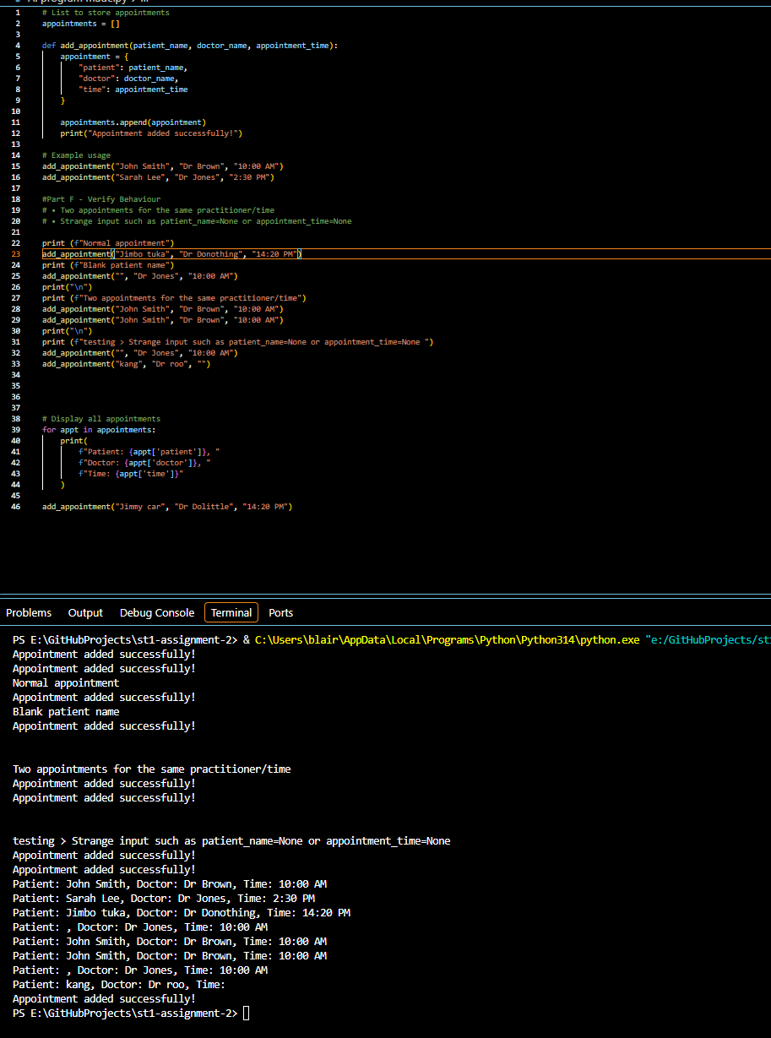

Part G - Improve One Thing
Choose exactly one controlled improvement, for example: if not patient_name: raise ValueError("Patient name cannot be empty")

if not appointment_time:
raise ValueError("A Time must be chosen")

Part H - Reflection (150-250 words)
What did you build before using AI?
A simple program that used functions to add patient name, doctor name, and appointment time. That data was then put into a list then printed at the end. Nothing is saved permanently and no checks are done except for name check if the line is empty. So many things are bound to go wrong as human error is always a probability.
What did AI help you understand?
Ai helped make little fixes such as adding loops. But it still did not add permanent storage. If I did not ask to limit database and Gui it would have given me a much bigger code layout with more functions.
Did AI make assumptions?
Not really, as I queried a simple booking system without a database and Gui it gave me roughly the same as the human code example.
How did you verify the AI output?
I copied the code into my visual studio code and ran the code, checked line by line and seen if anything was missing. No validation checks were used in the code so it ran easily without interruption but that is a disaster waiting to happen.
What engineering work remained for you?
Improvements are needed to add validation checks but that can be done through Ai with precise questions to fix the code. File storage will need to be added at some point to save the appointments instead of resetting every time the file is opened.

Submission checklist [GitHub Commit]
- Python file runs.
- Comparison table completed.
- Normal and unusual inputs tested.
- AI assistance documented.
- Reflection completed.
- I can explain my code.

