Assignment 2- Case Study

Stage 3 Lab Activities

SmartCare Domain Modelling
AI OFF -> AI ON -> COMPARE -> VERIFY | 1 hour

A - Requirements Review
Highlight nouns, verbs and business rules in SmartCare v0.2.
FR-01: The system will allow the receptionist book appointments for patients.
FR-02: The system will allow the receptionist to cancel (patient) appointments.
FR-03: The system will allow patients to update their contact information.
FR-04: The system will allow practitioners to view their schedule.
FR-05: The system will allow practitioners to view patient records.
FR-06: The system will show practitioners availability schedule.
FR-07: The system will stop the receptionist from double booking an appointment.
FR-08: The system will allow receptionists to search patient records by name or a unique identifier.
FR-09: The system will allow receptionists to create new patient profiles.
FR-10: The system will update its availability if an appointment is cancelled.

B - Candidate Classes
Record candidate concepts, supporting requirements, state and behaviour.
Candidate Concept | Supporting requirements | State | Behaviour
Patient | FR-01 “Book Appointments”  FR-02 “cancel Appointment  FR-03 “Update patient info”  FR-09 “Create New Profile” | Patient(id), Name, DOB, Address, Contact details, next of kin | ViewRecords()  UpdateProfileDetails()
Receptionist | FR-01 “Book Appointment”  FR-02 “Cancel patient booking”  FR-07 “Unable to double book”  FR-08 “Search patient profile”  FR-09 “Create new patient profile” | Receptionist(id), Name, DOB, Address, Contact details | CreateProfile()  BookAppointment()  CancelAppointment()  UpdateInformaiton()  SearchPatient()  RegisterNewPatient()  ViewAppointmentCalender()
Practitioner | FR-04 “Can view schedule”  FR-05 “View patient records” | Practitioner(id), Name, Working hours | ViewSchedule()  AcceptAppointment()  CancelAppointment()
Appointment | FR-01 “Allow booking appointments”  FR-02 “Allow cancel bookings”  FR-07 “unable double bookings”  FR-10 “Update Availability schedule when patient cancels appointment” | Appointment(id), Patient(id), Staff(id), receptionist(id), appointmentDateTime | Schedule()  Cancel()  Modify-extratime()-example: requires longer appointment

C - CRC Cards
Create CRC cards for Patient, Practitioner and Appointment.

Patient
Responsibilities | Collaborators
name, DOB and provides when interacting with reception to create profile | Receptionist, appointment
Patient(id), name, DOB when attending appointment | Receptionist, Practitioner, appointment

Practitioner
Responsibilities | Collaborators
Know practitioner(id), name | Appointment
Know Patient(ID) Patient records() | Patient

Appointment
Responsibilities | Collaborators
Know appointment(id), Patient(id), Practitioner(id), date, time, and current status for appointment booked | Practitioner, Patient, Receptionist
Know appointment(id), Patient(id), Practitioner(id), date, time, and current status for appointment cancelled | Practitioner, Patient, Receptionist

Receptionist
Responsibilities | Collaborators
Know receptionist(id), name, and helps patients manage appointment | Patient
Know receptionist(id), name, and helps patient create profile | Patient

D - UML Model
Draw classes, attributes, operations, associations and multiplicities.

Before AI: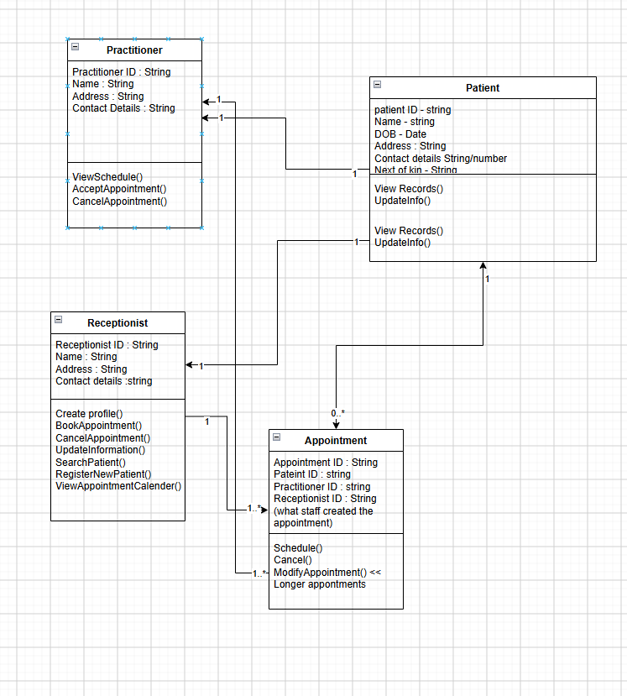
After AI:
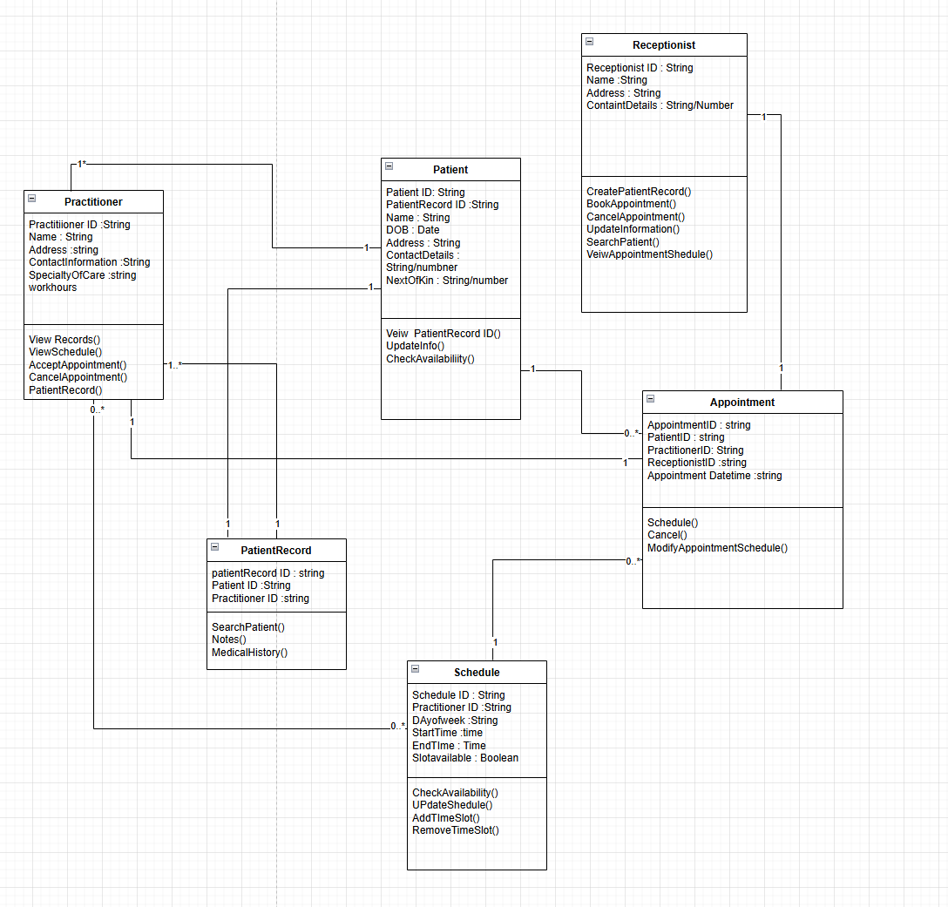

E - AI Design Review
Ask AI to suggest classes and relationships using only confirmed requirements; require supporting requirement IDs.

F - Compare and Decide
Record at least one accepted, modified and rejected AI suggestion.
Accepted = Clinic Controller
Modified = NotificationManager
Rejected = ScheduleEngine

G - Python Skeletons
Create simple Patient, Practitioner and Appointment class skeletons.
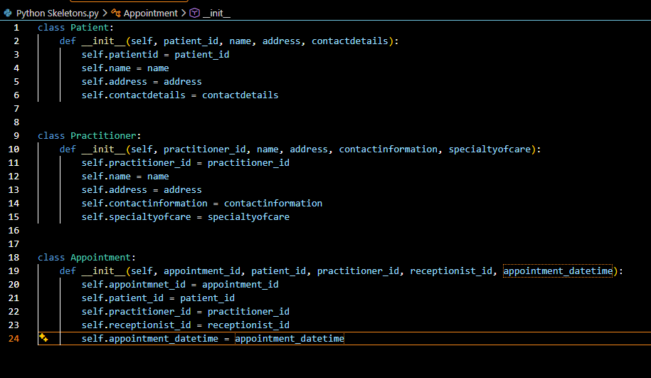

H - Consistency Check
Check model-code consistency; do not implement full behaviour yet.
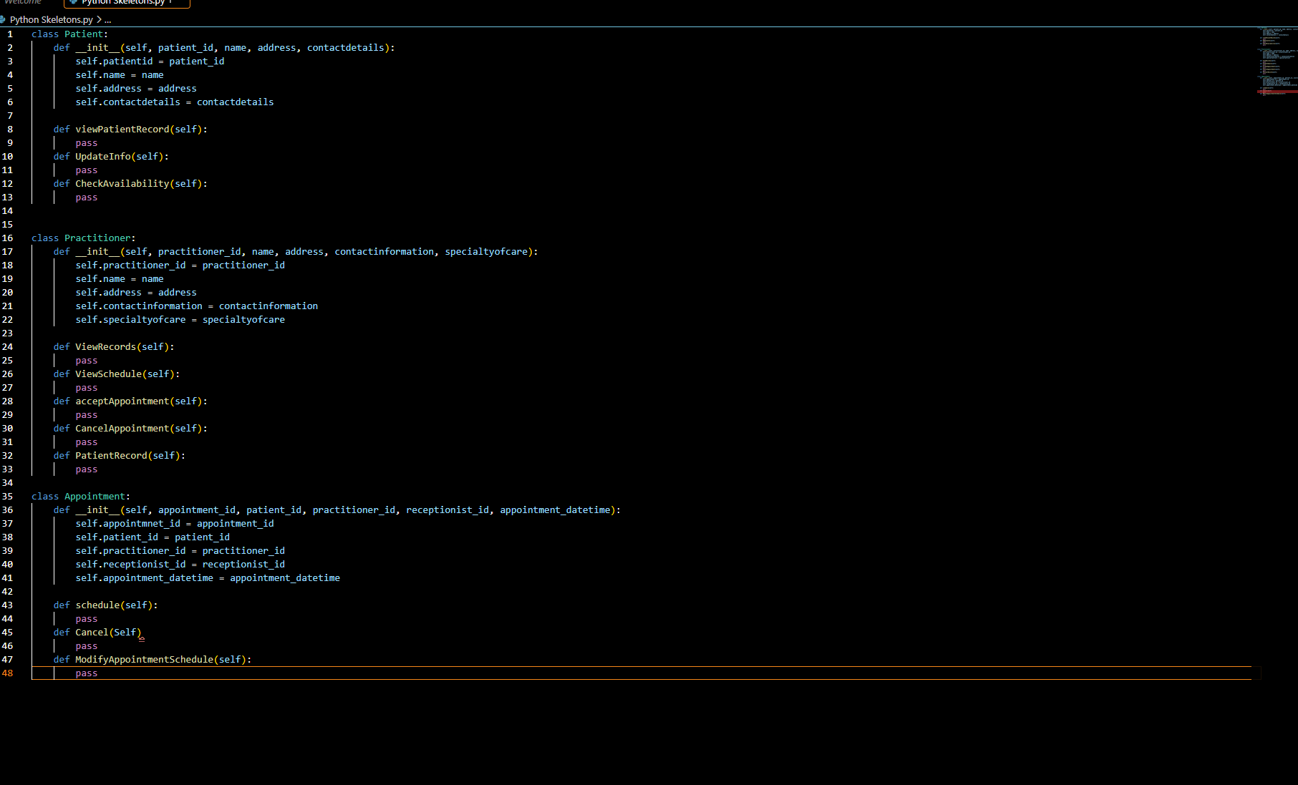

Reflection
What modelling decision was hardest? Where did AI over-design? What evidence supported your final choices?

The decision to make 2 new classes (Schedule and PatientRecord) as needed to think about how to implement these classes into the system. Ai was not over-designed with the questions and limitations I set when asked it questions so it just focused on my already done content and suggested slight areas of improvement but nothing over the top. Evidence that forced me to implement the two new classes were the schedule access to view and edit and finally the patientrecord class will be used to store sensitive information of a patient that may require more security for government specifications.

