SmartCare v0.3 - Domain Model Workbook
Week 6 student resource

Requirement-to-Concept Trace
Requirement | Concept | State/behaviour | Decision
FR-01: book appointment | Receptionist, patient, appointment | Patient Requires:  Receptionist needs:  Patient (ID), Appointment (id), Date, time | Allow appointments to be booked.
FR-02: Cancel appointment | Receptionist, patient, appointment |  | Life happens so cancelations must be possible otherwise it’s just wasting practitioners time.
FR-03: update contact details | Patient, receptionist |  | Details change over time, so it needs a way to edit.
FR-04: Practitioner can view schedule | Practitioner, appointment |  | See upcoming appointments
FR-05: Practitioner can View patient records | Practitioner |  | Call in patients and update records
FR-06: Practitioners’ availability schedule (work hours) | Practitioner, appointment |  | Needed for system time slots tom book appointments
FR-07: Prevent double booking | Receptionist, appointment |  | Stops double booking
FR-08: Search patient profile | Receptionist |  | Needed to check in patient
FR-09: Create new patient profile | Receptionist, patient |  | Part of patient class
FR-10: availability schedule updates after cancelations | appointment |  | Needed so the availability is constantly updated after each appointment is made or canceled.

CRC Cards

Patient
Responsibilities | Collaborators
name, DOB and provides when interacting with reception to create profile | Receptionist, appointment
Patient(id), name, DOB when attending appointment | Receptionist, Practitioner, appointment

Practitioner
Responsibilities | Collaborators
Know practitioner(id), name | Appointment
Know Patient(ID) Patient records() | Patient

Appointment
Responsibilities | Collaborators
Know appointment(id), Patient(id), Practitioner(id), date, time, and current status for appointment booked | Practitioner, Patient, Receptionist
Know appointment(id), Patient(id), Practitioner(id), date, time, and current status for appointment cancelled | Practitioner, Patient, Receptionist

Receptionist
Responsibilities | Collaborators
Know receptionist(id), name, and helps patients manage appointment | Patient
Know receptionist(id), name, and helps patient create profile | Patient

UML Class Diagram
Insert/draw UML here. Include defensible relationships and multiplicities.
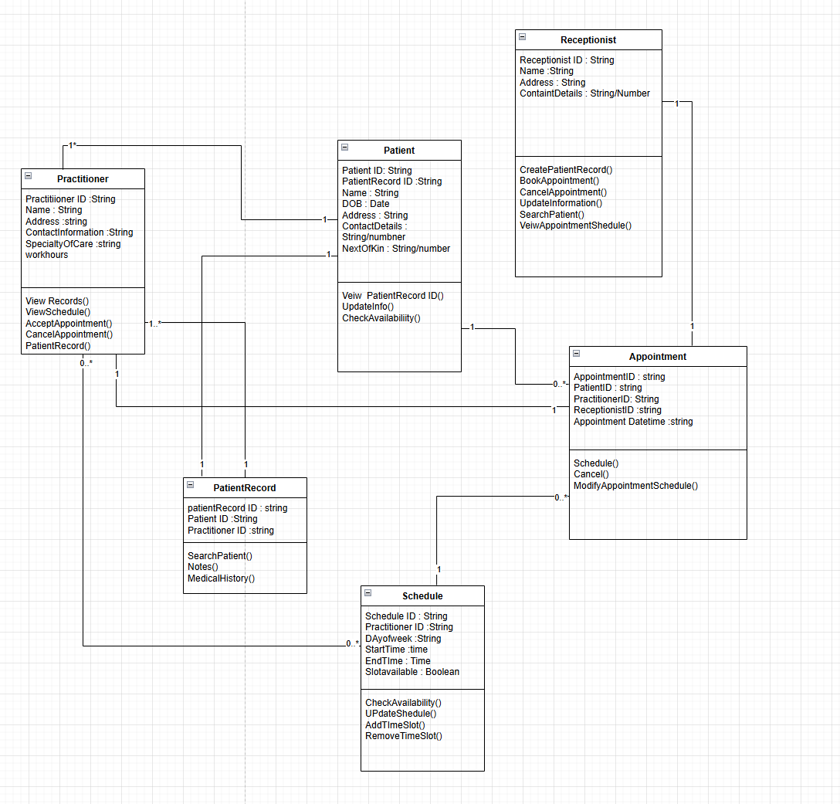

Design Rationale
Explain class selection, responsibility allocation and key relationships.

Class:
- Patient = Patients need medical attention and need a profile for data records, and personal information
- Receptionist = Handles clinic appointments, helps patients with queries.
- Practitioner = specialist in medicine that cares for patients
- Appointment = Handles appointment tracking, details, patient, practitioner, and who created the appointment.
Responsibility allocation: Each class has a role to do that interact with the system appointments. From creating, attending, viewing, and cancelling. All these play a part in responsibility allocation.
Key Relationships: patient 1 - 0* appointment, appointment 1-1 practitioner, patient 1-1* receptionist, receptionist 1-1*appointment

AI Design Review Record
AI suggestion | Evidence | Decision | Reason | Model change
Suggested class = PatientRecord | FR-05: Practitioners view patient records  FR-08 has mention of a patient record | Accepted | Every patient requires a record for history and potentially needs more security to access this information that the receptionist is not allowed to view. (government requirements for safe handling of sensitive information) | Added class PatientRecord with attributes of patientID, PractitionerID, patientHistory.
Suggested class = Schedule | FR-04: View schedule  FR-06: Availability schedule  Mention of calender and daily appointments | Accepted | Scheduling could use its own class to handle appointment availability and allow practitioners to view their calender to acceptappointments to call a patient into the room. | Added class Schedule with attributes (ScheduleID, PractitionerID, DayOfWeek, StartTIme, EndTime, SlotAvailable.  Methods (CheckAvailability(), UpdateSchedule(), AddTimeSlot(), RemoveTimeSlot()
Medicare number attribute | Patient Class | Rejected | Requirments have no mention of using medicare card. | None, can add to patient record by request of client.
Appointment class possible attributes  (AppointmentID, TimeSlot) | Fr-01 Book Appointments  Fr-02 Cancel Appointments  Fr-07 Prevent Double booking  Fr-10 Update availability after cancellation | Modify | Added to schedule class instead of appointment as schedule will handle calcender stuff while appointment will just handle booking. | AddTimeSlot(), RemoveTimeSlot() to schedule

