ALEKSANDR  POPOV  quietinst@gmail.com  https://github.com/quietinst  Telegram: @quietinst | 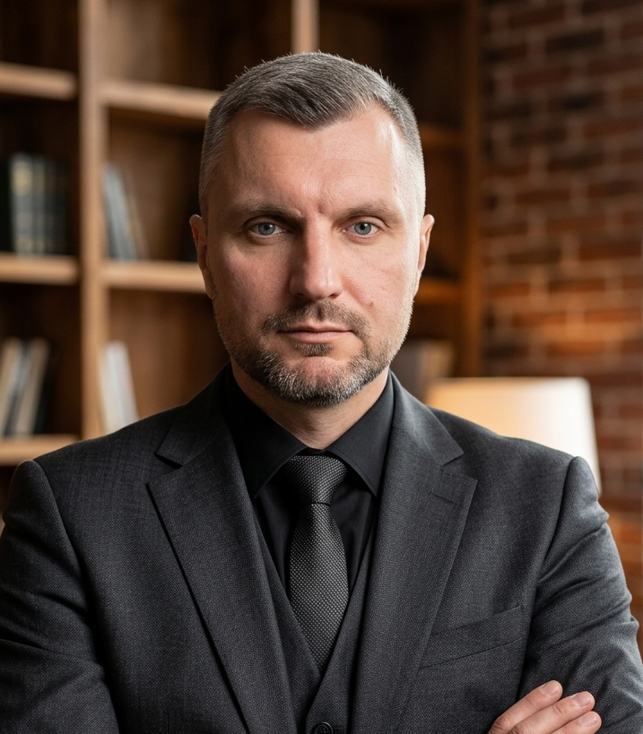

Frontend/full-stack developer focused on React and modern JavaScript. I enjoy turning complex interfaces into something simple and intuitive, and I don't stop until every pixel is in place. Always learning something new — from TypeScript to Node.js architecture — and I genuinely enjoy the process of solving problems, not just the result. Looking for a team that values attention to detail, independence, and healthy curiosity.
BIOGRAPHY  Born in 1986. Lives and works in Germany.  EDUCATION  2022 – 2023  TISchool GoIT, Online  Fullstack Developer  2003 – 2008  Donetsk National University  Donetsk International Economics  LANGUAGES  Ukrainian — Native  Russian — Native  English — B1  German — B1 | SKILLS  HTML5  CSS3  Sass  JavaScript  TypeScript  React  Redux  REST API  Webpack  Node.js  MongoDB  MySQL  Git

