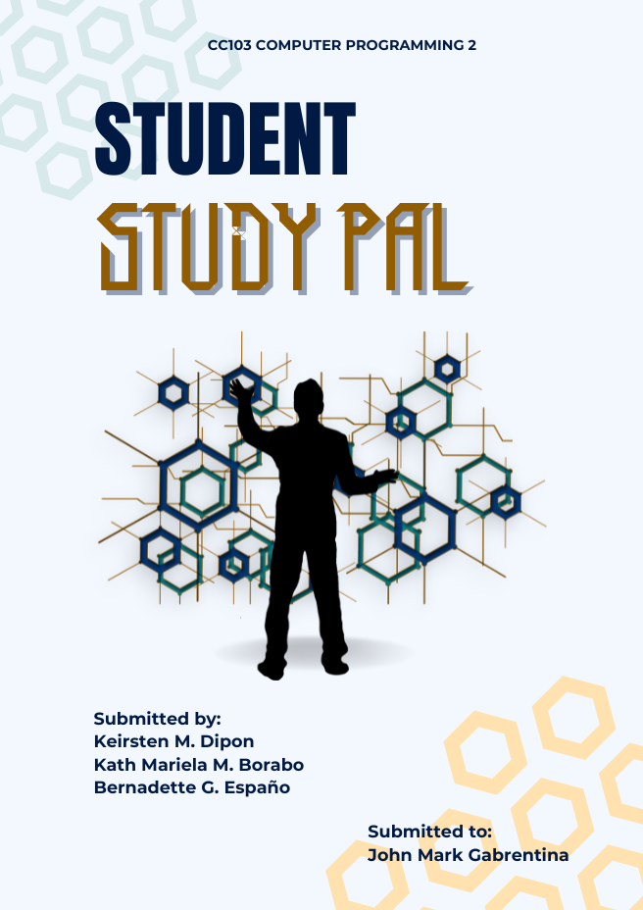

Final Project
Student Study Pal

Sorsogon State University
Bulan Campus

In Partial Fulfillment of the Requirements for the Subject CC103 Computer Programming 2
Under the Course of Bachelor of Science in Information Technology

By:
Keirsten M. Dipon
Kath Mariela Borabo
Bernadette Espano

July 2026
CHAPTER II

TABLE OF CONTENTS

CHAPTER III

RATIONALE

- Why was the application proposed?
The Student Study Pal was proposed to address the common challenges faced by many individuals especially students in managing their daily tasks, activities, quizzes, and even school schedules. Academic life involves balancing multiple subjects, assignments, and personal commitments, and students often find it overwhelming to keep everything arranged. In today’s fast-paced academic environment, students often struggle to keep track of their responsibilities in school because they rely on different tools such as separate planners, reminder apps, and manual notes which leads to confusion, disorganization, and missed deadlines or important academic events.

Additionally, not every student has stable or continuous internet access, especially in areas with poor connection or limited data. Most available study management tools operate online, making them unreliable or impossible to use at times when students need them most. There is a clear need for a dedicated, offline-capable system designed specifically for student needs that is something simple, effective, and accessible anywhere.

This application aims to create a unified digital space where students can organize their study plans, record important dates, build quizzes for review, and track their own development. By gathering all these essential features in one place, it removes the confusion and hassle of switching between different tools or searching through scattered notes. Built to be straightforward and easy to navigate, the system helps students maintain better order, use their time wisely, stay on top of deadlines, and ultimately perform better in their studies. It empowers learners to take full control of their academic routine, turning disorganized workloads into a clear, manageable, and productive plan.

- Problem being solved.
The main problem addressed by Student Study Pal is the absence of a dedicated, centralized, and student-oriented tool designed specifically to handle all aspects of academic life. Most existing applications only cover one function such as simple calendars or basic reminders or require a constant internet connection, which makes them unreliable or inaccessible for many students.

Learners face common difficulties when they often lose track of assignment due dates or exam schedules, leading to missed work or poor preparation. Study plans are frequently disorganized, making it hard to allocate time effectively across different subjects. Self-assessment is also challenging, as there are few easy ways to create and review practice quizzes offline. Important details or progress updates are often scattered across notebooks, apps, or notes, causing confusion and wasted time. Another major issue is the heavy reliance on online platforms, which may not be available in areas with weak signal or for students with limited data.

This application solves these problems by combining schedule management, deadline tracking, quiz creation, and progress monitoring into one complete, offline-capable system. With this tool, students can keep all their academic information in one place, access it anytime without internet, and organize their studies clearly and efficiently.

- Why the app features selected
The features of Student Study Pal were carefully chosen based directly on the daily needs of students for simplicity, efficiency, and practicality in managing their academic responsibilities.

- ADD AND VIEW STUDY SCHEDULES these allows users to add, view, and organize their daily or weekly study sessions and classes according to specific times and subjects. This feature is essential for proper time management; it helps students plan their learning activities, avoid conflicts, and ensure every subject gets enough attention.

- TRACK ACADEMIC TASK AND DEADLINES it enables users to record assignments, projects, and exam dates, and mark them as complete once finished. This helps learners keep track of their obligations, reduces the risk of forgetting important dates, and gives a clear sense of progress and accomplishment as tasks are done.

- CREATE QUIZZES MANUALLY that provides a space where students can build their own quizzes with questions, choices, and answers. This supports active learning and self-review, allowing users to test their knowledge anytime without needing internet or external materials.

- MONITOR PROGRESS AND COMPLETE TASKS it displays a summary of completed tasks, pending tasks, and total study hours recorded by the user. It lets students quickly see their academic standing without navigating through different parts of the system.

All these features were selected to create a balanced, powerful, yet simple system. The goal is to provide exactly what a student needs nothing unnecessary, nothing missing but making the app easy to use every day while significantly improving organization, discipline, and academic results.

- Sustainable Development Goal (SDG) Addressed by the Application
The development of Student Study Pal supports the United Nations Sustainable Development Goals, particularly;

- SDG 4: Quality Education
Promoting inclusive and equitable quality education by providing students with a free and accessible digital tool to manage their academic life. By improving student time management, accountability, and self-assessment through quizzes and progress tracking, the system directly supports the goal of enabling all learners to achieve relevant and effective learning outcome.
Furthermore, features such as manual quiz creation and progress monitoring encourage active learning and self-evaluation, allowing students to track their development and adjust their strategies. This enables all learners to build better habits, stay focused, and achieve meaningful academic results.
By integrating these essential functions into one reliable system, the application supports the broader goal of making quality education accessible and manageable. It serves as a practical aid that enhances organization and productivity, ensuring students have the necessary tools to succeed in their studies and fully benefit from their educational opportunities.

CHAPTER IV

SOLID PRINCIPLES

The design and development of Student Study Pal apply key SOLID principles to ensure that the system is well-structured, maintainable, scalable, and easy to modify or extend. Each principle is applied as follows:

- Single Responsibility Principle (SRP)
This principle ensures that every class in the system has only one clear purpose or responsibility. In this application, classes such as Schedule, Quiz, Deadline, StudyHour, and DataProcessor are each designed to handle a specific function. For instance, the Schedule class solely manages study timetables, while the DataProcessor class exclusively handles data storage, retrieval, and file operations. This separation of concerns simplifies understanding, testing, and maintenance, as changes to one feature or function will not affect or break unrelated parts of the system.

- Open/Closed Principle (OCP)
The system is designed to be open for extension but closed for modification. This means that new features or functionalities such as adding new types of academic activities, new output formats, or additional tracking options can be introduced by adding new classes or modules without altering the existing core code. This approach ensures that the system can grow and adapt to future requirements or changes without risking stability or rewriting already working components.

- Liskov Substitution Principle (LSP)
This principle is applied through the use of consistent interfaces. Classes such as ConsoleInputReader and ConsoleOutputWriter implement the base interfaces IInputReader and IOutputWriter, respectively. As a result, these subclasses can replace their base types anywhere in the system without altering the correctness or behavior of the program. Any object implementing these interfaces functions exactly as expected, allowing different input or output methods to be used interchangeably without breaking the overall operation.

- Interface Segregation Principle (ISP)
Interfaces are kept small, focused, and specific to their roles rather than being large and general-purpose. The IInputReader and IOutputWriter interfaces contain only the methods relevant to reading input and writing output, respectively. This ensures that no class is forced to implement methods or functionalities that it does not need. By separating behaviors into specialized interfaces, the system remains clean, flexible, and free from unnecessary complexity.

- Dependency Inversion Principle (DIP)
The application follows this principle by depending on abstractions rather than concrete implementations. The main StudentStudyPalApp class relies on the IInputReader and IOutputWriter interfaces instead of directly using specific classes like ConsoleInputReader or ConsoleOutputWriter. This reduces tight coupling between components, allowing dependencies to be easily swapped, updated, or tested independently. It ensures that the high-level logic remains unaffected by changes in low-level modules, making the system more robust and adaptable. By following these principles, the application becomes more reliable, easier to maintain, and adaptable for future improvements.

CHAPTER V

TESTING METHODS

The application was tested using several methods to make sure all features work as expected, inputs are properly validated, and errors are handled without crashing the system.

Functional Testing
Functional testing was done to check each feature of the application individually. This includes the Study Schedule, Deadlines, Quiz, and Progress Tracker features. Each feature was tested by providing valid inputs and checking if the system produces the correct and expected output.

Manual Testing
Manual testing was done by simulating actual user scenarios to see how the system run during real use. The following scenarios were tested:

- Adding a study schedule with a valid date, time, and task
- Creating a quiz with a subject, question, four choices, and a correct answer
- Taking a quiz and checking if the score is computed correctly
- Adding a deadline task and marking it as completed or incomplete
- Viewing the progress tracker to check if total study hours and task statuses are shown correctly

This process helped identify any usability issues that may not show up during code-level testing.

Error Handling Testing
The system was tested with invalid and incorrect inputs to make sure it handles errors properly without stopping the program. The following error scenarios were tested:

- Entering a wrong date and time format.
- Leaving the task or subject field empty
- Entering a letter instead of a number when selecting a menu option or task number
- Entering an answer that are not A, B, C, or D when creating or taking a quiz

Automated Unit Testing using Unittest.
Automated testing was done using Python's built-in unittest framework. A test class called TestDataProcessor check if the Student Study Pal application works correctly. The automated test cases covered the following features:

- Schedule creation and retrieval
- Quiz creation and retrieval
- Deadline task creation and retrieval
- Study hour logging and retrieval
- Deadline status toggling
- Schedule attribute validation
- Quiz attribute validation
- Study hour attribute validation
- Invalid input validation (date format, time format, empty fields, negative hours, invalid answer, invalid index)
- Interface compliance of ConsoleInputReader and ConsoleOutputWriter

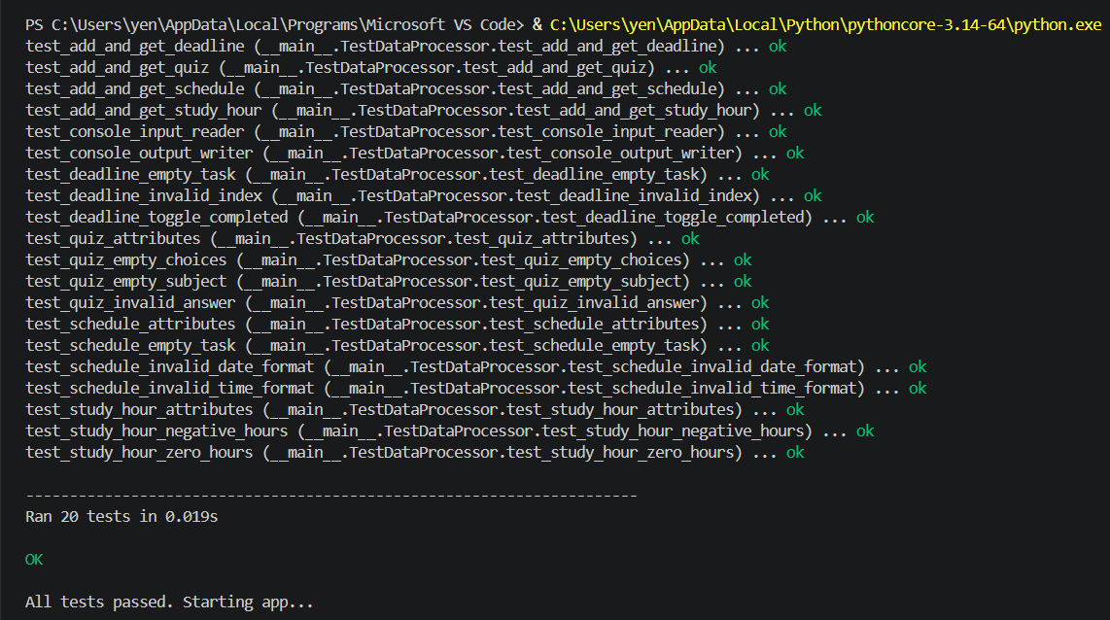

Figure 1. Unittest Execution Result Showing All Test Cases Passed

The results showed that all test cases passed successfully without errors, confirming that the application behaves correctly and consistently under 20 expected conditions.

CHAPTER VI

FLOW CHARTS
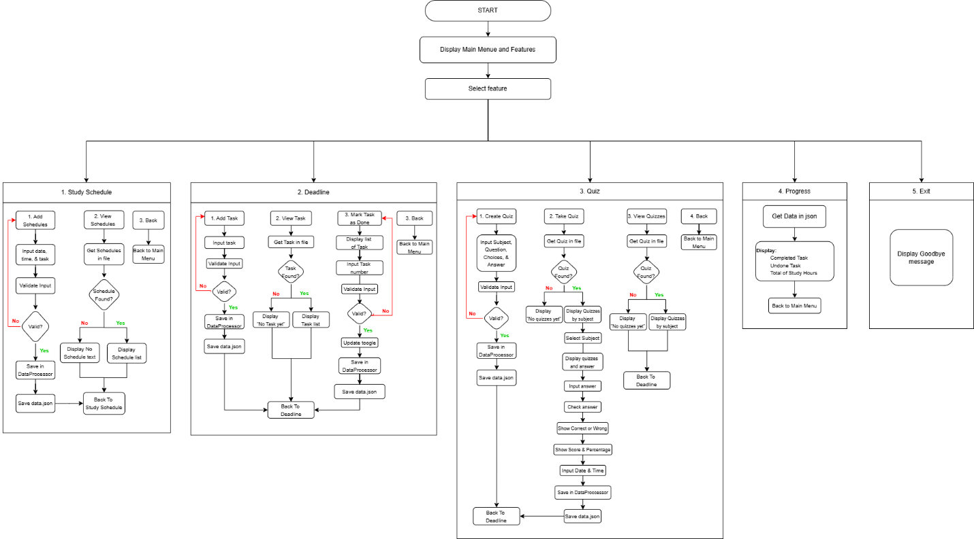

Figure 2.1. Student Study Pal Flowchart

The main flowchart shows the overall flow of the application from start to finish. When the program is launched, it loads any existing data from the data.json file using the DataProcessor class. The main menu is then displayed, showing five options: Study Schedule, Deadlines, Quiz, Progress, and Exit. The user enters a number to select a feature, and the system directs them to the chosen feature. If the user enters an invalid choice, an error message is shown and the menu is displayed again. This loop continues until the user selects option 5 to exit the program.

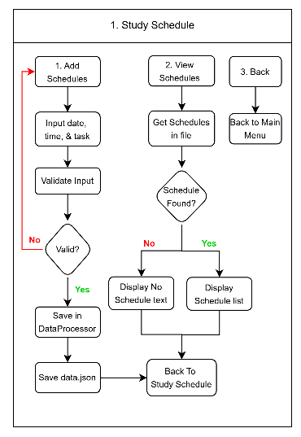
Figure 2.2. Study Schedule flowchart
a. Feature 1 – Study Schedule
The Study Schedule feature allows the user to add and view study schedules. When adding a schedule, the system asks for a date, time, and task description, and validates input before accepting it. If any input is in the wrong format or left empty, an error message is shown and the user is asked to try again. Once all inputs are valid, a Schedule object is created, saved through DataProcessor, and stored in the data.json file. When viewing schedules, the system retrieves and displays all saved entries in a numbered list. If none, a message is shown instead.
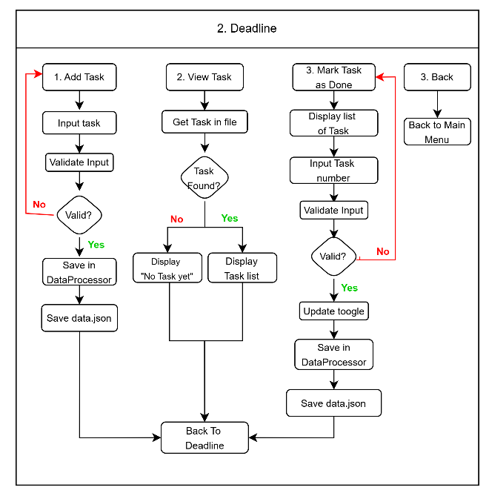
Figure 2.3. Deadline flowchart

b. Feature 2 – Deadlines
The Deadlines feature allows the user to add tasks, view them, and update their completion status. When a task is added, the system checks that the description is not empty before creating a Deadline object with a default status of not completed. Tasks are displayed in a numbered list with a checkmark for completed ones and a cross for unfinished ones. When marking a task, the user enters the task number and the system calls the toggle_completed() method to switch its status between done and not done, then saves the updated data back to the file.
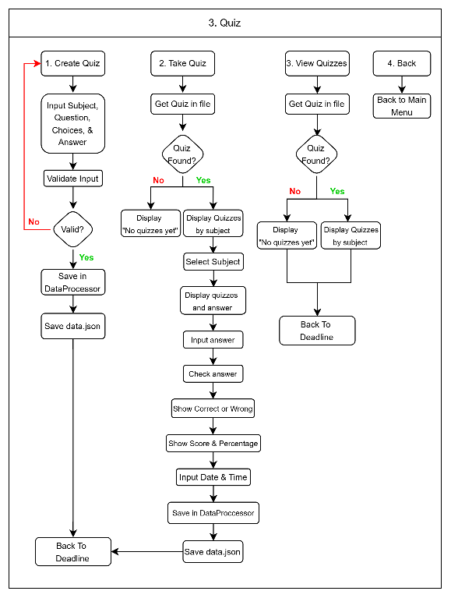
Figure 2.4. Quiz flowchart

c. Feature 3 – Quiz
The Quiz feature has three options: Create Quiz, Take Quiz, and View Quizzes. When creating a quiz, the user enters a subject, question, four answer choices, and the correct answer, all of which are validated before saving. When taking a quiz, the user selects a subject and answers each question one by one, with the system checking each answer and showing if it is correct or wrong. After finishing, the score and percentage are displayed, and the user is asked to log the date and study hours, which are saved as a StudyHour record for use in the Progress. When viewing quizzes, all saved questions are shown on screen grouped by subject.

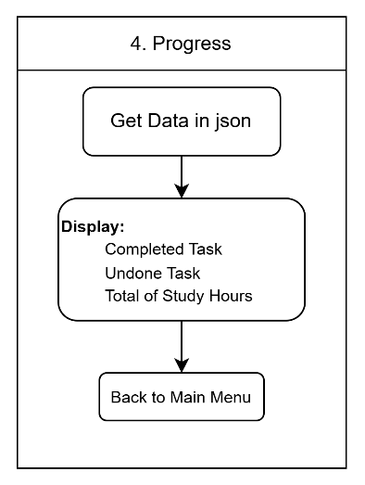
Figure 2.5. Progress feature flowchart

d. Feature 4 – Progress Tracker
The Progress Tracker feature gives the user a quick summary of their overall academic progress without requiring any input. The system retrieves data from DataProcessor and displays the number of completed tasks, the number of unfinished tasks, and the total study hours logged from all quiz sessions, giving the user a clear overview of how they are performing academically.

CHAPTER VII

CLASS DIAGRAMS

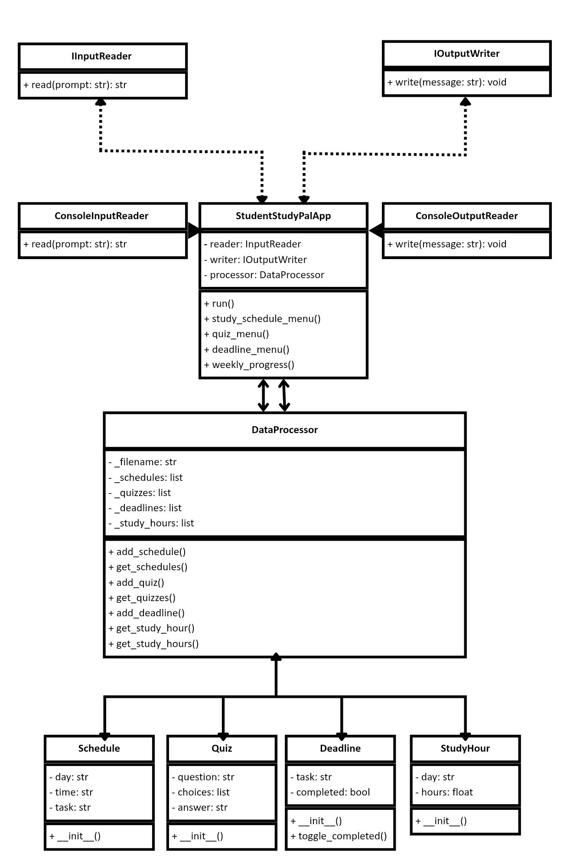

Figure 3.1. Student Study Pal Class Diagram

The UML Class Diagram of Student Study Pal shows the application structure and shows how its different parts work together. It details the system’s classes, along with their attributes, methods and connections to one another. This diagram also serves as the blueprint of a project and simplifies the development process.

This system consists of four features:
- Study Schedules
- Deadlines
- Quiz
- Progress Tracker

- Feature 1 – Study Schedules
The Study Schedules features helps users to create their own schedules for studying. This feature consists of scheduled date, and progression.
The schedule class consists of day, time, and task. It helps users to balance their schedules when it comes to studying.

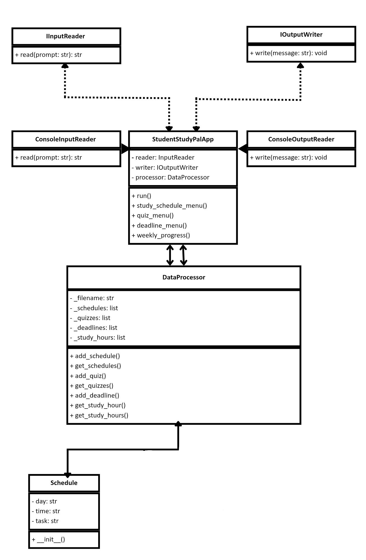

Figure 3.2. Study Schedules class diagram

- Feature 2 – Deadlines
The Deadlines features helps users to track their task’s due date. This feature consists of tasks deadline, and completed task.
The deadline class consists of task, and completed. It keeps the users updated for their deadline not to forget.

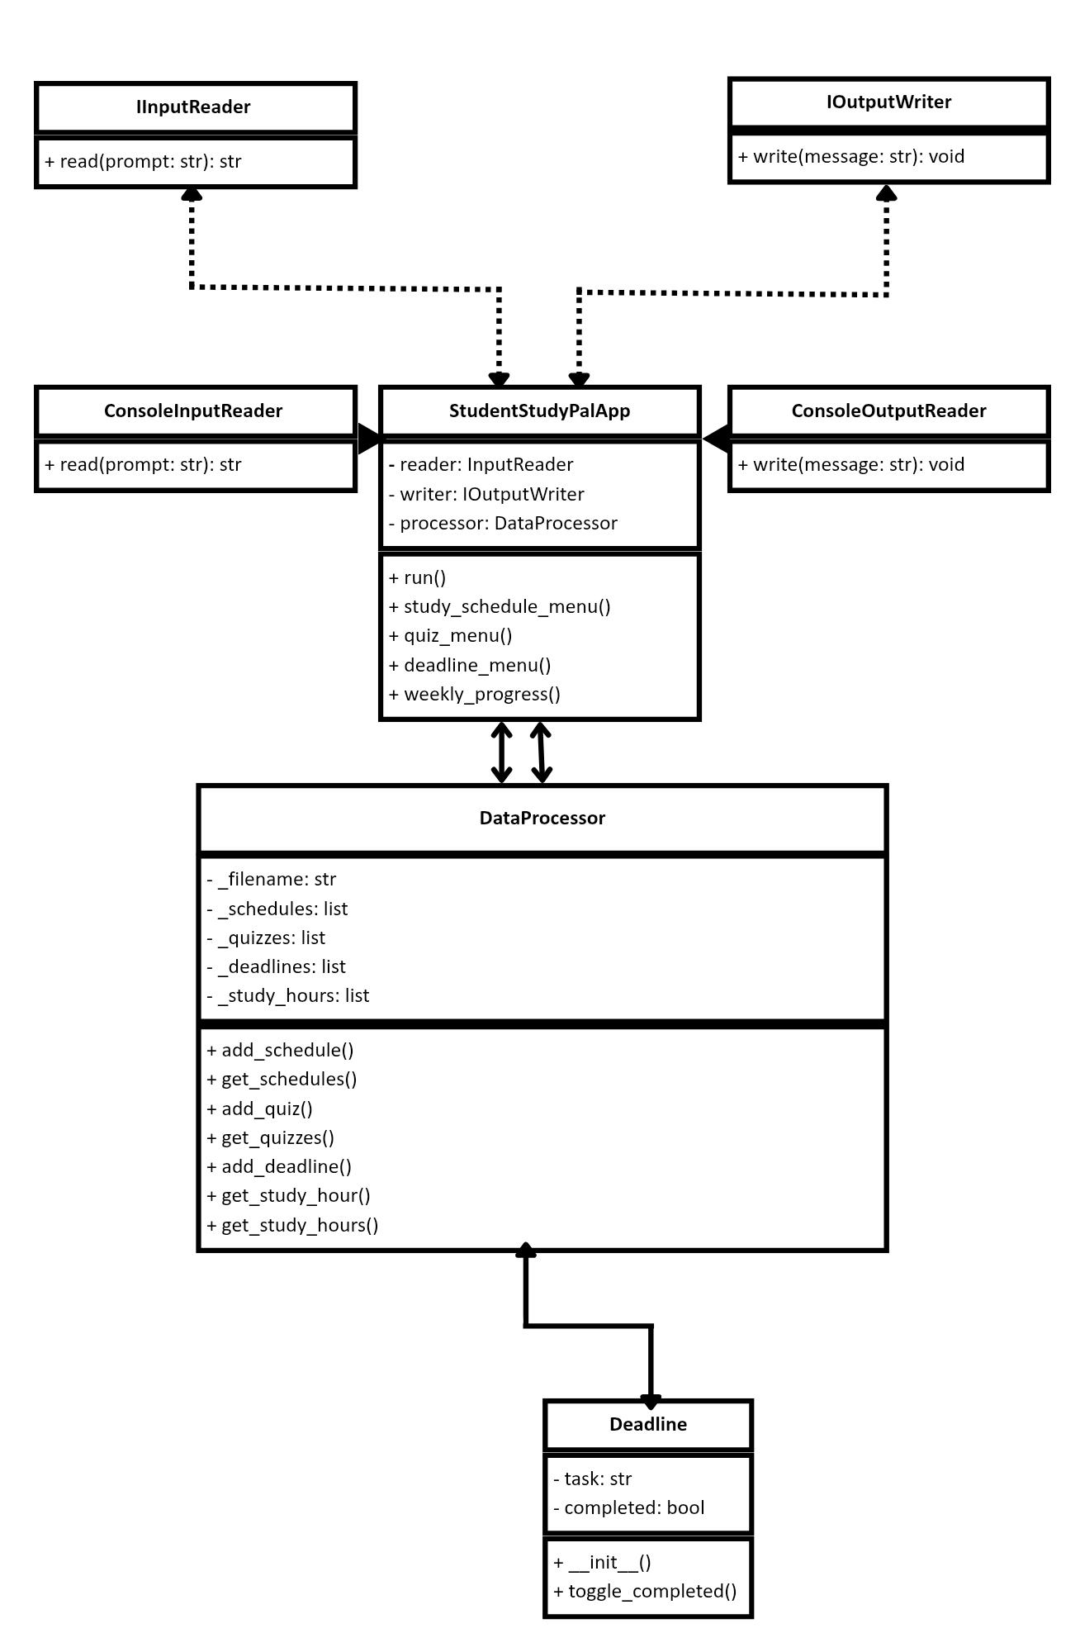

Figure 3.3. Deadlines class diagram

- Feature 3 – Quiz
The Quiz features helps users to review their task. This feature consists of questions, choices, and answer based on user’s input.
The Quiz class contains questions, choices, and answers. It makes the users study actively with their own made quiz.

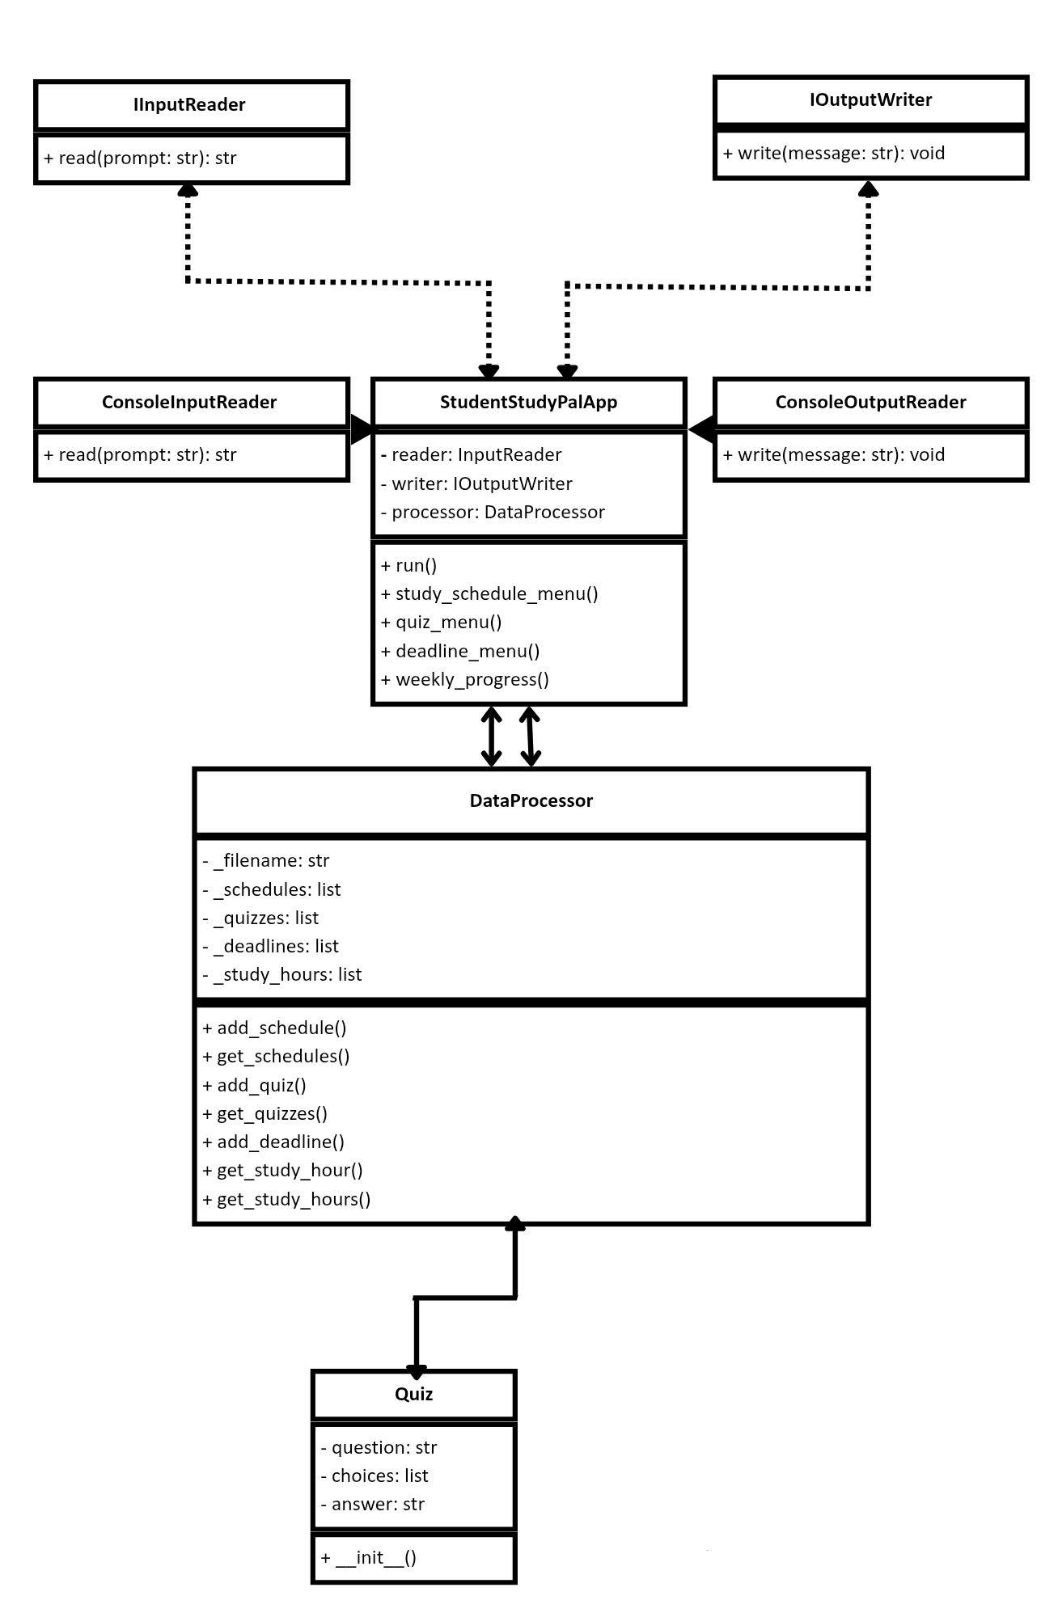

Figure 3.4. Quiz class diagram

- Feature 4 – Progress Tracker
The Progress Tracker feature creates user a summary of their academic progression.
The Study Hour class contains day, and hours. It helps user to know their progress on their academics.

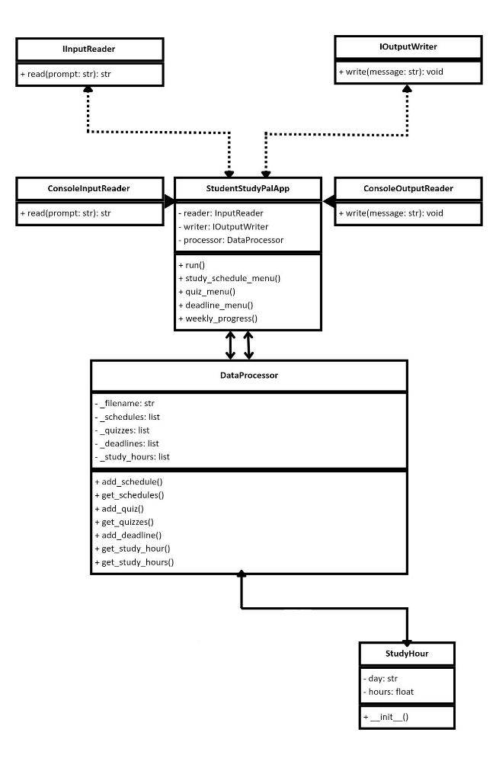

Figure 3.4. Quiz class diagram

CHAPTER VIII

SCREENSHOTS

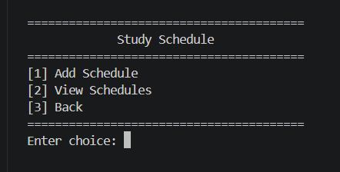
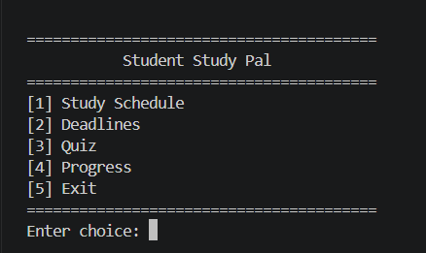

Feature 1 – Study Schedule
If user enter “1” from the Main Menu the Study Schedule will be displayed with three choices: Add Schedule, View Schedule, and Back.
Main Menu – Display the Main Menu console of the Student Study Pal with five options: Study Schedule, Deadlines, Quiz, Progress, and Exit. The user will enter a number to select the feature.

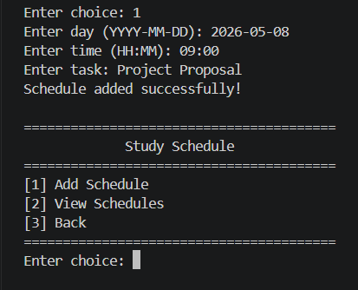
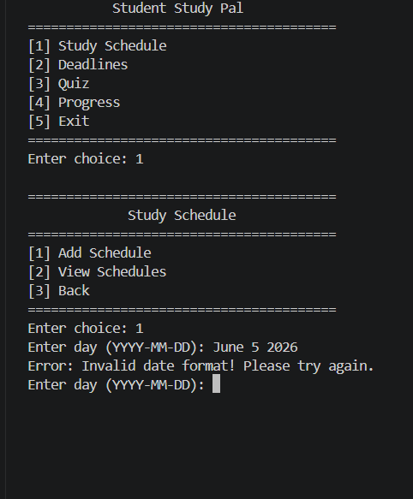
Add Schedule – The user will enter valid date, time, and task then the system will display confirmation if schedule is added successfully.
Invalid Input – Invalid message will be display to the console if user enter wrong format of date, time, and task and system will re-prompt until user enter valid format.

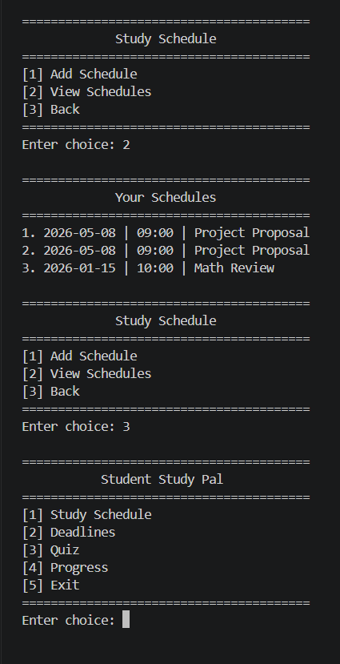
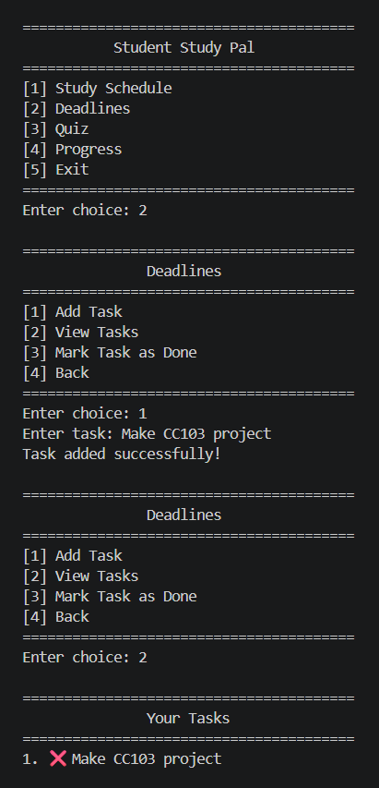
Feature 2 – Deadlines
If user enter “2” from the Main Menu the Deadline feature will be displayed with four choices: Add Task, View Tasks, Mark Task as Done, and Back.
View Schedules – The system will display all the saved schedules entered by user.

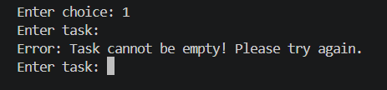
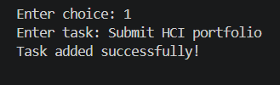

Add Task – The user will enter a task description and the system will display a message if successfully added with default status as not completed.
Invalid Input – Invalid message will be display to the console if user left task description empty and system will re-prompt until user enter valid format.

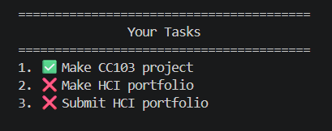
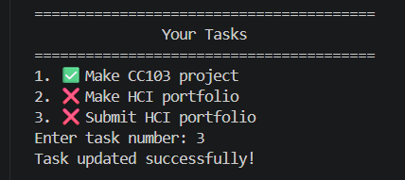
View Tasks – The system will display all the saved schedules entered by user.
Mark Task as Done – The system will display all task with its status and the user enter the number of the task to change its status then the system will update the file and save the changes.

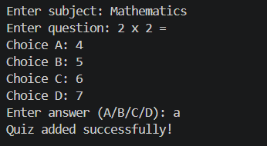
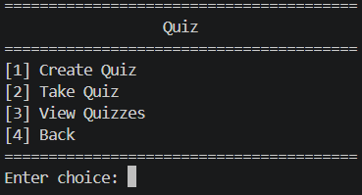
Creating Quiz – The user will enter the subject, question, four answer choices, and the correct answer and the system will validate all inputs and display a message if successfully added.
Feature 3 – Quiz
If user enter “3” from the Main Menu the Quiz will be displayed with four choices: Create Quiz, Take Quiz, View Quizzes, and Back.

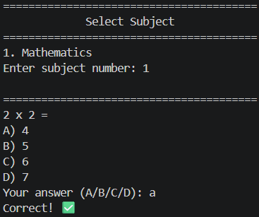

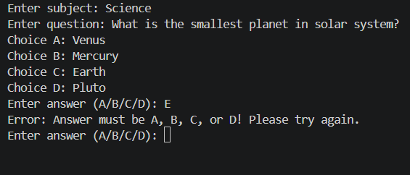

Invalid Input – – Invalid message will be display when there is left empty or an invalid answer letter is entered, the system displays an error and re-prompts the user for the specific field
Take Quiz – The user will select a subject, then answer all the question. The system will display if the answer is correct or wrong and show the correct answer if user enter a wrong answer

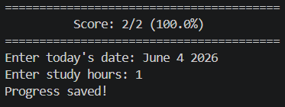
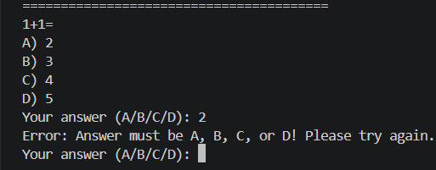

Quiz Score and Progress Saving – After completing all question, the system will display the score and the percentage, then the user will enter the date and study hours and will be saved in progress tracker.
Invalid Input – – Invalid message will be display when answer is left empty or an invalid answer letter is entered and system will re-prompt until user enter the valid choices.

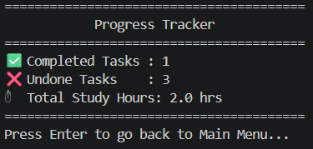
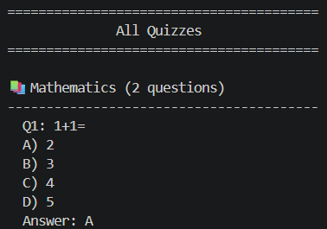

Feature 4 – Progress
If user enter “4” from the Main Menu the Progress will be displayed showing the number of user’s completed and undone tasks, and the total of study hours. After viewing, the user presses Enter to return to the main menu.

View Schedules – The system will display all the saved quizzes by grouped or subject, showing all question, choices, and correct the answer

CHAPTER IX

APPENDICES

- Group Members Role

The development of Student Study Pal was accomplished through collaborative teamwork, wherein each member was assigned distinct responsibilities while collectively contributing to the overall concept, design, and implementation of the system.
Dipon, Keirsten M.
- Code development and implementation
- Design and formulation of testing methodology
- Capture and preparation of system screenshots
- Make the Appendices and System flowcharts
- Edit and finalized the document
- Managae the project GitHub repository

Borabo, Kath Mariela M.
- Application and documentation of SOLID principles
- Development of project rationale
- Design formatting and project cover page
- Compilation and organization of appendices

Espano, Bernadette G.
- Creation of class diagrams
- Preparation and formatting of group members’ biodata
- Structuring and formatting of Table of Contents

Collaborative Collaborations
All group members actively participated in the conceptualization, planning, analysis, design, development, testing, and refinement phases of the Student Study Pal. Decisions were made collectively, and tasks were coordinated effectively. Through shared effort and cooperation, the team successfully completed the project and ensured system quality.

- Group Members Bio

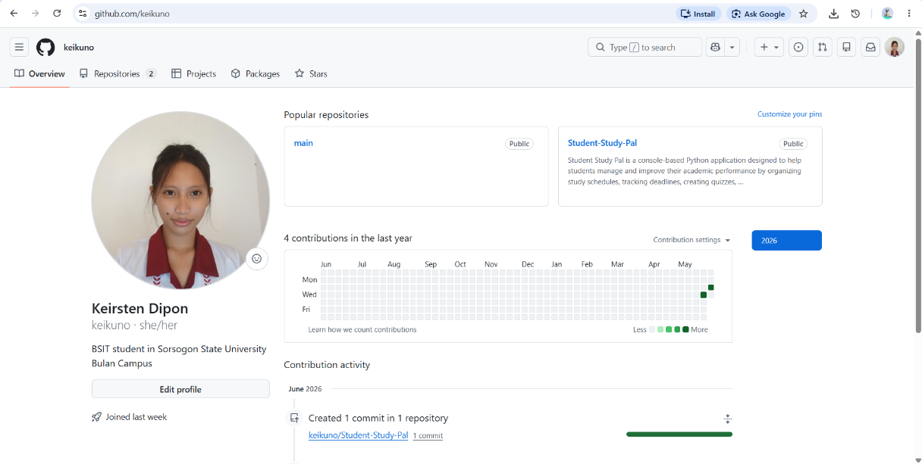
- Group Members GitHub Page

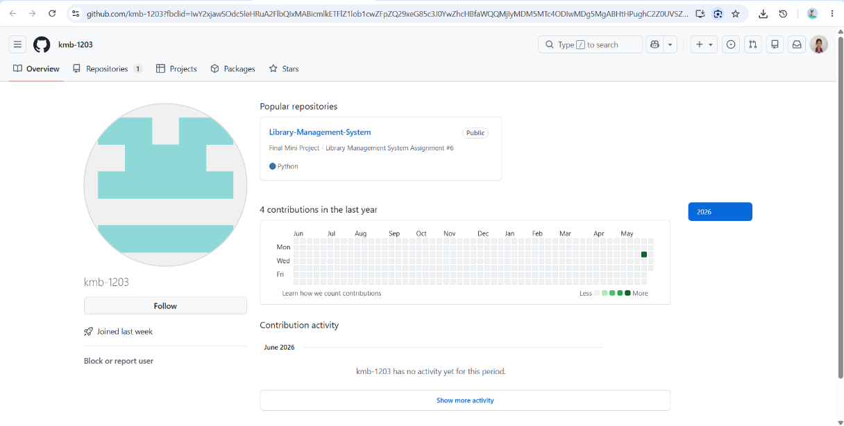
Keirsten M. Dipon (https://github.com/keikuno)

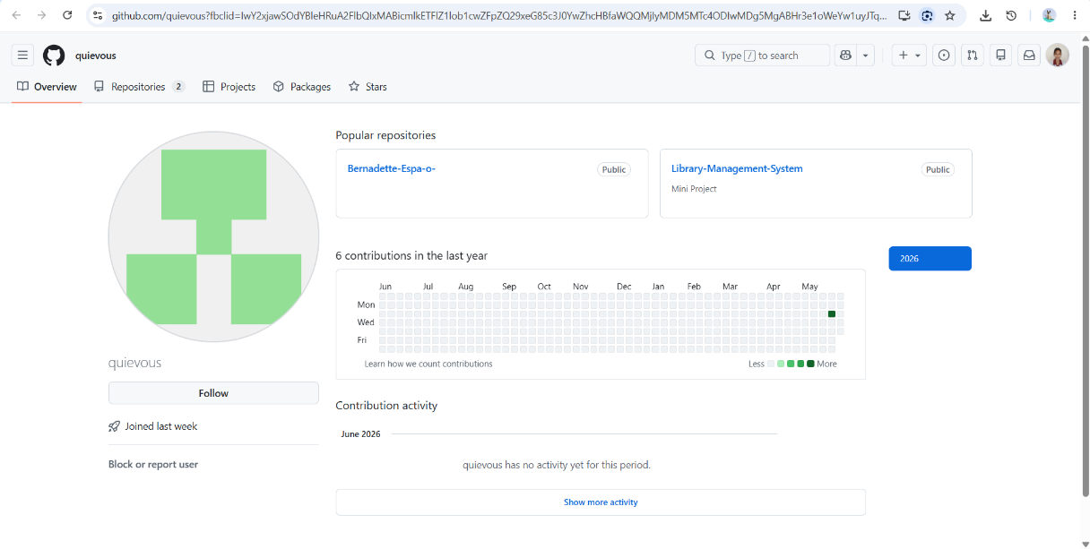
Kath Mariela M. Borabo (https://github.com/kmb-1203)

Bernadette G. Españo (https://github.com/quievous)

- Proof of GitHub Repositories (Link and ReadMe)

- Student Study Pal GitHub Repository Link:
https://github.com/keikuno/Student-Study-Pal
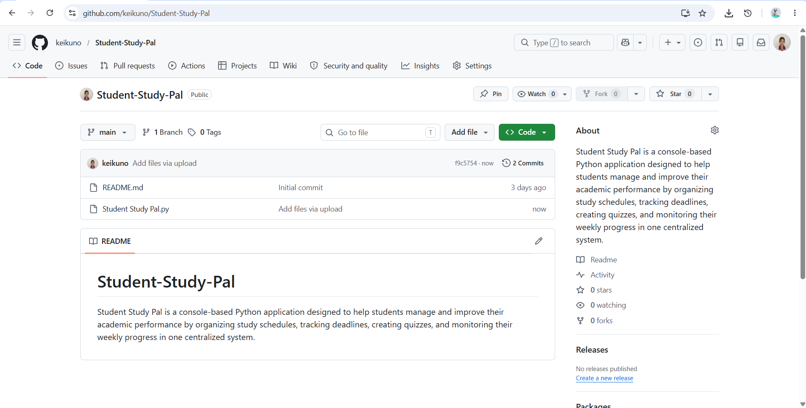

- README.md

Student Study Pal

Application Description
Student Study Pal is a console-based Python application designed to help students manage and improve their academic performance by organizing study schedules, tracking deadlines, creating quizzes, and monitoring their progress in one centralized system.

The application allows users to:
- Add and view study schedules with date, time, and task description.
- Track academic tasks, deadlines, and mark if it is completed.
- Create and take quiz manually by subject with automatic scoring.
- Monitor the progress of student and the tasks needed to be done and already done.

Built with a clean console-based interface, the system follows a structured Input → Process → Output model and operates entirely offline. Data is saved and retrieved using a local JSON file, ensuring reliable performance without relying on external databases or internet connectivity.
Through this application, students can improve their time management, stay organized, and increase academic productivity

OOP Concepts Used
Encapsulation - Data of each class (Schedule, Quiz, Deadline, StudyHour, DataProcessor) will be protected through private attributes and can only be controlled through methods.
Abstraction - IInputReader and IOutputWriter interfaces define standard methods for input and output operations.
Polymorphism - Input and Output interfaces allow different implementations without modifying the entire code.
Loose Coupling - Components will be designed to run independently and easily replaceable by using dependency injection.
Technologies Used
- Python (core programming language)
- unittest (built-in testing framework)
- JSON (file handling for data persistence)

Project Structure
student-study-pal/
│
└── Student Study Pal.py

How to Run
- Requirements: Python 3.x
- Clone this repository:
git clone https://github.com/keikuno/Student-Study-Pal

Navigate to the project folder:
- cd student-study-pal

Run the Application:
- Python Student Study Pal.py

Running Tests
- Tests run automatically on startup before the application launches. The terminal will display each test result.

Author
Developed as a school project by:
- Keirsten M. Dipon (https://github.com/keikuno)
- Kath Mariela M. Borabo (https://github.com/kmb-1203)
- Bernadette G. Españo (https://github.com/quievous)

In Partial Fulfillment of the Requirements for the Subject CC103 Computer Programming 2 Under the Course of Bachelor of Science in Information Technology at Sorsogon State University Bulan Campus. With the Supervision of our Professor John Mark Gabrentina.

- Artificial Intelligence (AI) Usage

Artificial Intelligence tools were used during the development of Student Study Pal to help in improving the lacking parts of the code by giving tips, and document accuracy to code in some parts of project proposal.

AI Tool Used by the Group:
- Claude by Anthropic

Purpose of AI Assistance
The AI tool was used to assist member for the following:
- Code Improvement
Guide the member and give suggestion to improve and complete the incorrect parts of the code.

- Code and Document Accuracy
Assist in making structure of the class diagram and flowchart.
Assist in verifying if the code matches the class diagram and flowchart.

- Documentation Assistance
Helped in improving the documents explanation and clarity of some parts of proposal.
Assist in making testing methods and appendices.
Check for wrong grammars and missing parts of the document.

Human Validation, Modification and Ethical Use of AI

AI tool was only used as support in developing Student Study Pal. The code and the documentation decision are all made by the members with little to no help by AI. All the outputs made by AI were reviewed, validated, and modified, and finalized by the members to ensure that the information are all correct and aligned with the project requirement. The students are fully responsible to the content of this project.

