Crops, Plants and Animals

Animals
Objectives
By the end of this lesson, you should be able to:
- Identify characteristics of vertebrates and invertebrates.
- Classify vertebrates into five groups.
- Describe the characteristics of vertebrates and invertebrates.
- State examples of vertebrates in each group.
- Identify vertebrates and invertebrates according to their habitats.

Introduction
All living things are broadly classified into two groups based on the presence or absence of a backbone: vertebrates and invertebrates. This classification helps us understand the incredible diversity of animal life.
1. Invertebrates
- These are animals without a backbone. They often have an external skeleton also known as an exoskeleton which supports and protects them. They are the most diverse group of animals and usually have simple body structures.
- Examples of invertebrates include:
  - Insects (butterflies, ants, grasshoppers)
  - Arachnids (animals that have eight legs, segmented bodies, and exoskeletons) for example spiders, ticks
  - Worms (earthworms, tapeworms)
  - Crustaceans (crabs, lobsters)
  - Mollusks (snails, clams, octopus)
  - Jellyfish
  - Starfish
- They are found in a wide range of environments, including land, water, and air.
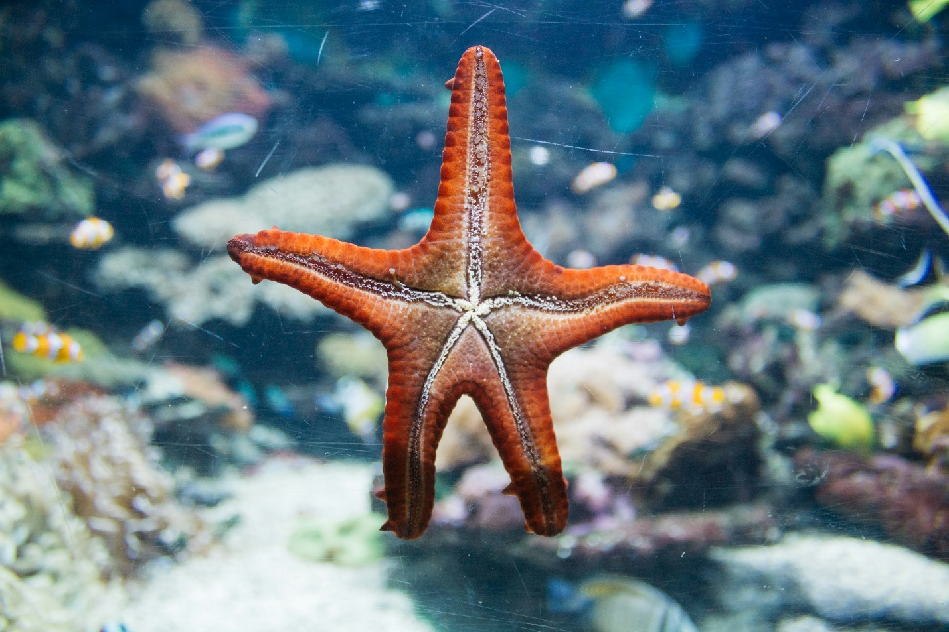
Fig 1 Starfish
2. Vertebrates
- These animals have a backbone or vertebral column. They possess a more complex nervous system and are generally larger with complex body structures. They have an internal skeleton that provides support.
- Five Groups: Vertebrates are classified into five groups: Fish, Amphibians, Reptiles, Birds, and Mammals.
2.1 Fish
- Characteristics: Aquatic animals with gills for breathing, fins for swimming, and usually covered in scales. They are cold-blooded.
- Examples: Salmon, goldfish, shark, tuna, catfish.

Activity 1 :
Fishpond Visit: If possible, visit a fishpond or aquarium to observe different fish species and discuss their adaptations for aquatic life. Use work cards with images of different fish to label their body parts.
2.2 Amphibians
- Characteristics: Animals that live both in water and on land. They have smooth, moist skin and undergo metamorphosis. They are cold-blooded.
- Examples: Frogs, salamanders, toads, newts.
2.3 Reptiles
- Characteristics: Land-dwelling animals with dry, scaly skin. They lay eggs with leathery shells and are cold-blooded.
- Examples: Snakes, lizards, turtles, crocodiles.
2.4 Birds
- Characteristics: Animals with feathers, wings, and beaks. They lay eggs with hard shells and are warm-blooded.
- Examples: Sparrows, eagles, penguins, ostriches.
2.5 Mammals
- Characteristics: Animals with fur or hair, mammary glands for feeding young, and they give birth to live young (with a few exceptions). They are warm-blooded.
- Examples: Humans, dogs, cats, whales, bats.

Activity 2:
In pairs, list 10 names of vertebrates and classify each of them into the correct group. Discuss external features that help distinguish each group.

3. Habitats
Here’s a breakdown of vertebrates and invertebrates categorized by their habitats:
Habitat | Vertebrates | Invertebrates
Aquatic | - fish (e.g. trout, goldfish, sharks, tuna)  - amphibians (e.g. frogs, salamanders)  - marine mammals (e.g. dolphins, whales) | - crustaceans (e.g., crabs, shrimp), mollusks (e.g., snails, clams)  - jellyfish, octopus
Terrestrial (Land) | - Mammals (e.g., lions, elephants)  - reptiles (e.g., snakes, lizards) | - insects (e.g., ants, beetles)  - arachnids (e.g., spiders)  - worms
Aerial (Air) | - Birds (e.g., eagles, sparrows) | - Insects (e.g., butterflies, bees)
Moist Environments | - Amphibians (e.g., toads, newts) | - Mollusks (e.g., slugs)

