Health and Hygiene

Respiratory System
Objectives
By the end of the lesson, you should be able to:
- Identify parts of the respiratory system.
- Explain functions of parts of the respiratory system.
- Identify respiratory diseases.
- Explain the effects of air pollution to the respiratory system

In this lesson, we will explore the important aspects of the respiratory system, including its structure and function, common diseases, and the impact of air pollution. Understanding these concepts will help us appreciate the significance of maintaining a healthy respiratory system.

Parts of the Respiratory System
- We need the respiratory system to bring air rich in oxygen into the body and to remove air with carbon dioxide from the body.
- Oxygen is needed for survival.
- The main organs of the respiratory system are the lungs.
- The respiratory system also has the following components:
  - mouth
  - trachea
  - bronchus
  - nose
  - diaphragm and
  - rib cage

Nose:
- The primary entry point for air, where it is filtered and warmed before reaching the lungs.
- It filters out dust and particles using mucus and tiny hairs (cilia).

Trachea (Windpipe):
- A tube that carries air from the nose and mouth to the lungs. It splits into two bronchi leading to each lung.
- It acts as a passage for air and is lined with cilia to trap and expel foreign particles.

Lungs:
- Organs that facilitate gas exchange. They allow oxygen to enter the bloodstream and carbon dioxide to be expelled.
- It enables gas exchange through tiny air sacs called alveoli, where oxygen and carbon dioxide are exchanged.

Diaphragm:
- A muscle located beneath the lungs that contracts and relaxes to help with breathing.
- Controls the inhalation and exhalation process by changing the pressure in the chest cavity.
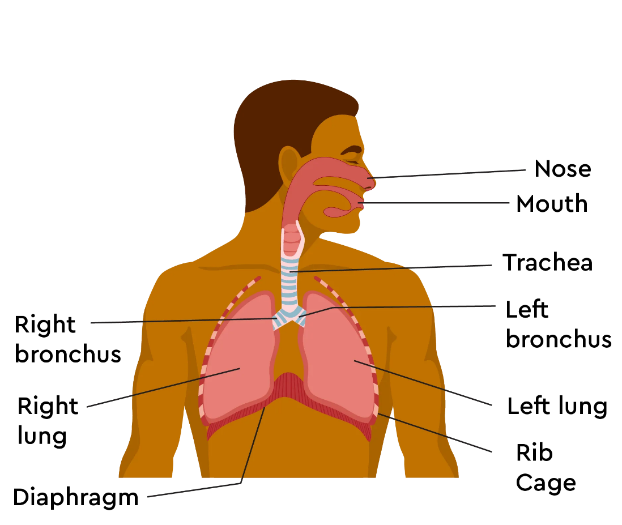
Fig 1: The respiratory system

- Breathing movements can be demonstrated using the following breathing model.

Activity 1
- Experiment 1:
  - Making a model of the respiratory system
- Materials
  - 2 x balloons
  - 2 x rubber bands
  - A clear plastic 1-litre bottle
  - A two-way hose connector
  - Rubber stopper with a hole
  - A pair of scissors
- Procedure
- Tightly fix a balloon onto each of the openings of the two-way hose connector with the rubber bands, ensuring the seal is airtight.
- Cut off the bottom 1 inch from the bottle using the scissors. Ensure the cut edge of the bottle is smooth.
- Place the balloons connected to the hose connector inside and seal the plastic as shown in Fig 2:
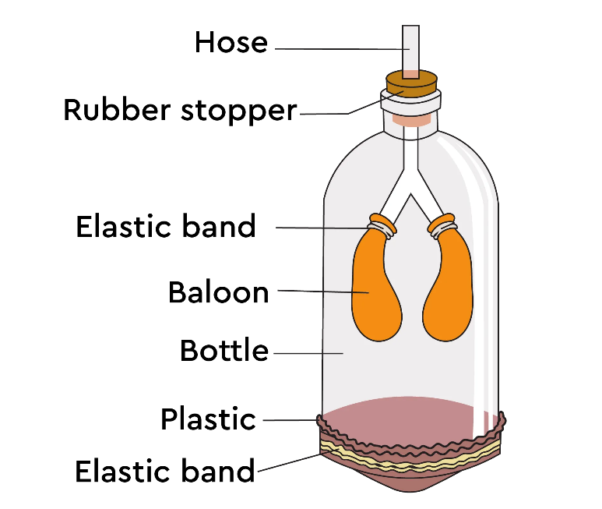
Fig 2
Model of the respiratory system
- On the model:
  - The hose connector represents the trachea, which branches into two bronchi like the trachea branches into two bronchi.
  - The two balloons represent the lungs.
  - The plastic at the bottom represents the diaphragm.
  - Elastic bands make the setup air-tight.
Activity 2 Demonstrating breathing.
Breathing in
- Pull the plastic down.
- Observe what happens to the balloons.
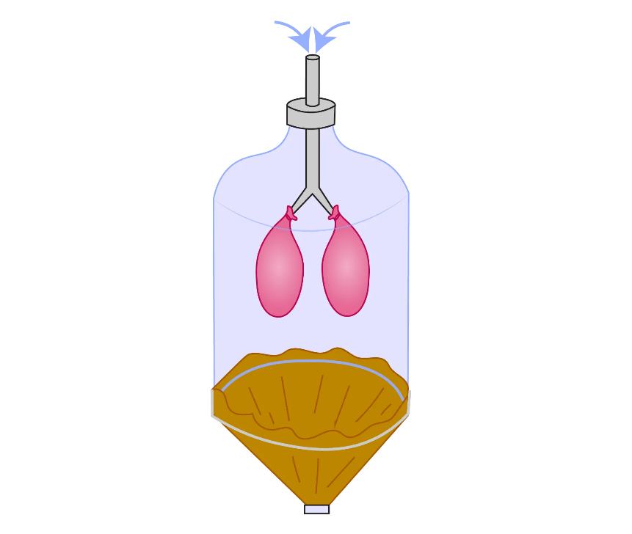
Fig 3
Breathing in
Breathing out
- Release the plastic.
- Observe what happens to the balloons.
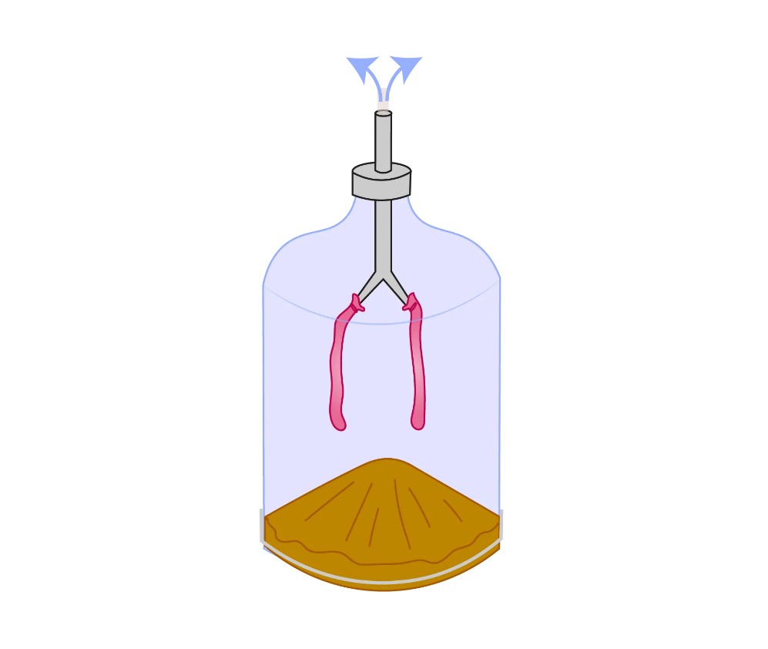
Fig 4
Breathing out
During breathing in:
- The diaphragm shortens (contracts) and moves downwards, and air enters the balloons (lungs).
- The balloons (lungs) are filled with air, and they swell.
During breathing out:
- The diaphragm relaxes and extends upwards, pushing the air out of the balloons (lungs).
- The balloons (lungs) shrink as the air moves out of them.

Respiratory Diseases
- There are several diseases that affect the respiratory system, including:
- Asthma:
  - A condition that causes the airways to become inflamed and narrowed, leading to difficulty in breathing.
- Chronic Obstructive Pulmonary Disease (COPD):
  - A progressive disease that makes it hard to breathe, often caused by long-term exposure to irritants like tobacco smoke.
- Pneumonia:
  - An infection that inflames the air sacs in one or both lungs, which may fill with fluid.
- Bronchitis
  - Inflammation of the airways, causing coughing and mucus production.
- Hay Fever
  - A condition that causes flue-like symptoms like sneezing and a running nose. It is often caused by allergic reactions.

Effects of Air Pollution on the Respiratory System
- Air pollution can have detrimental effects on respiratory health, including:
  - Increased Risk of Diseases: Exposure to pollutants can worsen conditions like asthma and lead to the development of chronic diseases.
  - Reduced Lung Function: Polluted air can impair lung development in children and reduce lung capacity in adults.
  - Increased Respiratory Infections: Poor air quality can make individuals more susceptible to infections such as bronchitis and pneumonia.
  - Increased Allergic Reactions: Air pollution can heighten the effect of allergens and therefore increase allergic reactions such as Rhinitis.
  - Lung Cancer: Exposure to certain air pollutants, such as particulate matter and diesel exhaust, has been linked to an increased risk of lung cancer.

