1. CloudFormation output

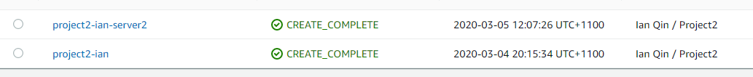

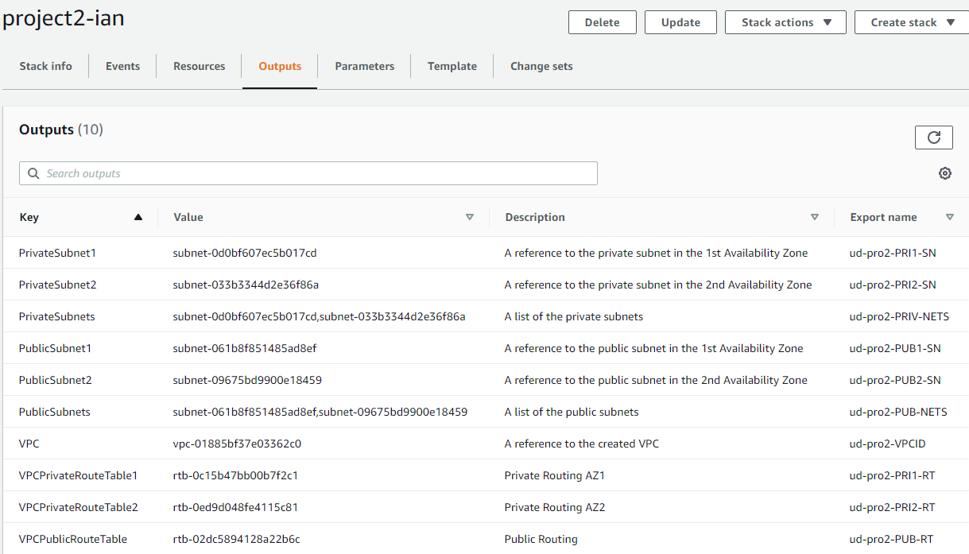

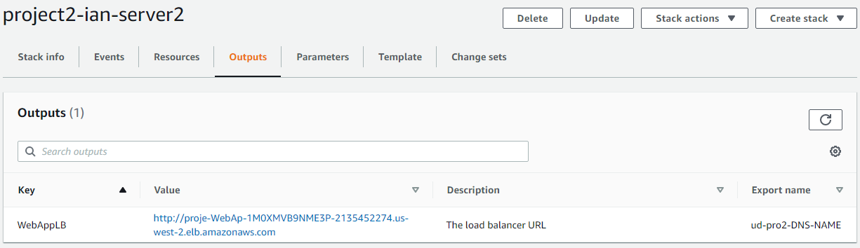

[http://proje-WebAp-1M0XMVB9NME3P-2135452274.us-west-2.elb.amazonaws.com](http://proje-webap-1m0xmvb9nme3p-2135452274.us-west-2.elb.amazonaws.com/)

Having 502 bad gateway error but cannot see anything wrong with my configuration.

1. IAM role in place

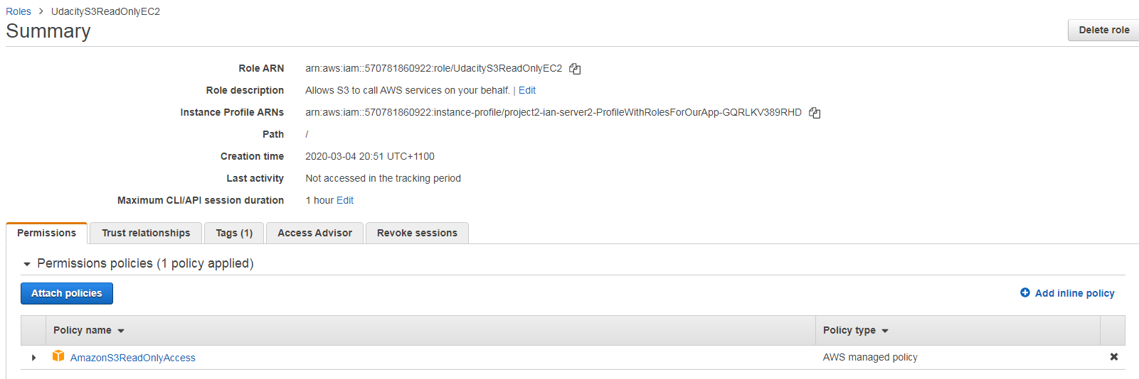

1. S3 bucket in place.

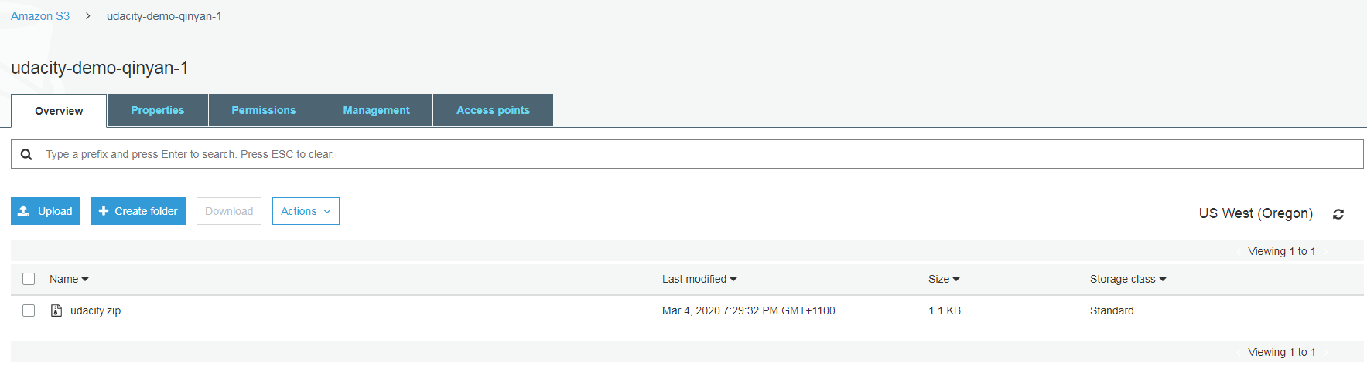

1. EC2 load balance and listener

