1D

Sequential reference code

for (unsigned int i = 0; i < arrayWidth; ++i) {

outputC[i] = inputScalar[0] * inputA[i] + inputB[i];

}

Output result verification

unsigned int size = width * height;

for (unsigned int k = 0; k < size; ++k)

{

if (resultPtr[k] != inputScalar[0] * inputA[k] + inputB[k])

{

LogError("Verification failed at %d: (%f * %f + %f = %f)\n", k, inputScalar[0], inputA[k], inputB[k], resultPtr[k]);

result = false;

}

}

2D

Sequential reference code and output result verification by comparing sequential result with kernel result

for (unsigned int i = 0; i < width; ++i) { // widthA

for (unsigned int j = 0; j < height; ++j) { // heightX

cl_float sum = 0; // AX

for (unsigned int k = 0; k < height; ++k) { // heightA

sum += inputA[i * height + k] * inputX[k * width + j];

//LogInfo("i j k= %d %d %d, inputA=%f, inputX=%f, sum = %f\n", i, j, k, inputA[i * height + k], inputX[k * width + j], sum);

}

if (resultPtr[i * height + j] != sum + inputY[i * height + j])

{

LogError("Verification failed at %d %d, resultPtr=%f, sum=%f, inputY=%f\n", i, j, resultPtr[i * height + j], sum, inputY[i * height + j]);

result = false;

}

}

}

Performance table (average over 100 runs if not specified)

|  |  |  |
| --- | --- | --- |
|  | 1D | 2D |
| Kernel | 0.320283 ms | 1316.753296 ms |
| Sequential | 0.020057 ms | 191214.00 ms (average over 15 runs) |

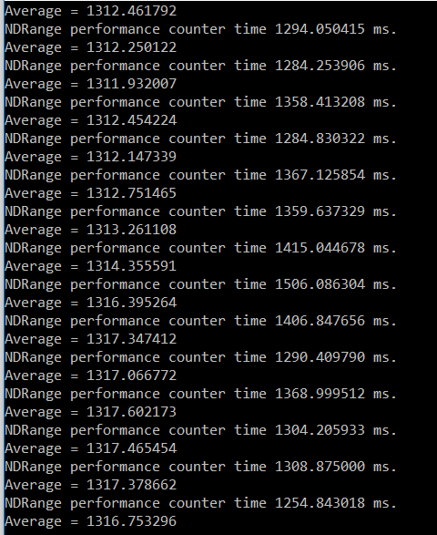

Figure A – Average over 100 runs using kernel. (2D)

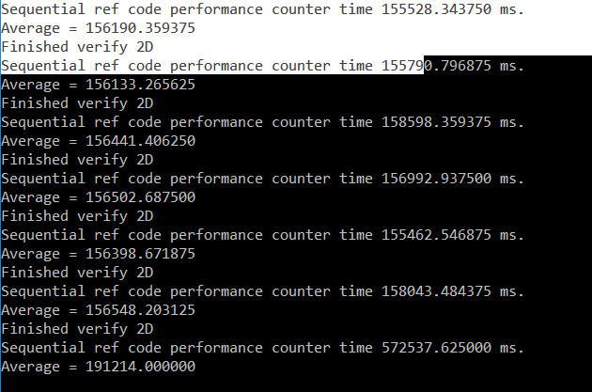

Figure B – Average over 15 runs using sequential (2D)

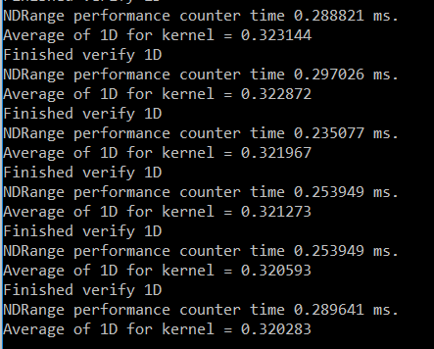

Figure C – Average over 100 runs using kernel (1D)

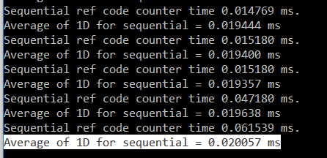

Figure D – Average over 100 runs using sequential (1D)