Win’ 17 EE 590B:

Raspberry Pi 3 Smart Door

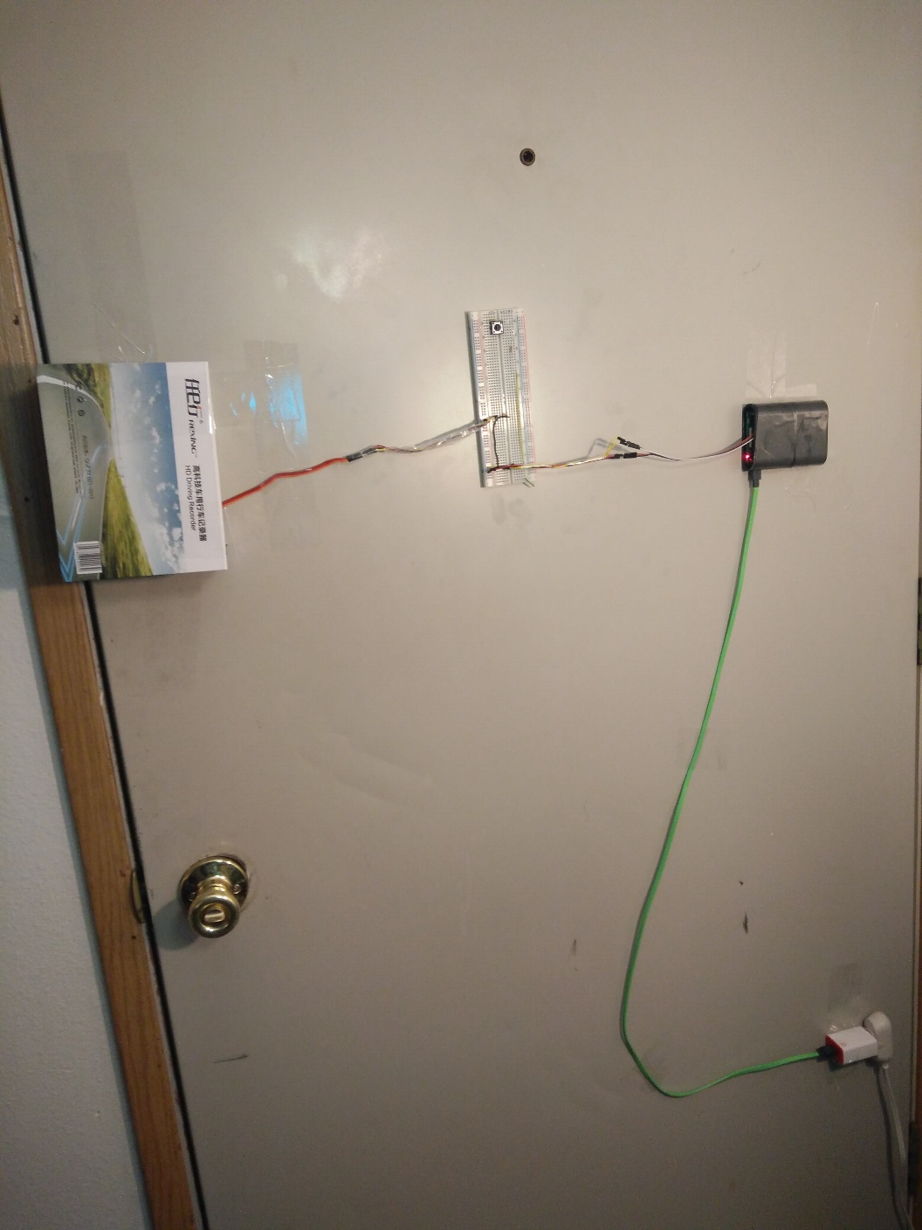

Quincy Wu  
University of Washington  
3/13/17  
Quincywu@live.com

# Summary

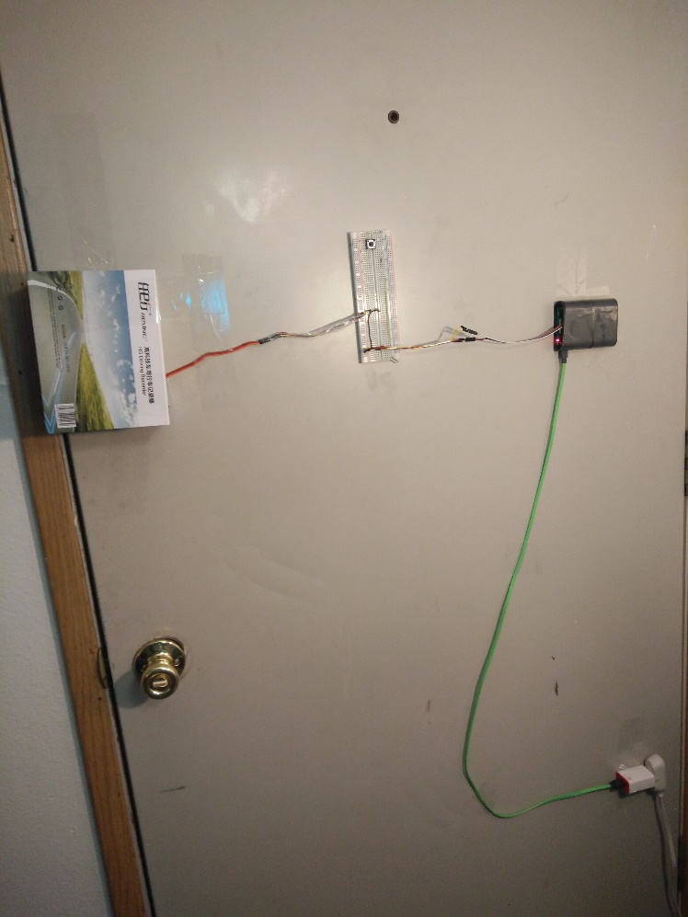This is a project for EE 590, winter’17. In this class, we used raspberry pi to build our own project. I chose to build a smart phone enable electric door lock with raspberry pi. Both Android and IPhone are compatible with this project. The door lock can be control with either the physical button or via smart phone app. The project was successful, and result in shown in this report.

# Contents

Executive Summary 1

Contents 2

Head 1 3

Head 1 3

# Problems / Motivation

This project was aimed to tackle the real life problems for me. I had trouble remembering whether I locked the door when I step out of my apartment, and this was main motivation for the project. On the side note, I am very lazy to stand up to open the door to my guest, once I sat down and focus on my work. I also wanted to give up virtual “keys” to my guest and allow them to open my door without giving them actual keys and my appearance. I also wanted to log the user who enter my apartment, and enable and disable different keys for accessing my apartment.

# Design

I originally designed the build a web server on a raspberry pi, and interact with smart phone. However, my apartment does not have a dedicated IP address, and a 3rd party open source web server was used.

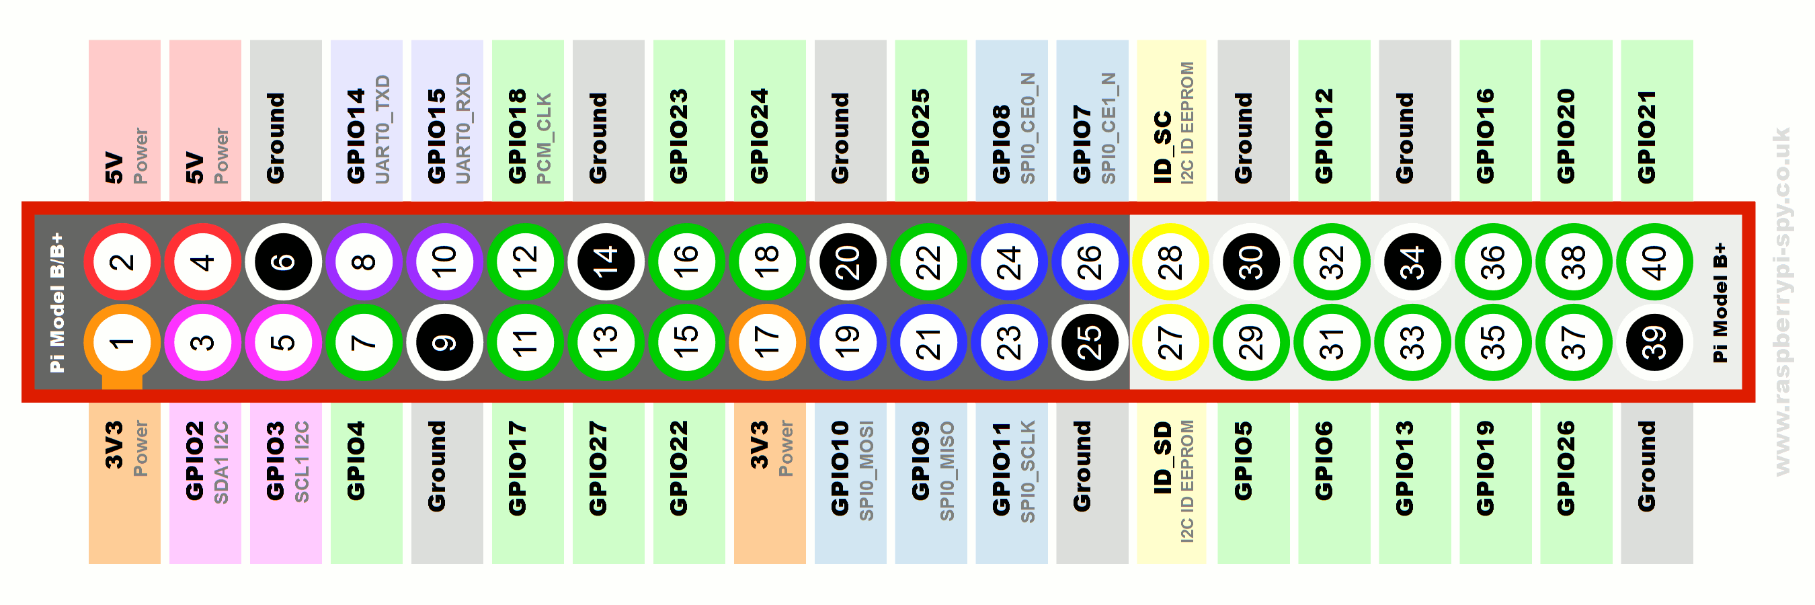

# Head 1

You can insert pictures. You can also use charts created in Microsoft Excel.

Add a caption here

You can use SmartArt to help make your point.

Add a caption here

gcc -D defines a macro to be used by the preprocessor.

http://www.rapidtables.com/code/linux/gcc/gcc-d.htm