Getting start with Raspberry pi 3

# Objective

Set up raspberry pi 3 with Raspbian as the Linux operating system.

# Tasks

* Set up SD card

Go to Raspberry pi official website and follow the list of instruction to download and set up the most current version of noobs. Flash the operating system into raspberry pi, and wait for set up to complete

* Update and upgrade system

Using command ‘sudo apt-get update’, and ‘sudo apt-get dist-upgrade’

* Change hostname

Use command to edit the file to change hostname ‘sudo nano /etc/hostname’, ‘sudo nano /etc/hostname’. Reboot device to activate changes.

* Set up Wi-Fi or Ethernet as communication tool

Using GUI to set up Wi-Fi. (Can also use console and change the raspi-config file)

* Set static IP address

Use command ‘sudo nano /etc/dhcpcd.conf’ to edit file for static ip address

* Set up host computer to communicate with pi

Use IP address above to SSH into pi.

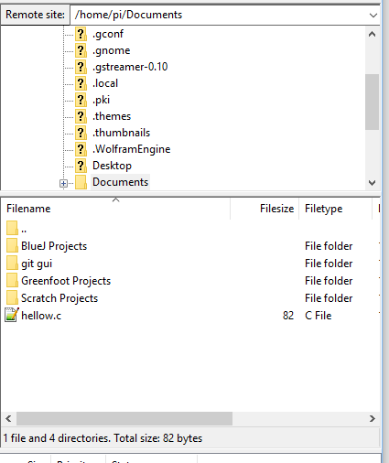

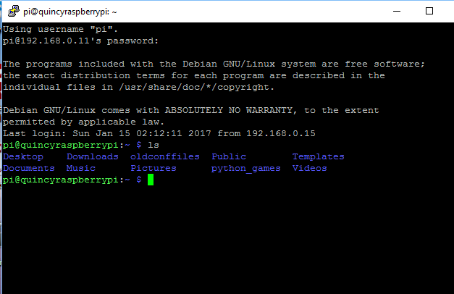

(successfully use host computer to communicate with pi)

* Turn pi into headless device

Desktop GUI has option under Raspberry pi option to change booting option

# Useful instructions / important Linux command

- sudo halt (halt the Linux system before unplug power)

- sudo startx (restart)

- sudo reboot

- sudo raspi −config (use this to turn into headless embedded device)

- sudo apt-get clean

- df -h (checking enough disk space free)

- dmesg | more (all the devices available on the target hardware)

- sudo nano / etc /hostname (change hostname)

sudo nano / etc /hostname (reboot to activate)

- ifconfig (get the ip address and ssh into pi)

- setting static ip address

- sudo nano /etc/dhcpcd.conf

interface eth0

static ip_address=192.168.0.10/24

static routers=192.168.0.1

static domain_name_servers=192.168.0.1

interface wlan0

static ip_address=192.168.0.200/24

static routers=192.168.0.1

static domain_name_servers=192.168.0.1

# Conclusion

It was fairly easy to get start with raspberry pi 3. Basically I followed all the steps on the raspberry pi official website to set up the device. Since I got a 64 Gb SD card as a storage device, and the pi was not compatible. I had to format the SD card to FAT32 in order for this SD card to work. Noobs was very easy plug and play, and many useful application is already installed in it, including gcc, and git. I can start prototyping on raspberry pi if I wanted to. Github is also installed on the pi, to source control the project.

# Reference

<https://www.cyberciti.biz/faq/how-do-i-find-out-screen-resolution-of-my-linux-desktop/>

<https://www.modmypi.com/blog/how-to-give-your-raspberry-pi-a-static-ip-address-update>