Assessment_3_Database2

Quinlan Hurt

1.

Connection to the database

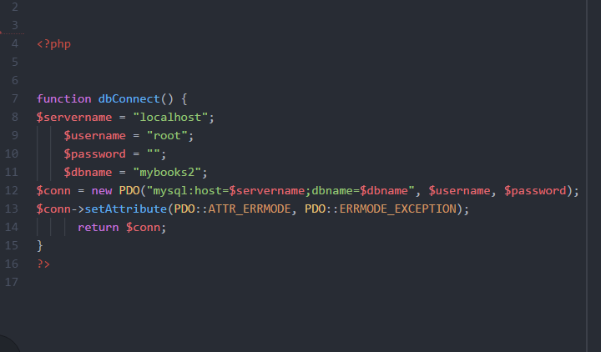

2.

Password_hash() utilisation

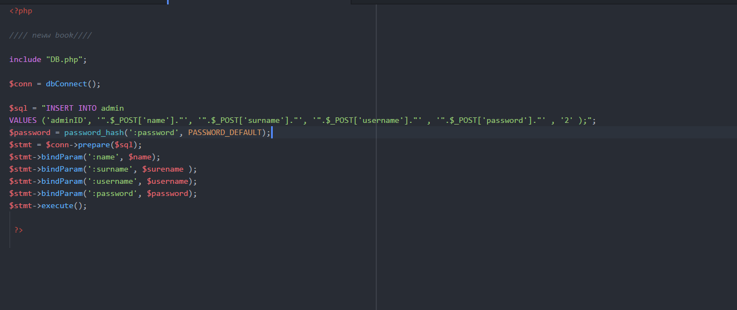

3.

Data input sanitation

Insert query statement/s

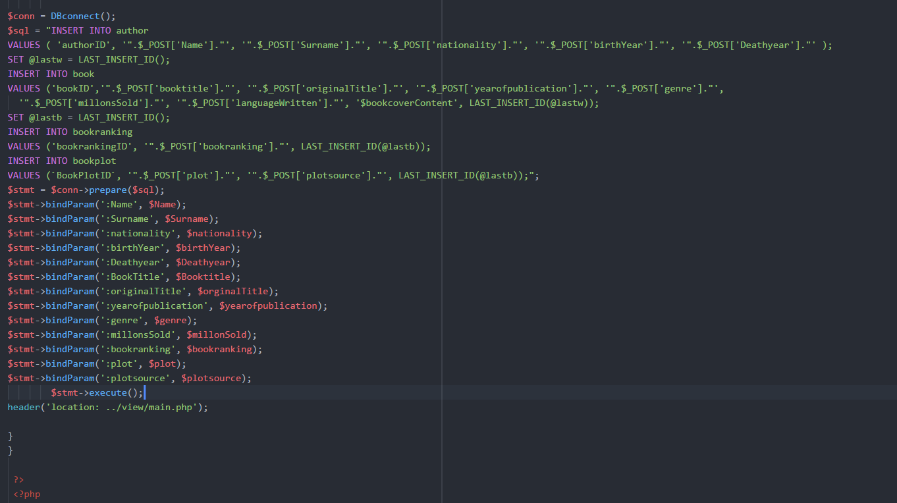

5.

Update query statement/s

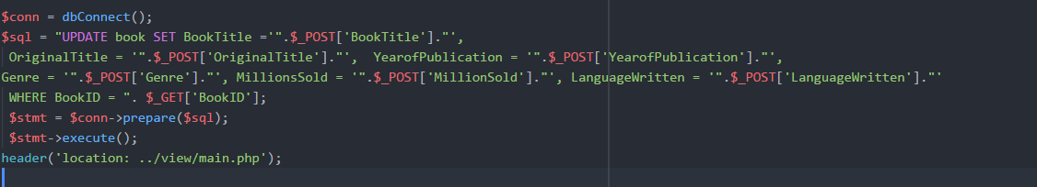

6.

Delete query statement/s

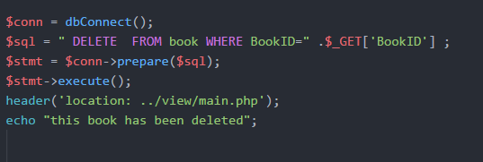

7.

Session code (create, destroy and redirect)

