E-Business

Contents

PART A - PLANNING 3

Details of name and address, web address (URL), social media sites 3

List of products/services to be sold or gifted on the e-commerce site 3

Current status of how they conduct business 3

PART B – GOALS 4

The reasons why the business wants go the e-commerce route 4

Provide a vision statement or describe their long-term goals 4

Mission statement or a paragraph describing their core values and purpose 4

` Describe their Unique Selling Proposition (USP) 5

**PART C - RESEARCH** 5

Describe industry sector, including key figures on sales, spending and growth 5

Statistically describe where the business and its product/services fit in 5

What is the target market and/or segments in a pie chart? 6

Comparison of the ten key criteria between your business and three of your competitors 6

**PART D - PLANNING** 7

SWOT analysis with details including how the business can take advantage of the opportunities and plan to counter threats 7

Value chain diagram which includes a finished value chain map of business and its relationships 7

Comparison chart listing essential criteria that must be met by chosen platform including terms and conditions, fees applicable 8

Results of the analysis and product comparison that proposes which model and platform you will use and why 9

Technical S.W.O.T. analysis for implementing the e-commerce site regarding technical aspects 9

Implementation flowchart showing the handover and project implementation workflow 9

# PART A - PLANNING

## Details of name and address, web address (URL), social media sites

The project website is called Learn to Learn

The URL is [learntolearn.quinlanhurt.com](http://www.quinlanhurt.com/learntolearn)

It has its own Facebook page: <https://www.facebook.com/Learn-to-Learn-653106241705843>

The headquarters of Learn to Learn will be in busses CBD and they can 55 stan street

## List of products/services to be sold or gifted on the e-commerce site

Learn to Learn provides an online learning service with an assignment feature added to it and will not be selling anything on an e-commerce site.

The way Learn to Learn will make money is by having by charge user a monthly fee of $25 to all student so they can use their services site. This will provide for the system requirements of the site

My some of my classes include

* High school maths B
* Maths for kids
* Web site development
* Junior and senior physics
* Chemistry in the human body
* Robotics building and programming

## Current status of how they conduct business

[admin@learntolearn.com](mailto:admin@learntolearn.com)

people can call 5555-555-555 24/7 for all support

there is a contact form on the site which anonymous and register user can uses and ask for help.

# PART B – GOALS

# The reasons why the business wants go the e-commerce route

An E-commerce or (electronic commerce) is the buying and selling of goods and services, or the transmit of payment an serveries, over an electronic network, primarily the internet. These can be done in several ways, a business to business, business to a consumer, a consumer to business

Learn to Learn is an online learning tool that does not have any products to sell so there will be no need to have an e-commerce shop like Shopify and BIG-Commerce but will still have monthly payment subscription to pay for it services.

The way Learn to Learn will make money is by having to charge user a monthly fee to all student so they can use their services site. This will provide for the system requirements of the site.

## Provide a vision statement or describe their long-term goals

If the beta testing of Learn to Learn takes off, Learn to Learn will want to start some long term goals of adding a payment gateway system and add video tutorial and testing and start hiring professionals for teaching the classes.

Learn to Learn wants to change and escape the normal learning concept and start a new era in learning and we want to become a household name. We want us to become a new alternative to school leavers and become a new resource in the learning system.

## Mission statement or a paragraph describing their core values and purpose

-

The mission of Learn to Learn is to provide an online learning experience with assignment features built in.

In the next six months we want to add more classes with a testing feature and have create better contact support. We want to eventually start expanding in to New Zealand and than rest of the world and become a household name.

Learn to Lean will provide a new learning sever that can provide in many different learning ways some of the many class that will take place are math ,human biology , business skill, simple and complex web development skills and many more, this is our mission.

## ` Describe their Unique Selling Proposition (USP)

Learn to Learn is to provide an online learning experience with assignment features built in.

The problem with normal learning styles is that they require people to go in to a learning centre and pay thousands of dollars to a attend. Learn to Learn wants to solve this problem, Learn to Learn is 100% online so people do not have leave the house and people can have more options to do what they want and how they learn.

Learn to Learn wants to achieve an online learning experience that will replace the conventional learning systems. Learn to Learn will have many subject’s the user can choose from and unlike other e-learn business it will have assignment features built into it.

# **PART C - RESEARCH**

## Describe industry sector, including key figures on sales, spending and growth

Learn to Learn falls under the E-learning or the (Education technology) industry and it will come under

private sector not tied to the government.

E-learn is a very new industry but is growing very fast ‘it stated in on article in Dallas,

United States – on June 15, 2017 — (According to ‘Stratistics MRC’, the [Global E-Learning Market](http://www.orbisresearch.com/reports/index/e-learning-global-market-outlook-2016-2022) is

accounted for $165.21 billion in 2015 and is expected to reach $275.10 billion by 2022.)

E-learn sector gives fixability of learning to use at a low coast. One of the many reason e-learn is so

popular is they have a wide range of learn recourse you can chose from for example instead of going to

class to learn a wide range of knowledge, you can learn one new skill instead of learn a range of

knowledge that you do not need or want. All E-learn are very flexible in learn time people can learn at

any time or place with an internet connection.

## Statistically describe where the business and its product/services fit in

Learn to Learn is open source learning centre that will provide a new learning server that can provide in

many different learning ways, some of the many class that will take place are math ,human biology ,

business skill, simple and complex web development skills and many more.

# What is the target market and/or segments in a pie chart?

# 

The target market for Learn to Learn has a large target market for kids that want learn simple maths and

spelling to elderly people that want learn new skills. But the main target market is are people who are

in their mid-twenty to middle age people, all genders, in middle class range people who are looking to

improve their Knowledge.

## Comparison of the ten key criteria between your business and three of your competitors

There are many companies in the E-learn sector from small learning that have an online website e.g

urbane e-learn to massive company the function all around the world E.g. Udemy and even government

use e-learn for one line for online course like e-learn Sydney and Connect.

1. customisable, mobile views
2. custom CSS editing
3. file storage
4. site-specific passwords
5. access levels
6. payment processing
7. stock library integration
8. responsive features
9. data entry forms
10. new technologies

most e-learn have the same premise of freedom of learning when and where they want to and Learn to

Learn is very similar to most E-learn systems it gives use the freedom to learn what they want and

when they want.

# **PART D - PLANNING**

## SWOT analysis with details including how the business can take advantage of the opportunities and plan to counter threats

A SWOT analysis is a good way to observe where your business compares to your opposition and how

you can improve your business.

|  |  |
| --- | --- |
| Strengths   * People learn in their own time * Have a cheap price * Has room to grow | Weakness   * there no money for payments. * Need to hire staff * Out dated design |
| Opportunities   * Can easily add new technologies * can add smaller learn business to it * we can provide for different learning types | Threats   * People can go to an educational place like Uni or Tafe to learn * Not well known * New competitors emergency * No money to back up the site |

## Value chain diagram which includes a finished value chain map of business and its relationships

A value chain is a set of activities that a firm operating in a specific industry performs in order

to deliver a valuable product or service for the market.

The value chain of Learn to Learn begins with admin creating class teachers to start creating lessons

and assignments then we need students to sign up for class and pay a monthly fee which will pay the for

more admin and teachers starting the chain again.

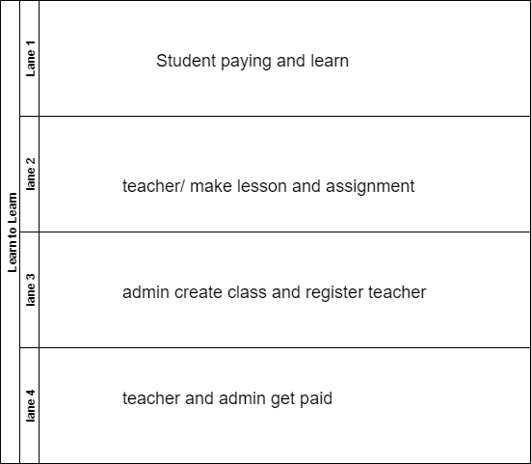

## Comparison chart listing essential criteria that must be met by chosen platform including terms and conditions, fees applicable

There will be many terms and conditions of the site and if user could be suspended from the site and will not be able to access there account.

Terms and conditions

1. No inappropriate language.
2. No inappropriate pictures.
3. Do not use site for bullying or harassment.
4. Pay your monthly fee.
5. Do not use site for sharing copyrighted content.
6. No bribe teacher for passing.

The Learn to Learn testing phase will be free and if the testing works out it be they will add payment

gateway that will charge all students use a $25 month per class they choose, they can take and

choose any class they want to when they want to.

## Results of the analysis and product comparison that proposes which model and platform you will use and why

Comparing my business model to other business. I found there are two kinds of business in the e-learn

Sector, there are the ones tied to education system like Tafe or Uni and there are ones that are

privately owned. My business falls under the privately-owned side.

Most private places have the same business model of the freedom to learn what you want to and when

you want to learn and where you want to learn. My business is no different I want to achieve an on line

services that provides the same that all e-businesses want to do which is a freedom of learning.

My business wants to go a step further than this and wants to cater to all types of learning and not just

watching videos or reading a 100-page document and then have a test that just testes your memory, me

business will fix this by have both at the videos that will teach staff you will need to know and a step

by step instruction explaining how to achieve your new skill and a big file you can use and read on the

go.

## Technical S.W.O.T. analysis for implementing the e-commerce site regarding technical aspects

Learn to Learn is an online learning tool that does not have any products to sell so there will be no need to have an e-commerce shop.

|  |  |
| --- | --- |
|  |  |
| STRENGTH | WEAKNESSES |
| Large customer base  Successful marketing strategies  Detailed customer service  Excellent inventory records | Cash flow problems  High staff turnover  charter Variable stock supply  poor record |
| OPPORTUNITIES | THREATS |
| Customers asking for online option  Cost-effective marketing support  Contacts in web design agency rises Professional photos of stock | Unpredictable supplier  Large, established competitor  Supply prices and import tax  Import/export legislation changes |

## Implementation flowchart showing the handover and project implementation workflow

A work workflow flowchart is a type of diagram that represents an algorithm, workflow or process.

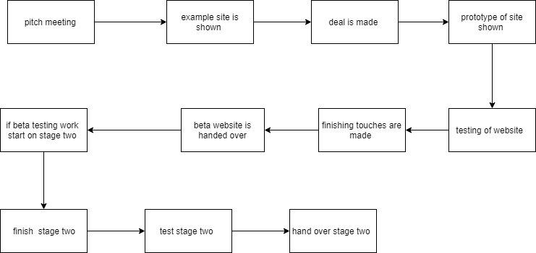

# Bibliography

<https://www.reuters.com/brandfeatures/venture-capital/article?id=11353>

date access 25/05/18

<https://faculty.londondeanery.ac.uk/e-learning/e-learning-in-clinical-teaching-1/what-is-e-learning>

date access 05/06/18