# PART A - PLANNING

## Details of name and address, web address (URL), social media sites

The project website is called Learn to Learn

The URL is [www.quinlanhurt.com/learntolearn](http://www.quinlanhurt.com/learntolearn)

It has it own Facebook page: <https://www.facebook.com/Learn-to-Learn-653106241705843>

## List of products/services to be sold or gifted on the e-commerce site

Learn to learn provides an online learning service with an assignment feature added to it and will not be selling anything on an e-commerce site.

## Current status of how they conduct business

admin@learntolearn.com

# PART B – GOALS

# the reasons why the business wants go the e-commerce route

Learn to Learn is an online learning tool that does not have any products to sell so there will be no need to have an e-commerce shop.

## Provide a vision statement or describe their long-term goals

If the beta testing of learn to learn takes off, Learn to Learn will want to start some long to term goals of adding a payment or add system and add video tutorial and test and start hiring professional for teaching tea classes.

## Mission statement or a paragraph describing their core values and purpose

The mission of Learn to Learn is to provide an online learning experience with assignment feature built in.

## ` Describe their Unique Selling Proposition (USP)

Learn has many subject’s user can choose from and unlike other it will have assignment feature with it.

# **PART C - RESEARCH**

## Describe industry sector, including key figures on sales, spending and growth

Learn to learn fall under the E-learning (Education technology) industry and in a private sector not tie to the government.

Dallas, United States – June 15, 2017 —

(According to ‘Stratistics MRC’, the [Global E-Learning Market](http://www.orbisresearch.com/reports/index/e-learning-global-market-outlook-2016-2022) is accounted for $165.21 billion in 2015 and is expected to reach $275.10 billion by 2022.)

<https://www.reuters.com/brandfeatures/venture-capital/article?id=11353>

## Statistically describe where the business and its product/services fit in

Learn to Learn is open source learning centre it fit in as small online as a E-learning. It will struggle to take off with out and review to pay for adds.

# What is the target market and/or segments in a pie chart?

# 

The target market for Learn to Learn is are people who are in there mid twenty to middle age people

All genders, meddle class people who are looking to improve their Knowledge.

## Comparison of the ten key criteria between your business and three of your competitors

e-learn Sydney

Udemy

urban e-learn

1. customisable, mobile views
2. custom CSS editing
3. file storage
4. site-specific passwords
5. access levels
6. payment processing
7. stock library integration
8. responsive features
9. data entry forms
10. data entry forms

# **PART D - PLANNING**

## SWOT analysis with details including how the business can take advantage of the opportunities and plan to counter threats

|  |  |
| --- | --- |
| Strengths   * People learn in their own time * Have a cheap price * Has room to grow | Weakness   * there no money for payments. * Need to hire staff * Out dated design |
| Opportunities   * Can easily add new technologies * can add smaller learn business to it | Threats   * People can go to an educational place like Uni or Tafe to learn * Not well known * New competitors emergency |

## Value chain diagram which includes a finished value chain map of business and its relationships

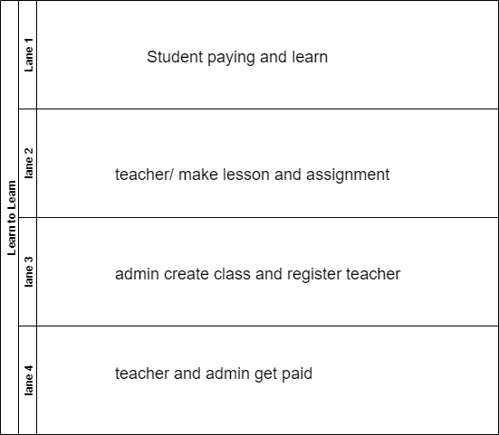

## Comparison chart listing essential criteria that must be met by chosen platform including terms and conditions, fees applicable

Terms and conditions

1. No inappropriate language.
2. No inappropriate pictures.
3. Do not use site for bullying or harassment.
4. Pay your monthly fee.
5. Do not use site for sharing copyrighted content.
6. No bribe teacher for passing.
7. If the term and conditions are not met the user will be suspended.

The learn to learn batá testing will be free and if the batá test work will a payment gateway will be added the site and it will be $20 a month

## Technical S.W.O.T. analysis for implementing the e-commerce site regarding technical aspects

Learn to Learn is an online learning tool that does not have any products to sell so there will be no need to have an e-commerce shop.

**But hear is one any way**

|  |  |
| --- | --- |
|  |  |
| STRENGTH | WEAKNESSES |
| Large customer base  Successful marketing strategies  Detailed customer service  Excellent inventory records | Cash flow problems  High staff turnover  charter Variable stock supply  poor record |
| OPPORTUNITIES | THREATS |
| Customers asking for online option  Cost-effective marketing support  Contacts in web design agency rises Professional photos of stock | Unpredictable supplier  Large, established competitor  Supply prices and import tax  Import/export legislation changes |

## Implementation flowchart showing the handover and project implementation workflow

