Procedure
This week was fairly simple. We cut 5 lengths of string and used them as cables for a pendulum. At the end of each length of string we attached a bob, and we did this twice; once for a wooden bob, once for a brass bob. The point was to compare the calculated frequency with the observed frequency. We timed how long it took for each pendulum to swing side to side 10 times, and divided that time by 10 to get the average time per swing. The average time per swing is matched by the formula T = 2 pi sqrt(L / 980), which you can use to predict average time per swing.

Data
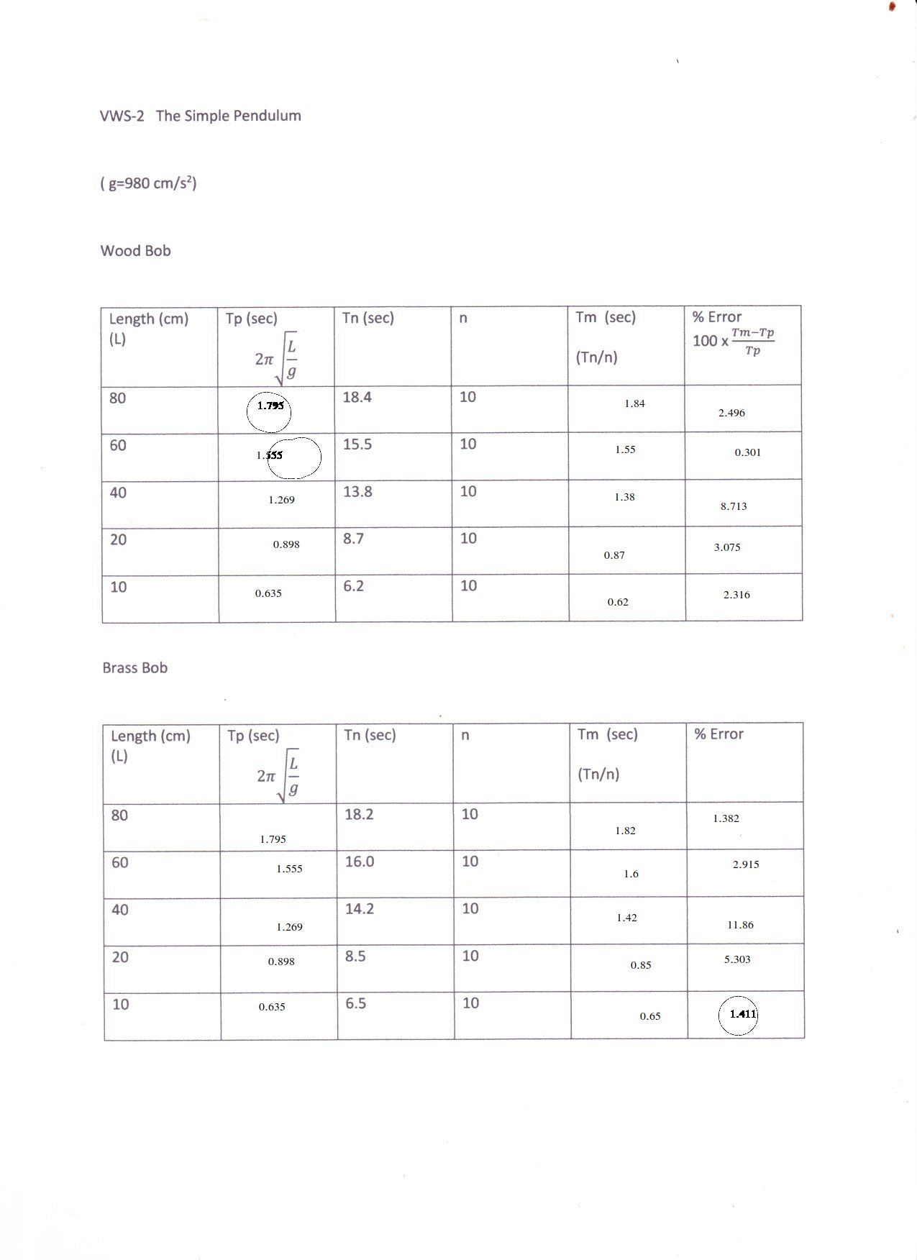
Calculations
>>> Tp = lambda L: 2 * pi * sqrt(L / 980)
>>> [Tp(x) for x in (10, 20, 40, 60, 80)]
[0.6346975625940523, 0.8975979010256552, 1.2693951251881046, 1.5546851693436152, 1.7951958020513104]
>>> Tps = [Tp(x) for x in (10, 20, 40, 60, 80)]
>>> Tms = [tn / 10 for tn in (6.2, 8.7, 13.8, 15.5, 18.4)]
>>> Tms
[0.62, 0.8699999999999999, 1.3800000000000001, 1.55, 1.8399999999999999]
>>> [100 * abs((tm - tp) / tp) for tm, tp in zip(Tms, Tps)]
[2.315679696953989, 3.0746396570357497, 8.71319517597057, 0.3013580778925967, 2.4957833511805925]
>>> Tms_brass = [tm / 10 for tm in (6.5, 8.5, 14.2, 16, 18.2)]
>>> [100 * abs((tm - tp) / tp) for tm, tp in zip(Tms_brass, Tps)]
[2.4109809628708225, 5.302808860322274, 11.864302282520427, 2.914727145401193, 1.381698749537324]

Analysis & Conclusion
I was surprised that mass of bob was not in the formula for frequency! Sure enough, our measured Tn values for each bob were not significantly different even though I’m sure the brass bob was heavier. In conclusion, we should be able to predict that the frequency with the brass bob is negligibly different from the frequency with the wooden bob from the lack of mass in the formula.

What is the length of a pendulum that has a period of 0.5 s?
Start with 1/2 = 2 pi sqrt(L / 980) and solve for L, yielding 980 / 2^2 / 4 / pi^2 = 6.206 centimeters.

Is there any difference between the period of oscillation of a wooden bob and a brass bob for a given length? Why?
There is negligible difference between the period of oscillation of a wooden bob and a brass bob for a given length because the restoring force of -mg sin(theta) is balanced out on one side of the equilibrium by it’s own opposite on the other side of equilibrium.

