1. ***What is Boolean? Write down 3 different expression that results a Boolean type (i.e. 5 == 6)***

* In general, boolean value is either true or false. And in Python, the two Boolean values are **True** and **False**.
* 3 different expressions:
  + 1 <= 8
  + 4 == (5 + 4)
  + “hi” != “hello”

1. ***What is a flow chart? Draw flow chart for the following code snippet: (you can draw on a paper, take a picture of it)***

* In programming, flowchart is a diagram which uses a set of standard graphic symbols to represent the sequence of coded instructions fed into a computer, enabling it to perform specified logical and arithmetical operations.
* 4 basic symbols:
  + **Start** event symbol signals the first step of a process.
  + **Process** is a series of actions or steps taken in order to achieve a particular end.
  + **Decision** is the action or process of deciding something or of resolving a question.
  + **End**event symbol stands for the result of a process.
* **Draw:**

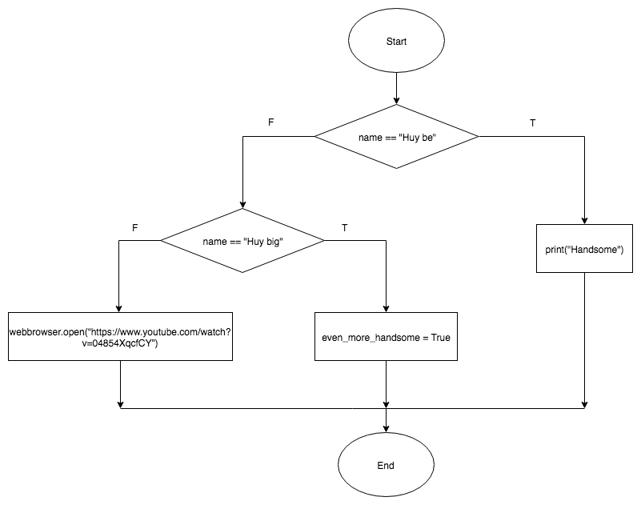

1. ***What is nested conditionals? Write a piece of code that uses nested conditionals***

* Nested conditional is a conditional inside a branch of another conditional.
* **Example:**

if a % 4 == 0:

print(“a is divisible by 4”)

else:

if a % 2 == 0:

print(“a is not divisible by 4, but a is still an even number”)

else:

print(“a is an odd number”)