姓名：蔡佩津

学号：78066011

**第三作业**

1.答：综合统一，高度非过程化，面向集合的操作方式，语言简洁，易学易用，已同一语法结构提供两种使用方式（自含式，嵌入式）。

3.答：(1)SELECT * FROM S WHERE A=10

(2)SELECT DISTINCT A,B FROM S

(3)SELECT A,B,S.C,S.D,E,F FROM S,T WHERE S.C=T.C AND S.D=T.D

(4)SELECT A,B,S.C,S.D,T.C,T.D,E,F FROM S,T WHERE S.C=T.C

(5)SELECT A,B,S.C,S.D,T.C,T.D,E,F FROM S,T WHERE A<E

(6)SELECT S1.C,S1.D,T.C,T.D,E,F FROM T,(select DISTINCT C,D FROM S) AS S1

4.答：**建S表：**

S（SNO,SNAME,STATUS,CITY）;

CREATE TABLE S

(SNO CHAR(3), SNAME CHAR(10),STATUS CHAR(2),CITY CHAR(10));

**建P表：**

P（PNO,PNAME,COLOR,WEIGHT）;

CREATE TABLE P

(PNO CHAR(3), PNAME CHAR(10),COLOR CHAR(4),WEIGHT INT);

**建J表：**

J（JNO,JNAME,CITY）;

CREATE TABLE J

(JNO CHAR(3), JNAME CHAR(10),CITY CHAR(10));

**建SPJ表：**

SPJ（SNO,PNO,JNO,QTY）;

CREATE TABLE SPJ

(SNO CHAR(3), PNO CHAR(3),JNO CHAR(3),QTY INT);

5.答：(1)SELECT SNAME,CITY //pg 36

FROM S

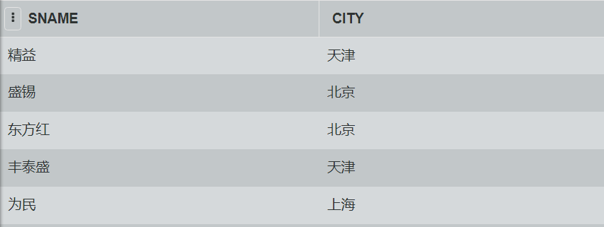

(2)SELECT PNAME,COLOR,WEIGHT

FROM P

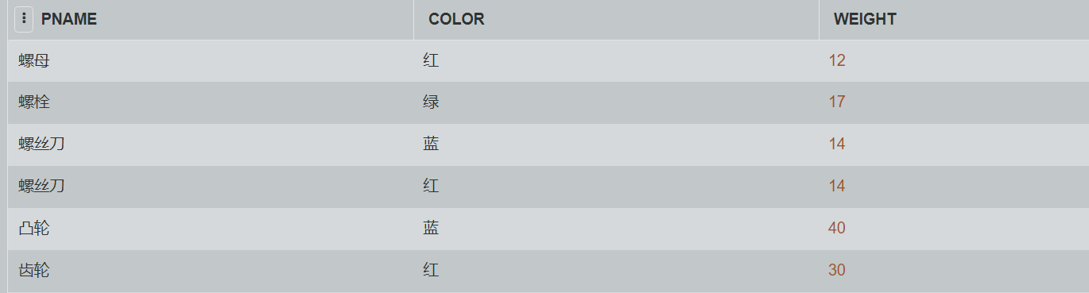

(3)SELECT JNO

FROM SPJ

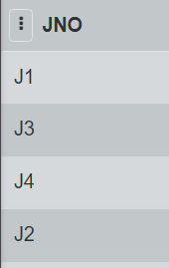 WHERE SNO=’S1’;

(4)SELECT P.PNAME,SPJ.QTY

FROM P,SPJ

WHERE P.PNO=SPJ.PNO

AND SPJ.JNO=’J2’;

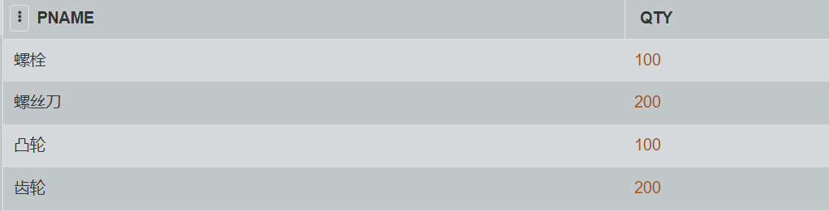

(5)SELECT DISTINCT PNO

FROM SPJ

WHERE SNO IN

(SELECT SNO

FROM S

WHERE CITY=’上海’)；

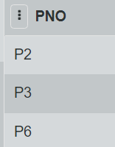

（6）SELECT JNAME

FROM J,SPJ,S

WHERE J.JNO=SPJ.JNO

AND SPJ.SNO=S.SNO

AND S.CITY=’上海’;

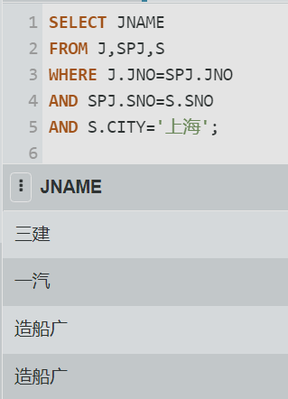

（7）SELECT JNO

FROM J

WHERE NOT EXISTS

(SELECT *

FROM SPJ

WHERE SPJ.JNO=J.JNO

AND SNO IN

(SELECT SNO

FROM S

WHERE CITY=’天津’))；

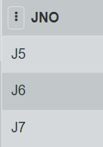

（8）UPDATE P

SET COLOR=’蓝’

WHERE COLOR=’红’；

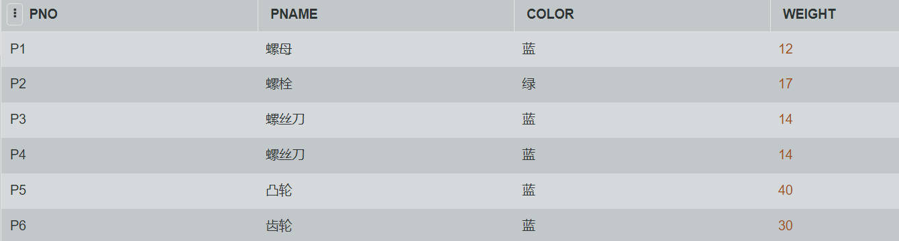

（9）UPDATE SPJ

SET SNO=’S3’

WHERE SNO=’S5’

AND JNO=’J4’

AND PNO=’P6’;

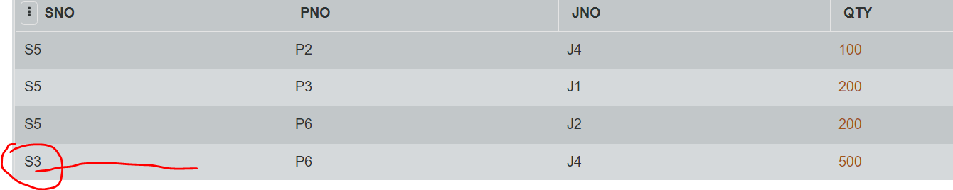

(10)DELETE

FROM SPJ

WHERE SNO=’S2’;

DELETE

FROM S

WHERE SNO=’S2’;

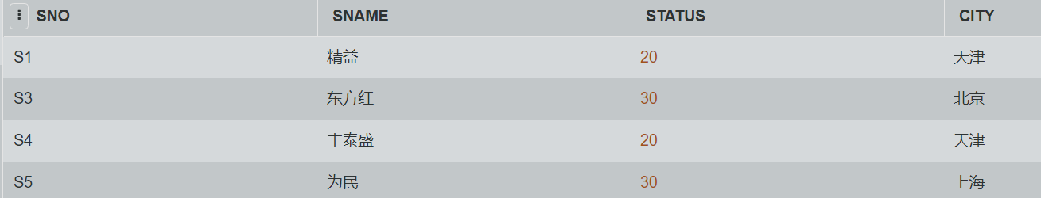

6.答：**基本表**式本身独立存在的表，在SQL中一个关系就对应一个基本表。

**视图**是从一个或几个基本表导出的表。

视图本身不存在独立存储在数据库中，是一个虚表。即数据库中只存放视图的定义而不存放视图对应的数据，这些数据仍然存放在导出视图的基本表中。视图在概念上基本与表等同。视图在概念上与基本表等同，用户可以在基本表那样使用视图，可以在视图上再定义视图。

9.答：创建视图：

1) CREATE VIEW V_SPJ AS

SELECT SNO,PNO,QTY

FROM SPJ

WHERE JNO=

(SELECT JNO FROM J WHERE JNAME=’三建’);

对该视图查询：

1. SELECT PNO,QTY

FROM V_SPJ;

2) SELECT PNO,QTY

FROM V_SPJ

WHERE SNO=’S1’;