*“Can a Neural Network write poetry? Leveraging next sentence prediction with Transformer GPT-2”*

*Research Computing Center Workshop — Summer 2020*

*Jeffrey Tharsen* [*tharsen@uchicago.edu*](mailto:tharsen@uchicago.edu)

***This Guide + source files and sample outputs for Blake and Shakespeare :***

[**https://github.com/rcc-uchicago/BERT-GPT2_tutorial_Summer2020**](https://github.com/rcc-uchicago/BERT-GPT2_tutorial_Summer2020)

*Materials from the previous workshop on BERT & GPT-2 :*

<https://github.com/rcc-uchicago/BERT-GPT2-Workshop>

1. (For those who haven’t seen this yet.)  
   “This Grad Student Used a Neural Network to Write His Papers” (GPT-2)   
   <https://futurism.com/grad-student-neural-network-write-papers>
2. **Why GPT-2? What can Trained Transformers achieve? (Encoder-Decoder stacks)**

<https://medium.com/huggingface/encoder-decoders-in-transformers-a-hybrid-pre-trained-architecture-for-seq2seq-af4d7bf14bb8>

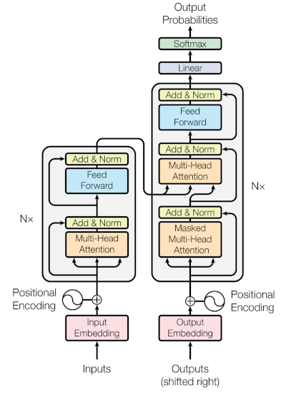

<https://openai.com/blog/better-language-models/>

*Original source for this tutorial:*

<https://medium.com/@ngwaifoong92/beginners-guide-to-retrain-gpt-2-117m-to-generate-custom-text-content-8bb5363d8b7f>

1. **Training GPT-2 on your Source Corpus and Producing NN-generated Text**

(With Tensorflow – we’ll be using Tf 1.13.1 for this tutorial.)

1. Get the GPT-2 framework – from the command line, do:  
   **git clone https://github.com/nshepperd/gpt-2.git**

*(Or go to this link, click on “Code” and download the zip file:*<https://github.com/nshepperd/gpt-2> *)*

1. cd gpt-2
2. Get the model files:

**python download_model.py 117M**

1. pip install fire==0.1.3 *(if using Midway, include the --user flag)*

pip install regex==2017.4.5

pip install requests==2.21.0

pip install tqdm==4.31.1

pip install toposort

AND

pip install tensorflow==1.13.1

*(*** this tutorial does not work with Tensorflow 1.14+ or 2.x ***)*

1. **Put your Source Text File in /gpt-2/src**

e.g. “blake_poems_gpt2.txt”

*I split the file into sections with “<|endoftext|>”.*

1. Copy the Python code into /src:

cp encode.py src

cp train.py src

cp -r models src

1. cd src

*If using Midway:*

sinteractive --partition=gpu2 --gres=gpu:1

module load Anaconda3/2018.12

source activate tf-gpu-1.13.1

1. python encode.py [source.txt] [output.npz]
2. python train.py --dataset [output.npz]

***It will display samples as it runs; let it run until your loss/avg is under 0.2 .***

Train.py will run until you hit Ctrl-C.

1. Set up the new model directory (I use “blake” here as the name):

mkdir models/blake

cd checkpoint/run1/* models/blake

cp model-9000* ../../models/blake

cp checkpoint ../../models/blake

cp models/117M/encoder.json models/blake

cp models/117M/hparams.json models/blake

cp models/117M/vocab.bpe models/blake

1. Now your model is ready to run:

python generate_unconditional_samples.py --model_name blake ( > outfile.txt )

*If you get a model error, edit the /blake/checkpoint file to match the model checkpoint number you wish to use.*

1. Or run (setting **temperature** and **top_k**) :

python generate_unconditional_samples.py --temperature 0.8 --top_k 40 --model_name blake

1. Finally, you can run interactively, supplying a prompt:

python interactive_conditional_samples.py --temperature 0.8 --top_k 40 --model_name blake