Test

1. Import the project DCNfinal into Eclipse.

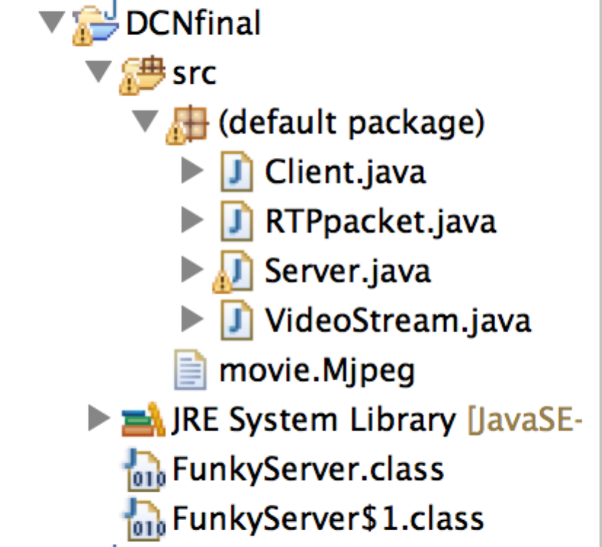

1. Start the server.

Java server 8888 in the terminal

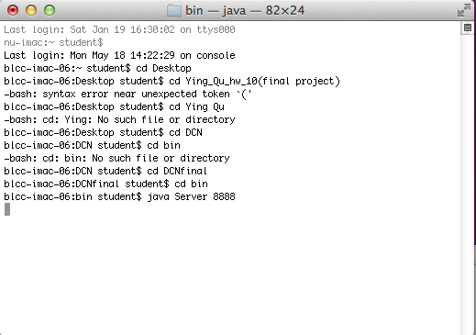

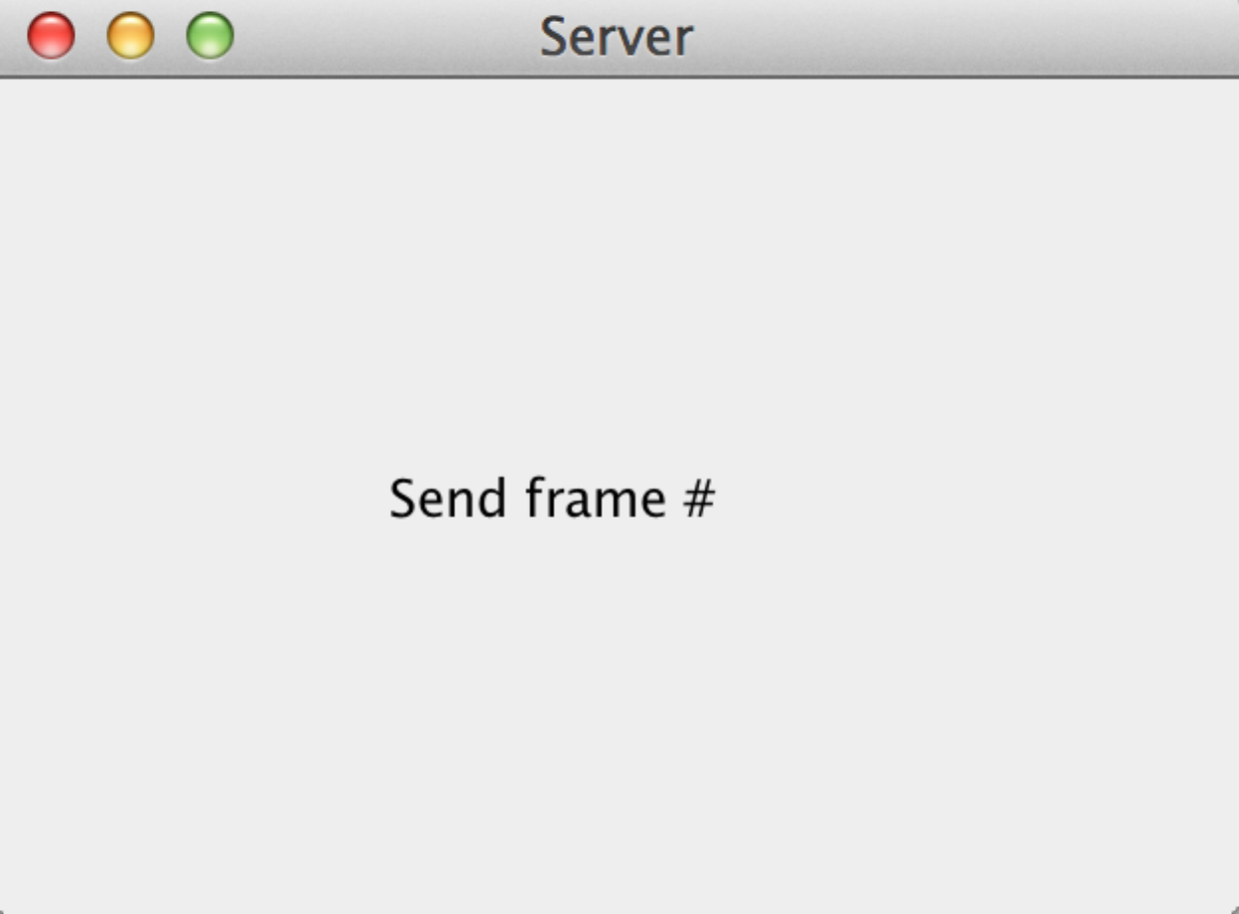

1. Start the client.

Java Client 127.0.0.1 movie.Mjpeg

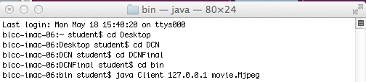

It looks as follows

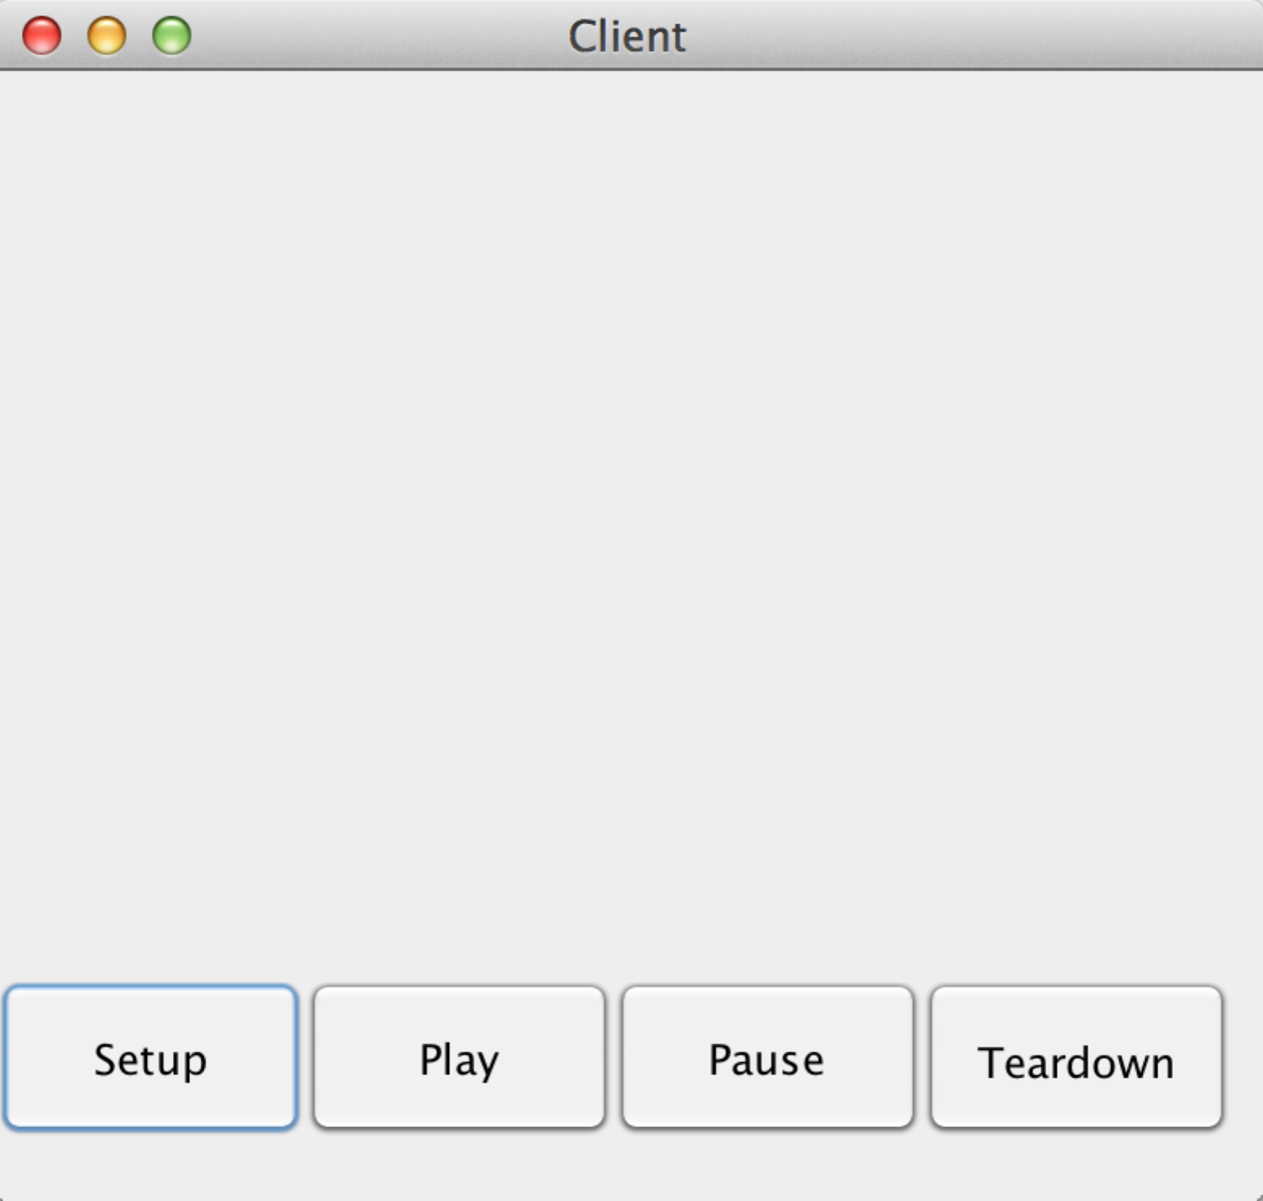

1. I can send RTSP commands to the server by pressing the buttons as shown.

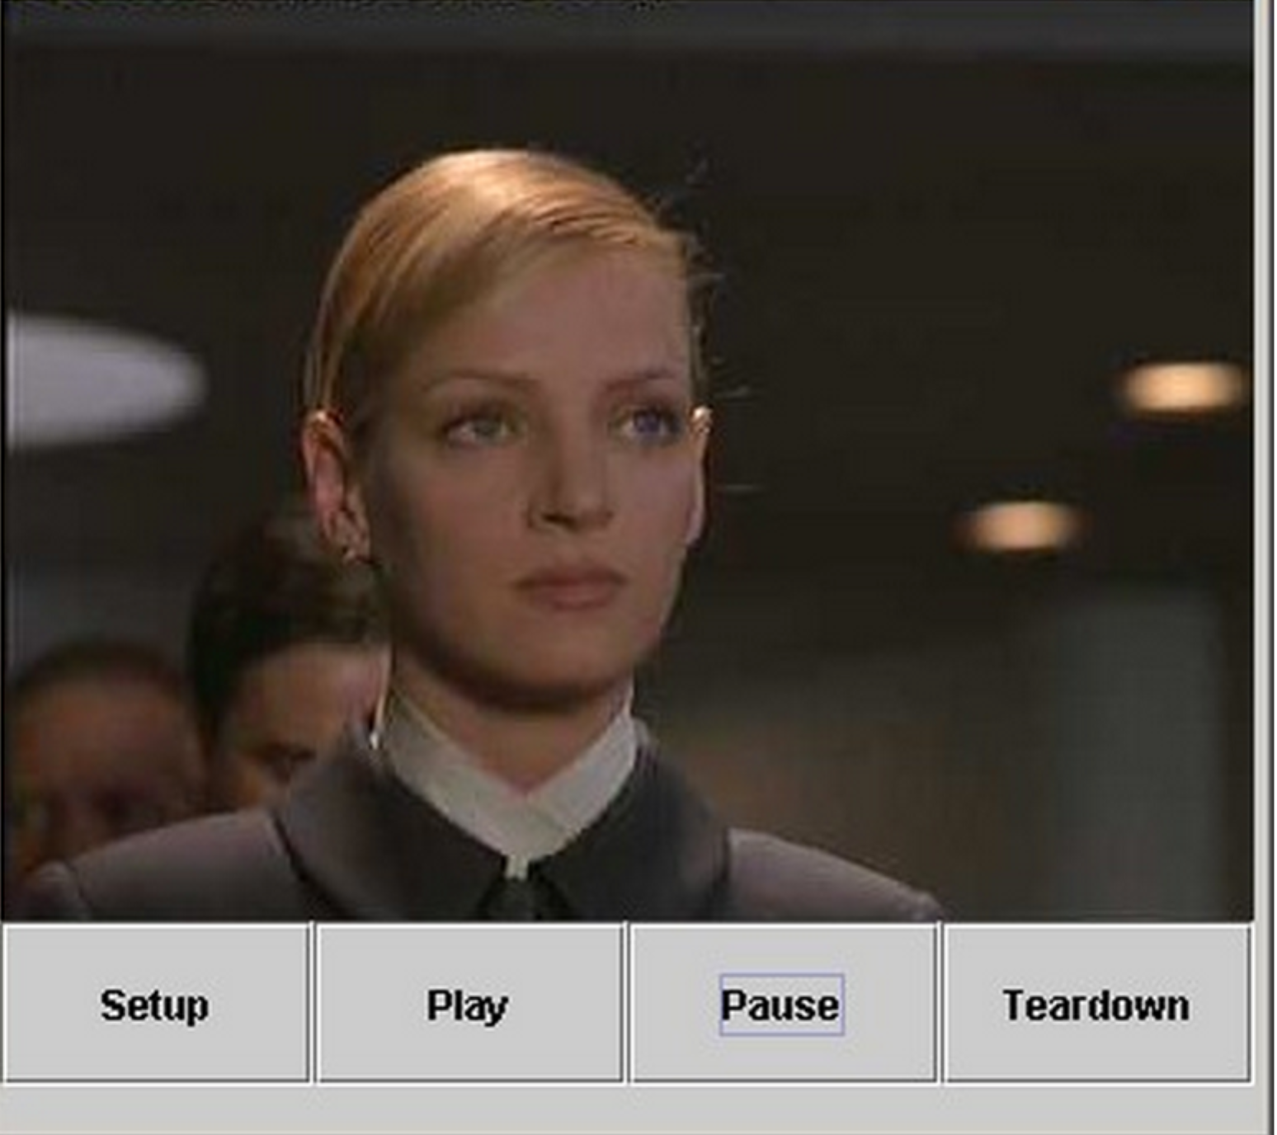

Thank you!